Object Oriented Programming using Java

## Programming Paradigm

* Paradigm means methodology
* A Programming Paradigm is a fundamental style of computer programming technique that defines how the structure and basic elements of a computer program is built
* While some programming languages strictly follow a single paradigm, others may draw concepts from more than one

## Types of Programming Paradigm

* Monolithic Programming – emphasizes on finding a solution
* Structured Programming – focus on modules
* Procedure-oriented Programming – lays stress on algorithm
* Object-oriented Programming – emphasizes on class and objects

## Monolithic Programming

* It indicates the program which contains a single function for a large program.
* A program is not divided into parts and hence is the name.
* When the program size increases it leads inconvenience and difficult to maintain.
* The program contains jump statements such as goto that transfer control to any statement as specified in it.
* The global data can be accessed and modified from any part of the program and hence posing a serious threat.
* It is suitable to develop simple and small application.
* Example : Basic

## Structured Programming

* Programming tasks can be split into smaller sections known as functions or subroutines, which can be called whenever they are required.
* It is often associated with “Top-down” approach to design.
* It attempts to divide the problem into smaller blocks or procedures which interact with each other.
* Example : Pascal,Ada,C

## Procedure-oriented Programming

* It basically consists of writing a list of instructions for the computer to follow and organizing these instructions into groups known as functions.
* The primary focus is on function rather than data.
* Examples : COBOL, Fortran

## Structure of Procedure-oriented Programming

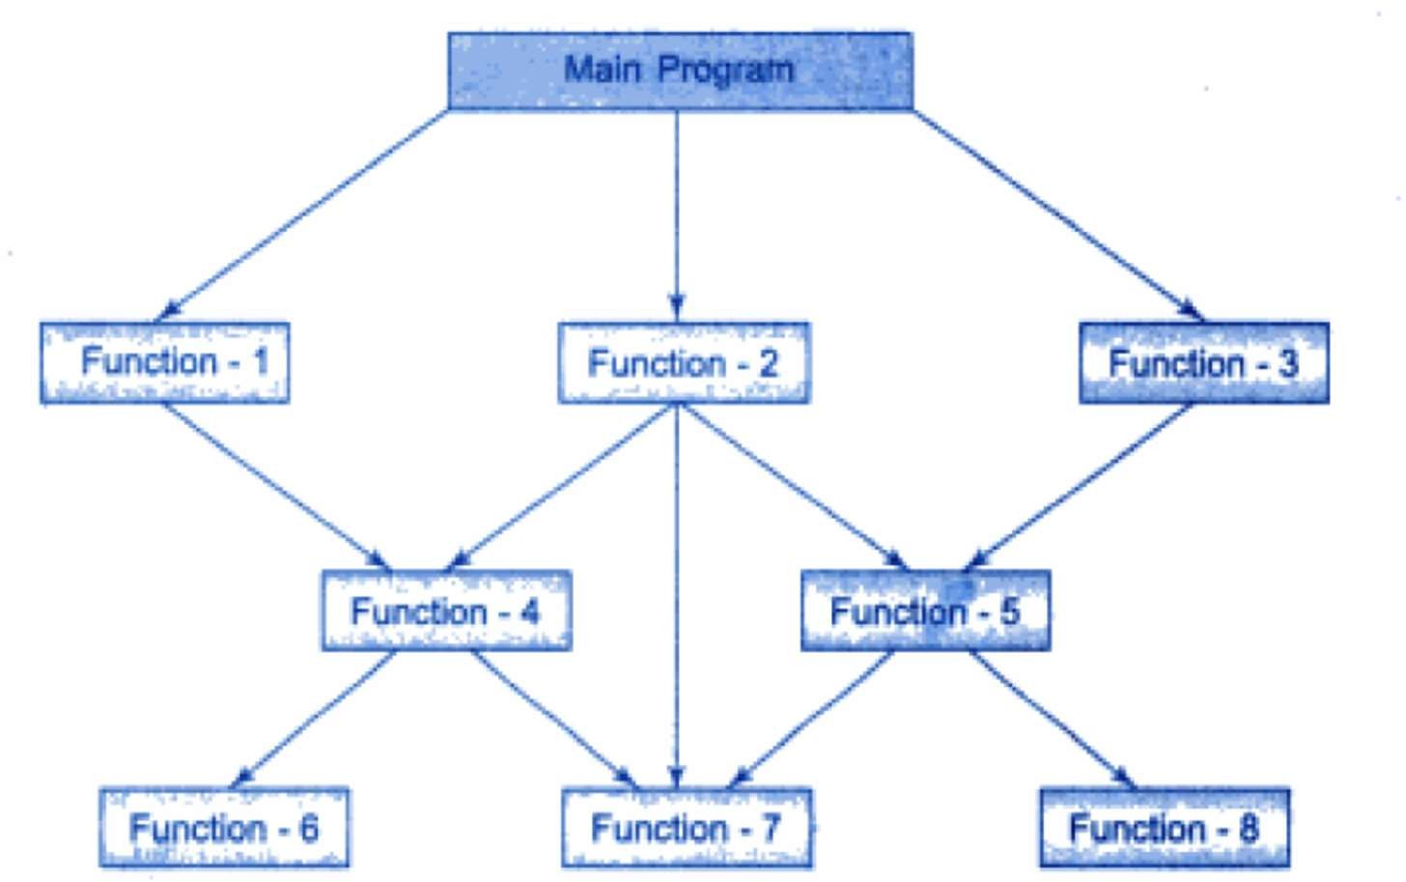

Characteristics of POP

* Emphasis is on doing things(Algorithms).
* Larger programs are divided into smaller programs known as functions.
* Most of the functions share global data.
* Data move openly around the system from function to function.
* Functions transform data from one form to another.
* Employs top-down approach in program design

## Relationship of Data and Functions in POP

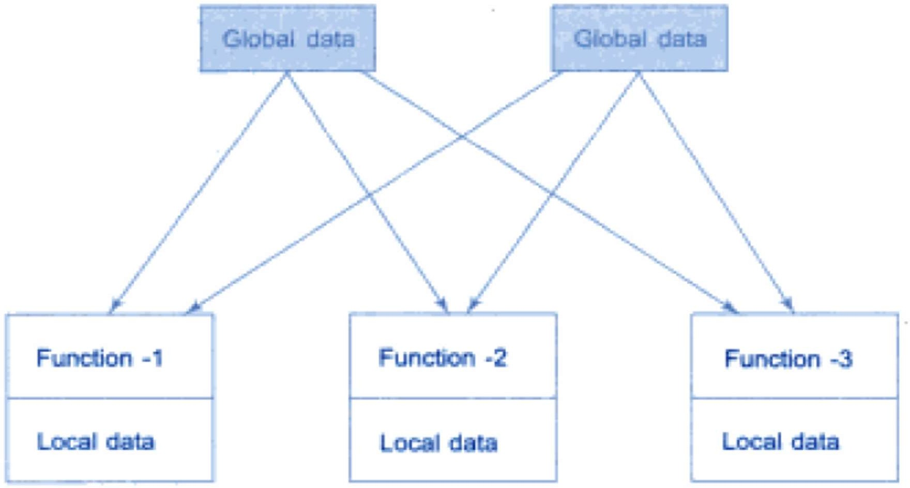

Object-oriented Programming

* It treats data as a critical element in program development and does not allow it to flow freely around the system.
* It ties data more closely to the functions that operate on it and protects it from accidental modification from outside functions.
* OOP allows decomposition of a problem into number of entities called objects and then build data and functions around these objects.
* The data of an object can be accessed only by the functions associated with that object.
* Functions of one object can access the functions of another object.

## Organization of data and function in OOP

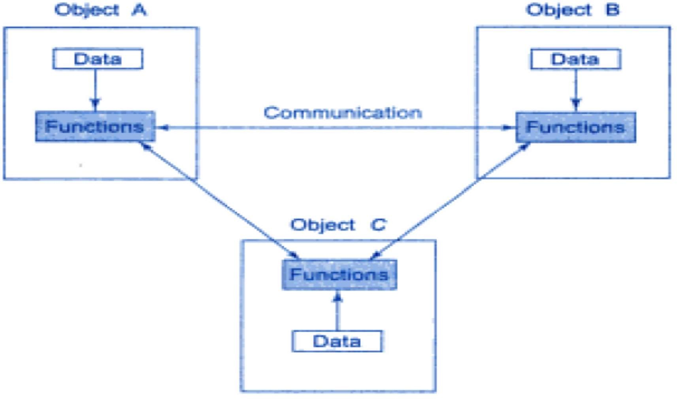

By Jagadish Sahoo

Characteristics of OOP

* Emphasis is on data rather than procedure.
* Programs are divided into objects.
* Data Structures are designed such that they characterize the objects.
* Functions that operate on data of an object are tied together in the data structure.
* Data is hidden and can not be accessed by external functions.
* Objects may communicate with each other through functions.
* New data and functions can be added easily whenever necessary.
* Follows bottom-up approach in program design.

## Basic concepts of OOP

* Classes
* Objects
* Data abstraction
* Encapsulation
* Inheritance
* Polymorphism
* Message Passing

## Classes

* Classes are user-defined datatypes
* A class is a collection of Data member and member functions.
* Variables declared in a class are called data member and functions declared in class are called member functions or methods.
* Objects are variable of type class. Once a class has been defined, we can create any number of objects belonging to that class.
* Each object is associated with the data of type class with which they are created.
* If Fruit is a class, then apple, orange, banana etc. are the objects of the class Fruit.
* Class is a logical structure.

## Object

* Basic run-time entities in an object-oriented system i.e. fundamental

building blocks for designing a software.

* It is a collection of data members and associated member function(method).
* An object represents a particular instance of a class.
* An object has 3 characteristics:

1. Name
2. State
3. Behavior

* Objects take up space in the memory and have associated address.
* When a program is executed, objects interact by sending messages to one another.
* Example : Book, Bank, Customer, Account etc.

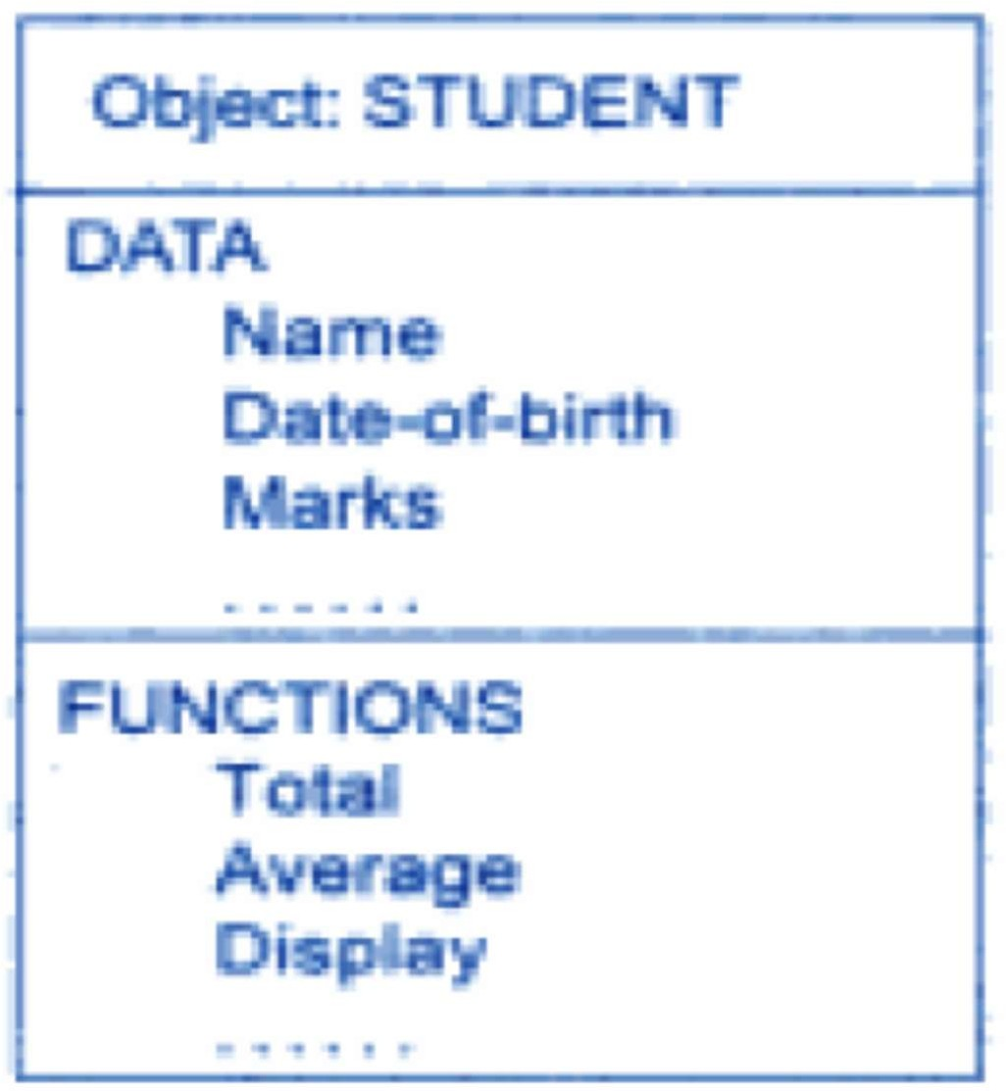

## Data Abstraction

* Abstraction refers to the act of representing essential features without including the background details or explanation.
* Data abstraction is an encapsulation of object’s state and behavior.
* Data abstraction increases the power of programming languages by creating user-defined data types.
* Classes uses the concept of abstraction and are defined as a list of abstract attributes(data members) and functions(methods).
* Since classes use the concept of data abstraction, they are also used as Abstract Data Type(ADT).

## Encapsulation

* Data encapsulation combines data and functions into a single unit

called class.

* When using data encapsulation, data is not accessed directly, it is only accessible through the methods present inside the class.
* Data encapsulation enables data hiding, which is an important concept of OOP.
* Example : Capsule is wrapped with different medicines.

## Inheritance

* It is the process by which one object can acquire the properties of another.
* It allows the declaration and implementation of new class/classes from existing class.
* The existing class is known as base class/parent class/super class and the new class/classes is/are known as derived class/child class/sub class.
* It uses the concept of Reusability.

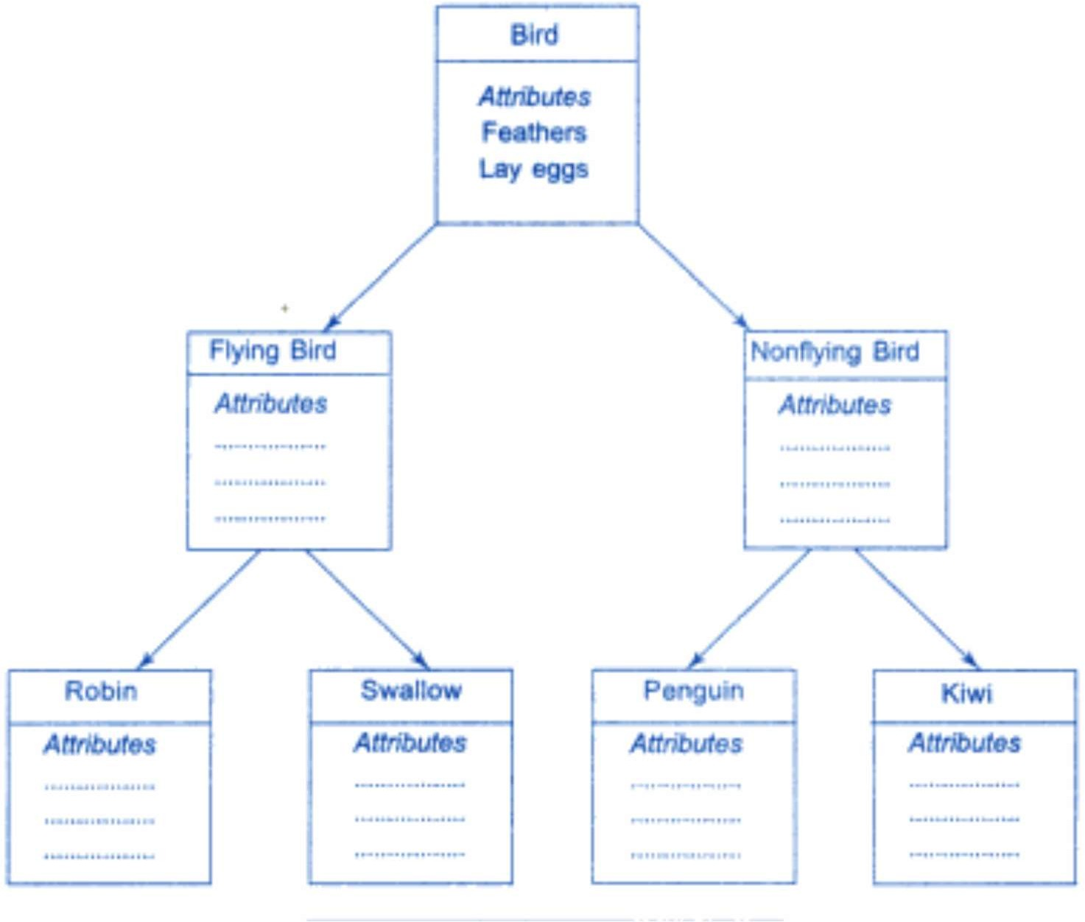

## Types of Inheritance

* Single Inheritance
* Multiple Inheritance
* Multilevel Inheritance
* Hierarchical Inheritance
* Hybrid Inheritance

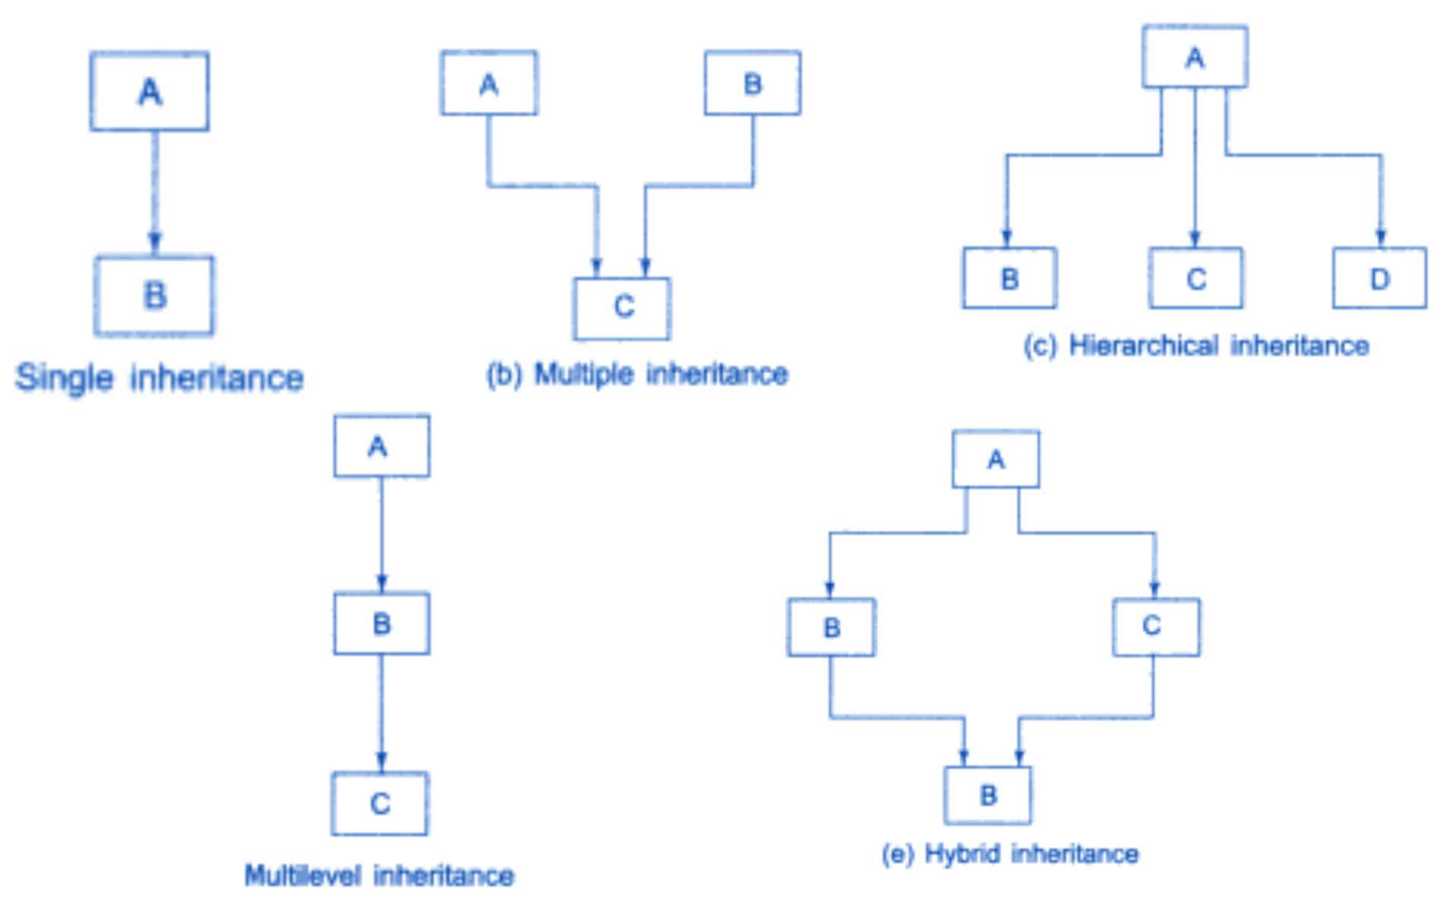

## Benefits of Inheritance

* It helps to reuse an existing part rather than hardcoding every time.
* It increases reliability and decreases maintenance cost.
* Development time is less & product can be generated more quickly.

## Polymorphism

* The ability to take more than one form is known as Polymorphism.
* An operation may exhibit different behaviors in different instances. The behavior depends upon the types of data used in the operation.

• + operator can be used to add 2 numbers and the result is sum of two numbers.

* Same + operators can be used to add 2 strings and the result is concatenation of 2 strings.
* This process of making an operator to exhibit different behaviors in different instances is known as operator overloading.

## Polymorphism(Function Overloading)

* A single function name can be used to handle different number and different types of arguments.
* Using a single function name to perform different types of tasks is known as function overloading.

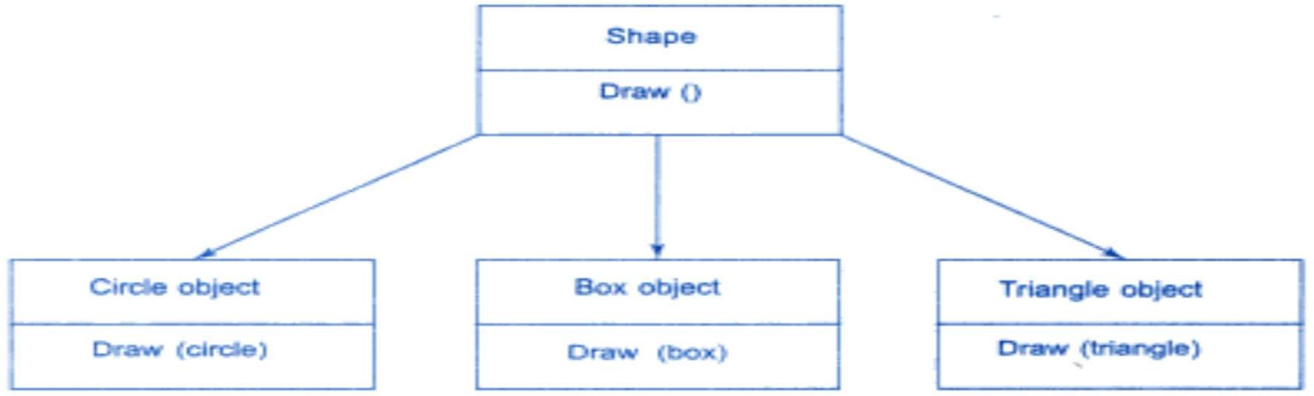

## Message Passing

* Any processing is accomplished by sending messages to objects.
* A message for an object is a request for execution of a procedure/function.
* It invoke a function on the receiving object that generates the desired result.
* Message passing involves specifying the name of the object, name of the function(message) and information to be sent.

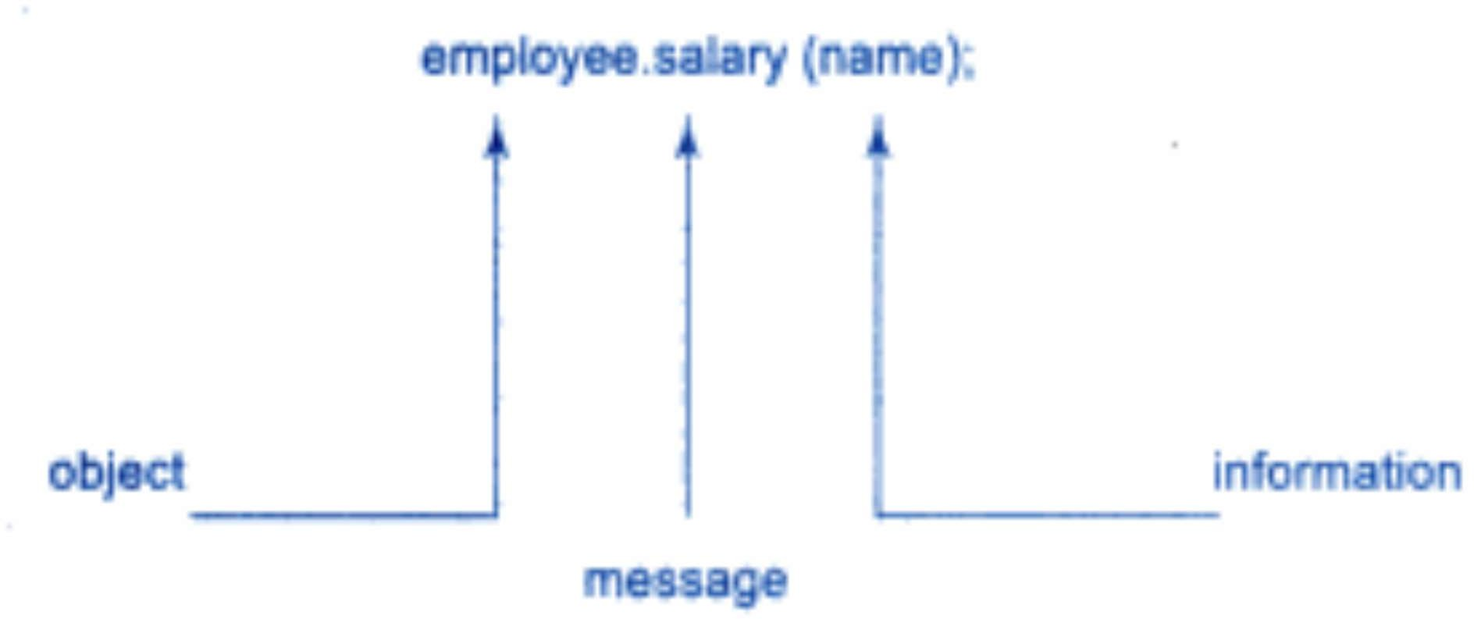

## What is Java

* Java is a **programming language** and a **platform**.
* Java was developed by *Sun Microsystems* (which is now the subsidiary of Oracle) in the year 1995.
* *James Gosling* is known as the father of Java.
* Before Java, its name was *Oak*.
* Since Oak was already a registered company, so James Gosling and his team changed the Oak name to Java.
* **Platform**: Any hardware or software environment in which a program runs, is known as a platform. Since Java has a runtime environment (JRE) and API, it is called a platform.

## **Application**

* Desktop Applications such as acrobat reader, media player, antivirus, etc.
* Web Applications such as irctc.co.in.
* Enterprise Applications such as banking applications.
* Mobile
* Embedded System
* Smart Card
* Robotics
* Games, etc.

## Types of Java Applications

1. Standalone Application

* Standalone applications are also known as desktop applications or window-based applications. These are traditional software that we need to install on every machine. Examples of standalone applications are Media player, antivirus, etc. AWT and Swing are used in Java for creating standalone applications.

1. Web Application

* An application that runs on the server side and creates a dynamic page is called a web application. Currently, Servlet, JSP, Struts, Spring, Hibernate, JSF, etc. technologies are used for creating web applications in Java.

1. Enterprise Application

* An application that is distributed in nature, such as banking applications, etc. is called enterprise application. In Java, EJB is used for creating enterprise applications.

1. Mobile Application

* An application that is created for mobile devices is called a mobile application. Currently, Android and Java ME are used for creating mobile applications.

## **Java Editions**

1. **Java SE (Java Standard Edition)**

* It is a Java programming platform. It includes Java programming APIs such as java.lang, java.io, java.net, java.util, java.sql, java.math etc. It includes core topics like OOPs, String, Regex, Exception, Inner classes, Multithreading, I/O Stream, Networking, AWT, Swing, etc.

1. **Java EE (Java Enterprise Edition)**

* It is an enterprise platform that is mainly used to develop web and enterprise applications. It is built on top of the Java SE platform. It includes topics like Servlet, JSP, Web Services, EJB etc.

1. **Java ME (Java Micro Edition)**

* It is a micro platform that is mainly used to develop mobile applications.

## Features of Java

* Simple
* Object-Oriented
* Platform independent / Portable
* Secured
* Robust
* Architecture neutral
* Interpreted
* High Performance
* Multithreaded
* Distributed
* Dynamic

Simple

* Java syntax is based on C++ (so easier for programmers to learn it after C++).
* Java has removed many complicated and rarely-used features, for example, explicit pointers, operator overloading, etc.
* There is no need to remove unreferenced objects because there is an Automatic Garbage Collection in Java.

Object-oriented

* Java is an object-oriented programming language. Everything in Java is an object.
* Object-oriented means we organize our software as a combination of different types of objects that incorporates both data and behavior.

Platform Independent

* + Java is platform independent because it is different from other languages like C, C++, etc. which are compiled into platform specific machines
  + Java is a write once, run anywhere language.

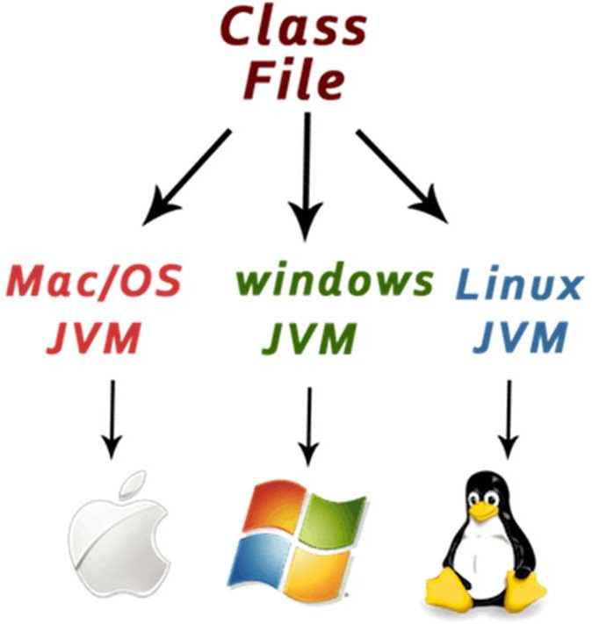

* A platform is the hardware or software environment in which a program runs.
* There are two types of platforms

1) software-based and

2) hardware-based.

* Java provides a software-based platform.
* The Java platform differs from most other platforms in the sense that it is a software-based platform that runs on the top of other hardware-based platforms.
* It has two components:

1. Runtime Environment
2. API (Application Programming Interface)

* Java code can be run on multiple platforms, for example, Windows, Linux, Sun Solaris, Mac/OS, etc.
* Java code is compiled by the compiler and converted into **bytecode**.
* This bytecode is a platform-independent code because it can be run on multiple platforms, i.e., Write Once and Run Anywhere(WORA).

Secured

* No explicit pointer
* Java Programs run inside a virtual machine sandbox
* **Classloader:** Classloader in Java is a part of the Java Runtime Environment(JRE) which is used to load Java classes into the Java Virtual Machine dynamically. It adds security by separating the package for the classes of the local file system from those that are imported from network sources.
* **Bytecode Verifier:** It checks the code fragments for illegal code that can violate access right to objects.
* **Security Manager:** It determines what resources a class can access such as reading and writing to the local disk.

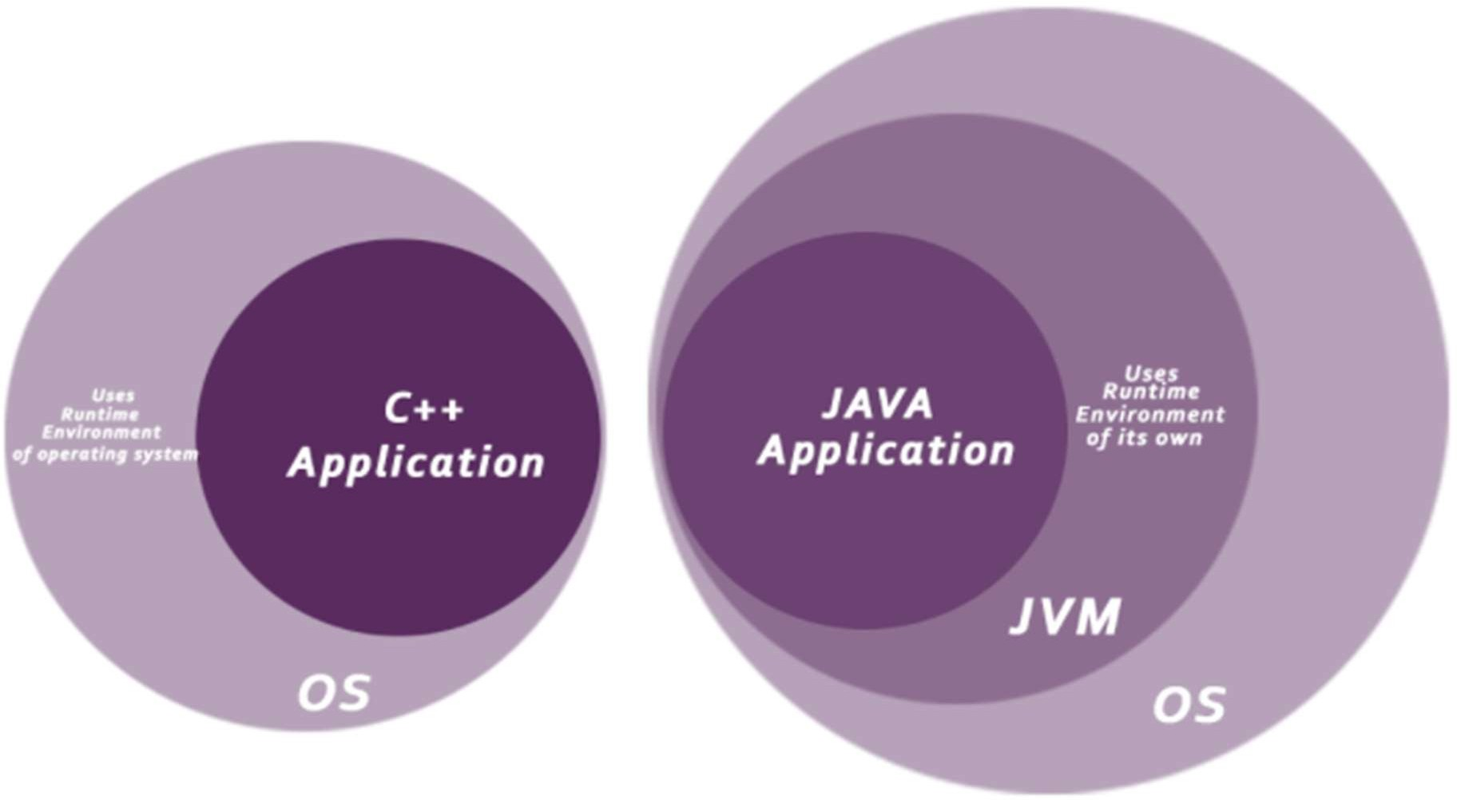

Robust(Strong)

* It uses strong memory management.
* There is no concept of pointers that avoids security problems.
* There is automatic garbage collection in java which runs on the Java Virtual Machine to get rid of objects which are not being used by a Java application anymore.
* There are exception handling and the type checking mechanism in Java. All these points make Java robust.

Architecture-neutral

* Java is architecture neutral because there are no implementation dependent features, for example, the size of primitive types is fixed.
* In C programming, int data type occupies 2 bytes of memory for 32-bit architecture and 4 bytes of memory for 64-bit architecture.
* It occupies 4 bytes of memory for both 32 and 64-bit architectures in Java.

High-performance

* Java is faster than other traditional interpreted programming languages because Java bytecode is "close" to native code.
* It is still a little bit slower than a compiled language (e.g., C++). Java is an interpreted language that is why it is slower than compiled languages, e.g., C, C++, etc.

Distributed

* Java is distributed because it facilitates users to create distributed applications in Java.
* RMI and EJB are used for creating distributed applications.
* This feature of Java makes us able to access files by calling the methods from any machine on the internet.

Multi-threaded

* A thread is like a separate program, executing concurrently.
* We can write Java programs that deal with many tasks at once by defining multiple threads.
* The main advantage of multi-threading is that it doesn't occupy memory for each thread.
* It shares a common memory area.
* Threads are important for multi-media, Web applications, etc.

Dynamic

* Java is a dynamic language. It supports dynamic loading of classes. It means classes are loaded on demand. It also supports functions from its native languages, i.e., C and C++.
* Java supports dynamic compilation and automatic memory management (garbage collection).

Difference between C++ and Java

|  |  |  |
| --- | --- | --- |
| **Features** | **C++** | **Java** |
| **Platform Independence** | Platform-dependent | Platform-independent |
| **Interpreter and Compiler** | Compiled programming language | Compiled and interpreted language |
| **Portability** | Not portable | Portable |
| **Memory Management** | Manual | System-controlled |
| **Multiple Inheritance** | Supports single inheritance and multiple inheritance | Only supports single inheritance |
| **Overloading** | Both operators and methods can be overloaded | Allows only method overloading |
| **Pointers** | Supports pointers | Supports pointers with restrictions |
| **Thread Support** | Does not support thread | Has built-in thread support via the “thread” class |

#### **Requirements to write a java program**

* Install the JDK
* Set path of the jdk/bin directory.
* Create the java program
* Compile and run the java program

**class** Simple{

**public static void** main(String args[]){ System.out.println("Hello Java");

}

}

* save this file as Simple.java

**To compile:** javac Simple.java

**To execute:** java Simple

# Compilation Flow

* When we compile Java program using javac tool, java compiler converts the source code into byte code

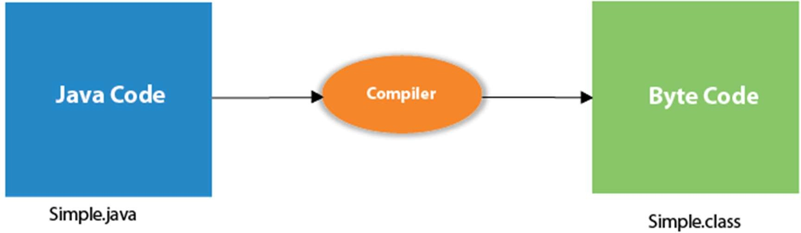

**class** Simple{

**public static void** main(String args[]){ System.out.println("Hello Java");

}

}

* class keyword is used to declare a class in java.
* public keyword is an access modifier which represents visibility. It means it is visible to all.
* **static** is a keyword. If we declare any method as static, it is known as the static method. The core advantage of the static method is that there is no need to create an object to invoke the static method. The main method is executed by the JVM, so it doesn't require creating an object to invoke the main method. So it saves memory.

**class** Simple{

**public static void** main(String args[]){ System.out.println("Hello Java");

}

}

* void is the return type of the method. It means it doesn't return any value.
* main represents the starting point of the program.
* String[] args is used for command line argument.
* System.out.println() is used to print statement.
  + Here, **System** is a class
  + **out** is the object of **PrintStream** class
  + **println()** is the method of **PrintStream** class.

## How many ways can we write a Java program

* **By changing the sequence of the modifiers, method prototype is not changed in Java.**

**static public void** main(String args[])

* **The subscript notation in Java array can be used after type, before the variable or after the variable.**

**public static void** main(String[] args) **public static void** main(String []args) **public static void** main(String args[])

* **You can provide var-args support to the main method by passing 3 ellipses (dots)**

**public static void** main(String... args)

* **Having a semicolon at the end of class is optional in Java. class** A{

**static public void** main(String... args){ System.out.println("hello java");

}

};

## Valid java main method signature

* **public static void** main(String[] args)
* **public static void** main(String []args)
* **public static void** main(String args[])
* **public static void** main(String... args)
* **static public void** main(String[] args)
* **public static final void** main(String[] args)
* **final public static void** main(String[] args)
* **final strictfp public static void** main(String[] args)

## Invalid java main method signature

* **public void** main(String[] args)
* **static void** main(String[] args)
* **public void static** main(String[] args)
* **abstract public static void** main(String[] args)

## What happens at compile time?

* At compile time, java file is compiled by Java Compiler (It does not interact with OS) and converts the java code into bytecode.



#### What happens at runtime?

* 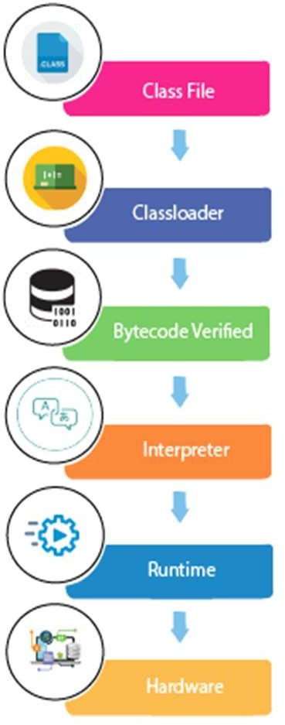At runtime, following steps are performed:

**Classloader:** is the subsystem of JVM that is used to load class files.

**Bytecode Verifier:** checks the code fragments for illegal code that can violate access right to objects.

**Interpreter:** read bytecode stream then execute the instructions.

#### Can we save a java source file by other name than the class name?

* Yes, if the class is not public.

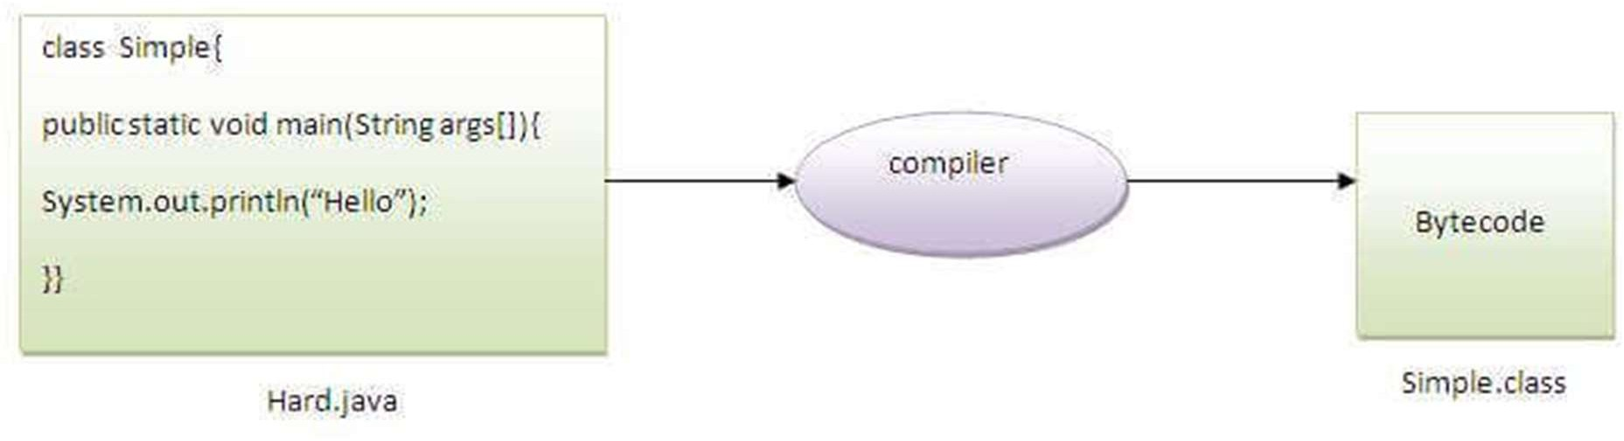

**To compile:** javac Hard.java

**To execute:**

Java Simple

#### Can we have multiple classes in a java source file?

* Yes

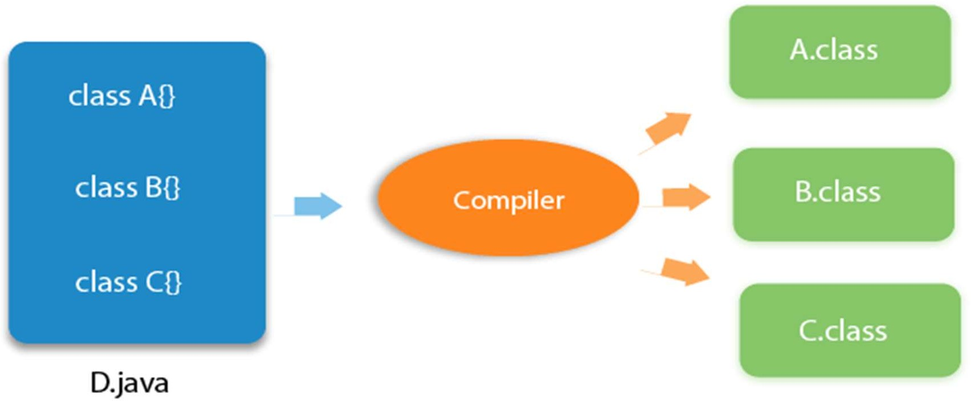

## JVM

* JVM (Java Virtual Machine) is an abstract machine. It is called a virtual machine because it doesn't physically exist.
* It is a specification that provides a runtime environment in which Java bytecode can be executed.
* It can also run those programs which are written in other languages and compiled to Java bytecode.
* JVMs are available for many hardware and software platforms. JVM, JRE, and JDK are platform dependent because the configuration of each OS is different from each other.
* However, Java is platform independent.

## The JVM performs the following main tasks:

* Loads code
* Verifies code
* Executes code
* Provides runtime environment

## JRE

* JRE is an acronym for Java Runtime Environment.
* The Java Runtime Environment is a set of software tools which are used for developing Java applications.
* It is used to provide the runtime environment.
* It is the implementation of JVM.
* It physically exists. It contains a set of libraries + other files that JVM uses at runtime.

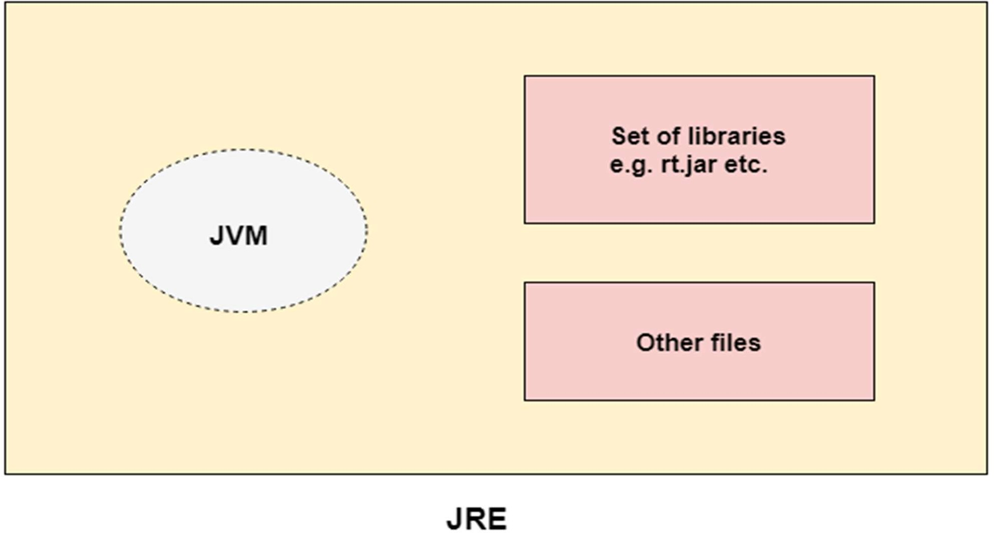

#### JDK

* JDK is an acronym for Java Development Kit.
* The Java Development Kit (JDK) is a software development environment which is used to develop Java applications and applets.
* It physically exists. It contains JRE + development tools.
* The JDK contains a private Java Virtual Machine (JVM) and a few other resources such as an interpreter/loader (java), a compiler (javac), an archiver (jar), a documentation generator (Javadoc), etc. to complete the development of a Java Application.

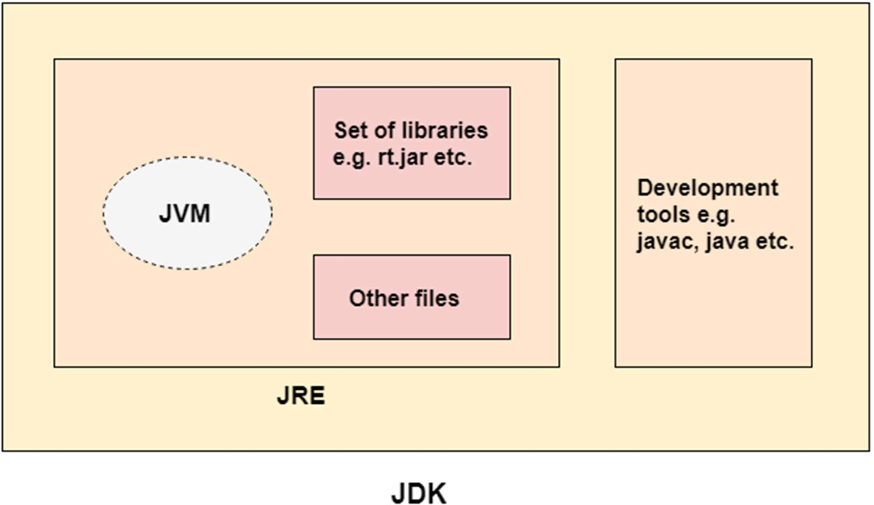

#### JVM (Java Virtual Machine) Architecture

* VM (Java Virtual Machine) is an abstract machine.
* It is a specification that provides a runtime environment in which java bytecode can be executed.
* JVMs are available for many hardware and software platforms (i.e. JVM is platform dependent).

#### What it does

The JVM performs following operation:

* Loads code
* Verifies code
* Executes code
* Provides runtime environment

## JVM Architecture

Classloader

Classloader is a subsystem of JVM which is used to load class files. Whenever we run the java program, it is loaded first by the classloader.

There are three built-in classloaders in Java.

* **Bootstrap ClassLoader**: This is the first classloader which is the super class of Extension classloader. It loads the *jar* file which contains all class files of Java Standard Edition like java.lang package classes, java.net package classes, java.util package classes, java.io package classes, java.sql package classes etc.
* **Extension ClassLoader**: This is the child classloader of Bootstrap and parent classloader of System classloader. It loads the jar files located inside *$JAVA_HOME/jre/lib/ext* directory.
* **System/Application ClassLoader**: This is the child classloader of Extension classloader. It loads the classfiles from classpath. By default, classpath is set to current directory. It is also known as Application classloader.
* Class(Method) Area

Class(Method) Area stores per-class structures such as the field and method data, the code for methods.

* Heap

It is the runtime data area in which objects are allocated.

* Stack

1. Java Stack stores frames. It holds local variables and partial results, and plays a part in method invocation and return.
2. Each thread has a private JVM stack, created at the same time as thread.
3. A new frame is created each time a method is invoked. A frame is destroyed when its method invocation completes.

* Program Counter Register

PC (program counter) register contains the address of the Java virtual machine instruction currently being executed.

* Native Method Stack

It contains all the native methods used in the application.

* Execution Engine It contains:

1. **A virtual processor**
2. **Interpreter:** Read bytecode stream then execute the instructions.
3. **Just-In-Time(JIT) compiler:** It is used to improve the performance. JIT compiles parts of the byte code that have similar functionality at the same time, and hence reduces the amount of time needed for compilation. Here, the term "compiler" refers to a translator from the instruction set of a Java virtual machine (JVM) to the instruction set of a specific CPU.

* Java Native Interface

1. Java Native Interface (JNI) is a framework which provides an interface to communicate with another application written in another language like C, C++, Assembly etc.
2. Java uses JNI framework to send output to the Console or interact with OS libraries.

## Java Variables

* A variable is a container which holds the value while the Java program is executed. A variable is assigned with a data type.
* Variable is name of reserved area allocated in memory.
* Variable is a name of memory location. There are three types of variables in java: local, instance and static.
* There are two types of data types in Java:

1. primitive
2. non-primitive.

# Beginning Java programming

The process of Java programming can be simplified in three steps:

* Create the program by typing it into a text editor and saving it to a file

– HelloWorld.java.

* Compile it by typing “javac HelloWorld.java” in the terminal window.
* Execute (or run) it by typing “java HelloWorld” in the terminal window.

/* This is a simple Java program. FileName : "HelloWorld.java". */ class HelloWorld

{

// Your program begins with a call to main().

// Prints "Hello, World" to the terminal window. public static void main(String args[])

{

System.out.println("Hello, World");

}

}

**Class definition:**This line uses the keyword **class** to declare that a new class is being defined. class HelloWorld

HelloWorld is an identifier that is the name of the class. The entire class definition, including all of its members, will be between the opening curly brace { and the closing curly brace } .

main method: In Java programming language, every application must contain a main method whose signature is:

public static void main(String[] args)

public: So that JVM can execute the method from anywhere. static: Main method is to be called without object.

The modifiers public and static can be written in either order. void: The main method doesn't return anything.

main(): Name configured in the JVM.

String[]: The main method accepts a single argument: an array of elements of type String.

System.out.println("Hello, World");

This line outputs the string “Hello, World” followed by a new line on the screen. Output is actually accomplished by the built-in println( *)* method. **System** is a predefined class that provides access to the system, and **out** is the variable of type output stream that is connected to the console.

Comments: They can either be multi-line or single line comments.

/* This is a simple Java program. Call this file "HelloWorld.java". */

This is a multiline comment. This type of comment must begin with /* and end with */. For single line you may directly use // as in C/C++.

# Important Points

* The name of the class defined by the program is HelloWorld, which is same as name of file(HelloWorld.java). This is not a coincidence. In Java, all codes must reside inside a class and there is at most one public class which contain main() method.
* By convention, the name of the main class(class which contain main method) should match the name of the file that holds the program.

**Compiling the program**

After successfully setting up the environment, we can open terminal in both Windows/Unix and can go to directory where the file – HelloWorld.java is present.

Now, to compile the HelloWorld program, execute the compiler – javac , specifying the name of the source file on the command line, as shown: javac HelloWorld.java

The compiler creates a file called HelloWorld.class (in present working directory) that contains the bytecode version of the program. Now, to execute our program, JVM(Java Virtual Machine) needs to be called using java, specifying the name of the class file on the command line, as shown: java HelloWorld

This will print “Hello World” to the terminal screen.

**Java Identifiers**

* + In programming languages, identifiers are used for identification purposes. In Java, an identifier can be a class name, method name, variable name, or label.

**Rules for defining Java Identifiers**

* + The only allowed characters for identifiers are all alphanumeric characters([**A-Z**],[**a-z**],[**0-9**]), ‘**$**‘(dollar sign) and ‘**_**‘ (underscore).For example “roll@” is not a valid java identifier as it contain ‘@’ special character.
  + Identifiers should **not** start with digits(**[0-9]**). For example “123name” is a not a valid java identifier.
  + Java identifiers are **case-sensitive**.
  + There is no limit on the length of the identifier but it is advisable to use an optimum length of 4 – 15 letters only.
  + **Reserved Words** can’t be used as an identifier. For example “int while = 20;” is an invalid statement as while is a reserved word. There

are **53** reserved words in Java.

**Reserved Words**

* + Any programming language reserves some words to represent functionalities defined by that language. These words are called reserved words.
  + They can be briefly categorized into two parts : **keywords**(50) and **literals**(3).
  + Keywords define functionalities and literals define a value.

**Data types in Java**

There are majorly two types of languages.

* + **Statically typed language** where each variable and expression type is already known at compile time. Once a variable is declared to be of a certain data type, it cannot hold values of other data types. **Example:** C, C++, Java.
  + The other is **Dynamically typed languages.** These languages can receive different data types over time.

**Example:** Ruby, Python

* + Java is **statically typed and also a strongly typed language** because, in Java, each type of data (such as integer, character, hexadecimal, packed decimal, and so forth) is predefined as part of the programming language and all constants or variables defined for a given program must be described with one of the data types.

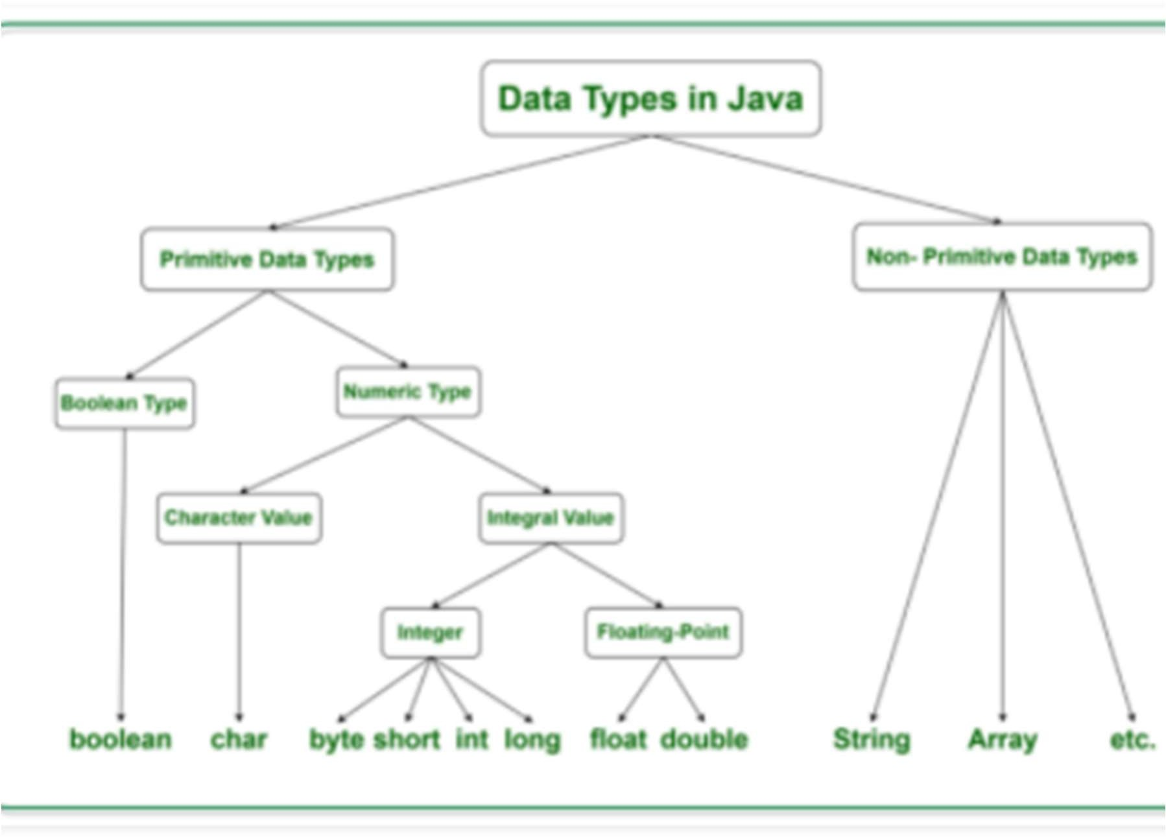

**Primitive Data Type**

* + Primitive data are only single values and have no special capabilities.

#### boolean

* + boolean data type represents only one bit of information **either true or false**, but the size of the boolean data type is **virtual machine- dependent**.
  + Values of type boolean are not converted implicitly or explicitly (with casts) to any other type.
  + **Syntax :** boolean booleanvariable;
  + **Size** : Virtual Machine dependent
  + **Values:** true or false
  + **Default Value:** false

#### byte

* + The byte data type is an 8-bit signed integer. The byte data type is useful for saving memory in large arrays.
  + **Syntax:** byte variablename;
  + **Size:** 1 byte(8 bits)
  + **Values:** -128 to +127
  + **Default Value:** 0

short

* + The short data type is a 16-bit signed integer.
  + Similar to byte, use a short to save memory in large arrays, in situations where the memory savings actually matters.
  + **Syntax:** short variablename;
  + **Size:** 2 bytes(16 bits)
  + **Values:** -32, 768 to 32, 767 (inclusive)
  + **Default Value:** 0

## int

* + It is a 32-bit signed integer.
  + **Syntax:** int variablename;
  + **Size:** 4 byte ( 32 bits )
  + **Values:** -2, 147, 483, 648 to 2, 147, 483, 647 (inclusive)
  + **Default Value:** 0

## long

* + The long data type is a 64-bit signed integer.
  + **Syntax:** long variablename;
  + **Size:** 8 byte ( 64 bits )
  + **Values:** -9, 223, 372, 036, 854, 775, 808

to

9, 223, 372, 036, 854, 775, 807(inclusive)

**Default Value:** 0

## float

* + The float data type is a 32-bit floating-point. Use a float (instead of double) if you need to save memory in large arrays of floating-point numbers.
  + **Syntax:** float variablename;
  + **Size:** 4 byte ( 32 bits )
  + **Values:** upto 7 decimal digits
  + **Default Value:** 0.0

## double

* + The double data type is a 64-bit floating-point. For decimal values, this data type is generally the default choice.
  + **Syntax:** double variablename;
  + **Size:** 8 byte ( 64 bits )
  + **Values:** upto 16 decimal digits
  + **Default Value:** 0.0

## char

* + The char data type is a single 16-bit Unicode character.
  + **Syntax:** char variablename;
  + **Size:** 2 byte ( 16 bits )
  + **Values:** '\u0000' (0) to '\uffff' (65535)
  + **Default Value:** '\u0000‘
  + Unicode defines a fully international character set that can represent most of the world’s written languages. It is a unification of dozens of character sets, such as Latin, Greeks, Cyrillic, Katakana, Arabic, and many more.

# Why is the size of char is 2 byte in java..?

* + In other languages like C/C++ uses only ASCII characters and to represent all ASCII characters 8-bits is enough, But java uses the Unicode system not the ASCII code system and to represent Unicode system 8 bit is not enough to represent all characters so java uses 2 bytes for characters.

#### Operators

* + Arithmetic Operators
  + Unary Operators
  + Assignment Operator
  + Relational Operators
  + Logical Operators
  + Ternary Operator
  + Bitwise Operators
  + Shift Operators
  + instance of operator

# Arithmetic Operators

They are used to perform simple arithmetic operations on primitive data types.

**\* :** Multiplication

**/ :** Division

**% :** Modulo

**+ :** Addition

**– :** Subtraction

### Unary Operators

Unary operators need only one operand. They are used to increment, decrement or negate a value.

* + **– :Unary minus**, used for negating the values.

• **+ :Unary plus**, indicates positive value (numbers are positive without this, however). It performs an automatic conversion to int when the type of its operand is byte, char, or short. This is called unary numeric promotion.

• **++ :Increment operator**, used for incrementing the value by 1.

* + **-- : Decrement operator**, used for decrementing the value by 1.

There are two varieties of increment operator.

* + **Post-Increment :** Value is first used for computing the result and then incremented.
  + **Pre-Increment :** Value is incremented first and then result is computed.

There are two varieties of decrement operator.

* + **Post-decrement :** Value is first used for computing the result and then decremented.
  + **Pre-Decrement :** Value is decremented first and then result is computed.
  + **! : Logical not operator**, used for inverting a boolean value.

### Assignment Operator

• **=’** Assignment operator is used to assign a value to any variable.

* + It has a right to left associativity, i.e value given on right hand side of operator is assigned to the variable on the left and therefore right hand side value must be declared before using it or should be a constant.
  + Syntax :

variable = value;

* + In many cases assignment operator can be combined with other operators to build a shorter version of statement called Compound Statement.
  + For example, instead of a **=** a+5, we can write a **+=** 5.

• **+=**, for adding left operand with right operand and then assigning it to variable on the left.

* + **-=**, for subtracting left operand with right operand and then assigning it to variable on the left.
  + **\*=**, for multiplying left operand with right operand and then assigning it to variable on the left.
  + **/=**, for dividing left operand with right operand and then assigning it to variable on the left.
  + **%=**, for assigning modulo of left operand with right operand and then assigning it to variable on the left.

### Relational Operators

* + These operators are used to check for relations like equality, greater than, less than.
  + They return boolean result after the comparison and are extensively used in looping statements as well as conditional if else statements.
  + Syntax :

variable relation_operator value

• **==, Equal to :** returns true if left hand side is equal to right hand side.

* + **!=, Not Equal to :** returns true if left hand side is not equal to right hand side.
  + **<, less than :** returns true if left hand side is less than right hand side.
  + **<=, less than or equal to :** returns true if left hand side is less than or equal to right hand side.
  + **>, Greater than :** returns true if left hand side is greater than right hand side.
  + **>=, Greater than or equal to:** returns true if left hand side is greater than or equal to right hand side.

### Logical Operators

* + These operators are used to perform “logical AND” and “logical OR” operation, i.e. the function similar to AND gate and OR gate in digital electronics.
  + The second condition is not evaluated if the first one is false, i.e. it has a short-circuiting effect. Used extensively to test for several conditions for making a decision.
  + Conditional operators are-

1. **&&, Logical AND :** returns true when both conditions are true.
2. **||, Logical OR :** returns true if at least one condition is true.

### Ternary operator

* + Ternary operator is a shorthand version of if-else statement. It has three operands and hence the name ternary.
  + Syntax :

condition ? if true : if false

public class operators {

public static void main(String[] args)

{

int a = 20, b = 10, c = 30, result;

// result holds max of three

// numbers

result = ((a > b)? (a > c)? a:c (b > c)? b: c); System.out.println("Max of three numbers = "

+ result);

}

}

# Bitwise Operators

These operators are used to perform manipulation of individual bits of a number. They can be used with any of the integer types

* + **&, Bitwise AND operator:** returns bit by bit AND of input values.
  + **|, Bitwise OR operator:** returns bit by bit OR of input values.
  + **^, Bitwise XOR operator:** returns bit by bit XOR of input values.
  + **~, Bitwise Complement Operator:** This is a unary operator which returns the one’s compliment representation of the input value, i.e. with all bits inversed.

# Shift Operators

* + These operators are used to shift the bits of a number left or right thereby multiplying or dividing the number by two respectively.
  + They can be used when we have to multiply or divide a number by two.
  + Syntax

number shift_op number_of_places_to_shift;

* + **<<, Left shift operator:** shifts the bits of the number to the left and fills 0 on voids left as a result. Similar effect as of multiplying the number with some power of two.
  + **>>, Signed Right shift operator:** shifts the bits of the number to the right and fills 0 on voids left as a result. The leftmost bit depends on the sign of initial number. Similar effect as of dividing the number with some power of two.
  + **>>>, Unsigned Right shift operator:** shifts the bits of the number to the right and fills 0 on voids left as a result. The leftmost bit is set to 0.

#### instance of operator

* + Instance of operator is used for type checking. It can be used to test if an object is an instance of a class, a subclass or an interface.
  + Syntax :

object instance of class/subclass/interface

class operators {

public static void main(String[] args)

{

Person obj1 = new Person(); Person obj2 = new Boy();

System.out.println("obj1 instanceof Person: "

+ (obj1 instanceof Person)); System.out.println("obj1 instanceof Boy: "

+ (obj1 instanceof Boy)); System.out.println("obj1 instanceof MyInterface: "

+ (obj1 instanceof MyInterface)); System.out.println("obj2 instanceof Person: "

+ (obj2 instanceof Person)); System.out.println("obj2 instanceof Boy: "

+ (obj2 instanceof Boy)); System.out.println("obj2 instanceof MyInterface: "

+ (obj2 instanceof MyInterface));

}

}

class Person {

}

class Boy extends Person implements MyInterface {

}

interface MyInterface {

}

# Non-Primitive Data Type or Reference Data Types

* + The Reference Data Types will contain a memory address of variable value because the reference types won’t store the variable value directly in memory.
  + Example: strings, objects, arrays, etc.
  + String: Strings are defined as an array of characters. The difference between a character array and a string in Java is, the string is designed to hold a sequence of characters in a single variable whereas, a character array is a collection of separate char type entities.
  + Unlike C/C++, Java strings are not terminated with a null character.
  + Syntax :

<String_Type> <string_variable> = “<sequence_of_string>”; Example :

// Declare String without using new operator String s = “Jagadish";

// Declare String using new operator String s1 = new String(“Jagadish");

* + Class: A class is a user-defined blueprint or prototype from which objects are created. It represents the set of properties or methods that are common to all objects of one type. In general, class declarations can include these components, in order:
  + **Modifiers**: A class can be public or has default access
  + **Class name:** The name should begin with a initial letter (capitalized by convention).
  + **Superclass(if any):** The name of the class’s parent (superclass), if any, preceded by the keyword extends. A class can only extend (subclass) one parent.
  + **Interfaces(if any):** A comma-separated list of interfaces implemented by the class, if any, preceded by the keyword implements. A class can implement more than one interface.
  + **Body:** The class body surrounded by braces, { }.
  + Object: It is a basic unit of Object-Oriented Programming and represents the real-life entities. A typical Java program creates many objects, which as you know, interact by invoking methods. An object consists of :

1. State: It is represented by attributes of an object. It also reflects the properties of an object.
2. Behavior: It is represented by methods of an object. It also reflects the response of an object with other objects.
3. Identity: It gives a unique name to an object and enables one object to interact with other objects.
   * Interface: Like a class, an interface can have methods and variables, but the methods declared in an interface are by default abstract (only method signature, nobody).
   * Interfaces specify what a class must do and not how. It is the blueprint of the class.
   * An Interface is about capabilities like a Player may be an interface and any class implementing Player must be able to (or must implement) move(). So it specifies a set of methods that the class has to implement.
   * If a class implements an interface and does not provide method bodies for all functions specified in the interface, then the class must be declared abstract.
   * **Array:** An array is a group of like-typed variables that are referred to by a common name. Arrays in Java work differently than they do in C/C++. The following are some important points about Java arrays. In Java, all arrays are dynamically allocated.
   * Since arrays are objects in Java, we can find their length using function length. This is different from C/C++ where we find length using size.
   * A Java array variable can also be declared like other variables with [] after the data type.
   * The variables in the array are ordered and each has an index beginning from 0.
   * Java array can be also be used as a static field, a local variable or a method parameter.
   * The **size** of an array must be specified by an int value and not long or short.
   * The direct superclass of an array type is Object.

# Ways to read input from console in Java

* + In Java, there are four different ways for reading input from the user in the command line environment(console).

1. Using Buffered Reader Class
2. Using Scanner Class
3. Using Console Class
4. Using Command line argument

# Using Buffered Reader Class

* + This is the Java classical method to take input, Introduced in JDK1.0. This method is used by wrapping the System.in (standard input stream) in an InputStreamReader which is wrapped in a BufferedReader, we can read input from the user in the command line.
  + The input is buffered for efficient reading.
  + The wrapping code is hard to remember.
  + To read other types, we use functions like Integer.parseInt(), Double.parseDouble(). To read multiple values, we use split().

import java.io.BufferedReader; import java.io.IOException;

import java.io.InputStreamReader; public class Test {

public static void main(String[] args) throws IOException

{

// Enter data using BufferReader

BufferedReader reader = new BufferedReader(new InputStreamReader(System.in));

// Reading data using readLine String name = reader.readLine();

// Printing the read line System.out.println(name);

}

}

# Using Scanner Class

* + This is probably the most preferred method to take input. The main purpose of the Scanner class is to parse primitive types and strings using regular expressions, however, it is also can be used to read input from the user in the command line.
  + Convenient methods for parsing primitives (nextInt(), nextFloat(), …) from the tokenized input.
  + Regular expressions can be used to find tokens.

import java.util.Scanner; class GetInputFromUser {

public static void main(String args[])

{

// Using Scanner for Getting Input from User Scanner in = new Scanner(System.in);

String s = in.nextLine(); System.out.println("You entered string " + s); int a = in.nextInt();

System.out.println("You entered integer " + a); float b = in.nextFloat(); System.out.println("You entered float " + b);

// closing scanner in.close();

}

}

# Difference between Scanner and BufferReader Class in Java

**java.util.Scanner class is a simple text scanner which can parse primitive types and strings. It internally uses regular expressions to read different types.**



**Java.io.BufferedReader class reads text from a character-input stream, buffering characters so as to provide for the efficient reading of sequence of characters**

**Issue with Scanner when nextLine() is used after nextXXX()**

import java.util.Scanner; class Differ

{

public static void main(String args[])

{

Scanner scn = new Scanner(System.in); System.out.println("Enter an integer"); int a = scn.nextInt(); System.out.println("Enter a String"); String b = scn.nextLine(); System.out.printf("You have entered:- "

+ a + " " + "and name as " + b);

}

}

import java.io.*; class Differ

{

public static void main(String args[]) throws IOException

{

BufferedReader br = new BufferedReader(new InputStreamReader(System.in)); System.out.println("Enter an integer");

int a = Integer.parseInt(br.readLine()); System.out.println("Enter a String"); String b = br.readLine();

System.out.printf("You have entered:- " + a + " and name as " + b);

}

}

* + In Scanner class if we call nextLine() method after any one of the seven nextXXX() method then the nextLine() does not read values from console and cursor will not come into console it will skip that step. The nextXXX() methods are nextInt(), nextFloat(), nextByte(), nextShort(), nextDouble(), nextLong(), next().
  + In BufferReader class there is no such type of problem. This problem occurs only for Scanner class, due to nextXXX() methods ignore newline character and nextLine() only reads till first newline character. If we use one more call of nextLine() method between nextXXX() and nextLine(), then this problem will not occur because nextLine() will consume the newline character. This problem is same as scanf() followed by gets() in C/C++.
  + This problem can also be solved by using next() instead of nextLine() for taking input of strings

import java.util.Scanner; class Differ {

public static void main(String args[])

{

Scanner scn = new Scanner(System.in); System.out.println("Enter an integer"); int a = scn.nextInt();

scn.nextLine(); System.out.println("Enter a String"); String b = scn.next();

String c = scn.next(); int d = scn.nextInt();

System.out.printf("You have entered:- " + a + " " + "and name as " + b + " and " + c + d);

}

}

* + BufferedReader is synchronous while Scanner is not. BufferedReader should be used if we are working with multiple threads.
  + BufferedReader has significantly larger buffer memory than Scanner.
  + The Scanner has a little buffer (1KB char buffer) as opposed to the BufferedReader (8KB byte buffer), but it’s more than enough.
  + BufferedReader is a bit faster as compared to scanner because scanner does parsing of input data and BufferedReader simply reads sequence of characters.

# Using Console Class

* + It has been becoming a preferred way for reading user’s input from the command line. In addition, it can be used for reading password- like input without echoing the characters entered by the user; the format string syntax can also be used (like System.out.printf()).
  + Reading password without echoing the entered characters.
  + Format string syntax can be used.
  + Does not work in non-interactive environment (such as in an IDE)

public class Sample {

public static void main(String[] args)

{

// Using Console to input data from user String name = System.console().readLine();

System.out.println("You entered string " + name);

}

}

## Using Command line argument

* + Most used user input for competitive coding. The command-line arguments are stored in the String format. The parseInt method of the Integer class converts string argument into Integer.
  + Similarly, for float and others during execution.
  + The usage of args[] comes into existence in this input form. The passing of information takes place during the program run.
  + The command line is given to args[]. These programs have to be run on cmd.

class Hello {

public static void main(String[] args)

{

// check if length of args array is

// greater than 0

if (args.length > 0) { System.out.println(

"The command line arguments are:");

// iterating the args array and printing

// the command line arguments for (String val : args)

System.out.println(val);

}

else

System.out.println("No command line "

+ "arguments found.");

}

}

// Java program to demonstrate working of split(regex,

// limit) with small limit. public class GFG {

public static void main(String args[])

{

String str = “jagadish@kumar@sahoo"; String[] arrOfStr = str.split("@", 2);

for (String a : arrOfStr) System.out.println(a);

}

}

## Flow Control

* + Decision Making in Java
  + Decision Making in programming is similar to decision making in real life. In programming also we face some situations where we want a certain block of code to be executed when some condition is fulfilled.
  + A programming language uses control statements to control the flow of execution of program based on certain conditions. These are used to cause the flow of execution to advance and branch based on changes to the state of a program.

# Java’s Selection statements:

* + if
  + if-else
  + nested-if
  + if-else-if
  + switch-case
  + jump – break, continue, return

if: if statement is the most simple decision making statement. It is used to decide whether a certain statement or block of statements will be executed or not i.e if a certain condition is true then a block of statement is executed otherwise not.

Syntax: if(condition)

{

// Statements to execute if

// condition is true

}

* + Here, condition after evaluation will be either true or false. if statement accepts boolean values – if the value is true then it will execute the block of statements under it.
  + If we do not provide the curly braces ‘{‘ and ‘}’ after if( condition ) then by default if statement will consider the immediate one statement to be inside its block.
  + Example : if(condition)

statement1; statement2;

* + if-else: The if statement alone tells us that if a condition is true it will execute a block of statements and if the condition is false it won’t. But what if we want to do something else if the condition is false. Here comes the else statement. We can use the else statement with if statement to execute a block of code when the condition is false.

if (condition)

{

// Executes this block if

// condition is true

}

else

{

// Executes this block if

// condition is false

}

* + nested-if: A nested if is an if statement that is the target of another if or else. Nested if statements means an if statement inside an if statement. Java allows us to nest if statements within if statements. i.e, we can place an if statement inside another if statement.

if (condition1)

{

// Executes when condition1 is true if (condition2)

{

// Executes when condition2 is true

}

}

* + if-else-if ladder: Here, a user can decide among multiple options.The if statements are executed from the top down. As soon as one of the conditions controlling the if is true, the statement associated with that if is executed, and the rest of the ladder is bypassed. If none of the conditions is true, then the final else statement will be executed.

if (condition1) statement;

else if (condition2) statement;

.

.

else

statement;

* + switch-case The switch statement is a multiway branch statement. It provides an easy way to dispatch execution to different parts of code based on the value of the expression.

switch (expression)

{

case value1: statement1; break;

case value2: statement2; break;

.

.

case valueN: statementN; break; default:

statementDefault;

}

* + Expression can be of type byte, short, int char or an enumeration. Beginning with JDK7, expression can also be of type String.
  + Duplicate case values are not allowed.
  + The default statement is optional.
  + The break statement is used inside the switch to terminate a statement sequence.
  + The break statement is optional. If omitted, execution will continue on into the next case.
  + jump: Java supports three jump statement: break, continue and return. These three statements transfer control to other part of the program.
  + Break: In Java, break is majorly used for:

1. Terminate a sequence in a switch statement
2. To exit a loop.
3. Used as a “civilized” form of goto.

Using break, we can force immediate termination of a loop, bypassing the conditional expression and any remaining code in the body of the loop.

Note: Break, when used inside a set of nested loops, will only break out of the innermost loop.

class BreakLoopDemo

{

public static void main(String args[])

{

// Initially loop is set to run from 0-9 for (int i = 0; i < 10; i++)

{

// terminate loop when i is 5. if (i == 5)

break;

System.out.println("i: " + i);

}

System.out.println("Loop complete.");

}

}

* + Java does not have a goto statement because it provides a way to branch in an arbitrary and unstructured manner. Java uses label. A Label is use to identifies a block of code.

label:

{

statement1; statement2; statement3;

.

.

}

* + break statement can be use to jump out of target block.
  + Note: You cannot break to any label which is not defined for an enclosing block.

break label;

#### Continue

* + Sometimes it is useful to force an early iteration of a loop. That is, you might want to continue running the loop but stop processing the remainder of the code in its body for this particular iteration.

class ContinueDemo

{

public static void main(String args[])

{

for (int i = 0; i < 10; i++)

{

// If the number is even

// skip and continue if (i%2 == 0)

continue;

// If number is odd, print it System.out.print(i + " ");

}

}

}

#### Return

* + The return statement is used to explicitly return from a method. That is, it causes a program control to transfer back to the caller of the method.
  + class Return
  + {
  + public static void main(String args[])
  + {
  + boolean t = true;
  + System.out.println("Before the return.");

•

* + if (t)
  + return;

•

* + // Compiler will bypass every statement
  + // after return
  + System.out.println("This won't execute.");
  + }
  + }

**Loops in Java**

* + Looping in programming languages is a feature which facilitates the execution of a set of instructions/functions repeatedly while some condition evaluates to true.
  + Java provides three ways for executing the loops. While all the ways provide similar basic functionality, they differ in their syntax and condition checking time.
  + while loop: A while loop is a control flow statement that allows code to be executed repeatedly based on a given Boolean condition. The while loop can be thought of as a repeating if statement.

while (boolean condition)

{

loop statements...

}

* + While loop starts with the checking of condition. If it evaluated to true, then the loop body statements are executed otherwise first statement following the loop is executed. For this reason it is also called Entry control loop
  + Once the condition is evaluated to true, the statements in the loop body are executed. Normally the statements contain an update value for the variable being processed for the next iteration.
  + When the condition becomes false, the loop terminates which marks the end of its life cycle.

#### for loop

* + for loop: for loop provides a concise way of writing the loop structure. Unlike a while loop, a for statement consumes the initialization, condition and increment/decrement in one line thereby providing a shorter, easy to debug structure of looping.

for (initialization condition; testing condition;

increment/decrement)

{

statement(s)

}

* + Initialization condition: Here, we initialize the variable in use. It marks the start of a for loop. An already declared variable can be used or a variable can be declared, local to loop only.
  + Testing Condition: It is used for testing the exit condition for a loop. It must return a boolean value. It is also an Entry Control Loop as the condition is checked prior to the execution of the loop statements.
  + Statement execution: Once the condition is evaluated to true, the statements in the loop body are executed.
  + Increment/ Decrement: It is used for updating the variable for next iteration.
  + Loop termination:When the condition becomes false, the loop terminates marking the end of its life cycle.

### Enhanced For loop

* + Java also includes another version of for loop introduced in Java 5. Enhanced for loop provides a simpler way to iterate through the elements of a collection or array. It is inflexible and should be used only when there is a need to iterate through the elements in sequential manner without knowing the index of currently processed element.
  + The object/variable is immutable when enhanced for loop is used i.e it ensures that the values in the array can not be modified, so it can be said as read only loop where you can’t update the values as opposite to other loops where values can be modified.

for (T element:Collection obj/array)

{

statement(s)

}

public class enhancedforloop

{

public static void main(String args[])

{

String array[] = {"Ron", "Harry", "Hermoine"};

//enhanced for loop for (String x:array)

{

System.out.println(x);

}

/* for loop for same function

for (int i = 0; i < array.length; i++)

{

System.out.println(array[i]);

}

*/

}

}

do-while

* + do while loop is similar to while loop with only difference that it checks for condition after executing the statements, and therefore is an example of Exit Control Loop.

do

{

statements..

}

while (condition);

* + do while loop starts with the execution of the statement(s). There is no checking of any condition for the first time.
  + After the execution of the statements, and update of the variable value, the condition is checked for true or false value. If it is evaluated to true, next iteration of loop starts.
  + When the condition becomes false, the loop terminates which marks the end of its life cycle.
  + It is important to note that the do-while loop will execute its statements atleast once before any condition is checked, and therefore is an example of exit control loop.

### Pitfalls of Loops

* + Infinite loop: One of the most common mistakes while implementing any sort of looping is that that it may not ever exit, that is the loop runs for infinite time. This happens when the condition fails for some reason.

for (int i = 5; i != 0; i -= 2)

{

System.out.println(i);

}

* + Another pitfall is that you might be adding something into you collection object through loop and you can run out of memory. If you try and execute the below program, after some time, out of memory exception will be thrown.

import java.util.ArrayList; public class Integer1

{

public static void main(String[] args)

{

ArrayList<Integer> ar = new ArrayList<>(); for (int i = 0; i < Integer.MAX_VALUE; i++)

{

ar.add(i);

}

}

* + }

### Arrays in Java

* + An array is a group of like-typed variables that are referred to by a common name.
  + Arrays in Java work differently than they do in C/C++.
  + Following are some important points about Java arrays.
  + In Java all arrays are dynamically allocated.
  + Since arrays are objects in Java, we can find their length using the object property *length*. This is different from C/C++ where we find length using sizeof.
  + A Java array variable can also be declared like other variables with [] after the data type.
  + The variables in the array are ordered and each have an index beginning from 0.
  + Java array can be also be used as a static field, a local variable or a method parameter.
  + The **size** of an array must be specified by an int or short value and not long.
  + The direct superclass of an array type is Object.
  + Array can contain primitives (int, char, etc.) as well as object (or non- primitive) references of a class depending on the definition of the array.
  + In case of primitive data types, the actual values are stored in contiguous memory locations.

# One-Dimensional Arrays :

The general form of a one-dimensional array declaration is

type var-name[]; OR

type[] var-name;

An array declaration has two components: the type and the

name. *type* declares the element type of the array. The element type determines the data type of each element that comprises the array.

Like an array of integers, we can also create an array of other primitive data types like char, float, double, etc. or user-defined data types (objects of a class). Thus, the element type for the array determines what type of data the array will hold.

int intArray[]; or int[] intArray;

byte byteArray[]; short shortsArray[];

boolean booleanArray[]; long longArray[];

float floatArray[]; double doubleArray[]; char charArray[];

// an array of references to objects of

// the class MyClass (a class created by

// user)

MyClass myClassArray[];

Object[] ao, // array of Object

* + Although the first declaration above establishes the fact that intArray is an array variable, no actual array exists. It merely tells the compiler that this variable (intArray) will hold an array of the integer type. To link intArray with an actual, physical array of integers, you must allocate one using new and assign it to intArray.

### Instantiating an Array in Java

* + When an array is declared, only a reference of array is created. To actually create or give memory to array, you create an array in the following manner

The general form of new as it applies to one-dimensional arrays appears as follows:

var-name = new type [size];

Here, *type* specifies the type of data being allocated, *size* specifies the number of elements in the array, and *var-name* is the name of array variable that is linked to the array. That is, to use *new* to allocate an array, **you must specify the type and number of elements to allocate.**

int intArray[]; //declaring array

intArray = new int[20]; // allocating memory to array OR

int[] intArray = new int[20]; // combining both statements in one

The elements in the array allocated by new will automatically be initialized to zero (for numeric types), false (for boolean), or null (for reference types).

Obtaining an array is a two-step process. First, you must declare a variable of the desired array type. Second, you must allocate the memory that will hold the array, using new, and assign it to the array variable. Thus, in Java all arrays are dynamically allocated.

### Array Literal

* + In a situation, where the size of the array and variables of array are

already known, array literals can be used.

int[] intArray = new int[]{ 1,2,3,4,5,6,7,8,9,10 };

* + The length of this array determines the length of the created array.
  + There is no need to write the new int[] part in the latest versions of Java

# Accessing Java Array Elements using for Loop

* + Each element in the array is accessed via its index. The index begins with 0 and ends at (total array size)-1. All the elements of array can be accessed using Java for Loop.

for (int i = 0; i < arr.length; i++) System.out.println("Element at index " + i + " : "+ arr[i]);

### Arrays of Objects

* + An array of objects is created just like an array of primitive type data items in the following way.

Student[] arr = new Student[7]; //student is a user-defined class

The studentArray contains seven memory spaces each of size of student class in which the address of seven Student objects can be stored.The Student objects have to be instantiated using the constructor of the Student class and their references should be assigned to the array elements in the following way.

class Student

{

public int roll_no; public String name;

Student(int roll_no, String name)

{

this.roll_no = roll_no; this.name = name;

}

}

public class GFG

{

public static void main (String[] args)

{

Student[] arr;

arr = new Student[5];

arr[0] = new Student(1,"aman"); arr[1] = new Student(2,"vaibhav"); arr[2] = new Student(3,"shikar"); arr[3] = new Student(4,"dharmesh");

for (int i = 0; i < arr.length; i++) System.out.println("Element at " + i + " : " +

arr[i].roll_no +" "+ arr[i].name);

}

}

What happens if we try to access element outside the array size?

* + JVM throws **ArrayIndexOutOfBoundsException** to indicate that array has been accessed with an illegal index. The index is either negative or greater than or equal to size of array.

class GFG

{

public static void main (String[] args)

{

int[] arr = new int[2]; arr[0] = 10;

arr[1] = 20;

for (int i = 0; i <= arr.length; i++) System.out.println(arr[i]);

}

}

# Multidimensional Arrays

* + Multidimensional arrays are arrays of arrays with each element of the array holding the reference of other array.
  + These are also known as Jagged Arrays.
  + A multidimensional array is created by appending one set of square brackets ([]) per dimension.

Example

int[][] intArray = new int[10][20]; //a 2D array or matrix int[][][] intArray = new int[10][20][10]; //a 3D array

class multiDimensional

{

public static void main(String args[])

{

// declaring and initializing 2D array int arr[][] = { {2,7,9},{3,6,1},{7,4,2} };

// printing 2D array for (int i=0; i< 3 ; i++)

{

for (int j=0; j < 3 ; j++) System.out.print(arr[i][j] + " ");

System.out.println();

}

}

}

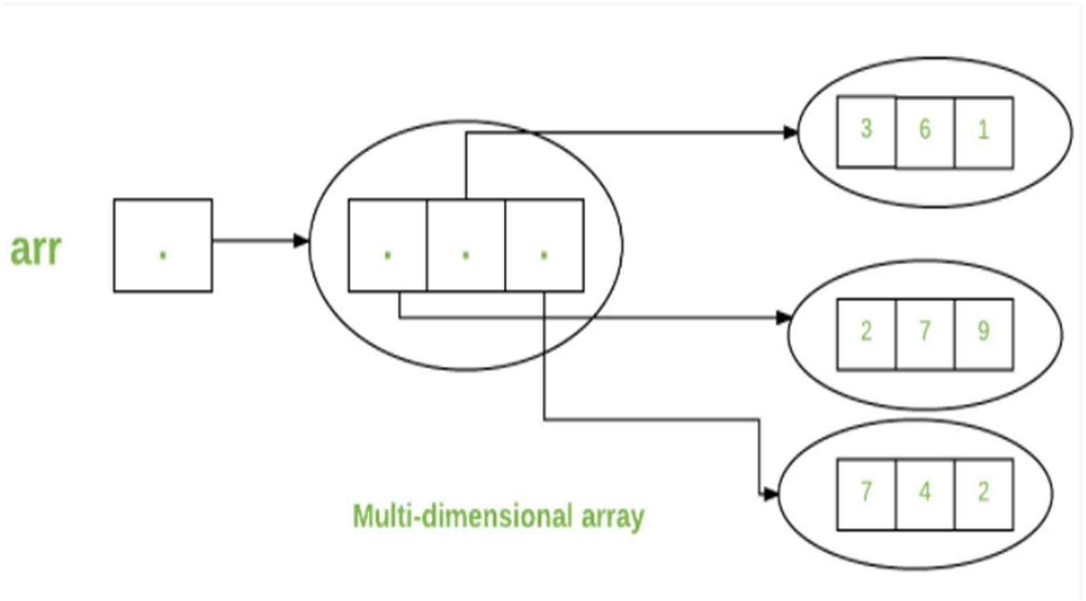

# Passing Arrays to Methods

* + Like variables, we can also pass arrays to methods.For example, below program pass array to method *sum* for calculating sum of array’s values.

class Test

{

public static void main(String args[])

{

int arr[] = {3, 1, 2, 5, 4};

sum(arr);

}

public static void sum(int[] arr)

{

int sum = 0;

for (int i = 0; i < arr.length; i++) sum+=arr[i];

System.out.println("sum of array values : " + sum);

}

}

# Returning Arrays from Methods

* + As usual, a method can also return an array. For example, below program returns an array from method *m1*.

class Test

{

public static void main(String args[])

{

int arr[] = m1();

for (int i = 0; i < arr.length; i++) System.out.print(arr[i]+" ");

}

public static int[] m1()

{

return new int[]{1,2,3};

}

} By Jagadish Sahoo

Class **Objects for Arrays**

* + Every array has an associated Class object, shared with all other arrays with the same component type. class Test

{

public static void main(String args[])

{

int intArray[] = new int[3];

byte byteArray[] = new byte[3]; short shortsArray[] = new short[3];

// array of Strings

String[] strArray = new String[3];

System.out.println(intArray.getClass()); System.out.println(intArray.getClass().getSuperclass()); System.out.println(byteArray.getClass()); System.out.println(shortsArray.getClass()); System.out.println(strArray.getClass());

}

}

#### Output

class [I

class java.lang.Object class [B

class [S

class [Ljava.lang.String;

* + The string “[I” is the run-time type signature for the class object “array with component type int“.
  + The only direct superclass of any array type is java.lang.Object.
  + The string “[B” is the run-time type signature for the class object “array with component type byte“.
  + The string “[S” is the run-time type signature for the class object “array with component type short“.
  + The string “[L” is the run-time type signature for the class object “array with component type of a Class”. The Class name is then followed.

# Array Members

* + arrays are object of a class and direct superclass of arrays is class Object.The members of an array type are all of the following:

1. The public final field *length*, which contains the number of components of the array. *length* may be positive or zero.
2. All the members inherited from class Object; the only method of Object that is not inherited is its clone method.
3. The public method *clone()*, which overrides clone method in class Object and throws no checked exceptions.

#### Cloning of arrays

* + When you clone a single dimensional array, such as Object[], a “deep copy” is performed with the new array containing copies of the original array’s elements as opposed to references.

class Test

{

public static void main(String args[])

{

int intArray[] = {1,2,3};

int cloneArray[] = intArray.clone();

// will print false as deep copy is created

// for one-dimensional array System.out.println(intArray == cloneArray);

for (int i = 0; i < cloneArray.length; i++) { System.out.print(cloneArray[i]+" ");

}

}

}

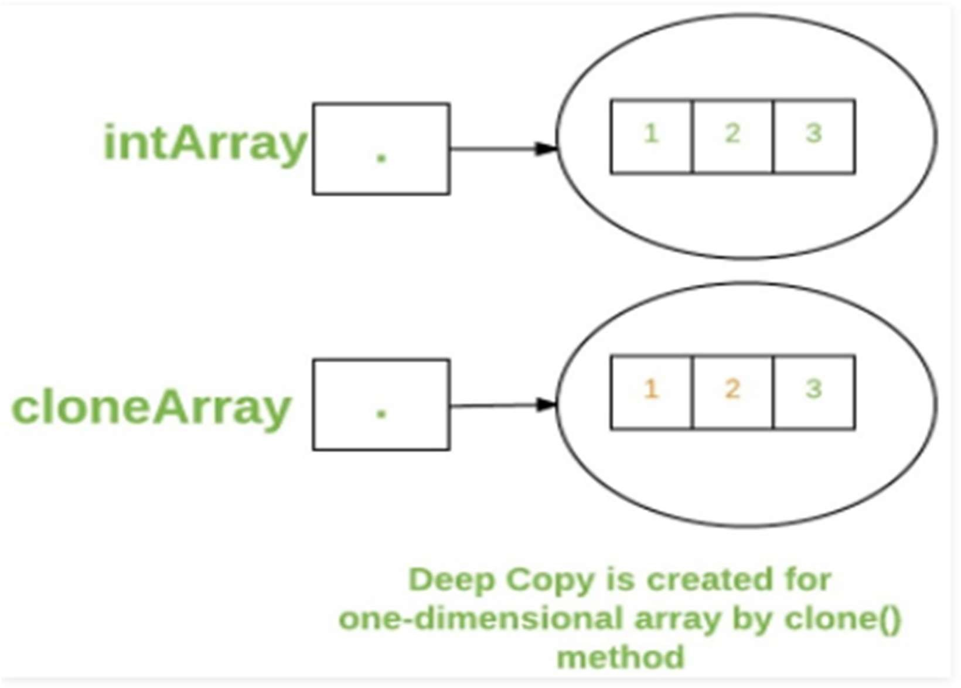

* + A clone of a multi-dimensional array (like Object[][]) is a “shallow copy” however, which is to say that it creates only a single new array with each element array a reference to an original element array, but subarrays are shared.

class Test

{

public static void main(String args[])

{

int intArray[][] = {{1,2,3},{4,5}};

int cloneArray[][] = intArray.clone();

/ / will print false System.out.println(intArray == cloneArray);

// will print true as shallow copy is created

// i.e. sub-arrays are shared System.out.println(intArray[0] == cloneArray[0]); System.out.println(intArray[1] == cloneArray[1]);

}

}

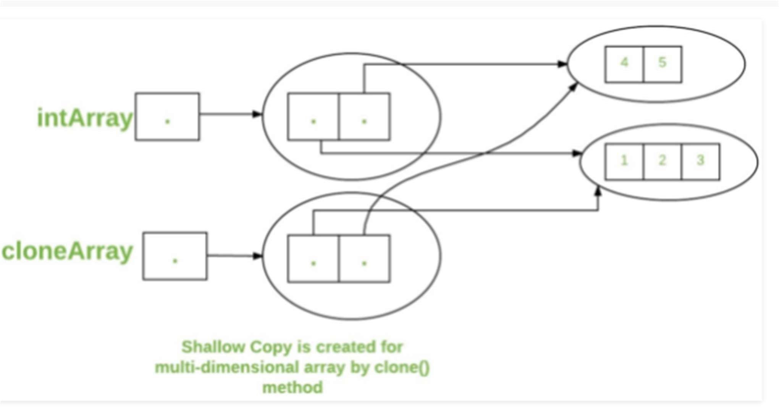

**Classes and Objects in Java**

* + A class is a user defined blueprint or prototype from which objects are created. It represents the set of properties or methods that are common to all objects of one type. In general, class declarations can include these components, in order:
  + **Modifiers**: A class can be public or has default access.
  + **class keyword:** class keyword is used to create a class.
  + **Class name:** The name should begin with an initial letter (capitalized by convention).
  + **Superclass(if any):** The name of the class’s parent (superclass), if any, preceded by the keyword extends. A class can only extend (subclass) one parent.
  + **Interfaces(if any):** A comma-separated list of interfaces implemented by the class, if any, preceded by the keyword implements. A class can implement more than one interface.
  + **Body:** The class body surrounded by braces, { }.

### Access specifiers for classes or interfaces in Java

* + In Java, methods and data members of a class/interface can have one of the following four access specifiers. The access specifiers are listed according to their restrictiveness order.

1. private (accessible within the class where defined)
2. default or package private (when no access specifier is specified)
3. protected
4. public (accessible from any class)

The classes and interfaces themselves can have only two access specifiers when declared outside any other class.

1. Public
2. default (when no access specifier is specified)

We cannot declare class/interface with private or protected access specifiers. For example, following program fails in compilation.

protected class Test {}

public class Main {

public static void main(String args[]) {

}

}

Note : Nested interfaces and clasBysJaegasdishcSaahono

have all access specifiers.

### Object

* + It is a basic unit of Object-Oriented Programming and represents the real life entities. A typical Java program creates many objects, interact by invoking methods. An object consists of :
  + **State**: It is represented by attributes of an object. It also reflects the properties of an object.
  + **Behavior**: It is represented by methods of an object. It also reflects the response of an object with other objects.
  + **Identity**: It gives a unique name to an object and enables one object to interact with other objects.

Example of an object: dog

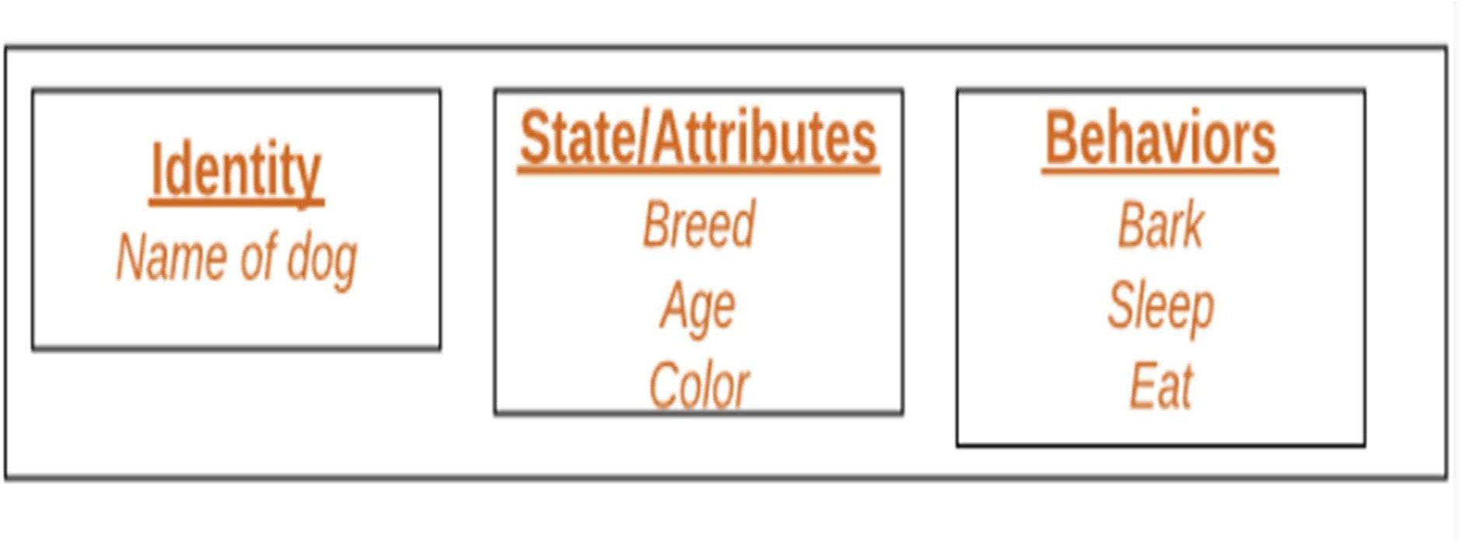

* + Objects correspond to things found in the real world.
  + For example, a graphics program may have objects such as “circle”, “square”, “menu”.
  + An online shopping system might have objects such as “shopping cart”, “customer”, and “product”.

#### Declaring Objects (Also called instantiating a class)

* + When an object of a class is created, the class is said to be instantiated.
  + All the instances share the attributes and the behavior of the class.
  + But the values of those attributes, i.e. the state are unique for each object.
  + A single class may have any number of instances.

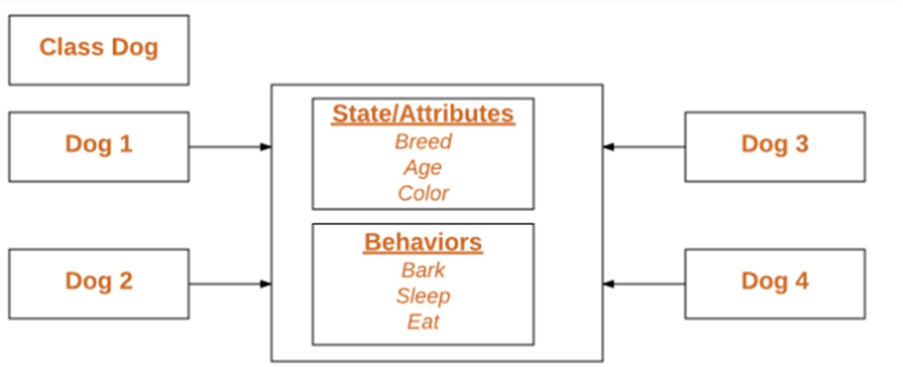

* + As we declare variables like (type name;). This notifies the compiler that we will use name to refer to data whose type is type.
  + With a primitive variable, this declaration also reserves the proper amount of memory for the variable.
  + So for reference variable, type must be strictly a concrete class name.
  + In general, we can’t create objects of an abstract class or an interface.

Example Dog tuffy;

* + if we declare reference variable(tuffy) like this, its value will be undetermined(null) until an object is actually created and assigned to it. Simply declaring a reference variable does not create an object.

## Initializing an object

* + The new operator instantiates a class by allocating memory for a new object and returning a reference to that memory. The new operator also invokes the class constructor.

public class Dog

{

// Instance Variables String name;

String breed; int age; String color;

// Constructor Declaration of Class

public Dog(String name, String breed, int age, String color)

{

this.name = name; this.breed = breed; this.age = age; this.color = color;

}

public String getName()

{

return name;

}

public String getBreed()

{

return breed;

}

public int getAge()

{

return age;

}

public String getColor()

{

return color;

}

public String toString()

{

return("Hi my name is "+ this.getName()+ ".\nMy breed,age and color are " + this.getBreed()+"," + this.getAge()+ ","+ this.getColor());

}

public static void main(String[] args)

{

Dog tuffy = new Dog("tuffy","papillon", 5, "white"); System.out.println(tuffy.toString());

}

}

* + This class contains a single constructor. We can recognize a constructor because its declaration uses the same name as the class and it has no return type. The Java compiler differentiates the constructors based on the number and the type of the arguments. The constructor in the Dog class takes four arguments. The following statement provides “tuffy”,”papillon”,5,”white” as values for those arguments:

Dog tuffy = new Dog("tuffy","papillon",5, "white");

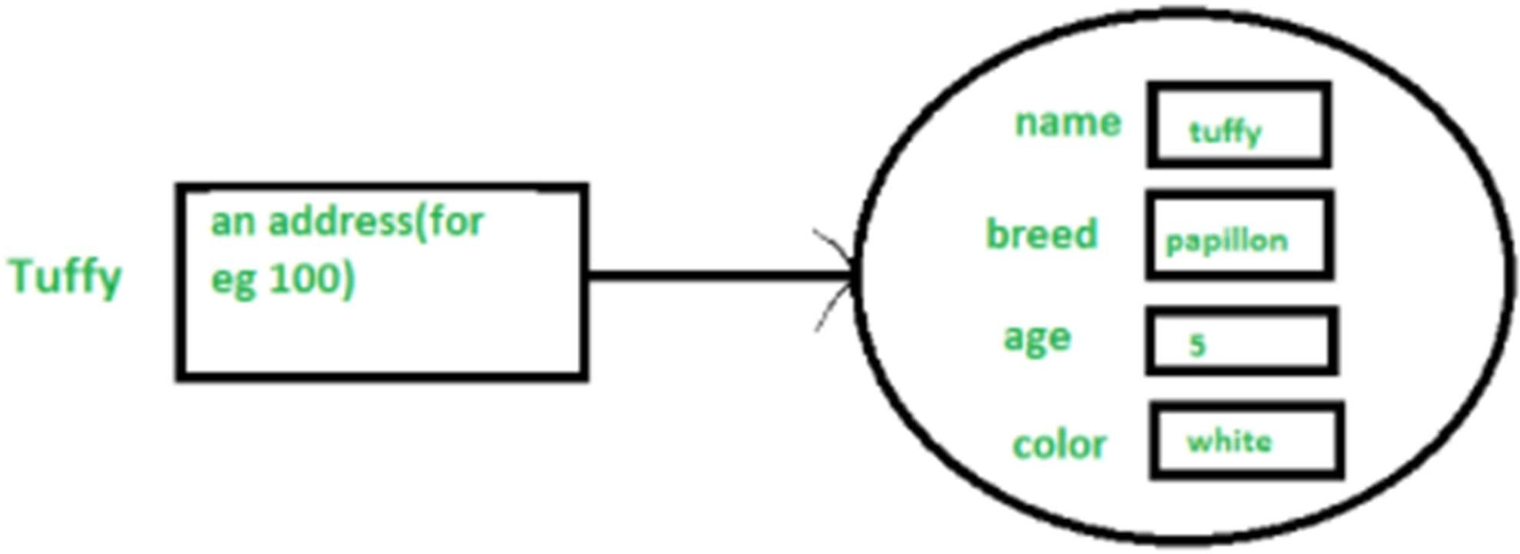

* + All classes have at least one constructor. If a class does not explicitly declare any, the Java compiler automatically provides a no-argument constructor, also called the default constructor.
  + This default constructor calls the class parent’s no-argument constructor (as it contain only one statement i.e super();), or the Object class constructor if the class has no other parent (as Object class is parent of all classes either directly or indirectly).

## Ways to create object of a class

* + There are four ways to create objects in java.
  + Strictly speaking there is only one way(by using new keyword),and the rest internally use new keyword.

#### Using new keyword

* + It is the most common and general way to create object in java. Example:

// creating object of class Test Test t = new Test();

#### Using Class.forName(String className) method:

* + There is a pre-defined class in java.lang package with name Class. The forName(String className) method returns the Class object associated with the class with the given string name.
  + We have to give the fully qualified name for a class.
  + On calling new Instance() method on this Class object returns new instance of the class with the given string name.
  + // creating object of public class Test
  + // consider class Test present in com.p1 package
  + Test obj = (Test)Class.forName("com.p1.Test").newInstance();

## Using clone() method

* + clone() method is present in Object class. It creates and returns a copy of the object.

// creating object of class Test Test t1 = new Test();

// creating clone of above object Test t2 = (Test)t1.clone();

## Deserialization

* + De-serialization is technique of reading an object from the saved state in a file.

FileInputStream file = new FileInputStream(filename); ObjectInputStream in = new ObjectInputStream(file); Object obj = in.readObject();

## Creating multiple objects by one type only

* + In real-time, we need different objects of a class in different methods. Creating a number of references for storing them is not a good practice and therefore we declare a static reference variable and use it whenever required. In this case, wastage of memory is less. The objects that are not referenced anymore will be destroyed by Garbage Collector of java.
  + Example:

Test test = new Test(); test = new Test();

* + In inheritance system, we use parent class reference variable to store a sub-class object. In this case, we can switch into different subclass objects using same referenced variable. Example:

class Animal {}

class Dog extends Animal {} class Cat extends Animal {}

public class Test

{

// using Dog object Animal obj = new Dog();

// using Cat object obj = new Cat();

}

#### Anonymous objects

* + Anonymous objects are the objects that are instantiated but are not stored in a reference variable.

1. They are used for immediate method calling.
2. They will be destroyed after method calling.
3. They are widely used in different libraries. For example, in AWT libraries, they are used to perform some action on capturing an event(eg a key press).

## Methods in Java

* + A method is a collection of statements that perform some specific task and return the result to the caller.
  + A method can perform some specific task without returning anything.
  + Methods allow us to reuse the code without retyping the code.
  + In Java, every method must be part of some class which is different from languages like C, C++, and Python.

## Method Declaration

* + In general, method declarations has six components :

1. Modifier-: Defines access type of the method i.e. from where it can be accessed in your application. In Java, there 4 type of the access specifiers.
   * public: accessible in all class in your application.
   * protected: accessible within the class in which it is defined and in its subclass(es)
   * private: accessible only within the class in which it is defined.
   * default (declared/defined without using any modifier) : accessible within same class and package within which its class is defined.
2. The return type : The data type of the value returned by the method or void if does not return a value.
3. Method Name : the rules for field names apply to method names as well, but the convention is a little different.
4. Parameter list : Comma separated list of the input parameters are defined, preceded with their data type, within the enclosed parenthesis. If there are no parameters, you must use empty parentheses ().
5. Exception list : The exceptions you expect by the method can throw, you can specify these exception(s).
6. Method body : it is enclosed between braces. The code you need to be executed to perform your intended operations.

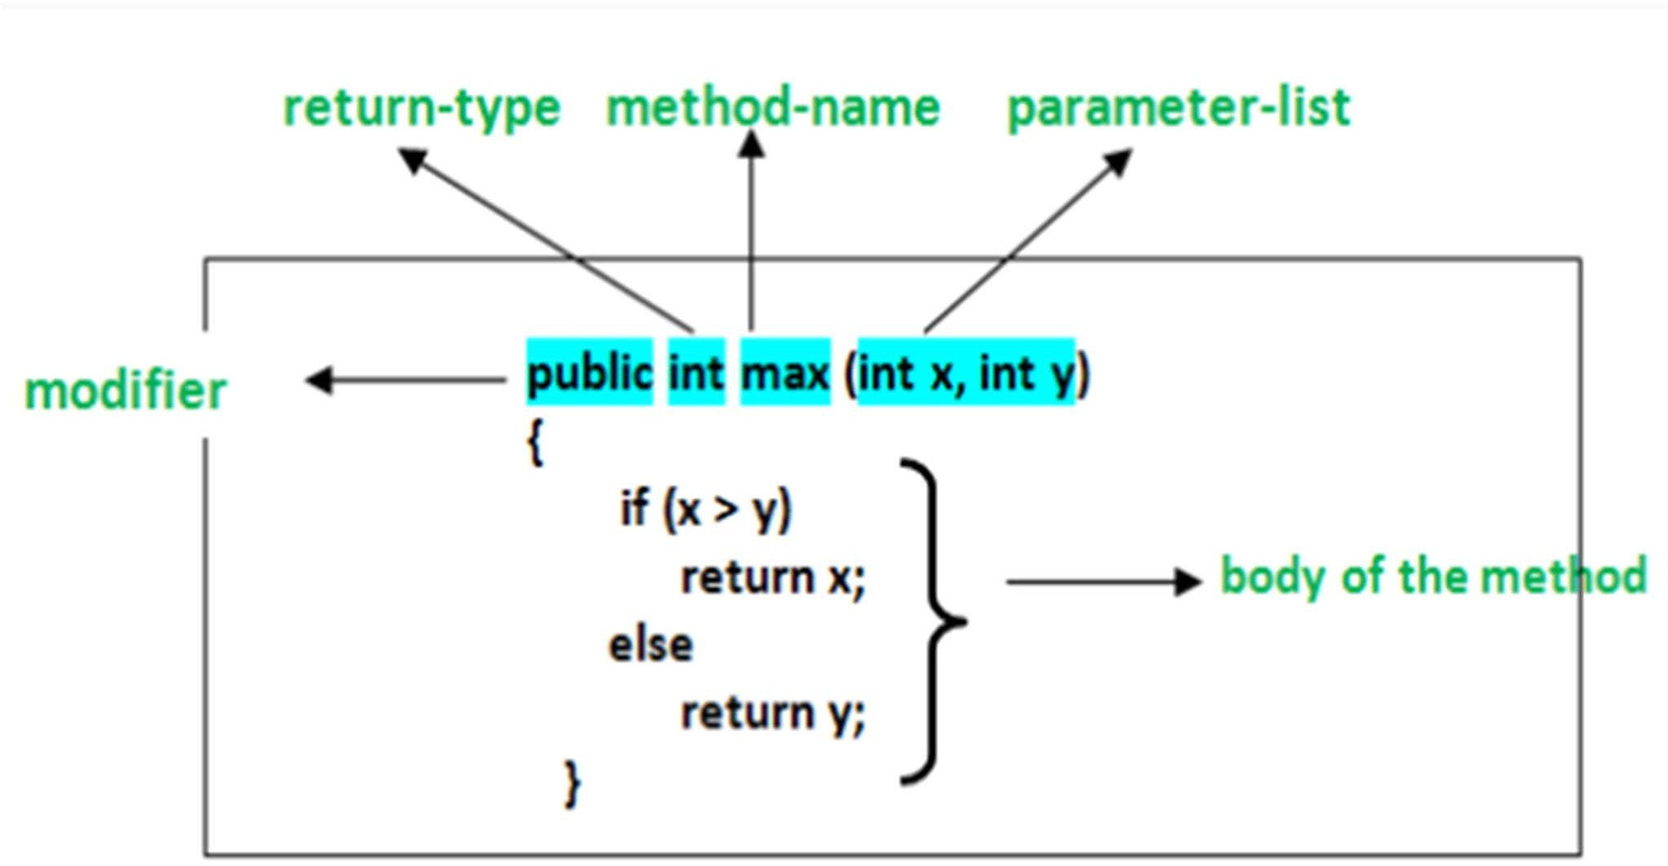

* + **Method signature**: It consists of the method name and a parameter list (number of parameters, type of the parameters and order of the parameters). The return type and exceptions are not considered as part of it.

max(int x, int y)

**How to name a Method?**: A method name is typically a single word that should be a **verb** in lowercase or multi-word, that begins with

a **verb** in lowercase followed by **adjective, noun…..** After the first word, first letter of each word should be capitalized. For example, findSum, computeMax, setX and getX

## Calling a method

* + The method needs to be called for using its functionality.
  + A method returns to the code that invoked it when:

1. It completes all the statements in the method
2. It reaches a return statement
3. Throws an exception

## Call by Value

* + Pass By Value: Changes made to formal parameter do not get transmitted back to the caller. Any modifications to the formal parameter variable inside the called function or method affect only the separate storage location and will not be reflected in the actual parameter in the calling environment. This method is also called as call by value.
  + Java in fact is strictly call by value.

class CallByValue {

public static void Example(int x, int y)

{

x++; y++;

}

}

public class Main {

public static void main(String[] args)

{

int a = 10; int b = 20;

CallByValue object = new CallByValue(); System.out.println("Value of a: " + a + " & b: " + b); object.Example(a, b);

System.out.println("Value of a: “ + a + " & b: " + b);

}

}

# Call by reference(aliasing)

* + Changes made to formal parameter do get transmitted back to the caller through parameter passing.
  + Any changes to the formal parameter are reflected in the actual parameter in the calling environment as formal parameter receives a reference (or pointer) to the actual data.
  + This method is also called as call by reference. This method is efficient in both time and space.

class CallByReference { int a, b;

CallByReference(int x, int y)

{

a = x; b = y;

}

void ChangeValue(CallByReference obj)

{

obj.a += 10;

obj.b += 20;

}

}

public class Main {

public static void main(String[] args)

{

CallByReference object = new CallByReference(10, 20); System.out.println("Value of a: “ + object.a + " & b: “ + object.b); object.ChangeValue(object);

System.out.println("Value of a: “ + object.a + " & b: “ + object.b);

}

}

* + when we pass a reference, a new reference variable to the same object is created.
  + So we can only change members of the object whose reference is passed.
  + We cannot change the reference to refer to some other object as the received reference is a copy of the original reference.
  + Methods calls are implemented through stack.
  + Whenever a method is called a stack frame is created within the stack area and after that the arguments passed to and the local variables and value to be returned by this calling method are stored in this stack frame and when execution of the called method is finished, the allocated stack frame would be deleted.
  + There is a stack pointer register that tracks the top of the stack which is adjusted accordingly.

#### Returning Multiple values in Java

class Test {

static int[] getSumAndSub(int a, int b)

{

int[] ans = new int[2]; ans[0] = a + b;

ans[1] = a - b; return ans;

}

public static void main(String[] args)

{

int[] ans = getSumAndSub(100, 50); System.out.println("Sum = " + ans[0]); System.out.println("Sub = " + ans[1]);

}

}

#### If returned elements are of different types

* + Using Pair (If there are only two returned values)

import javafx.util.Pair; class GfG {

public static Pair<Integer, String> getTwo()

{

return new Pair<Integer, String>(10, “Jagadish Sahoo");

}

// Return multiple values from a method in Java 8 public static void main(String[] args)

{

Pair<Integer, String> p = getTwo(); System.out.println(p.getKey() + " " + p.getValue());

}

}

#### If there are more than two returned values

* + We can encapsulate all returned types into a class and then return an object of that class.

class MultiDivAdd {

int mul; // To store multiplication double div; // To store division int add; // To store addition

MultiDivAdd(int m, double d, int a)

{

mul = m; div = d; add = a;

}

}

class Test {

static MultiDivAdd getMultDivAdd(int a, int b)

{

// Returning multiple values of different

// types by returning an object

return new MultiDivAdd(a * b, (double)a / b, (a + b));

}

public static void main(String[] args)

{

MultiDivAdd ans = getMultDivAdd(10, 20); System.out.println("Multiplication = " + ans.mul); System.out.println("Division = " + ans.div); System.out.println("Addition = " + ans.add);

}

}

Returning list of Object Class

import java.util.*; class GfG {

public static List<Object> getDetails()

{

String name = "Geek"; int age = 35;

char gender = 'M';

return Arrays.asList(name, age, gender);

}

public static void main(String[] args)

{

List<Object> person = getDetails(); System.out.println(person);

}

}

#### Method Overloading in Java

* + Java can distinguish the methods with different method signatures.

i.e. the methods can have the same name but with different parameters list (i.e. the number of the parameters, the order of the parameters, and data types of the parameters) within the same class.

* + Overloaded methods are differentiated based on the number and type of the parameters passed as an argument to the methods.
  + You can not define more than one method with the same name, Order and the type of the arguments. It would be a compiler error.
  + The compiler does not consider the return type while differentiating the overloaded method. But you cannot declare two methods with the same signature and different return type. It will throw a compile- time error.

## Why do we need Method Overloading?

* + if we need to do some kind of the operation with different ways i.e. for different inputs.
  + For example , we are doing the addition operation for different inputs. It is hard to find many meaningful names for a single action.

#### Different ways of doing overloading methods

Method overloading can be done by changing:

* + The number of parameters in methods.
  + The data types of the parameters of methods.
  + The Order of the parameters of methods.

Method 1: By changing the number of parameters.

import java.io.*; class Addition {

public int add(int a, int b)

{

int sum = a + b; return sum;

}

public int add(int a, int b, int c)

{

int sum = a + b + c; return sum;

}

}

class GFG {

public static void main(String[] args)

{

Addition ob = new Addition(); int sum1 = ob.add(1, 2);

System.out.println("sum of the two integer value :" + sum1); int sum2 = ob.add(1, 2, 3);

System.out.println( "sum of the three integer value :" + sum2);

}

}

Method 2: By changing the Data types of the parameters

import java.io.*; class Addition {

public int add(int a, int b, int c)

{

int sum = a + b + c; return sum;

}

public double add(double a, double b, double c)

{

double sum = a + b + c; return sum;

}

}

class GFG {

public static void main(String[] args)

{

Addition ob = new Addition(); int sum2 = ob.add(1, 2, 3);

System.out.println( "sum of the three integer value :" + sum2); double sum3 = ob.add(1.0, 2.0, 3.0);

System.out.println("sum of the three double value :“ + sum3);

}

}

Method 3: By changing the Order of the parameters

import java.io.*; class Para {

public void getIdentity(String name, int id)

{

System.out.println(“Name :" + name + " " + "Id :" + id);

}

public void getIdentity(int id, String name)

{

System.out.println("Id :" + id + " " + “Name :" + name);

}

}

class GFG {

public static void main(String[] args)

{

Para p = new Para(); p.getIdentity("Mohit", 1);

p.getIdentity(2, "shubham");

}

}

## What happens when method signature is the same and the return type is different?

* + The compiler will give an error as the return value alone is not sufficient for the compiler to figure out which function it has to call.
  + Only if both methods have different parameter types (so, they have a different signature), then Method overloading is possible.

import java.io.*; class Addition {

public int add(int a, int b)

{

int sum = a + b; return sum;

}

public double add(int a, int b)

{

double sum = a + b + 0.0; return sum;

}

}

class GFG {

public static void main(String[] args)

{

try {

Addition ob = new Addition(); int sum1 = ob.add(1, 2);

System.out.println("sum of the two integer value :" + sum1); int sum2 = ob.add(1, 2);

System.out.println("sum of the three integer value :" + sum2);

}

catch (Exception e) { System.out.println(e);

}

}

}

#### Scope of Variables In Java

* + Scope of a variable is the part of the program where the variable is accessible. Like C/C++, in Java, all identifiers are lexically (or statically) scoped, i.e.scope of a variable can determined at compile time.
  + Java programs are organized in the form of classes. Every class is part of some package.

#### Scope rules

* + Member Variables (Class Level Scope)
  + Local Variables (Method Level Scope)
  + Loop Variables (Block Scope)

#### Member Variables (Class Level Scope)

* + These variables must be declared inside class (outside any function). They can be directly accessed anywhere in class.

public class Test

{

// All variables defined directly inside a class

// are member variables int a;

private String b; void method1() { }

int method2() { }

char c;

}

* + We can declare class variables anywhere in class, but outside methods.
  + Access specified of member variables doesn’t affect scope of them within a class.
  + Member variables can be accessed outside a class with following rules

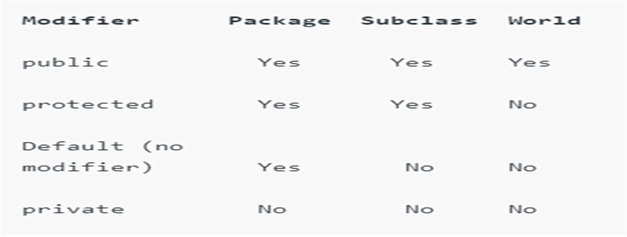

#### Local Variables (Method Level Scope)

* + Variables declared inside a method have method level scope and can’t be accessed outside the method.
  + Local variables don’t exist after method’s execution is over. public class Test

{

void method1()

{

// Local variable (Method level scope) int x;

}

}

class Test

{

private int x;

public void setX(int x)

{

this.x = x;

}

}

this keyword to differentiate between the local and class variables.

public class Test

{

static int x = 11; private int y = 33;

public void method1(int x)

{

Test t = new Test(); this.x = 22;

y = 44;

System.out.println("Test.x: " + Test.x); System.out.println("t.x: " + t.x);

System.out.println("t.y: " + t.y); System.out.println("y: " + y);

}

public static void main(String args[])

{

Test t = new Test(); t.method1(5);

}

}

#### Loop Variables (Block Scope)

* + A variable declared inside pair of brackets “{” and “}” in a method has scope within the brackets only.

public class Test

{

public static void main(String args[])

{

{

int x = 10; System.out.println(x);

}

// Uncommenting below line would produce error since variable x is out of scope.

// System.out.println(x);

}

}

class Test

{

public static void main(String args[])

{

for (int x = 0; x < 4; x++)

{

System.out.println(x);

}

// Will produce error System.out.println(x);

}

}

#### Predict the O/P

class Test

{

public static void main(String args[])

{

int a = 5;

for (int a = 0; a < 5; a++)

{

System.out.println(a);

}

}

}

In C++, it will run. But in java it is an error because in java, the name of the variable of inner and outer loop must be different.

#### Important Points about Variable scope in Java

* + In general, a set of curly brackets { } defines a scope.
  + In Java we can usually access a variable as long as it was defined within the same set of brackets as the code we are writing or within any curly brackets inside of the curly brackets where the variable was defined.
  + Any variable defined in a class outside of any method can be used by all member methods.
  + When a method has the same local variable as a member, “this” keyword can be used to reference the current class variable.
  + For a variable to be read after the termination of a loop, It must be declared before the body of the loop.

**Constructors in Java**

* + Constructors are used to initialize the object’s state. Like methods, a constructor also contains a collection of statements(i.e. instructions) that are executed at the time of Object creation.

Need of Constructor

Suppose there is a class with the name Box. If we talk about a box class then it will have some class variables (say length, breadth, and height). But when it comes to creating its object(i.e Box will now exist in the computer’s memory), then can a box be there with no value defined for its dimensions. The answer is no.

So constructors are used to assign values to the class variables at the time of object creation, either explicitly done by the programmer or by Java itself (default constructor).

### When is a Constructor called?

* + Each time an object is created using a **new()** keyword, at least one constructor (it could be the default constructor) is invoked to assign initial values to the **data members** of the same class.
  + A constructor is invoked at the time of object or instance creation. For Example:

class Hello

{

.......

// A Constructor Hello() {}

.......

}

// We can create an object of the above class

// using the below statement. This statement

// calls above constructor. Hello obj = new Hello();

### Rules for writing Constructor:

* + Constructor(s) of a class must have the same name as the class name in which it resides.
  + A constructor in Java can not be abstract, final, static and Synchronized.
  + Access modifiers can be used in constructor declaration to control its access i.e which other class can call the constructor.

### Types of constructor

1. No-argument constructor(Default constructor)
   * A constructor that has no parameter is known as the default constructor.
   * If we don’t define a constructor in a class, then the compiler creates default constructor(with no arguments) for the class. And if we write a constructor with arguments or no-arguments then the compiler does not create a default constructor.
   * Default constructor provides the default values to the object like 0, null, etc. depending on the type.

import java.io.*; class Myclass

{

int num; String name;

// this would be invoked while an object

// of that class is created. Myclass()

{

System.out.println("Constructor called");

}

}

class GFG

{

public static void main (String[] args)

{

// this would invoke default constructor. Myclass obj = new Myclass();

// Default constructor provides the default

// values to the object like 0, null System.out.println(obj.name); System.out.println(obj.num);

}

}

1. Parameterized Constructor:
   * A constructor that has parameters is known as parameterized constructor. If we want to initialize fields of the class with your own values, then use a parameterized constructor.

•

import java.io.*; class Student

{

// data members of the class. String name;

int id;

// constructor would initialize data members

// with the values of passed arguments while

// object of that class created. Student(String name, int id)

{

this.name = name; this.id = id;

}

}

class GFG

{

public static void main (String[] args)

{

// this would invoke the parameterized constructor.

Student obj = new Student("adam", 1); System.out.println("Name :" + obj.name +" and Id :" + obj.id);

}

} By Jagadish Sahoo

### Does constructor return any value?

* + There are no “return value” statements in the constructor, but the constructor returns the current class instance. We can write ‘return’ inside a constructor.

### Constructor Overloading

* + Like methods, we can overload constructors for creating objects in different ways.
  + Compiler differentiates constructors on the basis of numbers of parameters, types of the parameters and order of the parameters.

import java.io.*; class Paracon

{

Paracon(String name)

{

System.out.println("Constructor with one " +"argument - String : " + name);

}

Paracon(String name, int age)

{

System.out.println("Constructor with two arguments : " + " String and Integer

: " + name + " "+ age);

}

Paracon(long id)

{

System.out.println("Constructor with one argument : " + "Long : " + id);

}

}

class GFG

{

public static void main(String[] args)

{

Paracon obj1 = new Paracon(“Jagadish"); Paracon obj2 = new Paracon(“Aditya", 15); Paracon obj3 = new Paracon(325114552);

}

}

##### How constructors are different from methods in Java?

* + Constructor(s) must have the same name as the class within which it defined while it is not necessary for the method in java.
  + Constructor(s) do not return any type while method(s) have the return type or **void** if does not return any value.
  + Constructor is called only once at the time of Object creation while method(s) can be called any numbers of time.

### Copy Constructor in Java

* + Like C++, Java also supports copy constructor. But, unlike C++, Java doesn’t create a default copy constructor if you don’t write your own. class Complex {

private double re, im;

// A normal parameterized constructor public Complex(double re, double im) {

this.re = re; this.im = im;

}

// copy constructor Complex(Complex c) {

System.out.println("Copy constructor called"); re = c.re;

im = c.im;

}

// Overriding the toString of Object class @Override

public String toString() {

return "(" + re + " + " + im + "i)";

}

}

#### Constructor Overloading in Java

class Box

{

double width, height, depth; Box(double w, double h, double d)

{

width = w; height = h; depth = d;

}

Box()

{

width = height = depth = 0;

}

Box(double len)

{

width = height = depth = len;

}

// compute and return volume

double volume()

{

return width * height * depth;

}

}

public class Test

{

public static void main(String args[])

{

Box mybox1 = new Box(10, 20, 15); Box mybox2 = new Box();

Box mycube = new Box(7);

double vol;

// get volume of first box vol = mybox1.volume();

System.out.println(" Volume of mybox1 is " + vol);

// get volume of second box vol = mybox2.volume();

System.out.println(" Volume of mybox2 is " + vol);

// get volume of cube vol = mycube.volume();

System.out.println(" Volume of mycube is " + vol);

}

}

### Using this() in constructor overloading

* + this() reference can be used during constructor overloading to call default constructor implicitly from parameterized constructor.
  + this() should be the first statement inside a constructor.

public class Main {

public static void main(String[] args) { Complex c1 = new Complex(10, 15);

// Following involves a copy constructor call Complex c2 = new Complex(c1);

// Note that following doesn't involve a copy constructor call as

// non-primitive variables are just references. Complex c3 = c2;

System.out.println( c2.re + " + " + c2.im ); System.out.println( c2.re + " + " + c2.im );

}

}

class Box

{

double width, height, depth; int boxNo;

Box(double w, double h, double d, int num)

{

width = w; height = h; depth = d; boxNo = num;

}

Box()

{

width = height = depth = 0;

}

Box(int num)

{

this();

boxNo = num;

}

public static void main(String[] args)

{

Box box1 = new Box(1); System.out.println(box1.width);

}

}

* + we called Box(int num) constructor during object creation using only box number. By using this() statement inside it, the default constructor(Box()) is implicitly called from it which will initialize dimension of Box with 0.

# Important points to be taken care while doing Constructor Overloading

* + Constructor calling must be the **first** statement of constructor in Java.
  + If we have defined any parameterized constructor, then compiler will not create default constructor. and vice versa if we don’t define any constructor, the compiler creates the default constructor(also known as no-arg constructor) by default during compilation
  + Recursive constructor calling is invalid in java.

### Constructors overloading vs Method overloading

* + constructor overloading is somewhat similar to method overloading. If we want to have different ways of initializing an object using different number of parameters, then we must do constructor overloading as we do method overloading when we want different definitions of a method based on different parameters.

### Constructor Chaining

* + Constructor chaining is the process of calling one constructor from another constructor with respect to current object.

Constructor chaining can be done in two ways:

* + **Within same class**: It can be done using **this()** keyword for constructors in same class
  + **From base class:** by using **super()** keyword to call constructor from the base class.
  + Constructor chaining occurs through **inheritance**.
  + A sub class constructor’s task is to call super class’s constructor first.
  + This ensures that creation of sub class’s object starts with the initialization of the data members of the super class.
  + There could be any numbers of classes in inheritance chain.
  + Every constructor calls up the chain till class at the top is reached.

# Why do we need constructor chaining ?

* + This process is used when we want to perform multiple tasks in a single constructor rather than creating a code for each task in a single constructor we create a separate constructor for each task and make their chain which makes the program more readable.

###### Constructor Chaining within same class using this() keyword

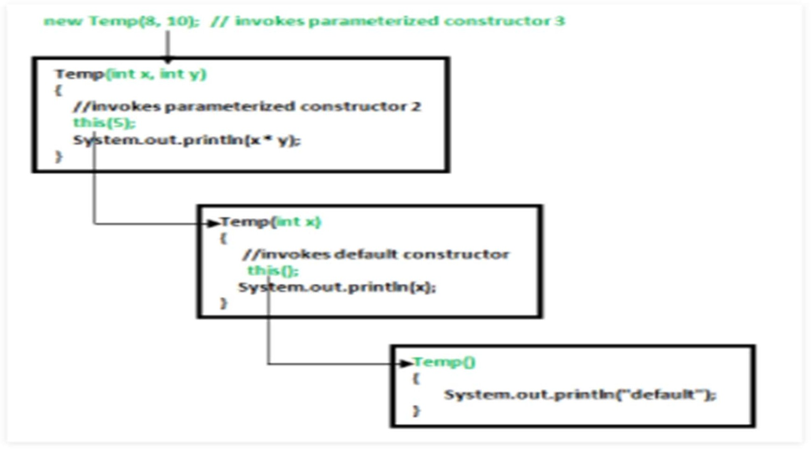

class Temp

{

Temp()

{

this(5);

System.out.println("The Default constructor");

}

Temp(int x)

{

this(5, 15);

System.out.println(x);

}

Temp(int x, int y)

{

System.out.println(x * y);

}

public static void main(String args[])

{

new Temp();

}

}

# Rules of constructor chaining :

* + The **this()** expression should always be the first line of the constructor.
  + There should be at-least be one constructor without the this() keyword (Temp(int x, int y) in previous example).
  + Constructor chaining can be achieved in any order.

What happens if we change the order of constructors?

Nothing, Constructor chaining can be achieved in any order

**Constructor Chaining to other class using super() keyword**

**class** Base

{

String name;

Base()

{

**this**("");

System.out.println("No-argument constructor of" + " base class");

}

Base(String name)

{

**this**.name = name;

System.out.println("Calling parameterized constructor“ + " of base");

}

}

**class** Derived **extends** Base

{

Derived()

{

System.out.println("No-argument constructor " + "of derived");

}

Derived(String name)

{

**super**(name);

System.out.println("Calling parameterized " + "constructor of derived");

}

**public static void** main(String args[])

{

Derived obj = **new** Derived("test");

}

}

**Strings in Java**

* + Strings in Java are Objects that are backed internally by a char array.
  + Since arrays are immutable(cannot grow), Strings are immutable as well.
  + Whenever a change to a String is made, an entirely new String is created.

Syntax:

<String_Type> <string_variable> = "<sequence_of_string>";

Example:

String str = “Jagadish";

# Memory allotment of String

* + Whenever a String Object is created as a literal, the object will be created in String constant pool. This allows JVM to optimize the initialization of String literal.

For example:

String str = “Jagadish";

* + The string can also be declared using **new** operator i.e. dynamically allocated. In case of String are dynamically allocated they are assigned a new memory location in heap. This string will not be added to String constant pool.

For example:

String str = new String(“Jagadish");

import java.io.*; import java.lang.*;

class Test {

public static void main(String[] args)

{

// Declare String without using new operator String s = “Jagadish";

// Prints the String. System.out.println("String s = " + s);

// Declare String using new operator String s1 = new String(“Jagadish");

// Prints the String. System.out.println("String s1 = " + s1);

}

}

#### StringBuffer

* + **StringBuffer** is a peer class of **String** that provides much of the functionality of strings.
  + The string represents fixed-length, immutable character sequences while StringBuffer represents growable and writable character sequences.

Syntax:

StringBuffer s = new StringBuffer(“Jagadish");

#### StringBuilder

* + The StringBuilder in Java represents a mutable sequence of characters. Since the String Class in Java creates an immutable sequence of characters, the StringBuilder class provides an alternate to String Class, as it creates a mutable sequence of characters.

Syntax:

StringBuilder str = new StringBuilder(); str.append(“Hello");

StringTokenizer

* + StringTokenizer class in Java is used to break a string into tokens.

class StringStorage {

public static void main(String args[])

{

String s1 = "TAT"; String s2 = "TAT";

String s3 = new String("TAT"); String s4 = new String("TAT"); System.out.println(s1); System.out.println(s2); System.out.println(s3); System.out.println(s4);

}

}

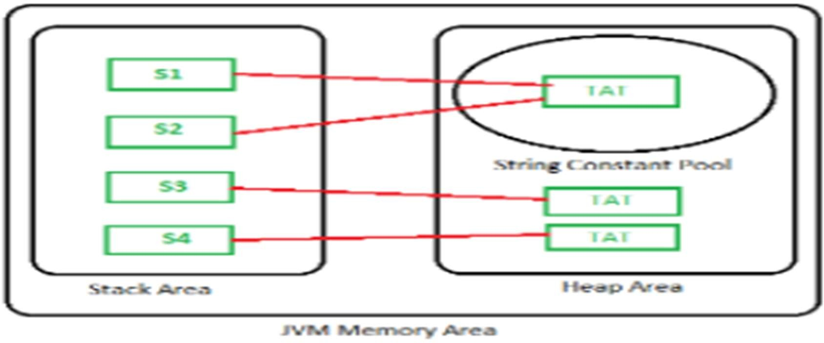

Note: All objects in Java are stored in a heap. The reference variable is to the object stored in the stack area or they can be contained in other objects which puts them in the heap area also.

### String class in Java

* + String is a sequence of characters. In java, objects of String are immutable which means a constant and cannot be changed once created.

### Creating a String

* + There are two ways to create string in Java:
  + String literal

String s = “Jagadish”;

* + Using new keyword

String s = new String (“Jagadish”);

# Constructors

1. **String(byte[] byte_arr)** – Construct a new String by decoding

the *byte array*. It uses the platform’s default character set for decoding.

* + Example:

byte[] b_arr = {72, 102, 102, 108, 115};

String s_byte =new String(b_arr);

1. String(byte[] byte_arr, Charset char_set)
   * Construct a new String by decoding the byte array. It uses the char_set for decoding.

Example:

byte[] b_arr = {72, 102, 102, 108, 115};

Charset cs = Charset.defaultCharset(); String s_byte_char = new String(b_arr, cs);

1. String(byte[] byte_arr, String char_set_name)
   * Construct a new String by decoding the byte array. It uses the char_set_name for decoding.
   * It looks similar to the previous constructs and they appear before similar functions but it takes the String(which contains char_set_name) as parameter while the previous constructor takes CharSet.

Example:

byte[] b_arr = {72, 102, 102, 108, 115};

String s = new String(b_arr, "US-ASCII");

1. String(byte[] byte_arr, int start_index, int length)
   * Construct a new string from the bytes array depending on the start_index(Starting location) and length(number of characters from starting location).

Example:

byte[] b_arr = {72, 102, 102, 108, 115};

String s = new String(b_arr, 1, 3);

1. String(byte[] byte_arr, int start_index, int length, Charset char_set)
   * Construct a new string from the bytes array depending on the start_index(Starting location) and length(number of characters from starting location).
   * Uses char_set_name for decoding. Example:

byte[] b_arr = {72, 102, 102, 108, 115};

Charset cs = Charset.defaultCharset(); String s = new String(b_arr, 1, 3, cs);

1. String(byte[] byte_arr, int start_index, int length, String char_set_name)
   * Construct a new string from the bytes array depending on the start_index(Starting location) and length(number of characters from starting location).Uses char_set_name for decoding.

Example:

byte[] b_arr = {72, 102, 102, 108, 115};

String s = new String(b_arr, 1, 4, "US-ASCII");

1. String(char[] char_arr)
   * Allocates a new String from the given Character array Example:

char char_arr[] = {‘H', 'e', ‘l', ‘l', ‘o'}; String s = new String(char_arr); //Hello

1. String(char[] char_array, int start_index, int count)
   * Allocates a String from a given character array but choose count characters from the start_index.

Example:

char char_arr[] = {‘H', 'e', ‘l', ‘l', ‘o'}; String s = new String(char_arr , 1, 3); //ell

1. String(int[] uni_code_points, int offset, int count)

Allocates a String from a uni_code_array but choose count characters from the start_index.

Example:

int[] uni_code = {72, 102, 102, 108, 115}; String s = new String(uni_code, 1, 3);

1. String(StringBuffer s_buffer)

Allocates a new string from the string in s_buffer Example:

StringBuffer s_buffer = new StringBuffer(“Jagadish"); String s = new String(s_buffer);

1. String(StringBuilder s_builder)

Allocates a new string from the string in s_builder

* + Example:
  + StringBuilder s_builder = new StringBuilder(“Jagadish");
  + String s = new String(s_builder);

# String Methods

1. **int length();** Returns the number of characters in the String. “jagadish".length(); // returns 13
2. **Char charAt(int i);** Returns the character at ith index. " jagadish".charAt(3); // returns ‘a’
3. **String substring (int i);** Return the substring from the ith index character to end.

" jagadish".substring(3); // returns “adish”

1. **String substring (int i, int j):** Returns the substring from i to j-1 index.

"jagadish".substring(2, 5); // returns “gad”

1. **String concat( String str);** Concatenates specified string to the end of this string.

String s1 = ”Jagadish”; String s2 = ”Sahoo”;

String output = s1.concat(s2); // returns “JagadishSahoo”

1. **int indexOf (String s);** Returns the index within the string of the first occurrence of the specified string.

String s = ”Learn Share Learn”;

int output = s.indexOf(“Share”); // returns 6

1. **int indexOf (String s, int i);** Returns the index within the string of the first occurrence of the specified string, starting at the specified index.

String s = ”Learn Share Learn”;

int output = s.indexOf("ea",3);// returns 13

1. **Int lastIndexOf( String s);** Returns the index within the string of the last occurrence of the specified string.

String s = ”Learn Share Learn”;

int output = s.lastIndexOf("a"); // returns 14

1. **boolean equals( Object otherObj);** Compares this string to the specified object.

Boolean out = “Jagadish”.equals(“Jagadish”); // returns true Boolean out = “Jagadish”.equals(“jagadish”); // returns false

1. **boolean equalsIgnoreCase (String anotherString);** Compares string to another string, ignoring case considerations.

Boolean out = “Jagadish”.equals(“Jagadish”); // returns true Boolean out = “Jagadish”.equals(“jagadish”); // returns true

1. **int compareTo( String anotherString);** Compares two string lexicographically. int out = s1.compareTo(s2); // where s1 and s2 are strings to be compared

This returns difference s1-s2. If :

out < 0 // s1 comes before s2 out = 0 // s1 and s2 are equal. out > 0 // s1 comes after s2.

1. **int compareToIgnoreCase( String anotherString);** Compares two string lexicographically, ignoring case considerations.

int out = s1.compareToIgnoreCase(s2);

// where s1 and s2 are strings to be compared This returns difference s1-s2. If :

out < 0 // s1 comes before s2 out = 0 // s1 and s2 are equal. out > 0 // s1 comes after s2.

1. String toLowerCase();

Converts all the characters in the String to lower case. String word1 = “HeLLo”;

String word3 = word1.toLowerCase(); // returns “hello"

1. String toUpperCase();

Converts all the characters in the String to upper case. String word1 = “HeLLo”;

String word2 = word1.toUpperCase(); // returns “HELLO”

1. String trim();

Returns the copy of the String, by removing whitespaces at both ends. It does not affect whitespaces in the middle.

String word1 = “ Learn Share Learn “;

String word2 = word1.trim(); // returns “Learn Share Learn”

1. String replace (char oldChar, char newChar);

Returns new string by replacing all occurrences of oldChar with newChar. String s1 = “Hello“;

String s2 = s1.replace(‘l’ ,’g’); // returns “Heggo”

**StringBuffer class in Java**

* + StringBuffer is a peer class of String that provides much of the functionality of strings. String represents fixed-length, immutable character sequences while StringBuffer represents growable and writable character sequences.
  + **StringBuffer** may have characters and substrings inserted in the middle or appended to the end. It will automatically grow to make room for such additions and often has more characters preallocated than are actually needed, to allow room for growth.

StringBuffer Constructors

* + StringBuffer( ): It reserves room for 16 characters without reallocation.

StringBuffer s=new StringBuffer();

* + StringBuffer( int size)It accepts an integer argument that explicitly sets the size of the buffer.

StringBuffer s=new StringBuffer(20);

* + StringBuffer(String str): It accepts a String argument that sets the initial contents of the StringBuffer object and reserves room for 16 more characters without reallocation.

StringBuffer s=new StringBuffer(“Jagadish");

### Methods

* **length( ) and capacity( ):** The length of a StringBuffer can be found by the length( ) method, while the total allocated capacity can be found by the capacity( ) method.

import java.io.*; class GFG {

public static void main(String[] args)

{

StringBuffer s = new StringBuffer(“Jagadish"); int p = s.length();

int q = s.capacity();

System.out.println("Length of string GeeksforGeeks=" + p); System.out.println("Capacity of string GeeksforGeeks=" + q);

}

}

* + append( ): It is used to add text at the end of the existence text. Here are a few of its forms:

StringBuffer append(String str) StringBuffer append(int num) import java.io.*;

class GFG {

public static void main(String[] args)

{

StringBuffer s = new StringBuffer(“Jagadish"); s.append(“Sahoo");

System.out.println(s); // returns JagadishSahoo s.append(123);

System.out.println(s); // returns JagadishSahoo123

}

}

* + insert( ): It is used to insert text at the specified index position.

StringBuffer insert(int index, String str) StringBuffer insert(int index, char ch)

Here, index specifies the index at which point the string will be inserted into the invoking StringBuffer object.

import java.io.*; class GFG {

public static void main(String[] args)

{

StringBuffer s = new StringBuffer(“JagadishSahoo"); s.insert(8, "for");

System.out.println(s); // returns JagadishforSahoo s.insert(0, 5);

System.out.println(s); // returns 5JagadishforSahoo s.insert(3, true);

System.out.println(s); s.insert(5, 41.35d); System.out.println(s); s.insert(8, 41.35f); System.out.println(s);

char geeks_arr[] = { 'p', 'a', 'w', 'a', 'n' };

// insert character array at offset 9 s.insert(2, geeks_arr); System.out.println(s);

}

}

* + reverse( ): It can reverse the characters within a StringBuffer object using reverse( ).This method returns the reversed object on which it was called.

import java.io.*; class GFG {

public static void main(String[] args)

{

StringBuffer s = new StringBuffer(“Jagadish"); s.reverse();

System.out.println(s);

}

}

* + delete( ) and deleteCharAt( ): It can delete characters within a StringBuffer by using the methods delete( ) and deleteCharAt( ).The delete( ) method deletes a sequence of characters from the invoking object. Here, start Index specifies the index of the first character to remove, and end Index specifies an index one past the last character to remove. Thus, the substring deleted runs from start Index to endIndex–1. The resulting StringBuffer object is returned. The deleteCharAt( ) method deletes the character at the index specified by loc. It returns the resulting StringBuffer object.These methods are shown here:
  + StringBuffer delete(int startIndex, int endIndex)
  + StringBuffer deleteCharAt(int loc)

import java.io.*; class GFG {

public static void main(String[] args)

{

StringBuffer s = new StringBuffer(“JagadishSahoo"); s.delete(0, 5);

System.out.println(s); s.deleteCharAt(7); System.out.println(s);

}

}

* + replace( ): It can replace one set of characters with another set inside a StringBuffer object by calling replace( ). The substring being replaced is specified by the indexes start Index and endIndex. Thus, the substring at start Index through endIndex–1 is replaced. The replacement string is passed in str. The resulting StringBuffer object is returned.
  + StringBuffer replace(int startIndex, int endIndex, String str) import java.io.*;

class GFG {

public static void main(String[] args)

{

StringBuffer s = new StringBuffer(“JagadishSahoo"); s.replace(5, 8, "are");

System.out.println(s);

}

}

* ensureCapacity( ): It is used to increase the capacity of a StringBuffer object. The new capacity will be set to either the value we specify or twice the current capacity plus two (i.e. capacity+2), whichever is larger. Here, capacity specifies the size of the buffer.
  + void ensureCapacity(int capacity)
* void setCharAt(int index, char ch): In this method, the character at the specified index is set to ch.

Syntax:

public void setCharAt(int index, char ch)

* + String substring(int start): This method returns a new String that contains a subsequence of characters currently contained in this character sequence.

Syntax:

public String substring(int start)

public String substring(int start, int end)

* + String toString(): This method returns a string representing the data in this sequence.

Syntax:

public String toString()

### StringBuilder Class in Java

* + The StringBuilder in Java represents a mutable sequence of characters. Since the String Class in Java creates an immutable sequence of characters, the StringBuilder class provides an alternative to String Class, as it creates a mutable sequence of characters.
  + The function of StringBuilder is very much similar to the StringBuffer class, as both of them provide an alternative to String Class by making a mutable sequence of characters.
  + However the StringBuilder class differs from the StringBuffer class on the basis of synchronization.
  + The StringBuilder class provides no guarantee of synchronization whereas the StringBuffer class does.
  + Therefore this class is designed for use as a drop-in replacement for StringBuffer in places where the StringBuffer was being used by a single thread (as is generally the case).
  + Where possible, it is recommended that this class be used in preference to StringBuffer as it will be faster under most implementations.
  + Instances of StringBuilder are not safe for use by multiple threads. If such synchronization is required then it is recommended that StringBuffer be used.

#### Access Modifiers in Java

* + There are two types of modifiers in Java: **access modifiers** and **non- access modifiers**.
  + The access modifiers in Java specifies the accessibility or scope of a field, method, constructor, or class.
  + We can change the access level of fields, constructors, methods, and class by applying the access modifier on it.
  + There are four types of Java access modifiers:
  1. Private: The access level of a private modifier is only within the class. It cannot be accessed from outside the class.
  2. Default: The access level of a default modifier is only within the package. It cannot be accessed from outside the package. If you do not specify any access level, it will be the default.
  3. Protected: The access level of a protected modifier is within the package and outside the package through child class. If you do not make the child class, it cannot be accessed from outside the package.
  4. Public: The access level of a public modifier is everywhere. It can be accessed from within the class, outside the class, within the package and outside the package.

**Note : There are many non-access modifiers, such as static, abstract, synchronized, native, volatile, transient, etc.**

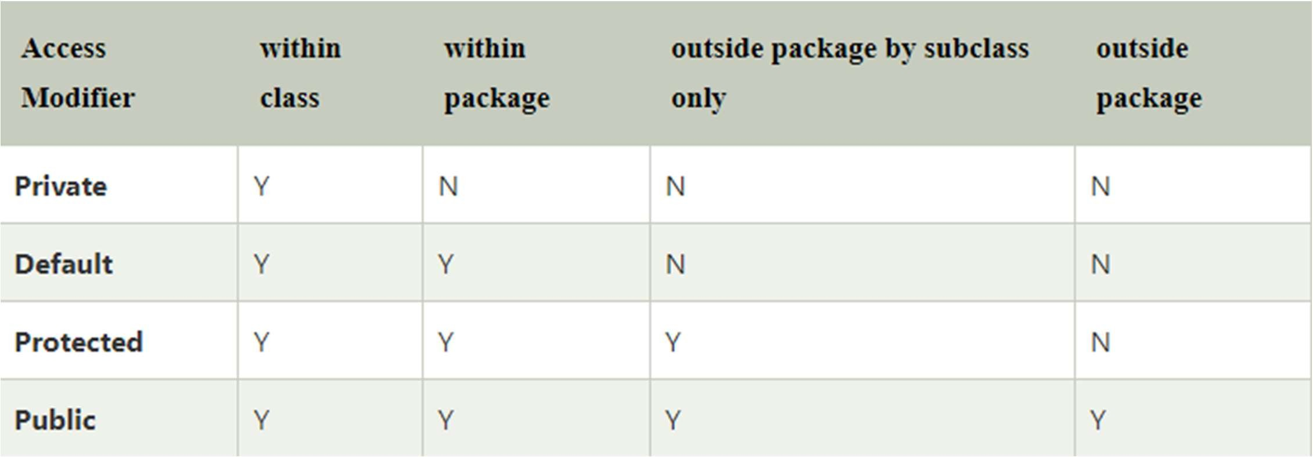

#### Private

class A{

private int data=40;

private void msg(){System.out.println("Hello java");}

}

public class Simple{

public static void main(String args[]){ A obj=new A();

System.out.println(obj.data);//Compile Time Error obj.msg();//Compile Time Error

}

}

* + If you make any class constructor private, you cannot create the instance of that class from outside the class. For example:

**class** A{

**private** A(){}//private constructor

**void** msg(){System.out.println("Hello java");}

}

**public class** Simple{

**public static void** main(String args[]){ A obj=**new** A();//Compile Time Error

}

}

#### Default

* + If you don't use any modifier, it is treated as default by default. The default modifier is accessible only within package. It cannot be accessed from outside the package.

//save by A.java **package** pack; **class** A{

**void** msg(){System.out.println("Hello");}

}

//save by B.java **package** mypack; **import** pack.*; **class** B{

**public static void** main(String args[]){ A obj = **new** A();//Compile Time Error obj.msg();//Compile Time Error

}

}

#### Protected

* The **protected access modifier** is accessible within package and outside the package but through inheritance only.

//save by A.java **package** pack; **public class** A{

**protected void** msg(){System.out.println("Hello");}

}

//save by B.java **package** mypack; **import** pack.*;

**class** B **extends** A{

**public static void** main(String args[]){ B obj = **new** B();

obj.msg();

}

} By Jagadish Sahoo

#### Public

* + The **public access modifier** is accessible everywhere. It has the widest scope among all other modifiers.

//save by A.java **package** pack; **public class** A{

**public void** msg(){System.out.println("Hello");}

}

//save by B.java **package** mypack; **import** pack.*;

**class** B{

**public static void** main(String args[]){ A obj = **new** A();

obj.msg();

}

}

#### Inheritance in Java

* + **Inheritance in Java** is a mechanism in which one object acquires all the properties and behaviors of a parent object.
  + The idea behind inheritance in Java is that you can create new classes that are built upon existing classes.
  + When you inherit from an existing class, you can reuse methods and fields of the parent class.
  + Moreover, you can add new methods and fields in your current class also.
  + Inheritance represents the **IS-A relationship** which is also known as a *parent-child* relationship.

#### Why use inheritance in java

* + For Method Overriding (so runtime polymorphism can be achieved).
  + For Code Reusability.

#### Terms used in Inheritance

* + **Class:** A class is a group of objects which have common properties. It is a template or blueprint from which objects are created.
  + **Sub Class/Child Class:** Subclass is a class which inherits the other class. It is also called a derived class, extended class, or child class.
  + **Super Class/Parent Class:** Superclass is the class from where a subclass inherits the features. It is also called a base class or a parent class.
  + **Reusability:** As the name specifies, reusability is a mechanism which facilitates you to reuse the fields and methods of the existing class when you create a new class. You can use the same fields and methods already defined in the previous class.

#### Syntax of Java Inheritance

**class** Subclass-name **extends** Superclass-name

{

//methods and fields

}

* + The **extends keyword** indicates that you are making a new class that derives from an existing class. The meaning of "extends" is to increase the functionality.
  + In the terminology of Java, a class which is inherited is called a parent or superclass, and the new class is called child or subclass.

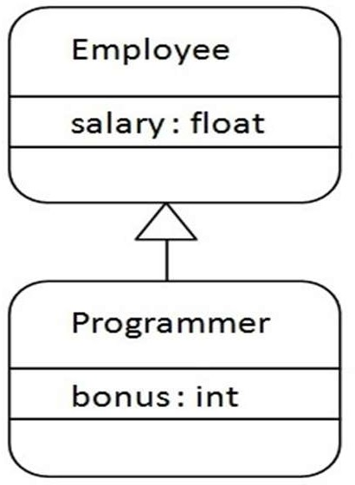

Programmer is the subclass and Employee is the superclass. The relationship between the two classes is Programmer IS-A Employee. It means that Programmer is a type of Employee.

class Employee{ float salary=40000;

}

class Programmer extends Employee{ int bonus=10000;

public static void main(String args[]){ Programmer p=new Programmer();

System.out.println("Programmer salary is:"+p.salary); System.out.println("Bonus of Programmer is:"+p.bonus);

}

}

#### Types of inheritance in java

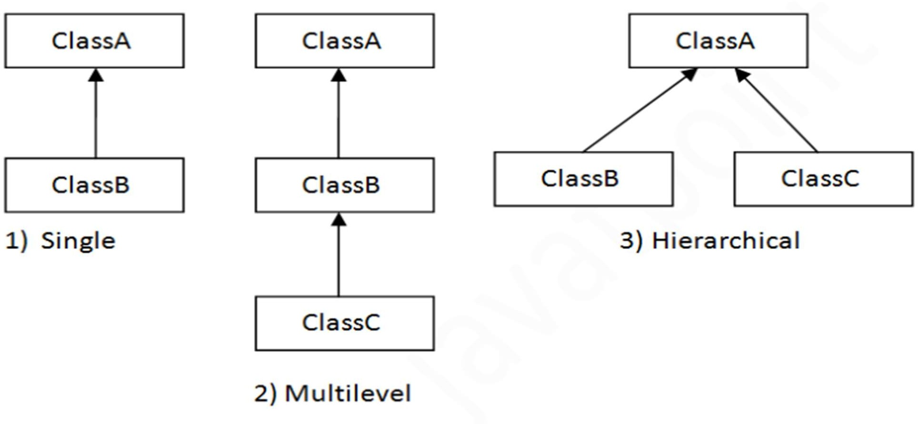

* + 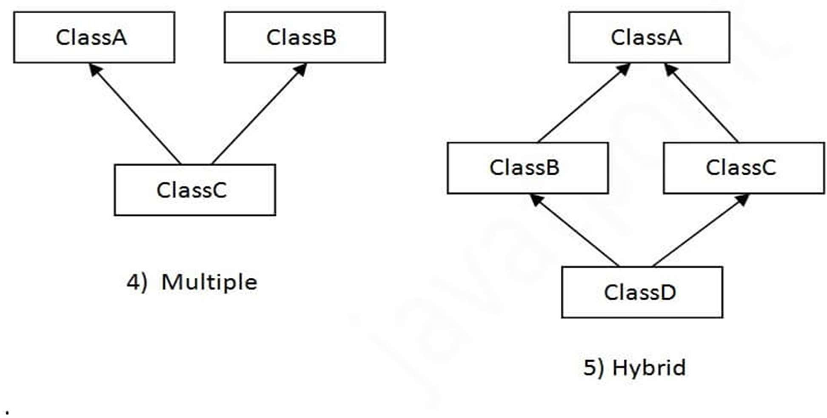In java programming, multiple and hybrid inheritance is supported through interface only.

## Single Inheritance

* + When a class inherits another class, it is known as a *single inheritance*.

**class** Animal{

**void** eat(){System.out.println("eating...");}

}

**class** Dog **extends** Animal{

**void** bark(){System.out.println("barking...");}

}

**class** TestInheritance{

**public static void** main(String args[]){ Dog d=**new** Dog();

d.bark();

d.eat();

}}

#### Multilevel Inheritance

* + When there is a chain of inheritance, it is known as *multilevel inheritance*.

class Animal{

void eat(){System.out.println("eating...");}

}

class Dog extends Animal{

void bark(){System.out.println("barking...");}

}

class BabyDog extends Dog{

void weep(){System.out.println("weeping...");}

}

class TestInheritance2{

public static void main(String args[]){ BabyDog d=new BabyDog(); d.weep();

d.bark();

d.eat();

}}

#### Hierarchical Inheritance

* + When two or more classes inherits a single class, it is known as *hierarchical inheritance*.

**class** Animal{

**void** eat(){System.out.println("eating...");}

}

**class** Dog **extends** Animal{

**void** bark(){System.out.println("barking...");}

}

**class** Cat **extends** Animal{

**void** meow(){System.out.println("meowing...");}

}

**class** TestInheritance3{

**public static void** main(String args[]){ Cat c=**new** Cat();

c.meow();

c.eat();

//c.bark();//C.T.Error

}}

Why multiple inheritance is not supported in java?

* + To reduce the complexity and simplify the language, multiple inheritance is not supported in java.
  + Consider a scenario where A, B, and C are three classes. The C class inherits A and B classes. If A and B classes have the same method and you call it from child class object, there will be ambiguity to call the method of A or B class.
  + Since compile-time errors are better than runtime errors, Java renders compile-time error if you inherit 2 classes. So whether you have same method or different, there will be compile time error.

**class** A{

**void** msg(){System.out.println("Hello");}

}

**class** B{

**void** msg(){System.out.println("Welcome");}

}

**class** C **extends** A,B{//suppose if it were

**public static void** main(String args[]){ C obj=**new** C();

obj.msg();//Now which msg() method would be invoked?

}

}

#### Java Package

* + A **java package** is a group of similar types of classes, interfaces and sub-packages.
  + Package in java can be categorized in two form, built-in package and user-defined package.
  + There are many built-in packages such as java, lang, awt, javax, swing, net, io, util, sql etc.

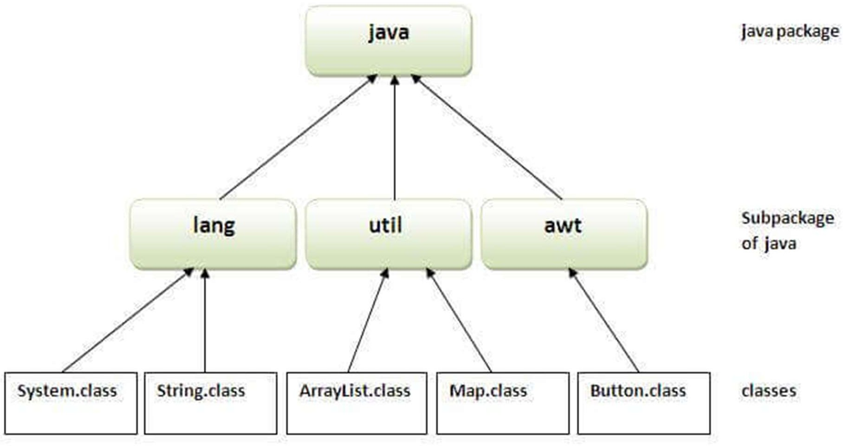

#### Advantage of Java Package

* + Java package is used to categorize the classes and interfaces so that they can be easily maintained.
  + Java package provides access protection.
  + Java package removes naming collision.

#### Creating Package

* + The **package keyword** is used to create a package in java.

//save as Simple.java **package** mypack; **public class** Simple{

**public static void** main(String args[]){ System.out.println("Welcome to package");

}

}

#### Compiling a Package

Syntax

javac -d directory javafilename javac -d . Simple.java

The -d is a switch that tells the compiler where to put the class file i.e. it represents destination. The . represents the current folder.

How to run java package program To Compile: javac -d . Simple.java To Run: java mypack.Simple

#### How to access package from another package?

* + There are three ways to access the package from outside the package.

1. import package.*;
2. import package.classname;
3. fully qualified name.

#### Using packagename.*

* + If you use package.* then all the classes and interfaces of this package will be accessible but not subpackages.
  + The import keyword is used to make the classes and interface of another package accessible to the current package.

//save by A.java **package** pack; **public class** A{

**public void** msg(){System.out.println("Hello");}

}

//save by B.java **package** mypack; **import** pack1.*;

**class** B{

**public static void** main(String args[]){ A obj = **new** A();

obj.msg();

}

}

#### Using packagename.classname

* + If you import package.classname then only declared class of this package will be accessible.

//save by A.java

**package** pack;

public class A{

**public void** msg(){System.out.println("Hello");}

}

//save by B.java **package** mypack; **import** pack.A;

**class** B{

**public static void** main(String args[]){ A obj = **new** A();

obj.msg();

}

}

#### Using fully qualified name

* + If you use fully qualified name then only declared class of this package will be accessible. Now there is no need to import. But you need to use fully qualified name every time when you are accessing the class or interface.
  + It is generally used when two packages have same class name e.g. java.util and java.sql packages contain Date class.

//save by A.java **package** pack; **public class** A{

**public void** msg(){System.out.println("Hello");}

}

//save by B.java **package** mypack; **class** B{

**public static void** main(String args[]){

pack.A obj = **new** pack.A();//using fully qualified name obj.msg();

}

}

* + If you import a package, all the classes and interface of that package will be imported excluding the classes and interfaces of the subpackages. Hence, you need to import the subpackage as well.
  + 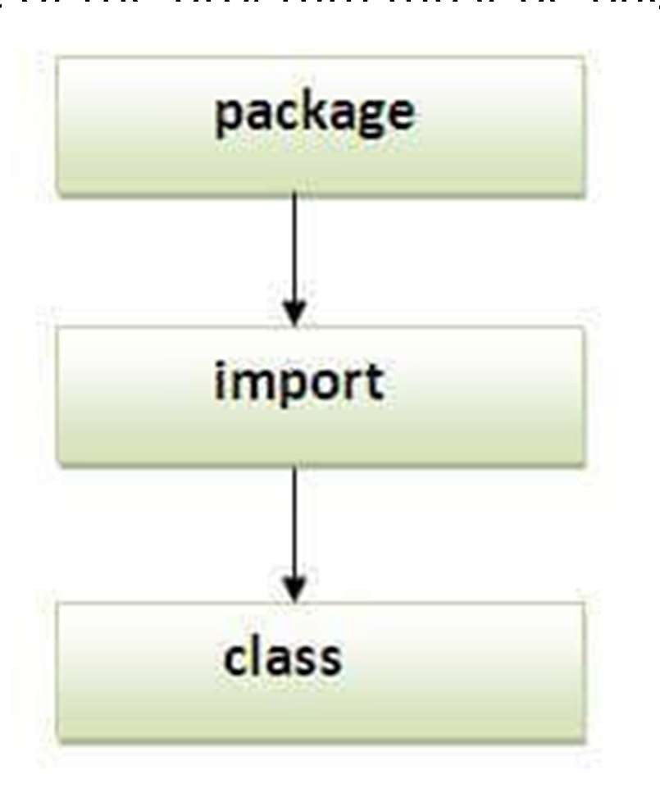Note: Sequence of the program must be package then import then class.

By Jagadish Sahoo

#### Subpackage in java

* + Package inside the package is called the **subpackage**. It should be created **to categorize the package further**.

**package** pack1.pack2;

**class** Simple{

**public static void** main(String args[]){ System.out.println("Hello subpackage");

}

}

* + To Compile: javac -d . Simple.java
  + To Run: java pack1.pack2.Simple

#### How to put two public classes in a package?

* + If you want to put two public classes in a package, have two java source files containing one public class, but keep the package name same. For example:

//save as A.java **package** javatpoint; **public class** A{}

//save as B.java **package** javatpoint; **public class** B{}

#### Interface in Java

* + An **interface in Java** is a blueprint of a class. It has static constants and abstract methods.
  + The interface in Java is *a mechanism to achieve abstraction*. There can be only abstract methods in the Java interface, not method body.
  + It is used to achieve abstraction and multiple inheritance in Java.
  + Interfaces can have abstract methods and variables. It cannot have a method body.
  + Java Interface also **represents the IS-A relationship**.
  + It cannot be instantiated just like the abstract class.
  + Since Java 8, we can have **default and static methods** in an interface.
  + Since Java 9, we can have **private methods** in an interface.

## Why use Java interface?

* + There are mainly three reasons to use interface. It is used to achieve abstraction.

By interface, we can support the functionality of multiple inheritance. It can be used to achieve loose coupling.

#### How to declare an interface?

* + An interface is declared by using the interface keyword.
  + It provides total abstraction; means all the methods in an interface are declared with the empty body, and all the fields are public, static and final by default.
  + A class that implements an interface must implement all the methods declared in the interface.

Syntax:

interface <interface_name>{

// declare constant fields

// declare methods that abstract by default.

}

* + The Java compiler adds public and abstract keywords before the interface method. Moreover, it adds public, static and final keywords before data members.
  + In other words, Interface fields are public, static and final by default, and the methods are public and abstract.

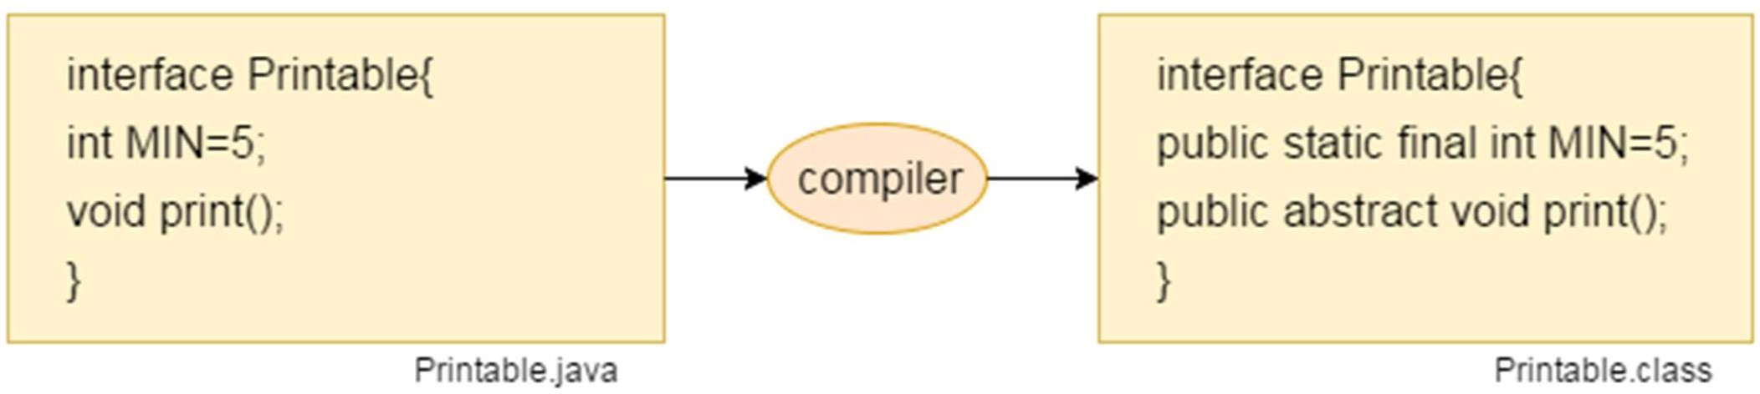

#### The relationship between classes and interfaces

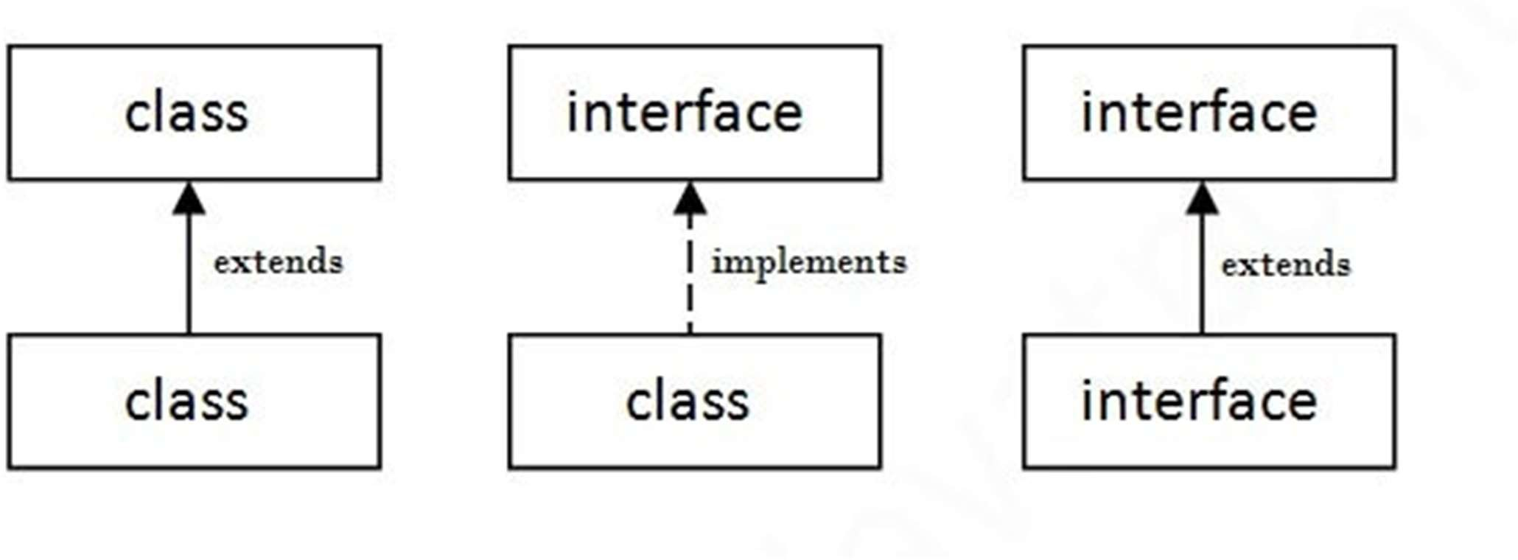

**interface** printable{

**void** print();

}

**class** A6 **implements** printable{

**public void** print(){System.out.println("Hello");}

**public static void** main(String args[]){ A6 obj = **new** A6();

obj.print();

}

}

* + In this example, the Drawable interface has only one method. Its implementation is provided by Rectangle and Circle classes.
  + In a real scenario, an interface is defined by someone else, but its implementation is provided by different implementation providers.
  + Moreover, it is used by someone else. The implementation part is hidden by the user who uses the interface.

//Interface declaration: by first user interface Drawable{

void draw();

}

//Implementation: by second user class Rectangle implements Drawable{

public void draw(){System.out.println("drawing rectangle");}

}

class Circle implements Drawable{

public void draw(){System.out.println("drawing circle");}

}

//Using interface: by third user class TestInterface1{

public static void main(String args[]){

Drawable d=new Circle();//In real scenario, object is provided by method e.g. getDrawable() d.draw();

}}

interface Bank{

float rateOfInterest();

}

class SBI implements Bank{

public float rateOfInterest(){return 9.15f;}

}

class PNB implements Bank{

public float rateOfInterest(){return 9.7f;}

}

class TestInterface2{

public static void main(String[] args){ Bank b=new SBI();

System.out.println("ROI: "+b.rateOfInterest());

}}

#### Multiple inheritance in Java by interface

* + If a class implements multiple interfaces, or an interface extends multiple interfaces, it is known as multiple inheritance.

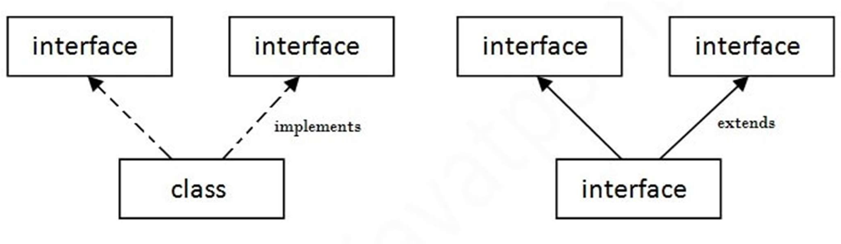

interface Printable{ void print();

}

interface Showable{ void show();

}

class A7 implements Printable,Showable{ public void print(){System.out.println("Hello");}

public void show(){System.out.println("Welcome");}

public static void main(String args[]){ A7 obj = new A7();

obj.print();

obj.show();

}

}

Multiple inheritance is not supported through class in java, but it is possible by an interface, why?

* + Multiple inheritance is not supported in the case of class because of ambiguity.
  + However, it is supported in case of an interface because there is no ambiguity. It is because its implementation is provided by the implementation class.

interface Printable{ void print();

}

interface Showable{ void print();

}

class TestInterface3 implements Printable, Showable{ public void print(){System.out.println("Hello");} public static void main(String args[]){

TestInterface3 obj = new TestInterface3(); obj.print();

}

}

#### Interface inheritance

• A class implements an interface, but one interface extends another interface.

**interface** Printable{

**void** print();

}

**interface** Showable **extends** Printable{

**void** show();

}

**class** TestInterface4 **implements** Showable{

**public void** print(){System.out.println("Hello");}

**public void** show(){System.out.println("Welcome");}

**public static void** main(String args[]){ TestInterface4 obj = **new** TestInterface4(); obj.print();

obj.show();

}

}

## Java 8 Default Method in Interface

• Since Java 8, we can have method body in interface. But we need to make it default method.

**interface** Drawable{

**void** draw();

**default void** msg(){System.out.println("default method");}

}

**class** Rectangle **implements** Drawable{

**public void** draw(){System.out.println("drawing rectangle");}

}

**class** TestInterfaceDefault{

**public static void** main(String args[]){ Drawable d=**new** Rectangle(); d.draw();

d.msg();

}}

## Java 8 Static Method in Interface

* Since Java 8, we can have static method in interface. interface Drawable{

void draw();

static int cube(int x){return x*x*x;}

}

class Rectangle implements Drawable{

public void draw(){System.out.println("drawing rectangle");}

}

class TestInterfaceStatic{

public static void main(String args[]){ Drawable d=new Rectangle(); d.draw(); System.out.println(Drawable.cube(3));

}}

What is marker or tagged interface?

An interface which has no member is known as a marker or tagged interface.

They are used to provide some essential information to the JVM so that JVM may perform some useful operation.

Nested Interface in Java

An interface can have another interface which is known as a nested interface.

**interface** printable{

**void** print();

**interface** MessagePrintable{

**void** msg();

}

}

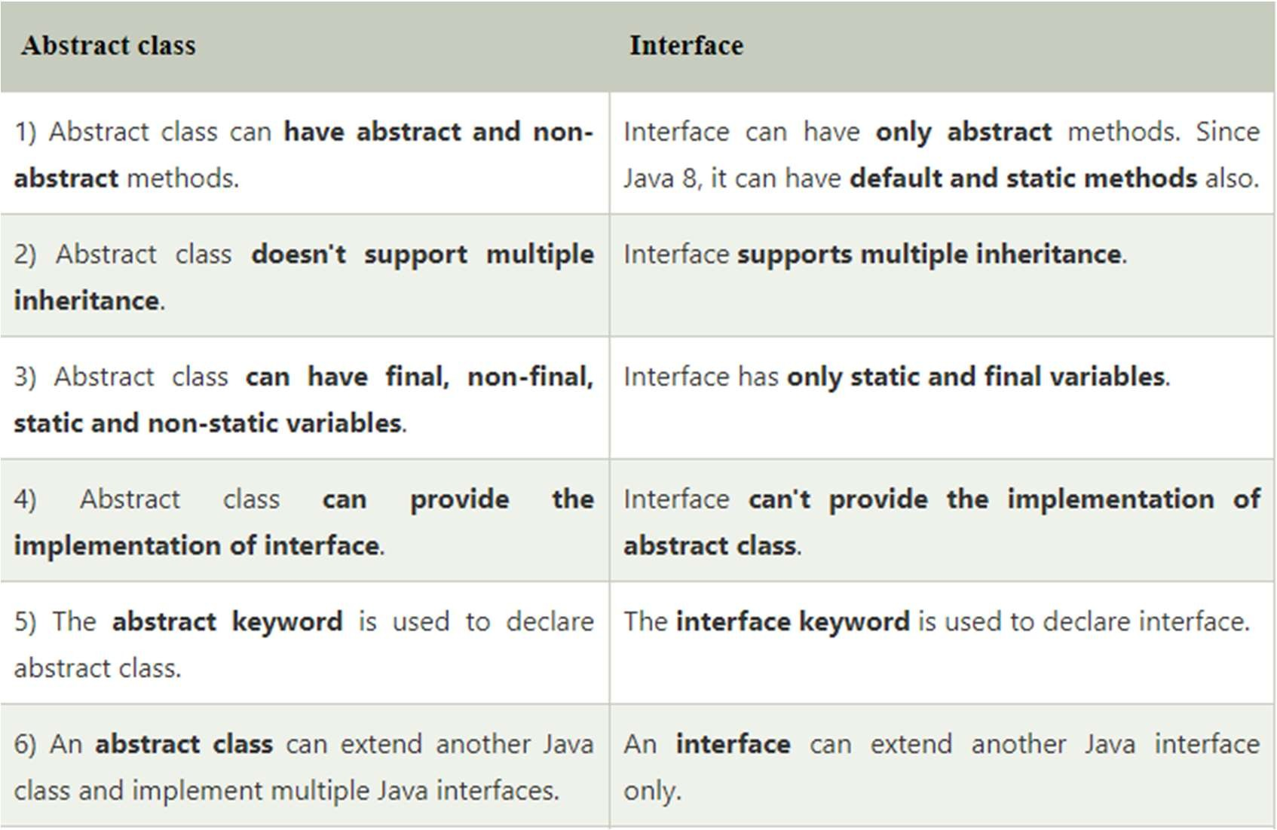Difference between abstract class and interface

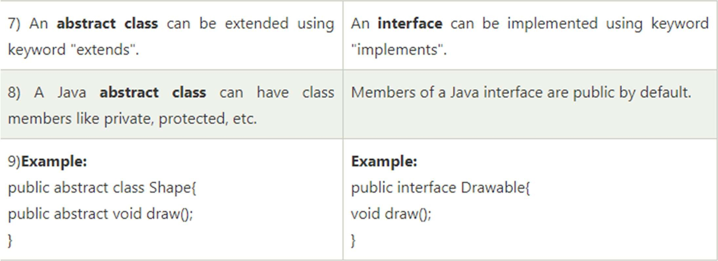

Wrapper classes in Java

* + The **wrapper class in Java** provides the mechanism *to convert primitive into object and object into primitive*.
  + Since J2SE 5.0, **autoboxing** and **unboxing** feature convert primitives into objects and objects into primitives automatically. The automatic conversion of primitive into an object is known as autoboxing and vice-versa unboxing.

#### Use of Wrapper classes in Java

* + Change the value in Method: Java supports only call by value. So, if we pass a primitive value, it will not change the original value. But, if we convert the primitive value in an object, it will change the original value.
  + Serialization: We need to convert the objects into streams to perform the serialization. If we have a primitive value, we can convert it in objects through the wrapper classes.
  + Synchronization: Java synchronization works with objects in Multithreading.
  + java.util package: The java.util package provides the utility classes to deal with objects.
  + Collection Framework: Java collection framework works with objects only. All classes of the collection framework (ArrayList, LinkedList, Vector, HashSet, LinkedHashSet, TreeSet, PriorityQueue, ArrayDeque, etc.) deal with objects only.
  + The eight classes of the *java.lang* package are known as wrapper classes in Java.

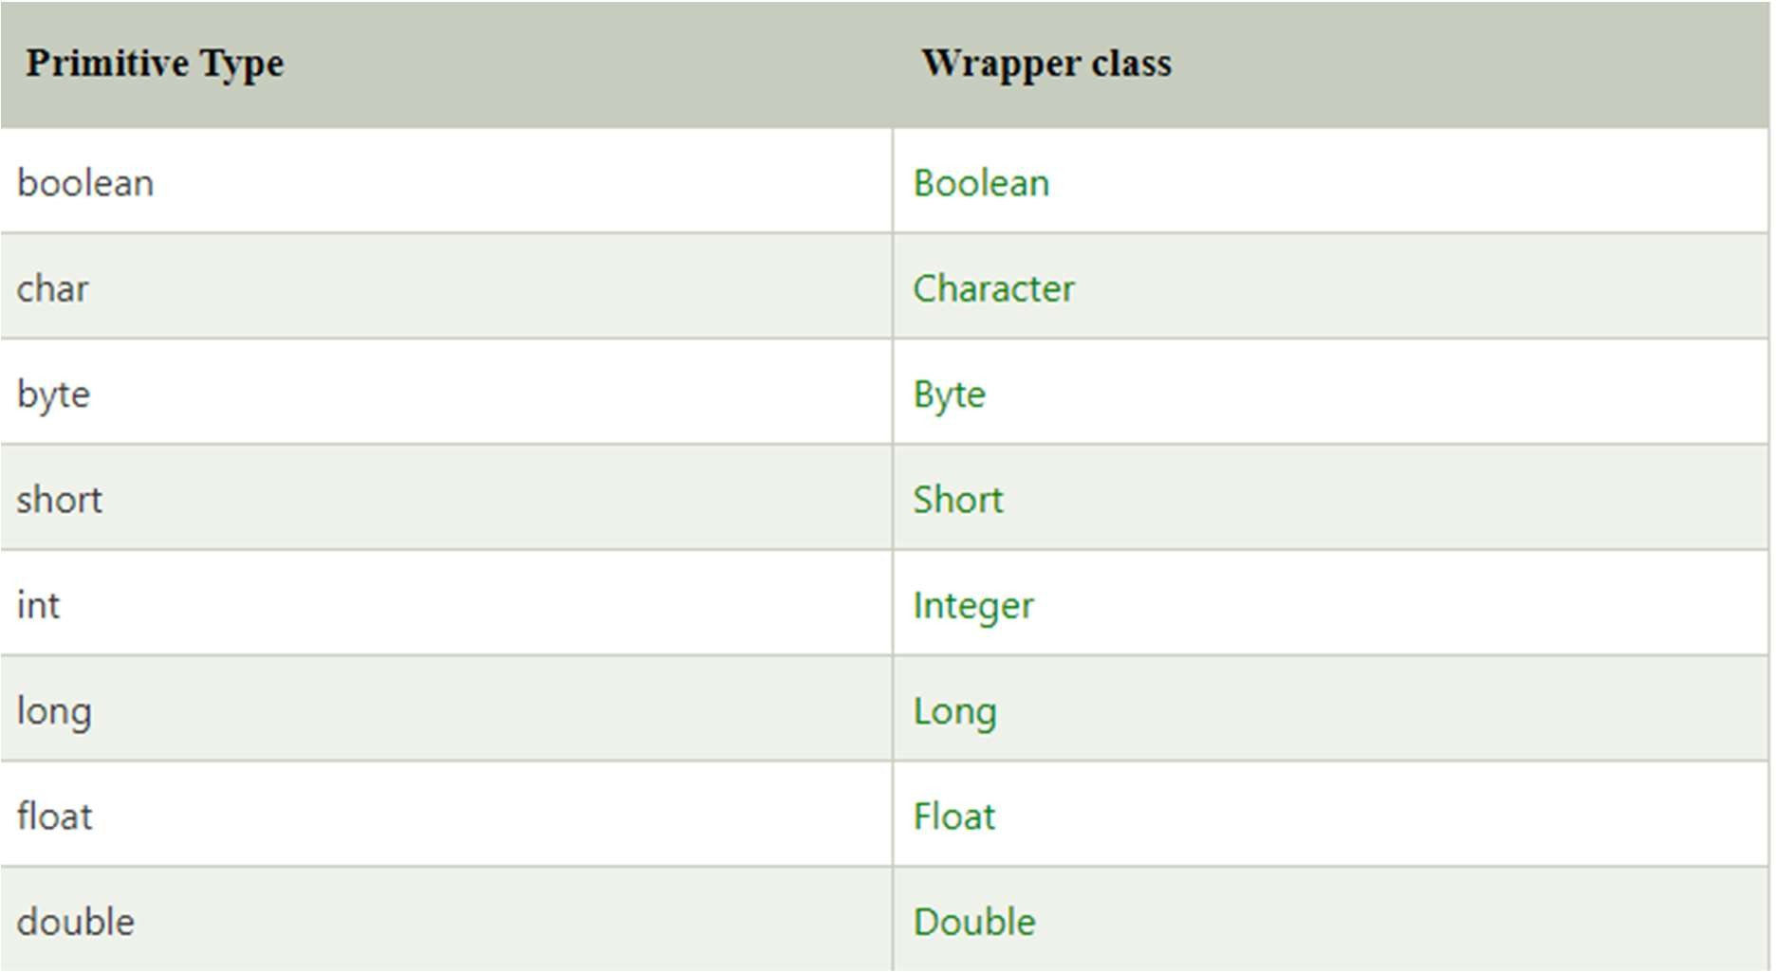

#### Autoboxing

* + The automatic conversion of primitive data type into its corresponding wrapper class is known as autoboxing,
  + For example, byte to Byte, char to Character, int to Integer, long to Long, float to Float, boolean to Boolean, double to Double, and short to Short.
  + Since Java 5, we do not need to use the valueOf() method of wrapper classes to convert the primitive into objects.

//Java program to convert primitive into objects

//Autoboxing example of int to Integer

**public class** WrapperExample1{

**public static void** main(String args[]){

//Converting int into Integer

**int** a=20;

Integer i=Integer.valueOf(a);//converting int into Integer explicitly

Integer j=a;//autoboxing, now compiler will write Integer.valueOf(a) int ernally

System.out.println(a+" "+i+" "+j);

}}

#### Unboxing

* The automatic conversion of wrapper type into its corresponding primitive type is known as unboxing. It is the reverse process of autoboxing. Since Java 5, we do not need to use the intValue() method of wrapper classes to convert the wrapper type into primitives.

//Java program to convert object into primitives

//Unboxing example of Integer to int **public class** WrapperExample2{ **public static void** main(String args[]){

//Converting Integer to int Integer a=**new** Integer(3);

**int** i=a.intValue();//converting Integer to int explicitly

**int** j=a;//unboxing, now compiler will write a.intValue() internally

System.out.println(a+" "+i+" "+j);

}}

**Utility methods of Wrapper classes**

* + The objective of Wrapper class is to define several utility methods which are required for the primitive types.
  + There are 4 utility methods for primitive type which is defined by Wrapper class:

1. valueOf() method
2. **xxxValue() method**
3. parseXxx() method
4. **toString() method**

### valueOf() method

* + We can use valueOf() method to create Wrapper object for given primitive or String.
  + There are 3 types of valueOf() methods:

1. Wrapper valueOf(String s)
2. **Wrapper valueOf(String s, int radix)**
3. Wrapper valueOf(primitive p)

**Wrapper valueOf(String s)**

* Every wrapper class except Character class contains a static valueOf() method to create Wrapper class object for given String.

Syntax:

public static Wrapper valueOf(String s); class GFG {

public static void main(String[] args)

{

Integer I = Integer.valueOf("10"); System.out.println(I);

Double D = Double.valueOf("10.0"); System.out.println(D);

Boolean B = Boolean.valueOf("true"); System.out.println(B);

// Here we will get RuntimeException Integer I1 = Integer.valueOf("ten");

}

} By Jagadish Sahoo

**Wrapper valueOf(String s, int radix)**

* + Every Integral Wrapper class Byte, Short, Integer, Long) contains the following valueOf() method to create a Wrapper object for the given String with specified radix. The range of the radix is 2 to 36.

Syntax:

public static Wrapper valueOf(String s, int radix) class GFG {

public static void main(String[] args)

{

Integer I = Integer.valueOf("1111", 2); System.out.println(I);

Integer I1 = Integer.valueOf("1111", 4); System.out.println(I1);

**Wrapper valueOf(primitive p)**

Every Wrapper class including Character class contains the following method to create a Wrapper object for the given primitive type.

Syntax:

public static Wrapper valueOf(primitive p); class GFG {

public static void main(String[] args)

{

Integer I = Integer.valueOf(10); Double D = Double.valueOf(10.5); Character C = Character.valueOf('a'); System.out.println(I); System.out.println(D); System.out.println(C);

xxxValue() method

* + - We can use xxxValue() methods to get the primitive for the given Wrapper Object. Every number type Wrapper class( Byte, Short, Integer, Long, Float, Double) contains the following 6 methods to get primitive for the given Wrapper object:

1. public byte byteValue()
2. public short shortValue()
3. public int intValue()
4. public long longValue()
5. public float floatValue()
6. public float doubleValue()

class GFG {

public static void main(String[] args)

{

Integer I = new Integer(130); System.out.println(I.byteValue()); System.out.println(I.shortValue()); System.out.println(I.intValue()); System.out.println(I.longValue()); System.out.println(I.floatValue()); System.out.println(I.doubleValue());

}

}

### parseXxx() method

* We can use parseXxx() methods to convert String to primitive.
* There are two types of parseXxx() methods:
  1. primitive parseXxx(String s)
  2. **parseXxx(String s, int radix)**
     + **primitive parseXxx(String s)** : Every Wrapper class except character class contains the following parseXxx() method to find primitive for the given String object.

Syntax:

public static primitive parseXxx(String s); class GFG {

public static void main(String[] args)

{

int i = Integer.parseInt("10");

double d = Double.parseDouble("10.5"); boolean b = Boolean.parseBoolean("true"); System.out.println(i); System.out.println(d); System.out.println(b);

}

}

* + - * **parseXxx(String s, int radix)** : Every Integral type Wrapper class (Byte, Short, Integer, Long) contains the following parseXxx() method to convert specified radix String to primitive.

Syntax:

public static primitive parseXxx(String s, int radix); class GFG {

public static void main(String[] args)

{

int i = Integer.parseInt("1000", 2); long l = Long.parseLong("1111", 4); System.out.println(i); System.out.println(l);

}

}

### toString() method

* + - * + We can use toString() method to convert Wrapper object or primitive to String. There are few forms of toString() method:
        + **public String toString() :** Every wrapper class contains the following toString() method to convert Wrapper Object to String type.

Syntax:

public String toString(); class GFG {

public static void main(String[] args)

{

Integer I = new Integer(10); String s = I.toString(); System.out.println(s);

}

}

* + - * + **toString(primitive p) :** Every Wrapper class including Character class contains the following static toString() method to convert primitive to String.

Syntax:

public static String toString(primitive p); class GFG {

public static void main(String[] args)

{

String s = Integer.toString(10); System.out.println(s);

String s1 = Character.toString('a'); System.out.println(s1);

}

}

* + - * + **toString(primitive p, int radix)** : Integer and Long classes contains the following toString() method to convert primitve to specified radix String.

Syntax:

public static String toString(primitive p, int radix); class GFG {

public static void main(String[] args)

{

String s = Integer.toString(15, 2); System.out.println(s);

String s1 = Long.toString(11110000, 4); System.out.println(s1);

}

}

#### Method Overriding in Java

* + - * + If subclass (child class) has the same method as declared in the parent class, it is known as **method overriding in Java**.
        + If a subclass provides the specific implementation of the method that has been declared by one of its parent class, it is known as method overriding.

## Usage of Java Method Overriding

* + - * + Method overriding is used to provide the specific implementation of a method which is already provided by its superclass.
        + Method overriding is used for runtime polymorphism

#### Rules for Java Method Overriding

* + - * + The method must have the same name as in the parent class
        + The method must have the same parameter as in the parent class.
        + There must be an IS-A relationship (inheritance).

class Vehicle{

void run(){System.out.println("Vehicle is running");}

}

//Creating a child class class Bike extends Vehicle{

public static void main(String args[]){

//creating an instance of child class Bike obj = new Bike();

//calling the method with child class instance obj.run();

}

}

class Vehicle{

void run(){System.out.println("Vehicle is running");}

}

class Bike2 extends Vehicle{ void run()

{

System.out.println("Bike is running safely");

}

public static void main(String args[]){ Bike2 obj = new Bike2();//creating object obj.run();//calling method

}

}

## A real example of Java Method Overriding

* + - * + Consider a scenario where Bank is a class that provides functionality to get the rate of interest. However, the rate of interest varies according to banks. For example, SBI, ICICI and AXIS banks could provide 8%, 7%, and 9% rate of interest.

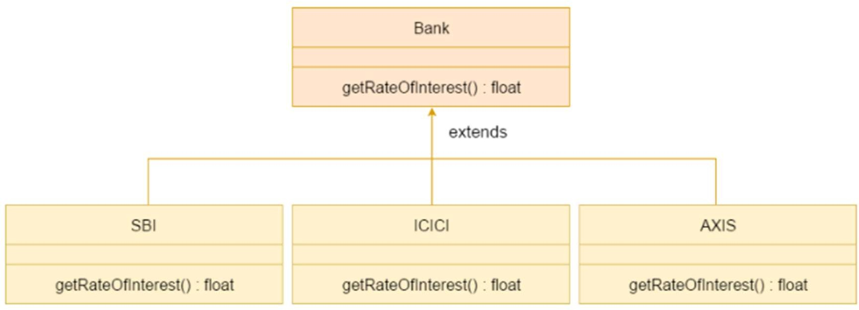

class Bank{

int getRateOfInterest(){return 0;}

}

class SBI extends Bank{

int getRateOfInterest(){return 8;}

}

class ICICI extends Bank{

int getRateOfInterest(){return 7;}

}

class AXIS extends Bank{

int getRateOfInterest(){return 9;}

}

class Test2{

public static void main(String args[]){ SBI s=new SBI();

ICICI i=new ICICI(); AXIS a=new AXIS();

System.out.println("SBI Rate of Interest: "+s.getRateOfInterest()); System.out.println("ICICI Rate of Interest: "+i.getRateOfInterest()); System.out.println("AXIS Rate of Interest: "+a.getRateOfInterest());

}

}

* + - Can we override static method?

No, a static method cannot be overridden.

* + - Why can we not override static method?

It is because the static method is bound with class whereas instance method is bound with an object. Static belongs to the class area, and an instance belongs to the heap area.

Can we override java main method?

* + - No, because the main is a static method.

#### Difference between method overloading and method overriding in java

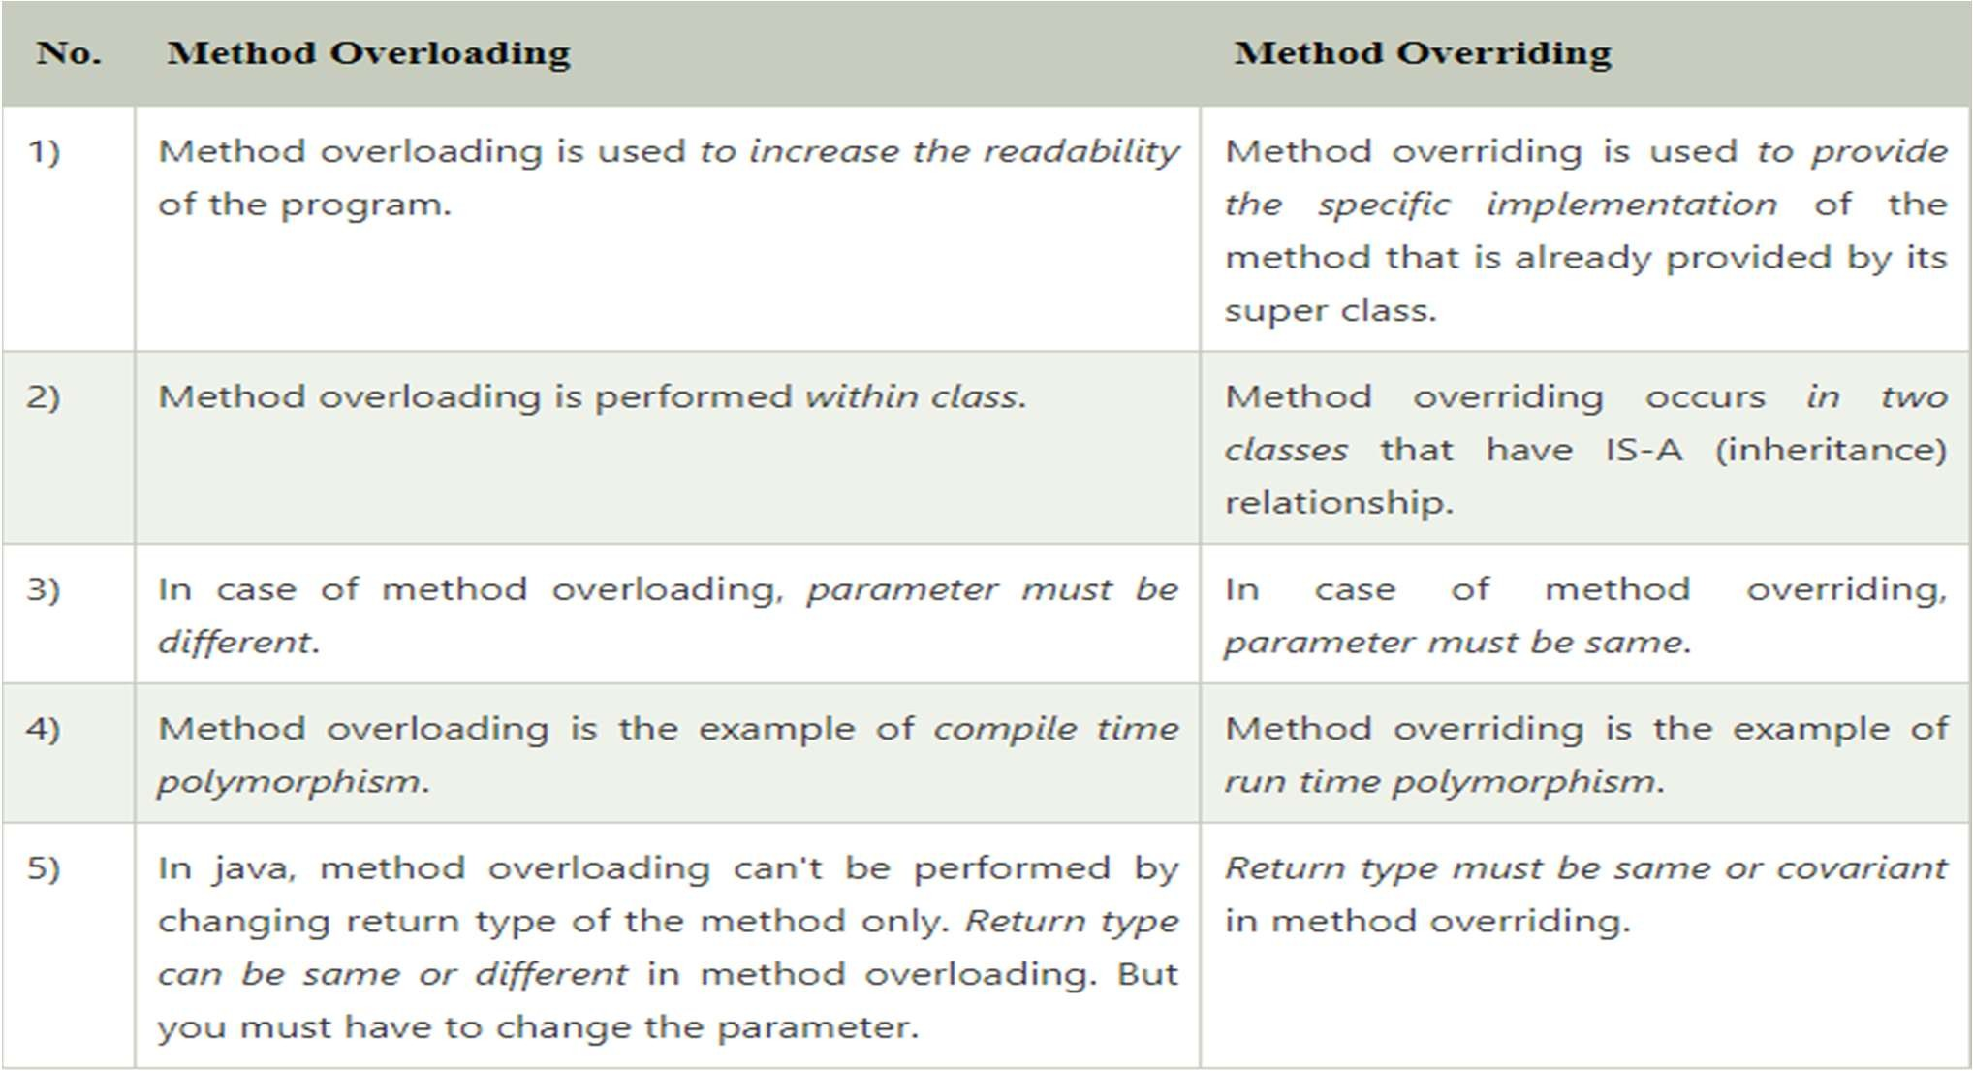

By Jagadish Sahoo

Abstract class in Java

* + - * A class which is declared with the abstract keyword is known as an abstract class.
      * It can have abstract and non-abstract methods (method with the body).
      * **Abstraction** is a process of hiding the implementation details and showing only functionality to the user.
      * Abstraction lets you focus on what the object does instead of how it does it.

## Ways to achieve Abstraction

* + - * There are two ways to achieve abstraction in java

1. Abstract class (0 to 100%)
2. Interface (100%)

## Abstract class in Java

* + - * A class which is declared as abstract is known as an **abstract class**. It can have abstract and non-abstract methods.
      * It needs to be extended and its method implemented. It cannot be instantiated.

## Rules for Java Abstract class

* + - * An abstract class must be declared with an abstract keyword.
      * It can have abstract and non-abstract methods.
      * It cannot be instantiated.
      * It can have constructors and static methods also.
      * It can have final methods which will force the subclass not to change the body of the method.
      * If there is an abstract method in a class, that class must be abstract.

#### Super Keyword in Java

* + - * The **super** keyword in Java is a reference variable which is used to refer immediate parent class object.
      * Whenever you create the instance of subclass, an instance of parent class is created implicitly which is referred by super reference variable.

#### Usage of Java super Keyword

* + - * super can be used to refer immediate parent class instance variable.
      * super can be used to invoke immediate parent class method.
      * super() can be used to invoke immediate parent class constructor.

#### super is used to refer immediate parent class instance variable.

**class** Animal{

String color="white";

}

**class** Dog **extends** Animal{ String color="black";

**void** printColor(){

System.out.println(color);//prints color of Dog class System.out.println(**super**.color);//prints color of Animal class

}

}

**class** TestSuper1{

**public static void** main(String args[]){ Dog d=**new** Dog();

d.printColor();

}} By Jagadish Sahoo

#### super can be used to invoke parent class method

**class** Animal{

**void** eat(){System.out.println("eating...");}

}

**class** Dog **extends** Animal{

**void** eat(){System.out.println("eating bread...");} **void** bark(){System.out.println("barking...");} **void** work(){

**super**.eat();

bark();

}

}

**class** TestSuper2{

**public static void** main(String args[]){ Dog d=**new** Dog();

d.work();

}}

#### super is used to invoke parent class constructor

**class** Animal{ Animal(){System.out.println("animal is created");}

}

**class** Dog **extends** Animal{ Dog(){

**super**();

System.out.println("dog is created");

}

}

**class** TestSuper3{

**public static void** main(String args[]){ Dog d=**new** Dog();

}}

* Example of abstract class abstract class A{}
* Abstract Method in Java

A method which is declared as abstract and does not have implementation is known as an abstract method.

* Example of abstract method

abstract void printStatus();//no method body and abstract

#### Example of Abstract class that has an abstract method

**abstract class** Bike{

**abstract void** run();

}

**class** Honda4 **extends** Bike{

**void** run(){System.out.println("running safely");}

**public static void** main(String args[]){ Bike obj = **new** Honda4();

obj.run();

}

}

**abstract class** Shape{

**abstract void** draw();

}

//In real scenario, implementation is provided by others i.e. unknown by end user

**class** Rectangle **extends** Shape{

**void** draw(){System.out.println("drawing rectangle");}

}

**class** Circle1 **extends** Shape{

**void** draw(){System.out.println("drawing circle");}

}

//In real scenario, method is called by programmer or user

**class** TestAbstraction1{

**public static void** main(String args[]){

Shape s=**new** Circle1();//In a real scenario, object is provided through method, e.g., getShape() method s.draw();

}

}

abstract class Bank{

abstract int getRateOfInterest();

}

class SBI extends Bank{

int getRateOfInterest(){return 7;}

}

class PNB extends Bank{

int getRateOfInterest(){return 8;}

}

class TestBank{

public static void main(String args[]){ Bank b;

b=new SBI();

System.out.println("Rate of Interest is: "+b.getRateOfInterest()+" %"); b=new PNB();

System.out.println("Rate of Interest is: "+b.getRateOfInterest()+" %");

}}

Abstract class having constructor, data member and methods

**abstract class** Bike{ Bike(){System.out.println("bike is created");} **abstract void** run();

**void** changeGear(){System.out.println("gear changed");}

}

//Creating a Child class which inherits Abstract class

**class** Honda **extends** Bike{

**void** run(){System.out.println("running safely..");}

}

//Creating a Test class which calls abstract and non-abstract methods

**class** TestAbstraction2{

**public static void** main(String args[]){ Bike obj = **new** Honda();

obj.run(); obj.changeGear();

}

}

Note: super() is added in each class constructor automatically by compiler if there is no super() or this().

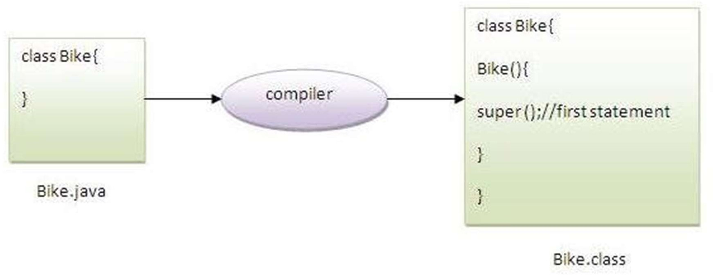

**class** Animal{ Animal(){System.out.println("animal is created");}

}

**class** Dog **extends** Animal{ Dog(){

System.out.println("dog is created");

}

}

**class** TestSuper4{

**public static void** main(String args[]){ Dog d=**new** Dog();

}}

Emp class inherits Person class so all the properties of Person will be inherited to Emp by default. To initialize all the property, we are using parent class constructor from child class. In such way, we are reusing the parent class constructor.

class Person{ int id;

String name;

Person(int id,String name){ this.id=id; this.name=name;

}

}

class Emp extends Person{ float salary;

Emp(int id,String name,float salary){ super(id,name);//reusing parent constructor this.salary=salary;

}

void display(){System.out.println(id+" "+name+" "+salary);}

} By Jagadish Sahoo

#### Final Keyword In Java

* The **final keyword** in java is used to restrict the user. The java final keyword can be used in many context. Final can be:

1. variable
2. method
3. class

* The final keyword can be applied with the variables, a final variable that have no value it is called blank final variable or uninitialized final variable.
* It can be initialized in the constructor only.
* The blank final variable can be static also which will be initialized in the static block only.

#### Java final variable

* If you make any variable as final, you cannot change the value of final variable(It will be constant).

**class** Bike9{

**final int** speedlimit=90;//final variable

**void** run(){ speedlimit=400;

}

**public static void** main(String args[]){ Bike9 obj=**new** Bike9();

obj.run();

}

}

**Output:Compile Time Error**

#### Java final method

* If you make any method as final, you cannot override it.

**class** Bike{

**final void** run(){System.out.println("running");}

}

**class** Honda **extends** Bike{

**void** run(){System.out.println("running safely with 100kmph");}

**public static void** main(String args[]){ Honda honda= **new** Honda(); honda.run();

}

}

**Output:Compile Time Error**

#### Java final class

* If you make any class as final, you cannot extend it.

**final class** Bike{}

**class** Honda1 **extends** Bike{

**void** run(){System.out.println("running safely with 100kmph");}

**public static void** main(String args[]){ Honda1 honda= **new** Honda1(); honda.run();

}

}

Output:Compile Time Error

Q) Is final method inherited?

Ans) Yes, final method is inherited but you cannot override it.

**class** Bike{

**final void** run(){System.out.println("running...");}

}

**class** Honda2 **extends** Bike{

**public static void** main(String args[]){

**new** Honda2().run();

}

}

Q) What is blank or uninitialized final variable?

A final variable that is not initialized at the time of declaration is known as blank final variable.

If you want to create a variable that is initialized at the time of creating object and once initialized may not be changed, it is useful. For example PAN CARD number of an employee.

**class** Student{

**int** id;

String name;

**final** String PAN_CARD_NUMBER;

...

}

Que) Can we initialize blank final variable? Yes, but only in constructor.

**class** Bike10{

**final int** speedlimit;//blank final variable

Bike10(){ speedlimit=70;

System.out.println(speedlimit);

}

**public static void** main(String args[]){

**new** Bike10();

}

}

Q) What is final parameter?

If you declare any parameter as final, you cannot change the value of it.

**class** Bike11{

**int** cube(**final int** n){

n=n+2;//can't be changed as n is final n*n*n;

}

**public static void** main(String args[]){ Bike11 b=**new** Bike11();

b.cube(5);

}

}

class TestSuper5{

public static void main(String[] args){ Emp e1=new Emp(1,"ankit",45000f); e1.display();

}}

## Exception Handling in Java

* The **Exception Handling in Java** is one of the powerful *mechanism to handle the runtime errors* so that the normal flow of the application can be maintained.
* Exception is an abnormal condition.
* In Java, an exception is an event that disrupts the normal flow of the program. It is an object which is thrown at runtime.
* Exception Handling is a mechanism to handle runtime errors such as ClassNotFoundException, IOException, SQLException, RemoteException, etc.
* The core advantage of exception handling is **to maintain the normal flow of the application**. An exception normally disrupts the normal flow of the application; that is why we need to handle exceptions.

## Hierarchy of Java Exception classes

* The java.lang.Throwable class is the root class of Java Exception hierarchy inherited by two subclasses:
* Exception and Error.

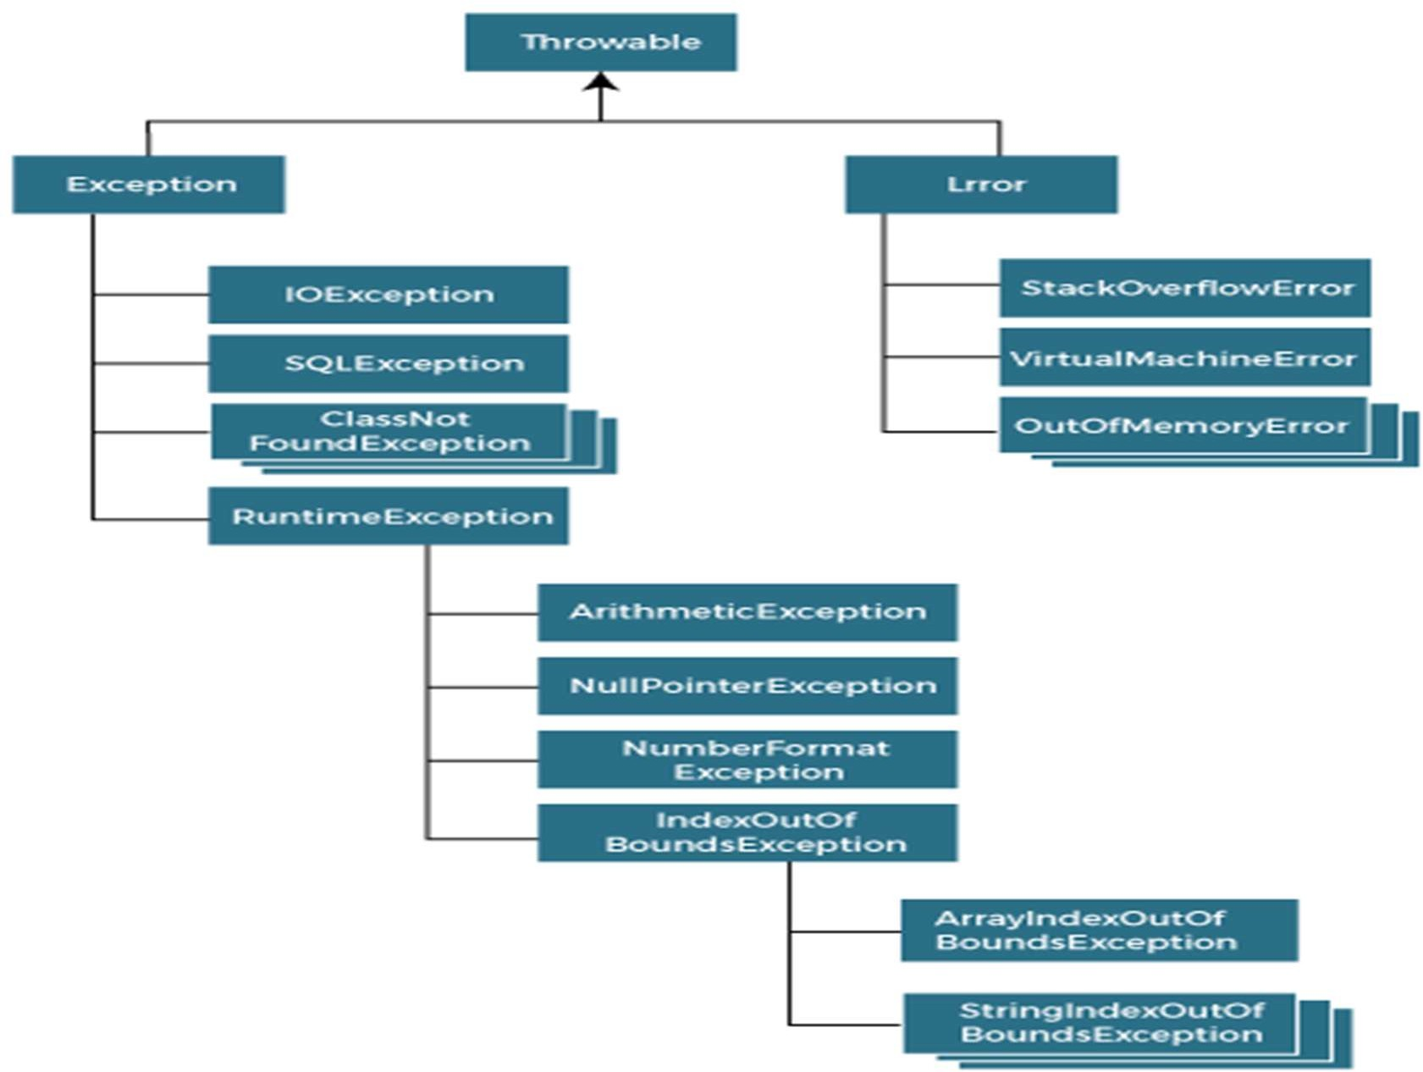

By Jagadish Sahoo

statement 1;

statement 2;

statement 3;

statement 4;

statement 5;//exception occurs statement 6;

statement 7;

statement 8;

statement 9;

statement 10;

* Suppose there are 10 statements in a Java program and an exception occurs at statement 5; the rest of the code will not be executed, i.e., statements 6 to 10 will not be executed.
* However, when we perform exception handling, the rest of the statements will be executed. That is why we use exception handling in Java.

Types of Java Exceptions

* There are mainly two types of exceptions: checked and unchecked.
* An error is considered as the unchecked exception.
* However, according to Oracle, there are three types of exceptions namely:

1. Checked Exception
2. Unchecked Exception
3. Error

Difference between Checked and Unchecked Exceptions

* 1) Checked Exception

The classes that directly inherit the Throwable class except RuntimeException and Error are known as checked exceptions. For example, IOException, SQLException, etc. Checked exceptions are checked at compile-time.

* 2) Unchecked Exception

The classes that inherit the RuntimeException are known as unchecked exceptions. For example, ArithmeticException, NullPointerException, ArrayIndexOutOfBoundsException, etc. Unchecked exceptions are not checked at compile-time, but they are checked at runtime.

* 3) Error

Error is irrecoverable. Some example of errors are OutOfMemoryError, VirtualMachineError, AssertionError etc.

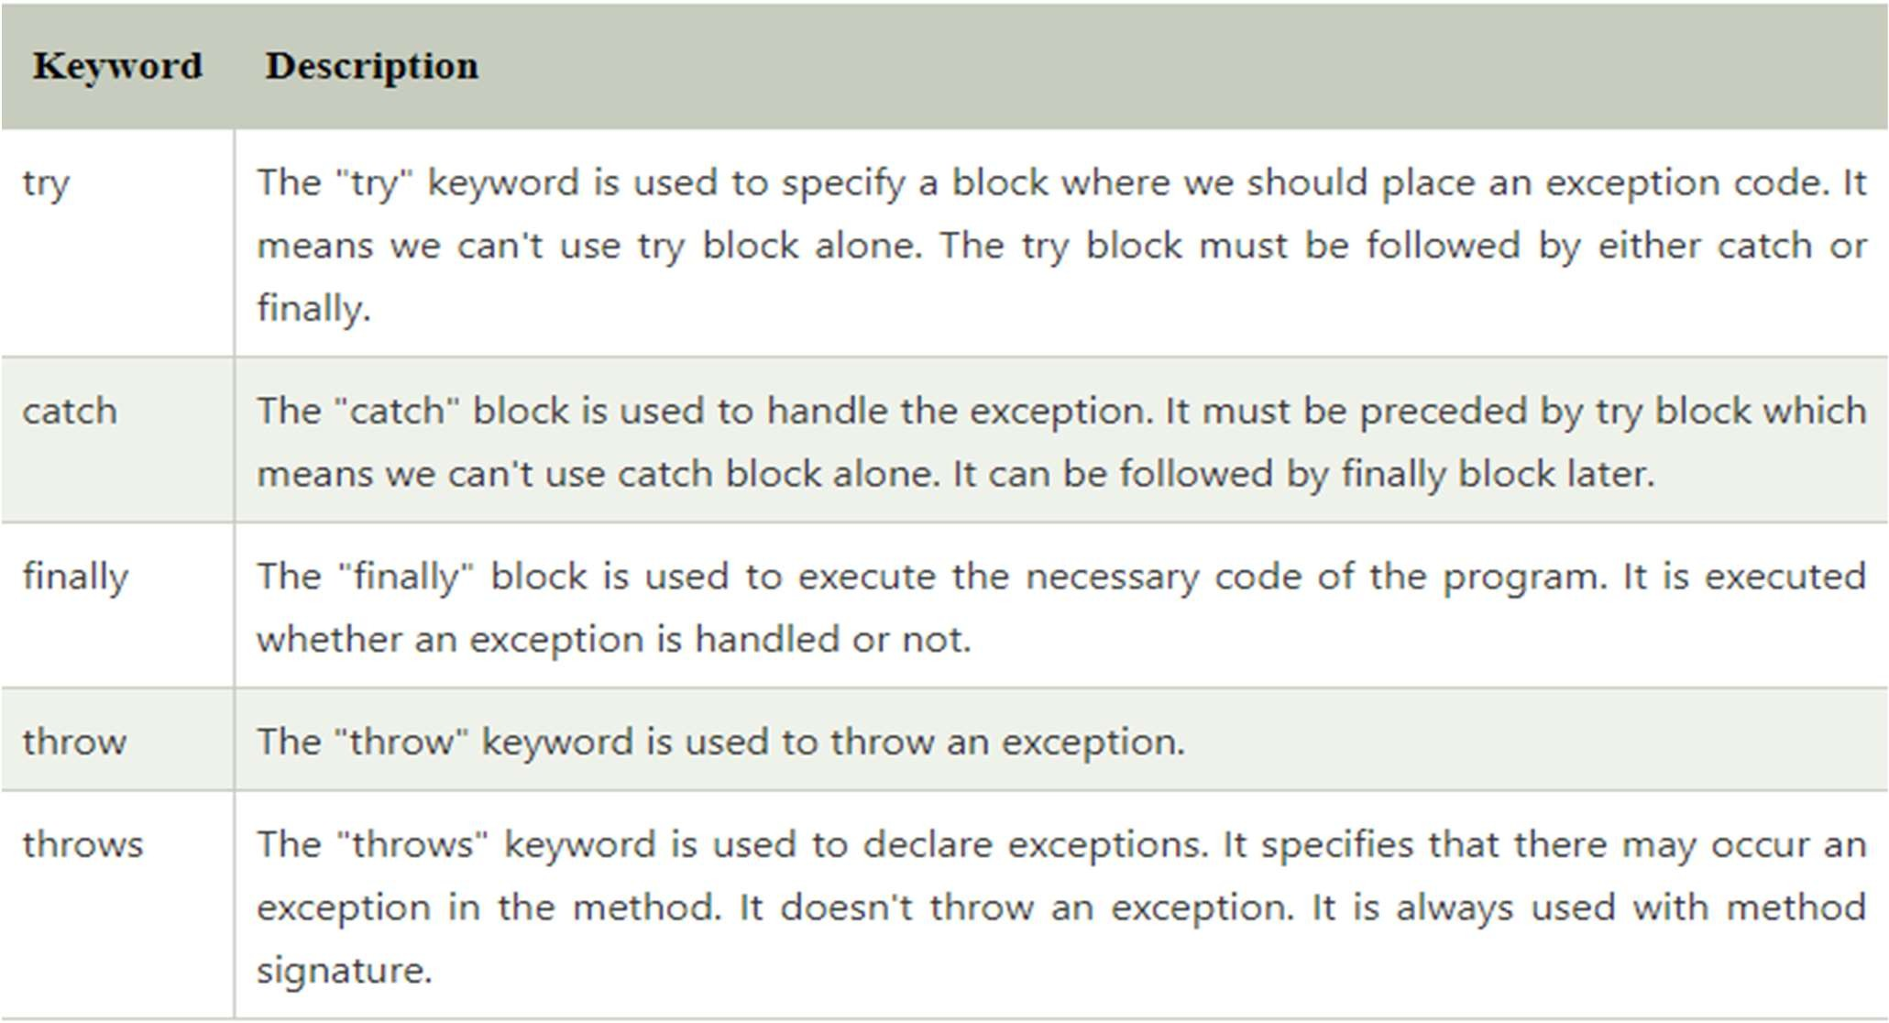Java Exception Keywords

## Java Exception Handling Example

**public class** JavaExceptionExample{ **public static void** main(String args[]){ **try**{

//code that may raise exception

**int** data=100/0;

}**catch**(ArithmeticException e){System.out.println(e);}

//rest code of the program System.out.println("rest of the code...");

}

}

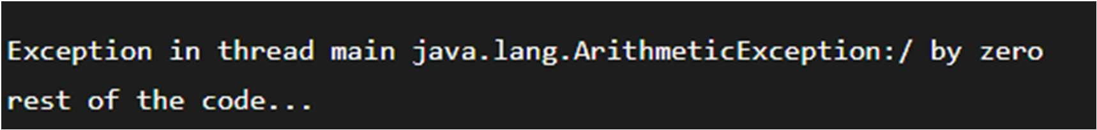

#### Common Scenarios of Java Exceptions

1. A scenario where ArithmeticException occurs

If we divide any number by zero, there occurs an ArithmeticException.

int a=50/0;//ArithmeticException

1. A scenario where NullPointerException occurs

If we have a null value in any variable, performing any operation on the variable throws a NullPointerException.

String s=null; System.out.println(s.length());//NullPointerException

1. A scenario where NumberFormatException occurs

If the formatting of any variable or number is mismatched, it may result into NumberFormatException. Suppose we have a string variable that has characters; converting this variable into digit will cause NumberFormatException.

String s="abc";

int i=Integer.parseInt(s);//NumberFormatException

1. A scenario where ArrayIndexOutOfBoundsException occurs

When an array exceeds to it's size, the ArrayIndexOutOfBoundsException occurs. there may be other reasons to occur ArrayIndexOutOfBoundsException. Consider the following statements.

int a[]=new int[5];

a[10]=50; //ArrayIndexOutOfBoundsException

#### Java try-catch block

* Java try block is used to enclose the code that might throw an exception. It must be used within the method.
* If an exception occurs at the particular statement in the try block, the rest of the block code will not execute. So, it is recommended not to keep the code in try block that will not throw an exception.
* Java try block must be followed by either catch or finally block.

Syntax of Java try-catch

try{

//code that may throw an exception

}

catch(Exception_class_Name ref){}

Syntax of try-finally block

try{

//code that may throw an exception

}

finally{}

#### Java catch block

* Java catch block is used to handle the Exception by declaring the type of exception within the parameter. The declared exception must be the parent class exception ( i.e., Exception) or the generated exception type. However, the good approach is to declare the generated type of exception.
* The catch block must be used after the try block only. You can use multiple catch block with a single try block.

#### Internal Working of Java try-catch block

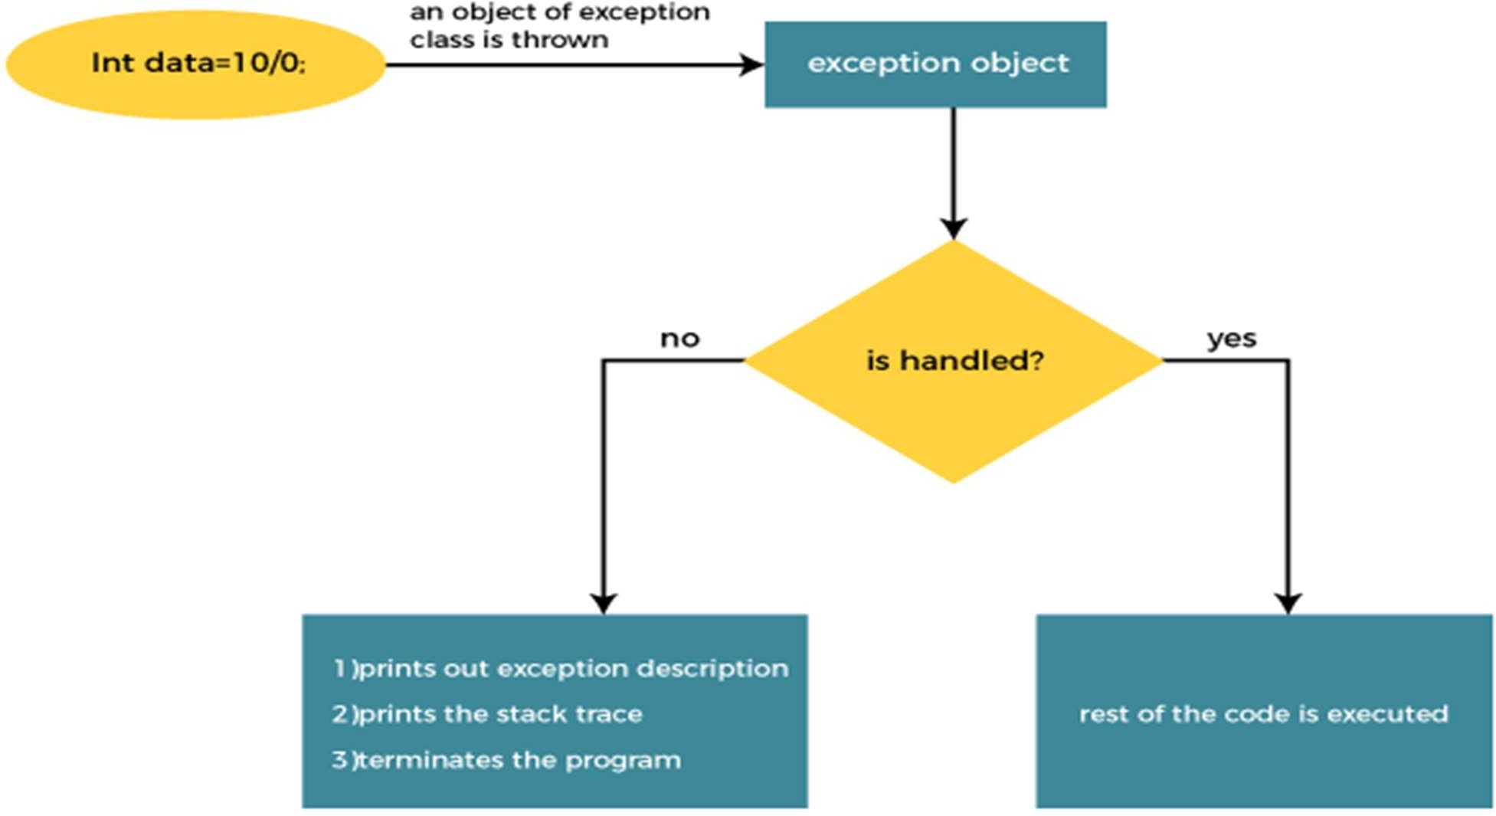

By Jagadish Sahoo

* The JVM firstly checks whether the exception is handled or not. If exception is not handled, JVM provides a default exception handler that performs the following tasks:

1. Prints out exception description.
2. Prints the stack trace (Hierarchy of methods where the exception occurred).
3. Causes the program to terminate.

* But if the application programmer handles the exception, the normal flow of the application is maintained, i.e., rest of the code is executed.

#### Problem without exception handling

**public class** TryCatchExample1 {

**public static void** main(String[] args) {

**int** data=50/0; //may throw exception System.out.println("rest of the code");

}

}



the rest of the code is not executed (in such case, the rest of the code statement is not printed).

## Solution by exception handling

**public class** TryCatchExample2 {

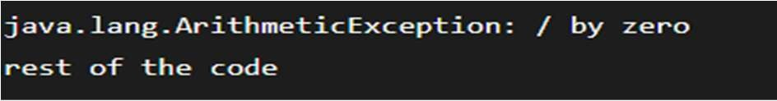**public static void** main(String[] args) {

**try**

{

**int** data=50/0; //may throw exception

}

//handling the exception

**catch**(ArithmeticException e)

{

System.out.println(e);

}

System.out.println("rest of the code");

}

}

public class TryCatchExample3 { public static void main(String[] args) {

try

{

int data=50/0; //may throw exception

// if exception occurs, the remaining statement will not exceute System.out.println("rest of the code");

}

// handling the exception catch(ArithmeticException e)

{

System.out.println(e);

}

}

}

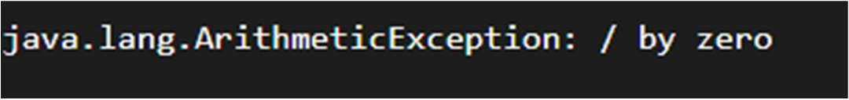

By Jagadish Sahoo

## Handle the exception using the parent class exception.

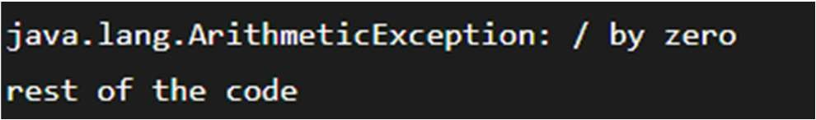**public class** TryCatchExample4 {

**public static void** main(String[] args) {

**try**

{

**int** data=50/0; //may throw exception

}

// handling the exception by using Exception class

**catch**(**Exception** e)

{

System.out.println(e);

}

System.out.println("rest of the code");

}

}

#### Print a custom message on exception

public class TryCatchExample5 {

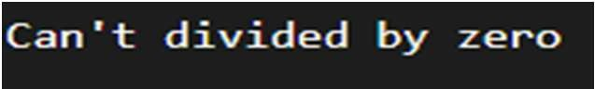public static void main(String[] args) { try

{

int data=50/0; //may throw exception

}

// handling the exception catch(Exception e)

{

// displaying the custom message System.out.println("Can't divided by zero");

}

}

}

## Resolve the exception in a catch block

**public class** TryCatchExample6 {

**public static void** main(String[] args) {

**int** i=50; **int** j=0; **int** data; **try**

{

data=i/j; //may throw exception

}

// handling the exception

**catch**(Exception e)

{

// resolving the exception in catch block System.out.println(i/(j+2));

}

} 

}

**public class** TryCatchExample9 {

**public static void** main(String[] args) {

**try**

{

**int** arr[]= {1,3,5,7};

System.out.println(arr[10]); //may throw exception

}

// handling the array exception

**catch**(ArrayIndexOutOfBoundsException e)

{

System.out.println(e);

}

System.out.println("rest of the code");

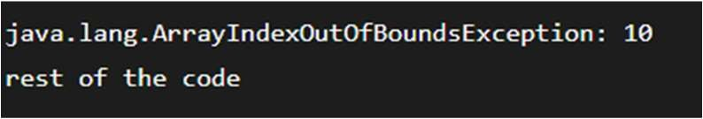}

}

#### Java Catch Multiple Exceptions

* A try block can be followed by one or more catch blocks.
* Each catch block must contain a different exception handler.
* So, if you have to perform different tasks at the occurrence of different exceptions, use java multi-catch block.
* At a time only one exception occurs and at a time only one catch block is executed.
* All catch blocks must be ordered from most specific to most general,

i.e. catch for ArithmeticException must come before catch for Exception.

#### Flowchart of Multi-catch Block

public class MultipleCatchBlock1 { public static void main(String[] args) {

try{

int a[]=new int[5]; a[5]=30/0;

}

catch(ArithmeticException e)

{

System.out.println("Arithmetic Exception occurs");

}

catch(ArrayIndexOutOfBoundsException e)

{

System.out.println("ArrayIndexOutOfBounds Exception occurs");

}

catch(Exception e)

{

System.out.println("Parent Exception occurs");

}

System.out.println("rest of the code");

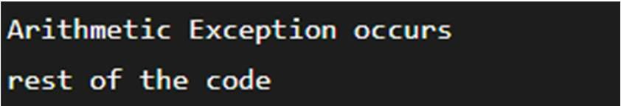}

}

By Jagadish Sahoo

**public class** MultipleCatchBlock2 {

**public static void** main(String[] args) {

**try**{

**int** a[]=**new int**[5];

System.out.println(a[10]);

}

**catch**(ArithmeticException e)

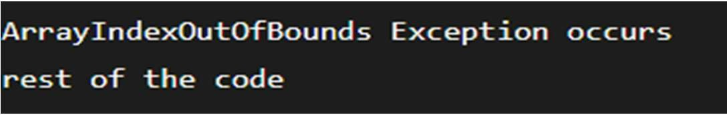{

System.out.println("Arithmetic Exception occurs");

}

**catch**(ArrayIndexOutOfBoundsException e)

{

System.out.println("ArrayIndexOutOfBounds Exception occurs");

}

**catch**(Exception e)

{

System.out.println("Parent Exception occurs");

}

System.out.println("rest of the code");

}

}

By Jagadish Sahoo

**public class** MultipleCatchBlock3 {

**public static void** main(String[] args) {

**try**{

**int** a[]=**new int**[5]; a[5]=30/0;

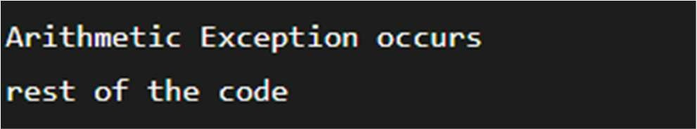System.out.println(a[10]);

}

**catch**(ArithmeticException e)

{

System.out.println("Arithmetic Exception occurs");

}

**catch**(ArrayIndexOutOfBoundsException e)

{

System.out.println("ArrayIndexOutOfBounds Exception occurs");

}

**catch**(Exception e)

{

System.out.println("Parent Exception occurs");

}

System.out.println("rest of the code");

}

}

By Jagadish Sahoo

public class MultipleCatchBlock4 { public static void main(String[] args) {

try{

String s=null; System.out.println(s.length());

}

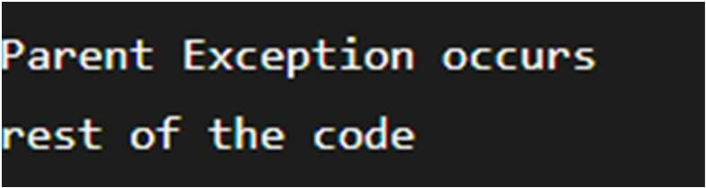catch(ArithmeticException e)

{

System.out.println("Arithmetic Exception occurs");

}

catch(ArrayIndexOutOfBoundsException e)

{

System.out.println("ArrayIndexOutOfBounds Exception occurs");

}

catch(Exception e)

{

System.out.println("Parent Exception occurs");

}

System.out.println("rest of the code");

}

}

class MultipleCatchBlock5{

public static void main(String args[]){ try{

int a[]=new int[5]; a[5]=30/0;

}

catch(Exception e){System.out.println("common task completed");} catch(ArithmeticException e){System.out.println("task1 is completed");} catch(ArrayIndexOutOfBoundsException e){System.out.println("task 2

completed");}

System.out.println("rest of the code...");

}

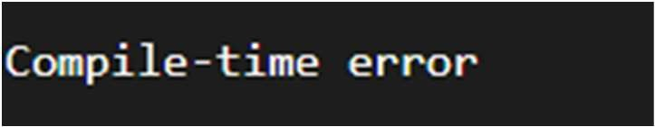}

## Java Nested try block

* In Java, using a try block inside another try block is permitted. It is called as nested try block.
* For example, the **inner try block** can be used to

handle **ArrayIndexOutOfBoundsException** while the **outer try block** can handle the **ArithemeticException** (division by zero).

* Sometimes a situation may arise where a part of a block may cause one error and the entire block itself may cause another error. In such cases, exception handlers have to be nested.

try

{

statement 1;

statement 2; try

{

try

}

}

statement 3;

statement 4;

{

statement 5;

statement 6;

catch(Exception e2)

{

}

catch(Exception e1)

{

}

}

//catch block of parent (outer) try block catch(Exception e3)

{

}

....

public class NestedTryBlock{

public static void main(String args[]){

//outer try block try{

//inner try block 1 try{

System.out.println("going to divide by 0"); int b =39/0;

}

//catch block of inner try block 1 catch(ArithmeticException e)

{

System.out.println(e);

}

//inner try block 2 try{

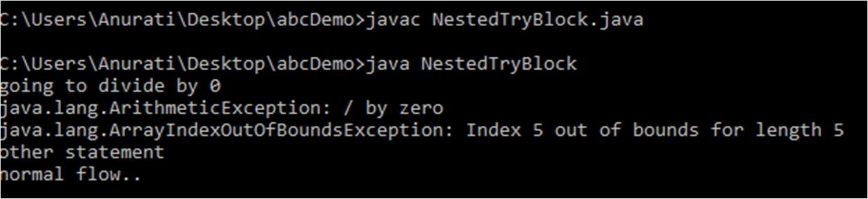int a[]=new int[5];

//assigning the value out of array bounds a[5]=4;

}

//catch block of inner try block 2 catch(ArrayIndexOutOfBoundsException e)

{

System.out.println(e);

}

System.out.println("other statement");

}

//catch block of outer try block catch(Exception e)

{

System.out.println("handled the exception (outer catch)");

}

System.out.println("normal flow..");

}

}

* When any try block does not have a catch block for a particular exception, then the catch block of the outer (parent) try block are checked for that exception, and if it matches, the catch block of outer try block is executed.
* If none of the catch block specified in the code is unable to handle the exception, then the Java runtime system will handle the exception. Then it displays the system generated message for that exception.

#### Example

* Here the try block within nested try block (inner try block 2) do not handle the exception. The control is then transferred to its parent try block (inner try block 1). If it does not handle the exception, then the control is transferred to the main try block (outer try block) where the appropriate catch block handles the exception. It is termed as nesting.

**public class** NestedTryBlock2 {

**public static void** main(String args[])

{

// outer (main) try block

**try** {

//inner try block 1

**try** {

// inner try block 2

**try** {

**int** arr[] = { 1, 2, 3, 4 };

//printing the array element out of its bounds System.out.println(arr[10]);

}

// to handles ArithmeticException catch (ArithmeticException e) {

System.out.println("Arithmetic exception"); System.out.println(" inner try block 2");

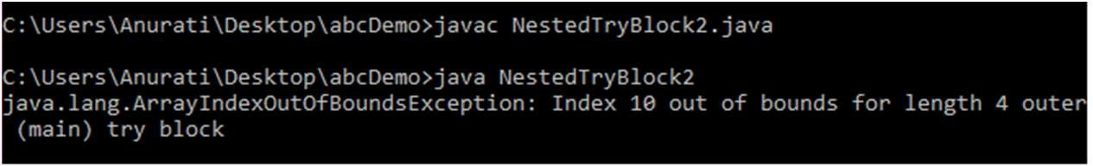}

}

// to handle ArithmeticException

catch (ArithmeticException e) { System.out.println("Arithmetic exception"); System.out.println("inner try block 1");

}

}

// to handle ArrayIndexOutOfBoundsException

catch (ArrayIndexOutOfBoundsException e4) { System.out.print(e4);

System.out.println(" outer (main) try block");

}

catch (Exception e5) { System.out.print("Exception"); System.out.println(" handled in main try-block");

}

}

}

#### Java finally block

* + **Java finally block** is a block used to execute important code such as closing the connection, etc.
  + Java finally block is always executed whether an exception is handled or not. Therefore, it contains all the necessary statements that need to be printed regardless of the exception occurs or not.
  + The finally block follows the try-catch block.

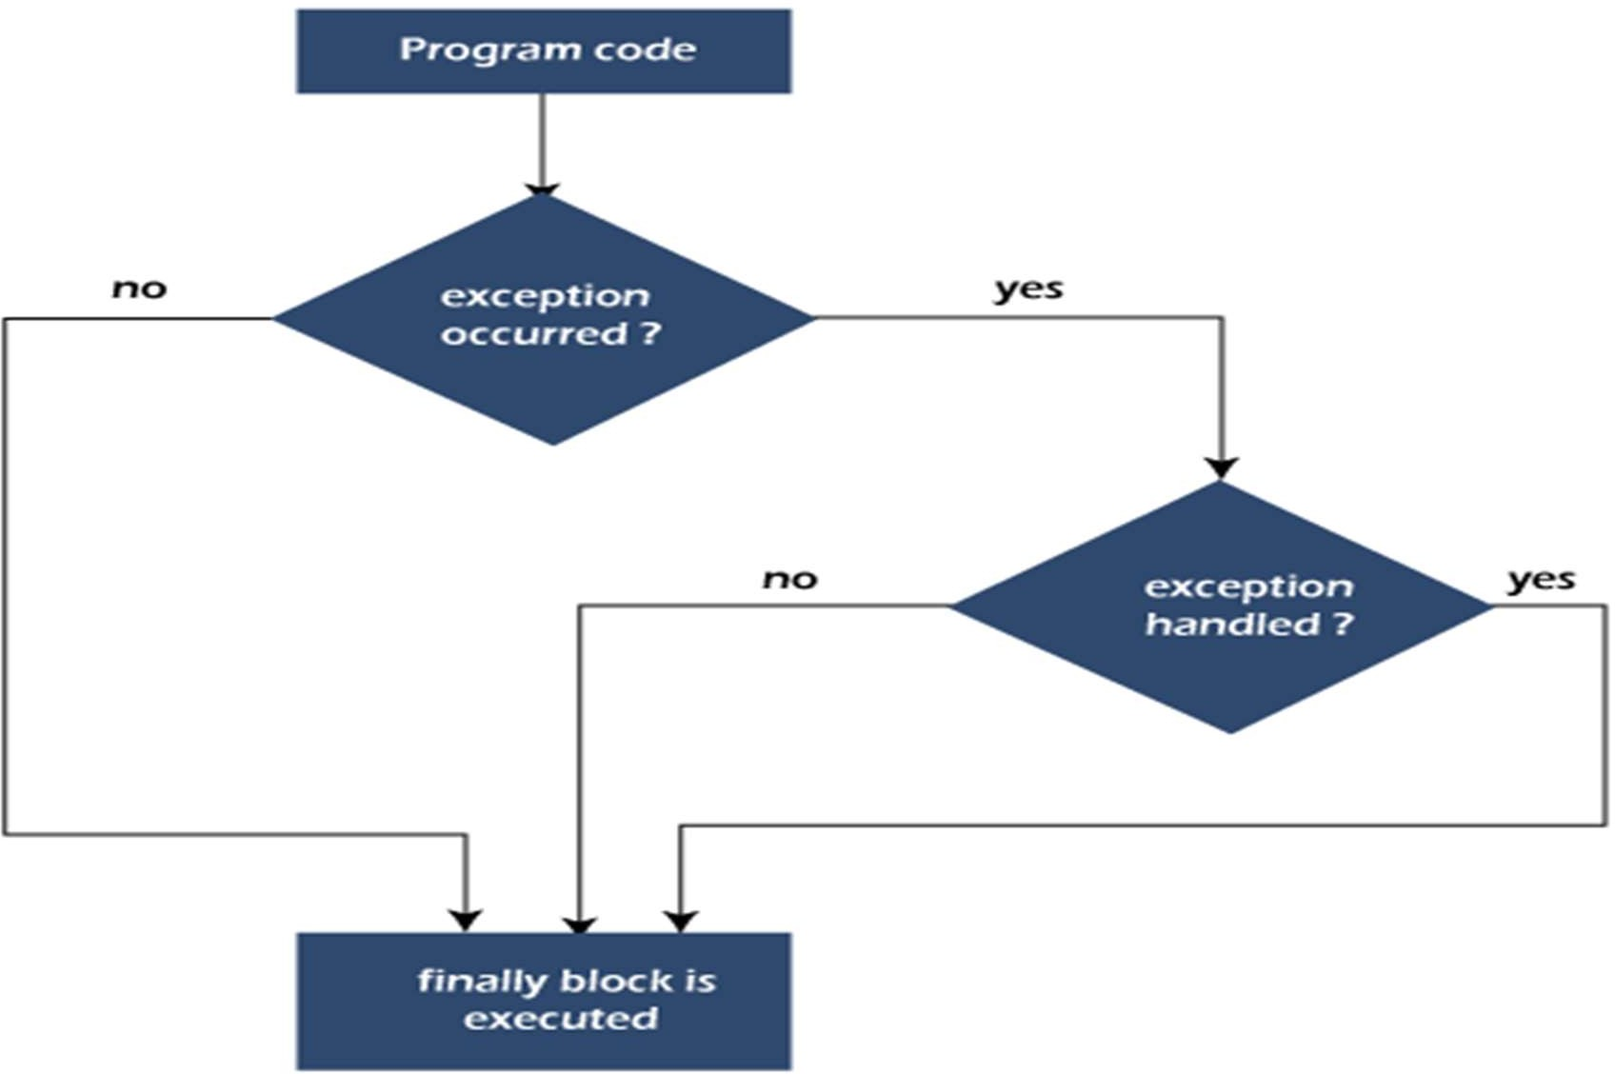

## Why use Java finally block?

* + finally block in Java can be used to put "**cleanup**" code such as closing a file, closing connection, etc.
  + The important statements to be printed can be placed in the finally block.

#### Case 1: When an exception does not occur

class TestFinallyBlock {

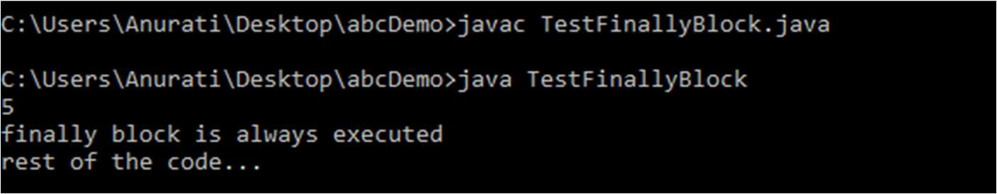public static void main(String args[]){ try{

//below code do not throw any exception int data=25/5;

System.out.println(data);

}

//catch won't be executed catch(NullPointerException e){ System.out.println(e);

}

//executed regardless of exception occurred or not finally {

System.out.println("finally block is always executed");

}

System.out.println("rest of phe code...");

Case 2: When an exception occurr but not handled by the catch block

public class TestFinallyBlock1{

public static void main(String args[]){ try {

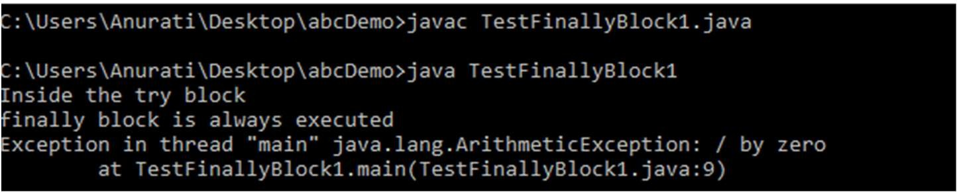System.out.println("Inside the try block");

//below code throws divide by zero exception

int data=25/0; System.out.println(data);

}

//cannot handle Arithmetic type exception

//can only accept Null Pointer type exception catch(NullPointerException e){ System.out.println(e);

}

//executes regardless of exception occured or not

finally {

System.out.println("finally block is always executed");

}

System.out.println("rest of the code...");

Case 3: When an exception occurs and is handled by the catch block

public class TestFinallyBlock2{

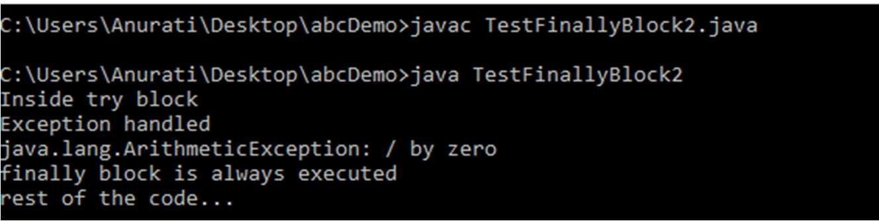public static void main(String args[]){ try {

System.out.println("Inside try block");

//below code throws divide by zero exception int data=25/0;

System.out.println(data);

}

//handles the Arithmetic Exception / Divide by zero exception catch(ArithmeticException e){

System.out.println("Exception handled"); System.out.println(e);

}

//executes regardless of exception occured or not

finally {

System.out.println("finally block is always executed");

}

System.out.println("rest of the code...");

#### Java throw Exception

* + In Java, exceptions allows us to write good quality codes where the errors are checked at the compile time instead of runtime and we can create custom exceptions making the code recovery and debugging easier.
  + The Java throw keyword is used to throw an exception explicitly.
  + We specify the **exception** object which is to be thrown. The Exception has some message with it that provides the error description. These exceptions may be related to user inputs, server, etc.
  + We can throw either checked or unchecked exceptions in Java by throw keyword. It is mainly used to throw a custom exception.
  + We can also define our own set of conditions and throw an exception explicitly using throw keyword.
  + For example, we can throw ArithmeticException if we divide a number by another number. Here, we just need to set the condition and throw exception using throw keyword.
  + The syntax of the Java throw keyword is **throw new** exception_class("error message"); **throw new** IOException("sorry device error");

#### Example 1: Throwing Unchecked Exception

In this example, we have created a method named validate() that accepts an integer as a parameter. If the age is less than 18, we are throwing the ArithmeticException otherwise print a message welcome to vote.

**public class** TestThrow1 {

//function to check if person is eligible to vote or not

**public static void** validate(**int** age) {

**if**(age<18) {

//throw Arithmetic exception if not eligible to vote

**throw new** ArithmeticException("Person is not eligible to vote");

}

**else** {

System.out.println("Person is eligible to vote!!");

}

}

//main method

**public static void** main(String args[]){

//calling the function validate(13);

System.out.println("rest of the code...");

}

}

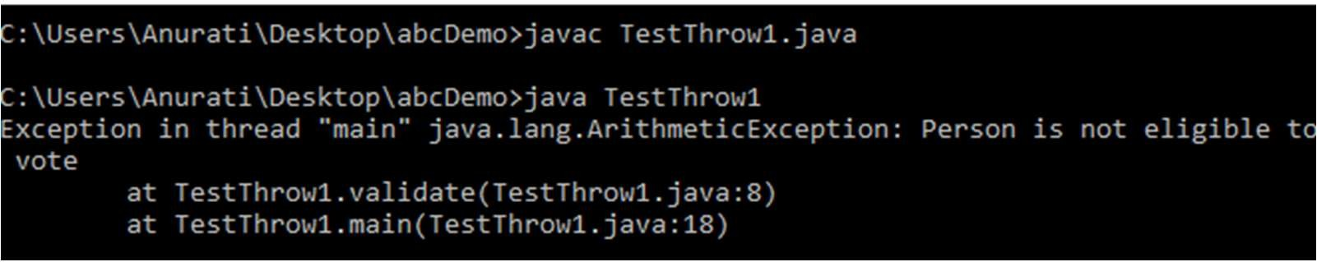

By Jagadish Sahoo

#### Example 2: Throwing Checked Exception

**import** java.io.*;

**public class** TestThrow2 {

**public static void** method() **throws** FileNotFoundException {

FileReader file = **new** FileReader("C:\\Users\\Anurati\\Desktop\\abc.txt"); BufferedReader fileInput = **new** BufferedReader(file);

**throw new** FileNotFoundException();

}

//main method

**public static void** main(String args[]){

**try**

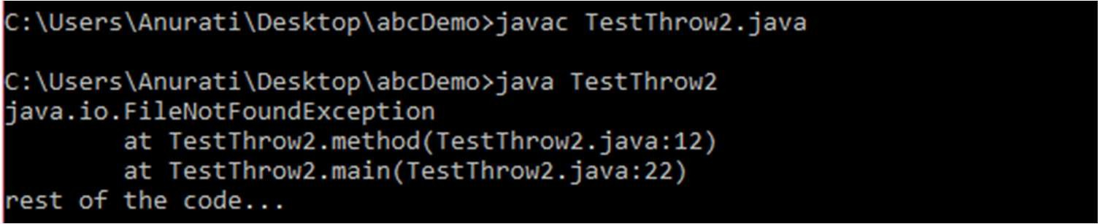{

method();

}

**catch** (FileNotFoundException e)

{

e.printStackTrace();

}

System.out.println("rest of the code...");

#### Example 3: Throwing User-defined Exception

* // class represents user-defined exception class UserDefinedException extends Exception

{

public UserDefinedException(String str)

{

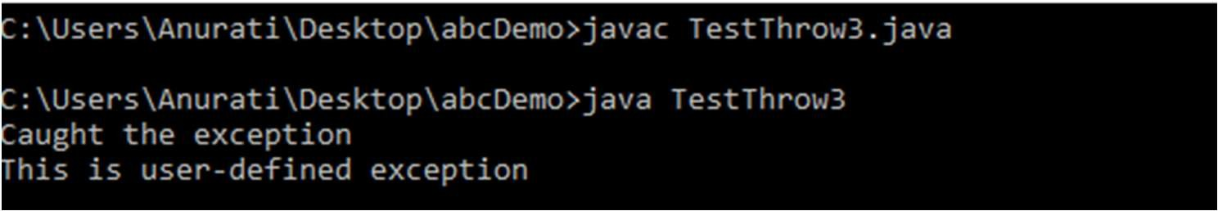// Calling constructor of parent Exception super(str);

}

}

// Class that uses above MyException public class TestThrow3

{

public static void main(String args[])

{

try

{

// throw an object of user defined exception

throw new UserDefinedException("This is user-defined exception");

}

catch (UserDefinedException ude)

{

System.out.println("Caught the exception");

// Print the message from MyException object System.out.println(ude.getMessage());

}

#### Java throws keyword

* + The **Java throws keyword** is used to declare an exception. It gives an information to the programmer that there may occur an exception. So, it is better for the programmer to provide the exception handling code so that the normal flow of the program can be maintained.
  + Exception Handling is mainly used to handle the checked exceptions. If there occurs any unchecked exception such as NullPointerException, it is programmers' fault that he is not checking the code before it being used.

Syntax of Java throws

return_type method_name() **throws** exception_class_name{

//method code

}

**Which exception should be declared? Ans:** Checked exception only, because:

**unchecked exception:** under our control so we can correct our code.

**error:** beyond our control. For example, we are unable to do anything if there occurs VirtualMachineError or StackOverflowError.

## 2 cases of throws

**Case 1:** We have caught the exception i.e. we have handled the exception using try/catch block.

**Case 2:** We have declared the exception i.e. specified throws keyword with the method.

#### Case 1: Handle Exception Using try-catch block

**import** java.io.*;

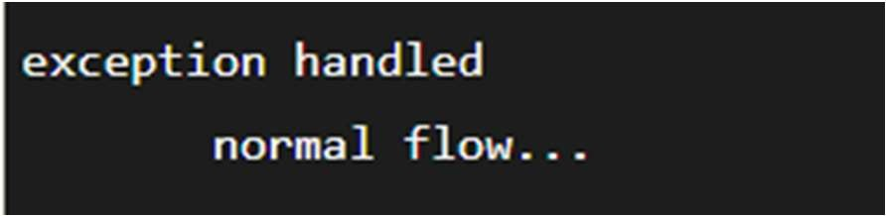**class** M{

**void** method()**throws** IOException{

**throw new** IOException("device error");

}

}

**public class** Testthrows2{

**public static void** main(String args[]){

**try**{

M m=**new** M(); m.method();

}**catch**(Exception e){System.out.println("exception handled");}

System.out.println("normal flow...");

}

}

## Case 2: Declare Exception

* + In case we declare the exception, if exception does not occur, the code will be executed fine.
  + In case we declare the exception and the exception occurs, it will be thrown at runtime because **throws** does not handle the exception.

1. ***If exception does not occur***

import java.io.*; class M{

void method()throws IOException{ System.out.println("device operation performed");

}

}

class Testthrows3{

public static void main(String args[])throws IOException{//declare exception M m=new M();

m.method();

System.out.println("normal flow...");

}

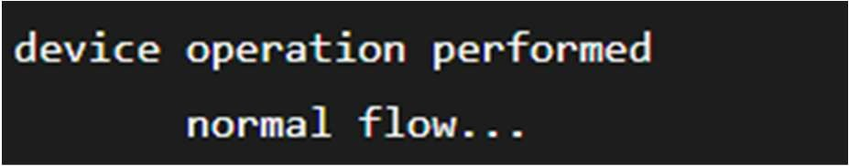

By Jagadish Sahoo

}

1. ***If exception occurs***

**import** java.io.*;

**class** M{

**void** method()**throws** IOException{

**throw new** IOException("device error");

}

}

**class** Testthrows4{

**public static void** main(String args[])**throws** IOException{//declare exception M m=**new** M();

m.method();

System.out.println("normal flow...");

}

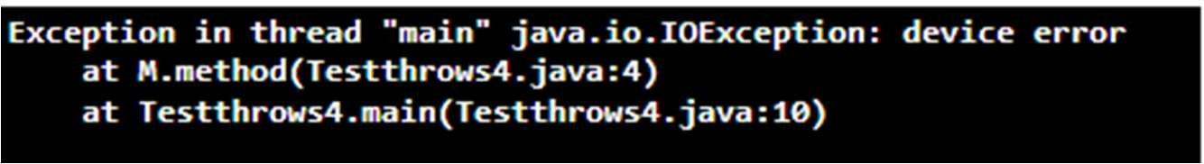

By Jagadish Sahoo

}

Difference between throw and throws

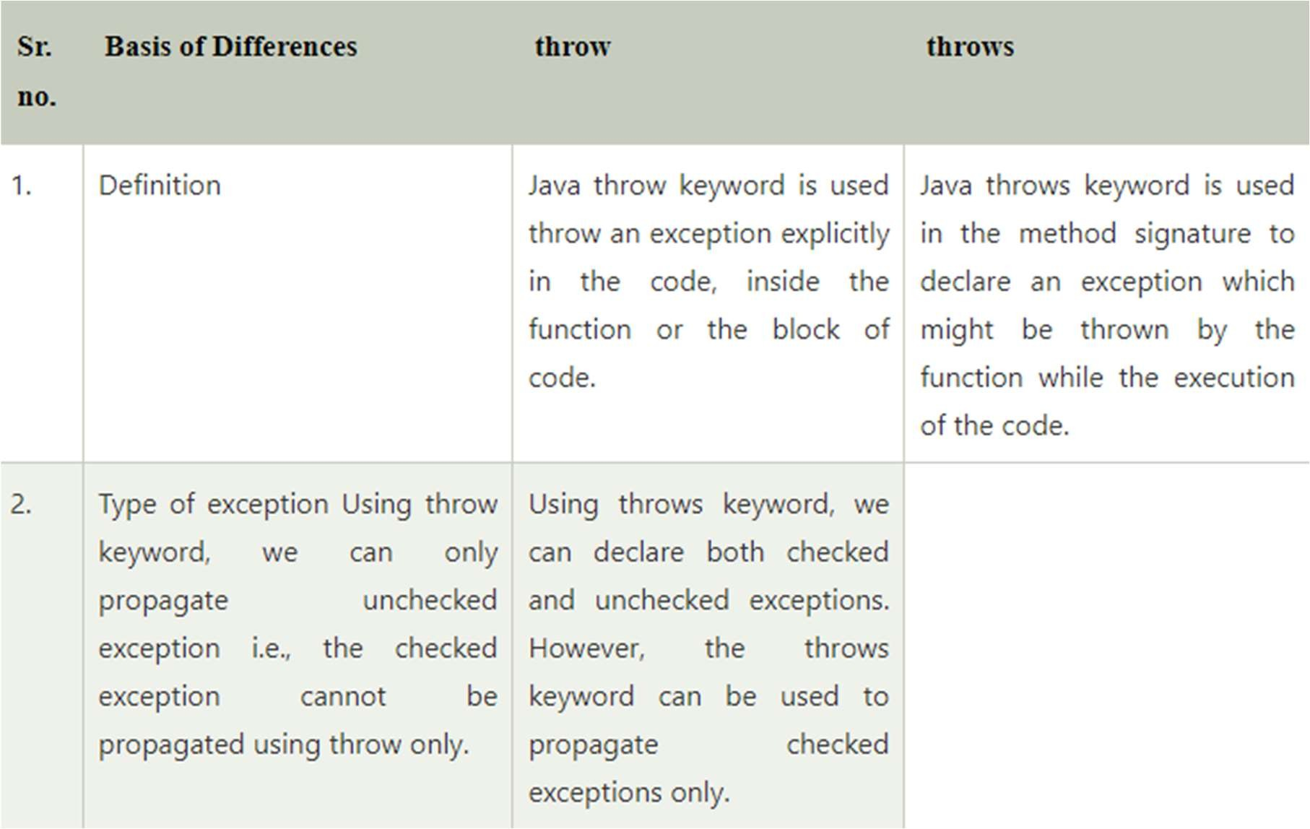

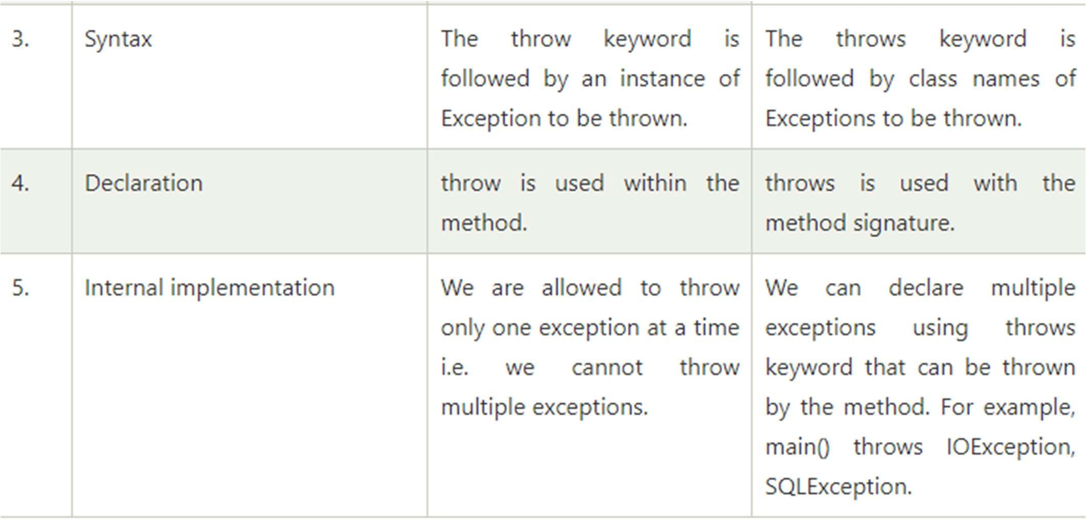

## Java throw Example

public class TestThrow {

//defining a method

public static void checkNum(int num) { if (num < 1) {

throw new ArithmeticException("\nNumber is negative, cannot calculate square");

}

else {

System.out.println("Square of " + num + " is " + (num*num));

}

}

//main method

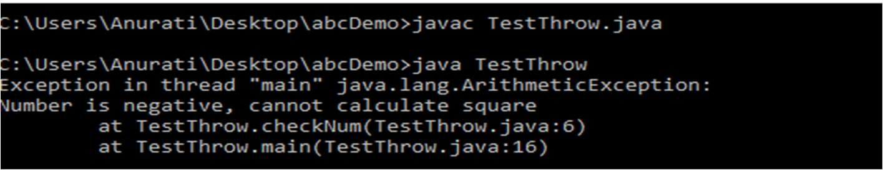public static void main(String[] args) { TestThrow obj = new TestThrow(); obj.checkNum(-3); System.out.println("Rest of the code..");

}

}

#### Java throws Example

**public class** TestThrows {

//defining a method

**public static int** divideNum(**int** m, **int** n) **throws** ArithmeticException {

**int** div = m / n;

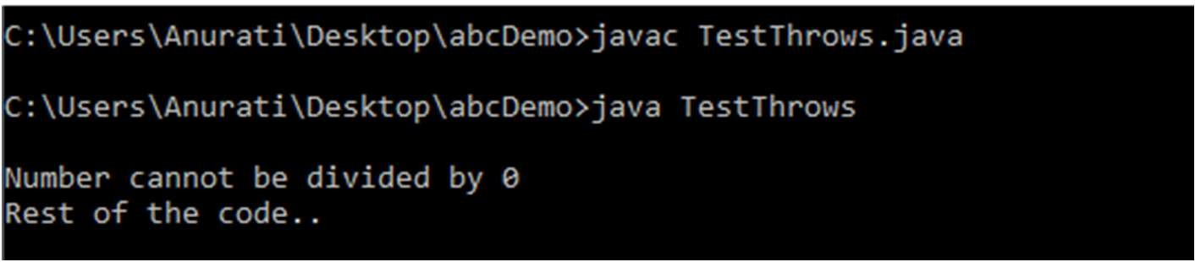**return** div;

}

//main method

**public static void** main(String[] args) { TestThrows obj = **new** TestThrows(); **try** {

System.out.println(obj.divideNum(45, 0));

}

**catch** (ArithmeticException e){ System.out.println("\nNumber cannot be divided by 0");

}

System.out.println("Rest of the code..");

}

}

#### Java throw and throws Example

**public class** TestThrowAndThrows

{

// defining a user-defined method

// which throws ArithmeticException

**static void** method() **throws** ArithmeticException

{

System.out.println("Inside the method()");

**throw new** ArithmeticException("throwing ArithmeticException");

}

//main method

**public static void** main(String args[])

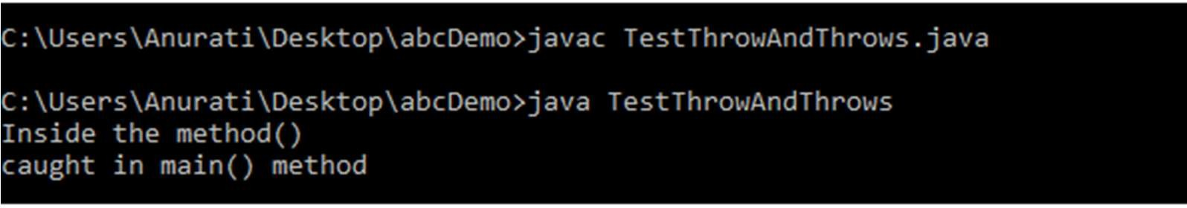{

**try**

{

method();

}

**catch**(ArithmeticException e)

{

System.out.println("caught in main() method");

}

}

} By Jagadish Sahoo

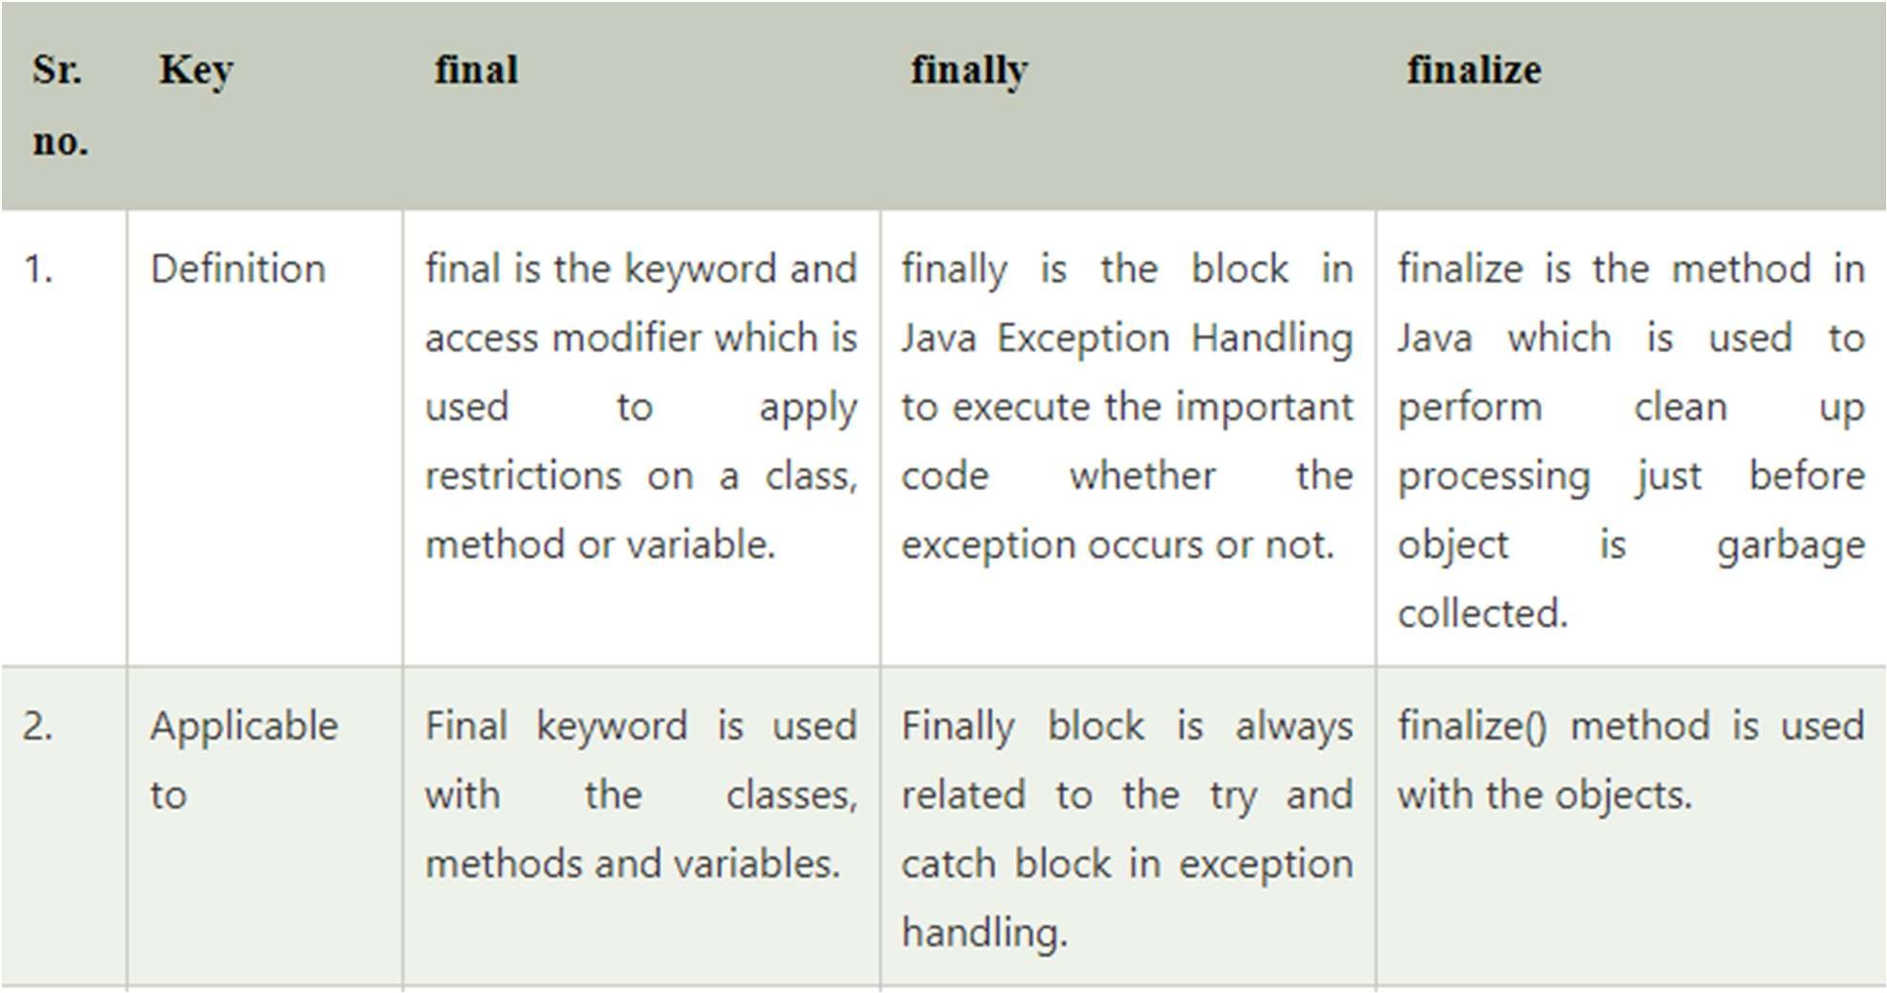Difference between final, finally and finalize

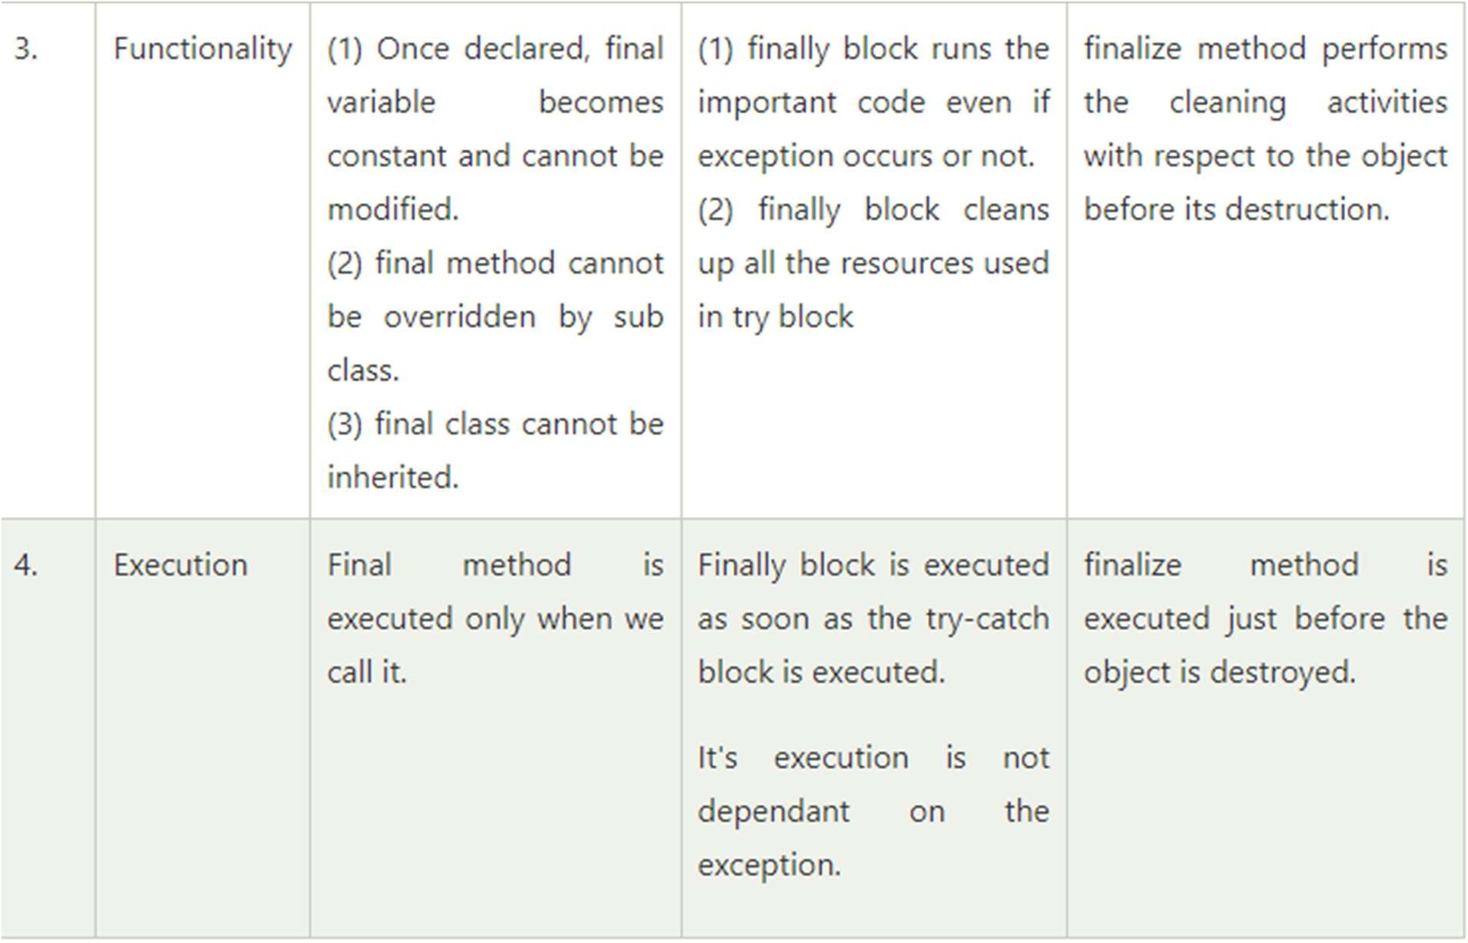

## Java finalize Example

**public class** FinalizeExample {

**public static void** main(String[] args)

{

FinalizeExample obj = **new** FinalizeExample();

// printing the hashcode System.out.println("Hashcode is: " + obj.hashCode()); obj = **null**;

// calling the garbage collector using gc() System.gc();

System.out.println("End of the garbage collection");

}

// defining the finalize method

**protected void** finalize()

{

System.out.println("Called the finalize() method");

}

}

#### Java Custom Exception

* + In Java, we can create our own exceptions that are derived classes of the Exception class.
  + Creating our own Exception is known as custom exception or user- defined exception.
  + Basically, Java custom exceptions are used to customize the exception according to user need.
  + Using the custom exception, we can have your own exception and message. Here, we have passed a string to the constructor of superclass i.e. Exception class that can be obtained using getMessage() method on the object we have created.

## Why use custom exceptions?

* + Java exceptions cover almost all the general type of exceptions that may occur in the programming.
  + However, we sometimes need to create custom exceptions.

1. To catch and provide specific treatment to a subset of existing Java exceptions.
2. Business logic exceptions: These are the exceptions related to business logic and workflow. It is useful for the application users or the developers to understand the exact problem.
   * In order to create custom exception, we need to extend Exception class that belongs to java.lang package.

**public class** WrongFileNameException **extends** Exception { **public** WrongFileNameException(String errorMessage) { **super**(errorMessage);

}

}

Note: We need to write the constructor that takes the String as the error message and it is called parent class constructor.

// class representing custom exception

class InvalidAgeException extends Exception

{

public InvalidAgeException (String str)

{

// calling the constructor of parent Exception super(str);

}

}

// class that uses custom exception InvalidAgeException public class TestCustomException1

{

// method to check the age

static void validate (int age) throws InvalidAgeException{ if(age < 18){

// throw an object of user defined exception

throw new InvalidAgeException("age is not valid to vote");

}

else {

System.out.println("welcome to vote");

}

}

// main method

public static void main(String args[])

{

try

{

// calling the method validate(13);

}

catch (InvalidAgeException ex)

{

System.out.println("Caught the exception");

// printing the message from InvalidAgeException object System.out.println("Exception occured: " + ex);

}

System.out.println("rest of the code...");

}

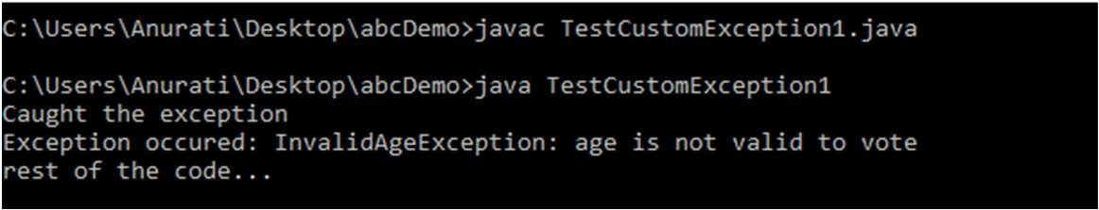

By Jagadish Sahoo

}

// class representing custom exception

class MyCustomException extends Exception

{

}

// class that uses custom exception MyCustomException public class TestCustomException2

{

// main method

public static void main(String args[])

{

The constructor of Exception class can be called without using a parameter and calling super() method is not mandatory.

try

{

// throw an object of user defined exception throw new MyCustomException();

}

catch (MyCustomException ex)

{

System.out.println("Caught the exception"); System.out.println(ex.getMessage());

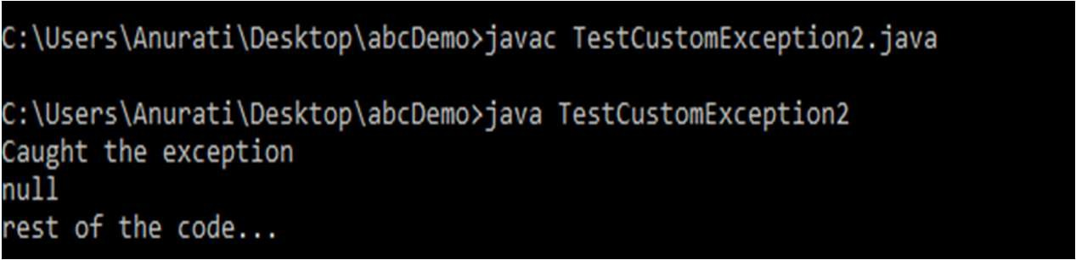

By Jagadish Sahoo

}

System.out.println("rest of the code...");

}

}

## Multithreading in Java

* + **Multithreading in Java** is a process of executing multiple threads simultaneously.
  + A thread is a lightweight sub-process, the smallest unit of processing. Multiprocessing and multithreading, both are used to achieve multitasking.
  + However, we use multithreading than multiprocessing because threads use a shared memory area. They don't allocate separate memory area so saves memory, and context-switching between the threads takes less time than process.
  + Java Multithreading is mostly used in games, animation, etc.

## Advantages of Java Multithreading

* + It **doesn't block the user** because threads are independent and you can perform multiple operations at the same time.
  + You can perform many operations together, so it saves time.
  + Threads are **independent**, so it doesn't affect other threads if an exception occurs in a single thread.

Multitasking

* + Multitasking is a process of executing multiple tasks simultaneously. We use multitasking to utilize the CPU. Multitasking can be achieved in two ways:

1. Process-based Multitasking (Multiprocessing)
2. Thread-based Multitasking (Multithreading)

#### Process-based Multitasking (Multiprocessing)

* Each process has an address in memory. In other words, each process allocates a separate memory area.
* A process is heavyweight.
* Cost of communication between the process is high.
* Switching from one process to another requires some time for saving and loading registers, memory maps, updating lists, etc.

## Thread-based Multitasking (Multithreading)

* + Threads share the same address space.
  + A thread is lightweight.
  + Cost of communication between the thread is low.

## What is Thread in java

* + A thread is a lightweight subprocess, the smallest unit of processing. It is a separate path of execution.
  + Threads are independent. If there occurs exception in one thread, it doesn't affect other threads. It uses a shared memory area.

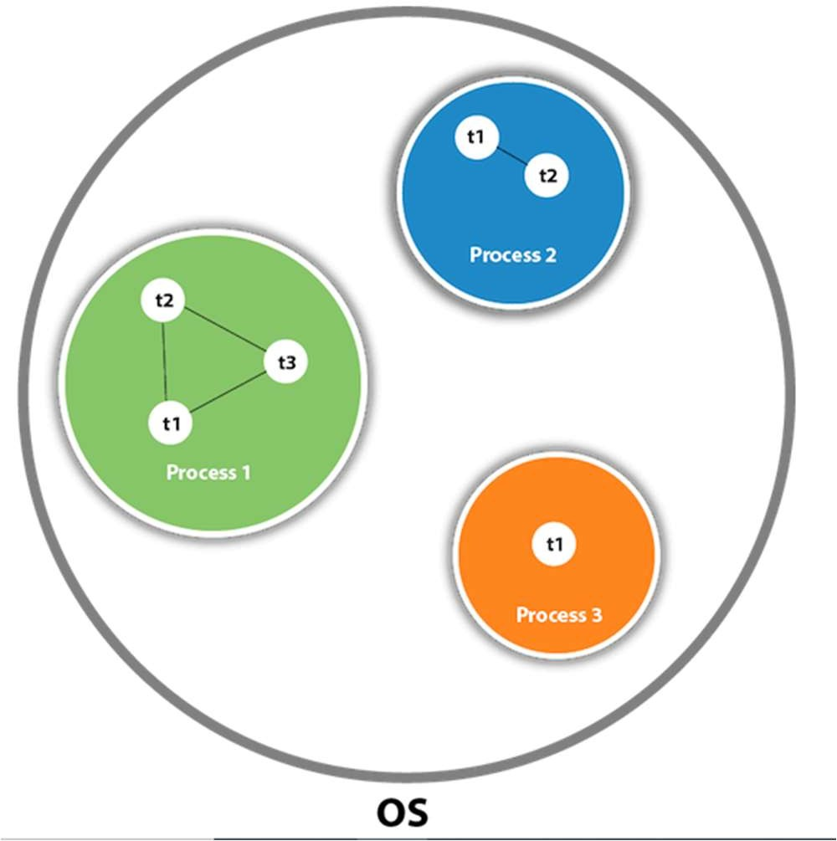

A thread is executed inside the process. There is context-switching between the threads. There can be multiple processes inside the OS, and one process can have multiple threads.

#### Java Thread class

* + Java provides **Thread class** to achieve thread programming.
  + Thread class provides constructors and methods to create and perform operations on a thread.
  + Thread class extends Object class and implements Runnable interface.

#### Java Thread Methods

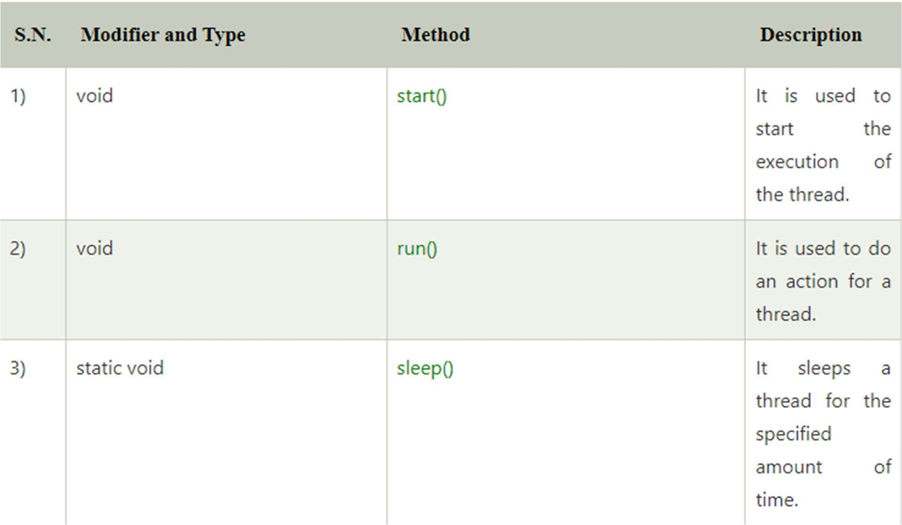

By Jagadish Sahoo

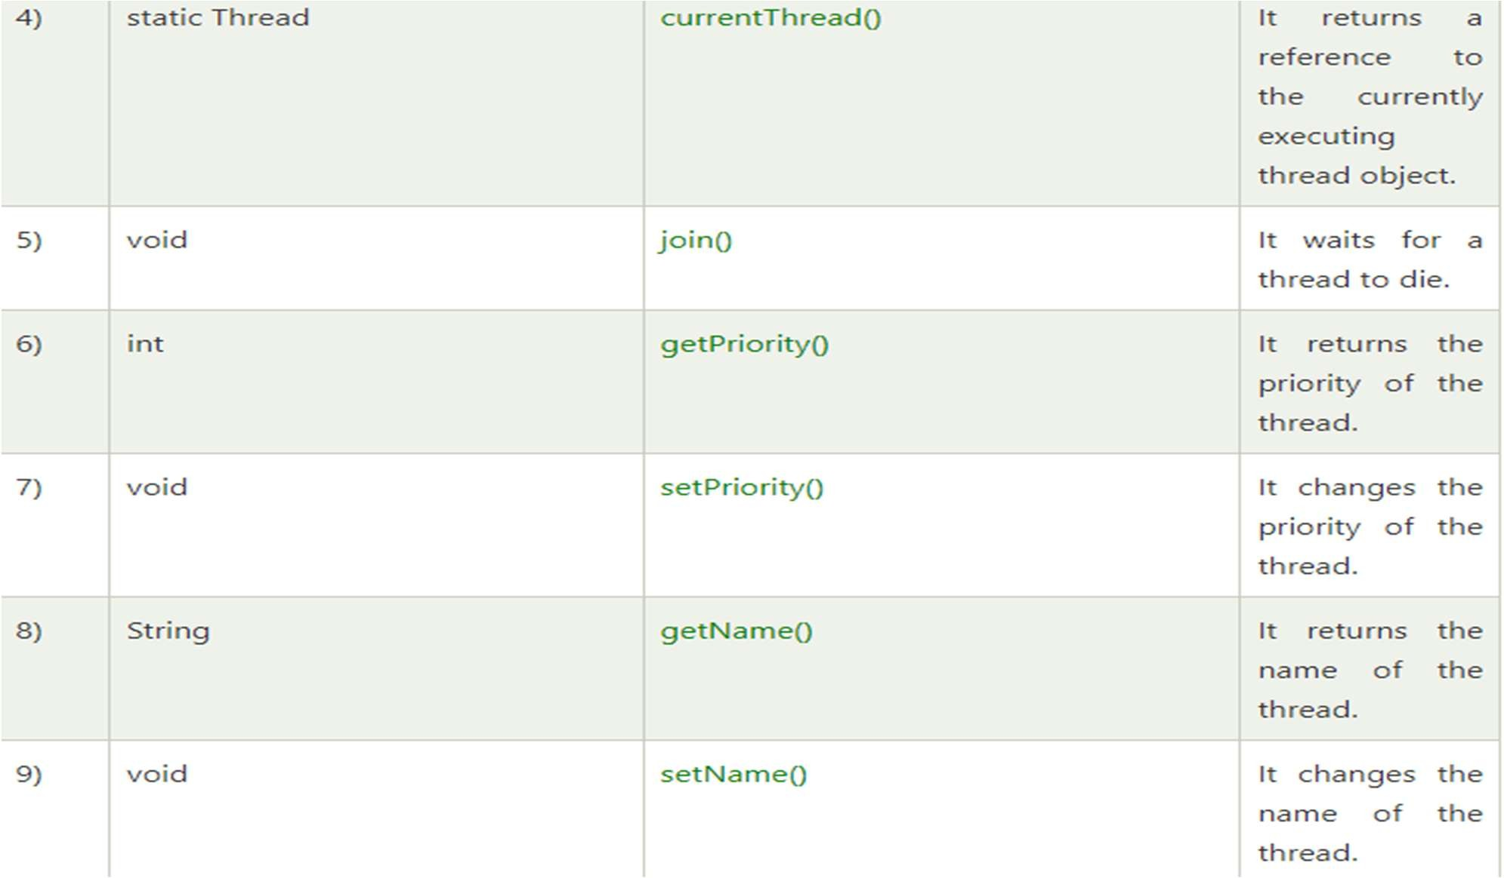

By Jagadish Sahoo

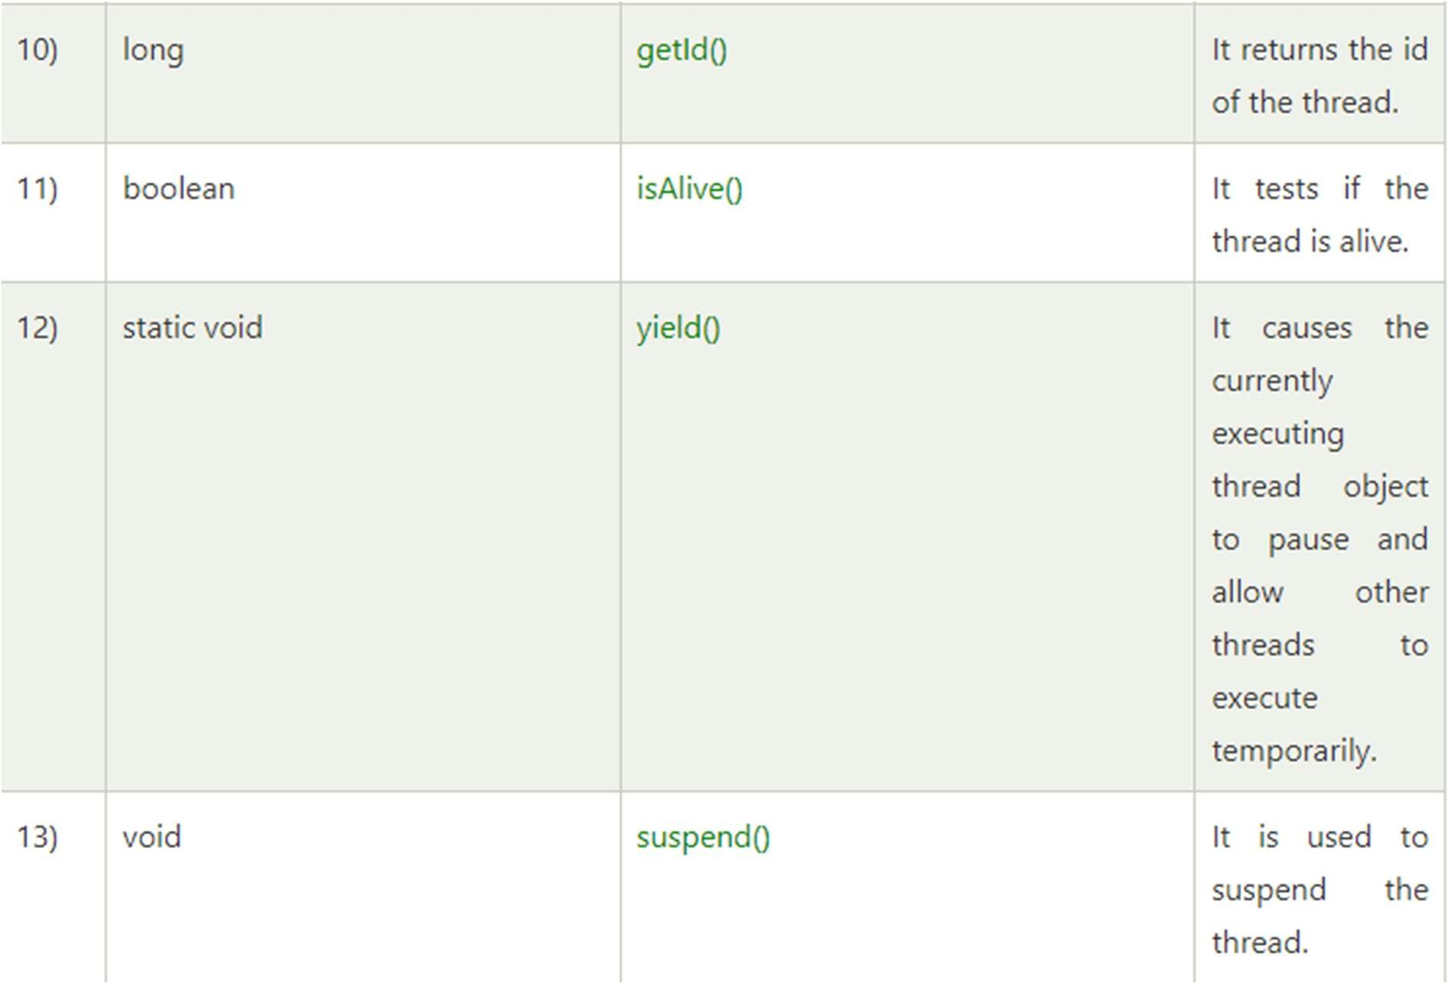By Jagadish Sahoo

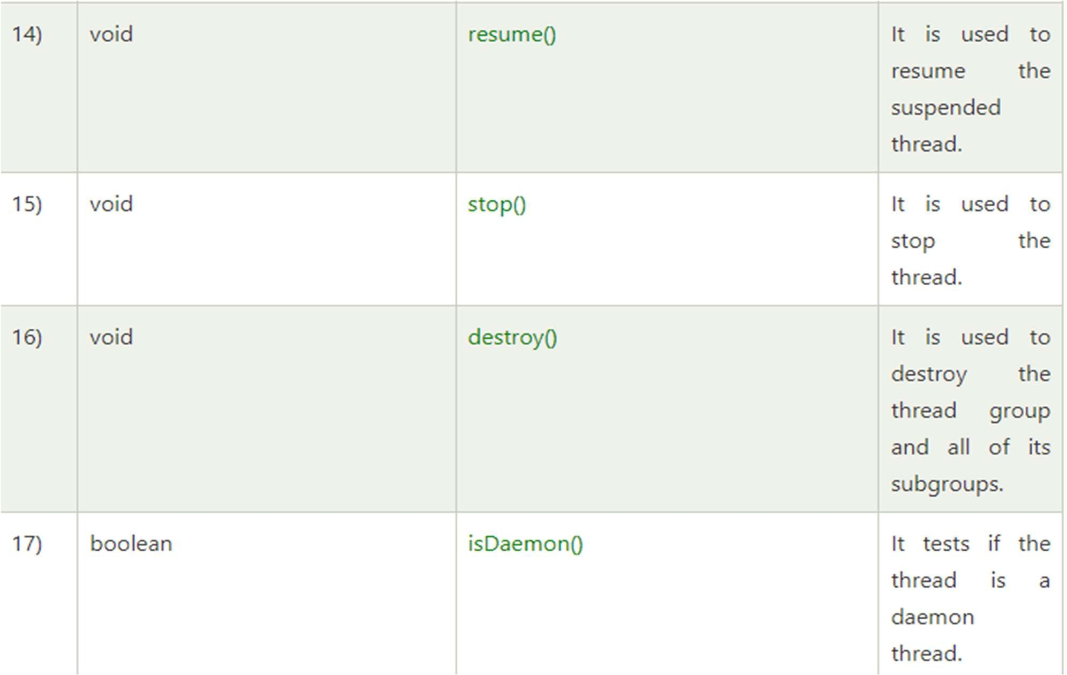By Jagadish Sahoo

#### Life cycle of a Thread (Thread States)

* + A thread can be in one of the five states.
  + According to sun, there is only 4 states in **thread life cycle in java** new, runnable, non-runnable and terminated. There is no running state.
  + The life cycle of the thread in java is controlled by JVM. The java thread states are as follows:

1. New
2. Runnable
3. Running
4. Non-Runnable (Blocked)
5. Terminated

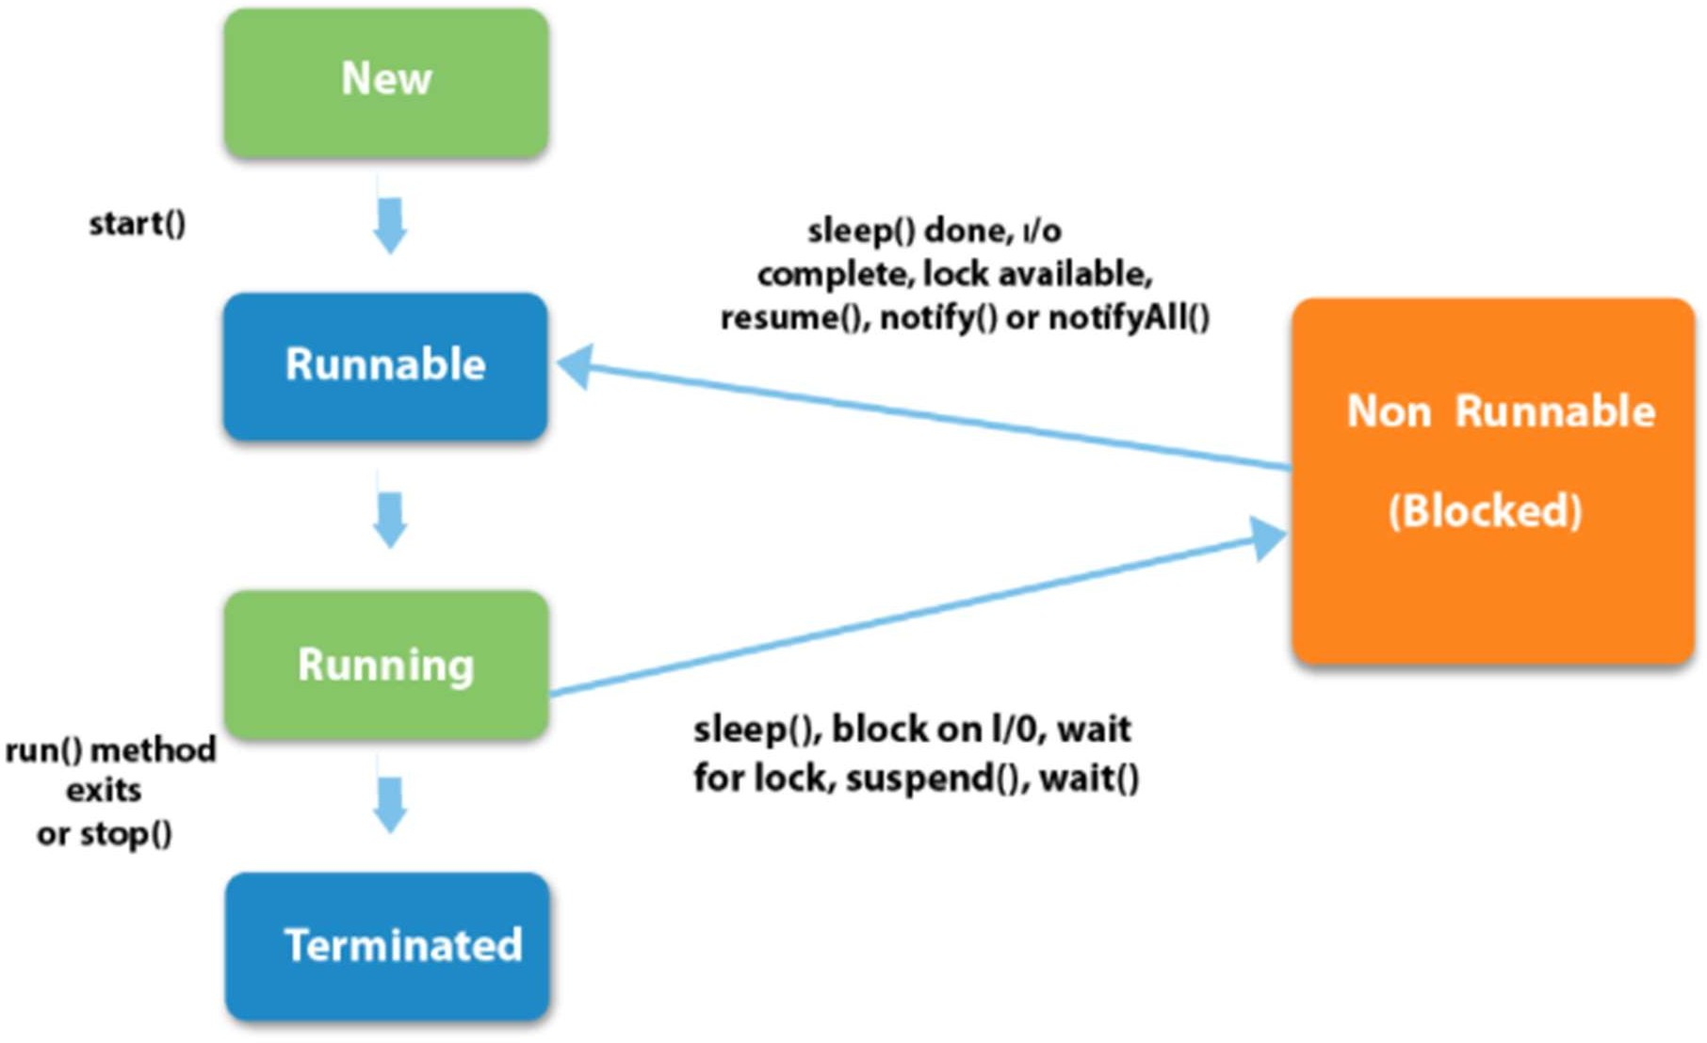

1. New

The thread is in new state if you create an instance of Thread class but before the invocation of start() method.

1. Runnable

The thread is in runnable state after invocation of start() method, but the thread scheduler has not selected it to be the running thread.

1. Running

The thread is in running state if the thread scheduler has selected it.

1. Non-Runnable (Blocked)

This is the state when the thread is still alive, but is currently not eligible to run.

1. Terminated

A thread is in terminated or dead state when its run() method exits.

#### How to create thread

* + There are two ways to create a thread:

1. By extending Thread class
2. By implementing Runnable interface.

#### Thread class:

* + Thread class provide constructors and methods to create and perform operations on a thread. Thread class extends Object class and implements Runnable interface.
  + Commonly used Constructors of Thread class:

1. Thread()
2. Thread(String name)
3. Thread(Runnable r)
4. Thread(Runnable r, String name)

#### Commonly used methods of Thread class:

* + **public void run():** is used to perform action for a thread.
  + **public void start():** starts the execution of the thread.JVM calls the run() method on the thread.
  + **public void sleep(long miliseconds):** Causes the currently executing thread to sleep (temporarily cease execution) for the specified number of milliseconds.
  + **public void join():** waits for a thread to die.
  + **public void join(long miliseconds):** waits for a thread to die for the specified miliseconds.
  + **public int getPriority():** returns the priority of the thread.
  + **public int setPriority(int priority):** changes the priority of the thread.
  + **public String getName():** returns the name of the thread.
  + **public void setName(String name):** changes the name of the thread.
  + **public Thread currentThread():** returns the reference of currently executing thread.
  + public int getId(): returns the id of the thread.
  + public Thread.State getState(): returns the state of the thread.
  + public boolean isAlive(): tests if the thread is alive.
  + public void yield(): causes the currently executing thread object to temporarily pause and allow other threads to execute.
  + public void suspend(): is used to suspend the thread(depricated).
  + public void resume(): is used to resume the suspended thread(depricated).
  + public void stop(): is used to stop the thread(depricated).
  + public boolean isDaemon(): tests if the thread is a daemon thread.
  + public void setDaemon(boolean b): marks the thread as daemon or user thread.
  + public void interrupt(): interrupts the thread.
  + public boolean isInterrupted(): tests if the thread has been interrupted.
  + public static boolean interrupted(): tests if the current thread has been interrupted.

## Runnable interface:

* + The Runnable interface should be implemented by any class whose instances are intended to be executed by a thread. Runnable interface have only one method named run().

1. public void run(): is used to perform action for a thread.

Starting a thread:

start() method of Thread class is used to start a newly created thread. It performs following tasks:

* A new thread starts.
* The thread moves from New state to the Runnable state.
* When the thread gets a chance to execute, its target run() method will run.

Java Thread Example by extending Thread class

class Multi extends Thread{ public void run(){

System.out.println("thread is running...");

}

public static void main(String args[]){ Multi t1=new Multi();

t1.start();

}

}

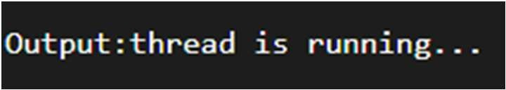

#### Java Thread Example by implementing Runnable interface

class Multi3 implements Runnable{ public void run(){ System.out.println("thread is running...");

}

public static void main(String args[]){ Multi3 m1=new Multi3();

Thread t1 =new Thread(m1); t1.start();

}

}

#### Thread Scheduler in Java

* + **Thread scheduler** in java is the part of the JVM that decides which thread should run.
  + There is no guarantee that which runnable thread will be chosen to run by the thread scheduler.
  + Only one thread at a time can run in a single process.
  + The thread scheduler mainly uses preemptive or time slicing scheduling to schedule the threads.

#### Difference between preemptive scheduling and time slicing

* + Under preemptive scheduling, the highest priority task executes until it enters the waiting or dead states or a higher priority task comes into existence.
  + Under time slicing, a task executes for a predefined slice of time and then reenters the pool of ready tasks. The scheduler then determines which task should execute next, based on priority and other factors.

## Sleep method in java

* + The sleep() method of Thread class is used to sleep a thread for the specified amount of time.

Syntax of sleep() method

The Thread class provides two methods for sleeping a thread:

1. public static void sleep(long miliseconds)throws InterruptedException
2. public static void sleep(long miliseconds, int nanos)throws InterruptedException

**class** TestSleepMethod1 **extends** Thread{

**public void** run(){

**for**(**int** i=1;i<5;i++){

**try**{Thread.sleep(500);} **catch**(InterruptedException e){System.out.println(e);}

System.out.println(i);

}

}

**public static void** main(String args[]){ TestSleepMethod1 t1=**new** TestSleepMethod1(); TestSleepMethod1 t2=**new** TestSleepMethod1();

t1.start();

t2.start();

}

}

**Note : At a time only one thread is executed. If you sleep a thread for the specified time, the thread scheduler picks up another thread and so on.**

## Can we start a thread twice

* + No. After starting a thread, it can never be started again. If you does so,

an *IllegalThreadStateException* is thrown. In such case, thread will run once but for second time, it will throw exception.

**public class** TestThreadTwice1 **extends** Thread{ **public void** run(){ System.out.println("running...");

}

**public static void** main(String args[]){ TestThreadTwice1 t1=**new** TestThreadTwice1(); t1.start();

t1.start();

}

}

#### What if we call run() method directly instead start() method?

* + Each thread starts in a separate call stack.
  + Invoking the run() method from main thread, the run() method goes onto the current call stack rather than at the beginning of a new call stack.

**class** TestCallRun1 **extends** Thread{ **public void** run(){ System.out.println("running...");

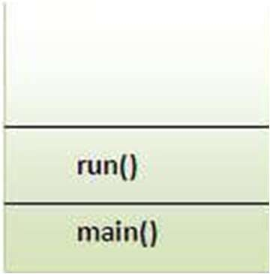}

**public static void** main(String args[]){ TestCallRun1 t1=**new** TestCallRun1();

t1.run();//fine, but does not start a separate call stack

}

}

## Problem if you direct call run() method

**class** TestCallRun2 **extends** Thread{

**public void** run(){

**for**(**int** i=1;i<5;i++){

**try**{Thread.sleep(500);}**catch**(InterruptedException e){System.out.println(e);} System.out.println(i);

}

}

**public static void** main(String args[]){ TestCallRun2 t1=**new** TestCallRun2(); TestCallRun2 t2=**new** TestCallRun2();

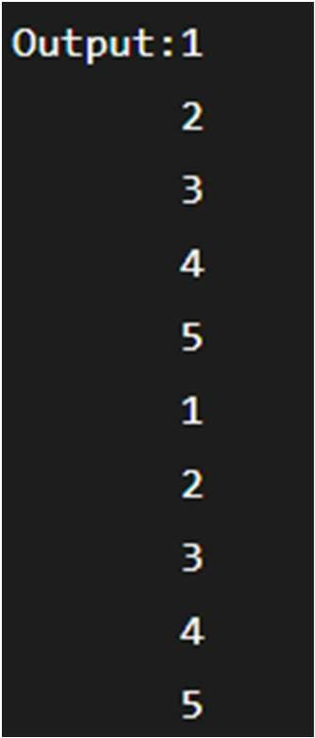t1.run();

t2.run();

}

}

**There is no context-switching because here t1 and t2 will be treated as normal object not thread object.**

#### Naming Thread and Current Thread

* + The Thread class provides methods to change and get the name of a thread. By default, each thread has a name i.e. thread-0, thread-1 and so on.
  + We can change the name of the thread by using setName() method. The syntax of setName() and getName() methods are given below:

1. **public String getName():** is used to return the name of a thread.
2. **public void setName(String name):** is used to change the name of a thread.

**class** TestMultiNaming1 **extends** Thread{ **public void** run(){ System.out.println("running...");

}

**public static void** main(String args[]){ TestMultiNaming1 t1=**new** TestMultiNaming1(); TestMultiNaming1 t2=**new** TestMultiNaming1(); System.out.println("Name of t1:"+t1.getName()); System.out.println("Name of t2:"+t2.getName());

t1.start();

t2.start();

t1.setName(“Jagadish");

System.out.println("After changing name of t1:"+t1.getName());

}

} By Jagadish Sahoo

#### Current Thread

* + The currentThread() method returns a reference of currently executing thread.

**Syntax : public static** Thread currentThread() **class** TestMultiNaming2 **extends** Thread{ **public void** run(){

System.out.println(Thread.currentThread().getName());

}

**public static void** main(String args[]){ TestMultiNaming2 t1=**new** TestMultiNaming2(); TestMultiNaming2 t2=**new** TestMultiNaming2();

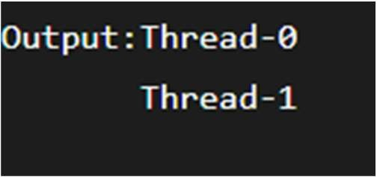t1.start();

t2.start();

}

}

#### Priority of a Thread (Thread Priority)

* Each thread have a priority.
* Priorities are represented by a number between 1 and 10. I
* n most cases, thread scheduler schedules the threads according to their priority (known as preemptive scheduling).
* But it is not guaranteed because it depends on JVM specification that which scheduling it chooses.

3 constants defined in Thread class:

1. public static int MIN_PRIORITY
2. public static int NORM_PRIORITY
3. public static int MAX_PRIORITY

Default priority of a thread is 5 (NORM_PRIORITY). The value of MIN_PRIORITY is 1 and the value of MAX_PRIORITY is 10.

**class** TestMultiPriority1 **extends** Thread{

**public void** run(){

System.out.println("running thread name is:"+Thread.currentThread().getName()); System.out.println("running thread priority is:"+Thread.currentThread().getPriority());

}

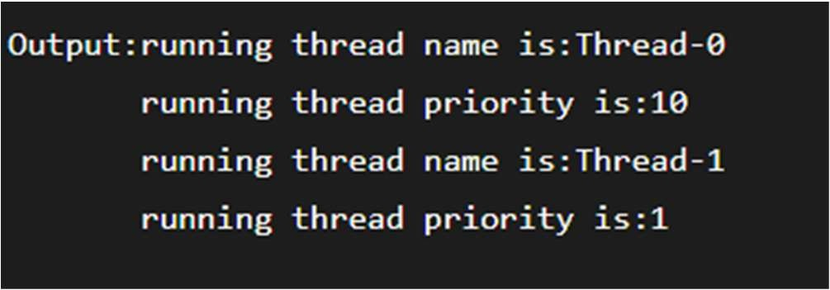**public static void** main(String args[]){ TestMultiPriority1 m1=**new** TestMultiPriority1(); TestMultiPriority1 m2=**new** TestMultiPriority1(); m1.setPriority(Thread.MIN_PRIORITY); m2.setPriority(Thread.MAX_PRIORITY); m1.start();

m2.start();

}

}

## Synchronization in Java

* Synchronization in Java is the capability to control the access of multiple threads to any shared resource.
* Java Synchronization is better option where we want to allow only one thread to access the shared resource.

#### Why use Synchronization?

The synchronization is mainly used to

* 1. To prevent thread interference.
  2. To prevent consistency problem.

#### Types of Synchronization

There are two types of synchronization

1. Process Synchronization
2. Thread Synchronization

## Thread Synchronization

* There are two types of thread synchronization mutual exclusive and inter-thread communication.

1. Mutual Exclusive
   * Synchronized method.
   * Synchronized block.
   * Static synchronization.
2. Cooperation (Inter-thread communication in java)

#### Mutual Exclusive

* Mutual Exclusive helps keep threads from interfering with one another while sharing data. It can be achieved by using the following three ways:

1. By Using Synchronized Method
2. By Using Synchronized Block
3. By Using Static Synchronization

## Concept of Lock in Java

* Synchronization is built around an internal entity known as the lock or monitor. Every object has a lock associated with it. By convention, a thread that needs consistent access to an object's fields has to acquire the object's lock before accessing them, and then release the lock when it's done with them.
* From Java 5 the package java.util.concurrent.locks contains several lock implementations.

#### Problem without Synchronization

* There is no synchronization, so output is inconsistent.

#### Java Synchronized Method

* If you declare any method as synchronized, it is known as synchronized method.
* Synchronized method is used to lock an object for any shared resource.
* When a thread invokes a synchronized method, it automatically acquires the lock for that object and releases it when the thread completes its task.

class Table{

synchronized void printTable(int n){//synchronized method for(int i=1;i<=5;i++){

System.out.println(n*i); try{

Thread.sleep(400);

}catch(Exception e){System.out.println(e);}

}

}

}

class MyThread1 extends Thread{ Table t;

MyThread1(Table t){ this.t=t;

}

public void run(){ t.printTable(5);

}

}

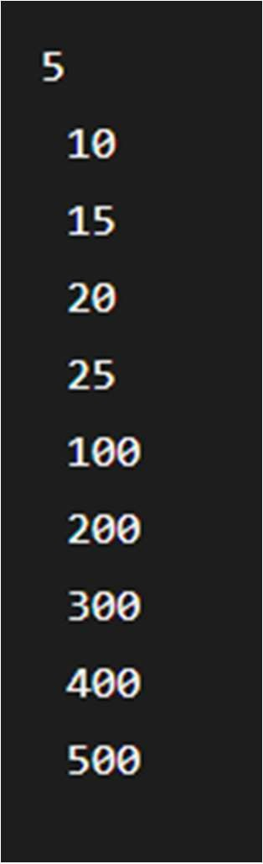class MyThread2 extends Thread{ Table t;

MyThread2(Table t){ this.t=t;

}

public void run(){ t.printTable(100);

}

}

public class TestSynchronization2{ public static void main(String args[]){ Table obj = new Table();//only one object MyThread1 t1=new MyThread1(obj); MyThread2 t2=new MyThread2(obj); t1.start();

t2.start();

}

} By Jagadish Sahoo

## Synchronized Block in Java

* Synchronized block can be used to perform synchronization on any specific resource of the method.
* Suppose we have 50 lines of code in our method, but we want to synchronize only 5 lines, in such cases, we can use synchronized block.
* If we put all the codes of the method in the synchronized block, it will work same as the synchronized method.
* Synchronized block is used to lock an object for any shared resource.
* Scope of synchronized block is smaller than the method.
* Java synchronized block is more efficient than Java synchronized method.

**Syntax**

**synchronized** (object reference expression) {

//code block

}

* **Example of Synchronized Block class** Table

{

**void** printTable(**int** n){ **synchronized**(**this**){//synchronized block **for**(**int** i=1;i<=5;i++){

System.out.println(n*i);

**try**{ Thread.sleep(400);

}**catch**(Exception e){System.out.println(e);}

}

}

}//end of the method

}

class MyThread1 extends Thread{ Table t;

MyThread1(Table t){ this.t=t;

}

public void run(){ t.printTable(5);

}

}

class MyThread2 extends Thread{ Table t;

MyThread2(Table t){ this.t=t;

}

public void run(){ t.printTable(100);

}

}

public class TestSynchronizedBlock1{ public static void main(String args[]){ Table obj = new Table();//only one object

MyThread1 t1=new MyThread1(obj); MyThread2 t2=new MyThread2(obj); t1.start();

t2.start();

}

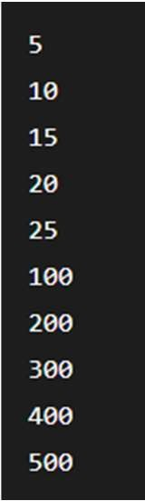}

By Jagadish Sahoo

## Static Synchronization

* + If you make any static method as synchronized, the lock will be on the class not on object.

#### Problem without static synchronization

* + 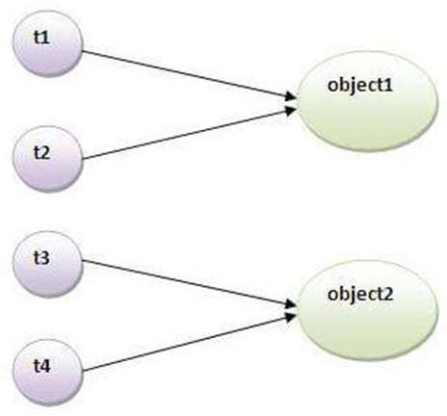Suppose there are two objects of a shared class(e.g. Table) named object1 and object2.In case of synchronized method and synchronized block there cannot be interference between t1 and t2 or t3 and t4 because t1 and t2 both refers to a common object that have a single lock.But there can be interference between t1 and t3 or t2 and t4 because t1 acquires another lock and t3 acquires another lock.I want no interference between t1 and t3 or t2 and t4.Static synchronization solves this problem.

#### Example of static synchronization

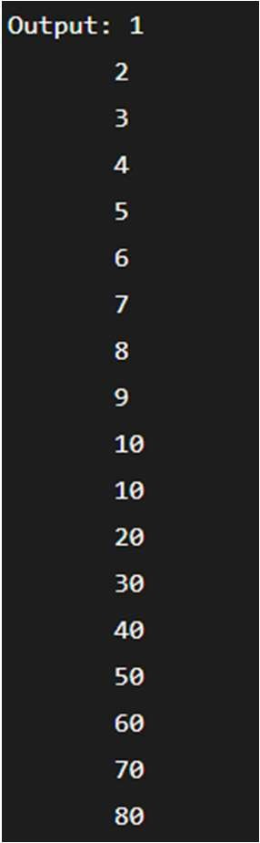class MyThread3 extends Thread{

class Table{

synchronized static void printTable(int n){ for(int i=1;i<=10;i++){ System.out.println(n*i);

try{

Thread.sleep(400);

}catch(Exception e){}

}

}

}

class MyThread1 extends Thread{ public void run(){ Table.printTable(1);

}

}

class MyThread2 extends Thread{ public void run(){ Table.printTable(10);

}

public void run(){ Table.printTable(100);

}

}

class MyThread4 extends Thread{ public void run(){ Table.printTable(1000);

}

}

public class TestSynchronization4{ public static void main(String t[]){ MyThread1 t1=new MyThread1(); MyThread2 t2=new MyThread2(); MyThread3 t3=new MyThread3(); MyThread4 t4=new MyThread4(); t1.start();

t2.start();

t3.start();

t4.start();

} } By Jagadish Sahoo

}

#### Deadlock in Java

* + Deadlock in Java is a part of multithreading. Deadlock can occur in a situation when a thread is waiting for an object lock, that is acquired by another thread and second thread is waiting for an object lock that is acquired by first thread. Since, both threads are waiting for each other to release the lock, the condition is called deadlock.



## Inter-thread communication in Java

* + **Inter-thread communication** or **Co-operation** is all about allowing synchronized threads to communicate with each other.
  + Cooperation (Inter-thread communication) is a mechanism in which a thread is paused running in its critical section and another thread is allowed to enter (or lock) in the same critical section to be executed.It is implemented by following methods of **Object class**:

1. wait()
2. notify()
3. notifyAll()

### wait() method

* Causes current thread to release the lock and wait until either another thread invokes the notify() method or the notifyAll() method for this object, or a specified amount of time has elapsed.
* The current thread must own this object's monitor, so it must be called from the synchronized method only otherwise it will throw exception.

###### notify() method

* Wakes up a single thread that is waiting on this object's monitor. If any threads are waiting on this object, one of them is chosen to be awakened. The choice is arbitrary and occurs at the discretion of the implementation. Syntax:

public final void notify()

notifyAll() method

Wakes up all threads that are waiting on this object's monitor. Syntax:

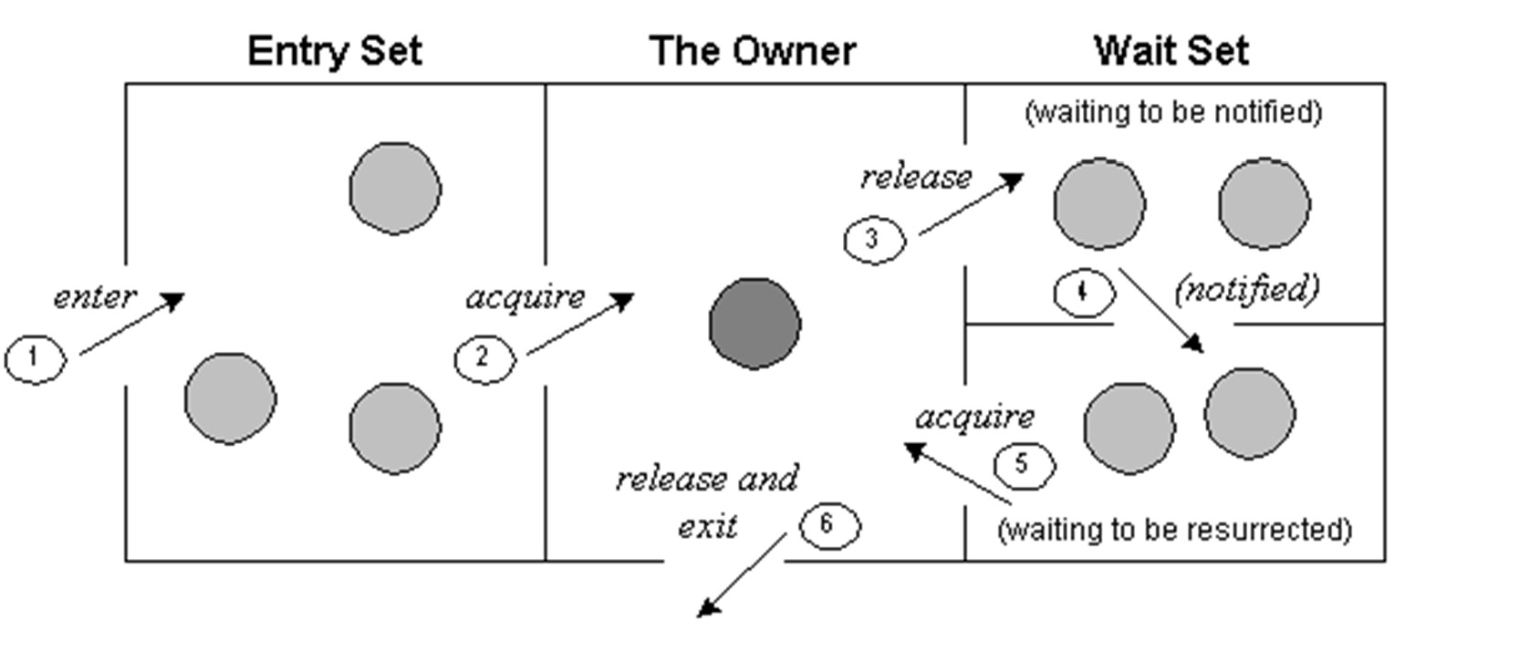public final void notifyAll()

1. Threads enter to acquire lock.
2. Lock is acquired by on thread.
3. Now thread goes to waiting state if you call wait() method on the object. Otherwise it releases the lock and exits.
4. If you call notify() or notifyAll() method, thread moves to the notified state (runnable state).
5. Now thread is available to acquire lock.
6. After completion of the task, thread releases the lock and exits the monitor state of the object.

Difference between wait and sleep?

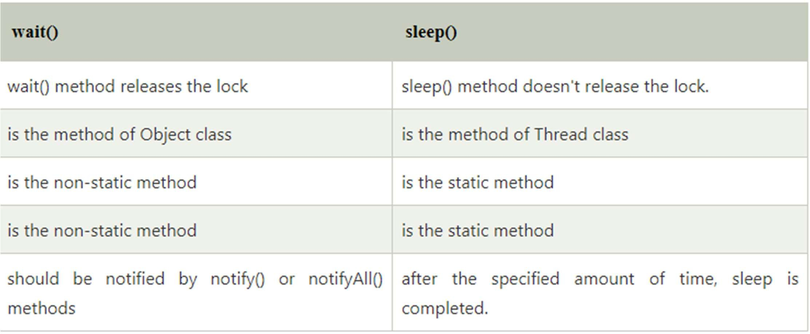

Example of inter thread communication in java

class Customer{

int amount=10000;

synchronized void withdraw(int amount){ System.out.println("going to withdraw...");

if(this.amount<amount){

System.out.println("Less balance; waiting for deposit..."); try{wait();}catch(Exception e){}

}

this.amount-=amount; System.out.println("withdraw completed...");

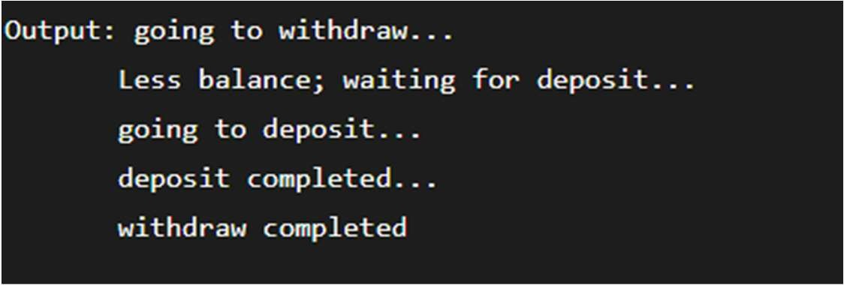}

synchronized void deposit(int amount){ System.out.println("going to deposit..."); this.amount+=amount; System.out.println("deposit completed... "); notify();

}

}

class Test{

public static void main(String args[]){ final Customer c=new Customer(); new Thread(){

public void run(){c.withdraw(15000);}

}.start();

new Thread(){

public void run(){c.deposit(10000);}

}.start();

}}

#### Java Applet

* Applet is a special type of program that is embedded in the webpage to generate the dynamic content.
* It runs inside the browser and works at client side.

### Advantage of Applet

* It works at client side so less response time.
* Secured
* It can be executed by browsers running under many platforms, including Linux, Windows, Mac Os etc.

##### Drawback of Applet

* Plugin is required at client browser to execute applet.

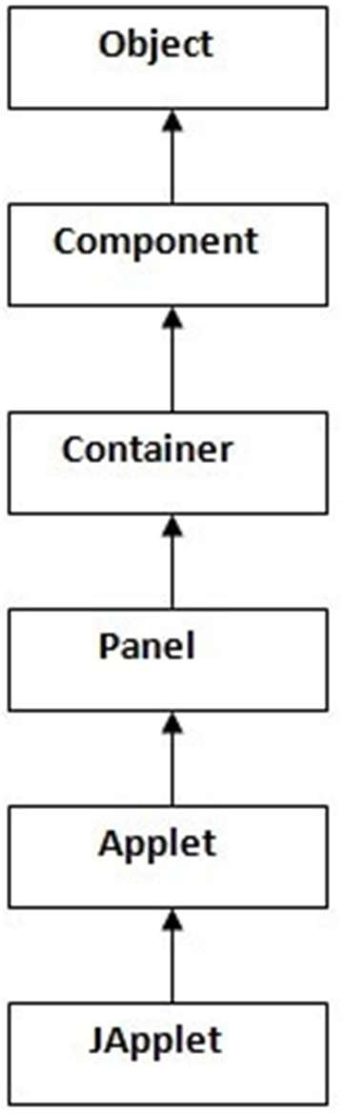Hierarchy of Applet

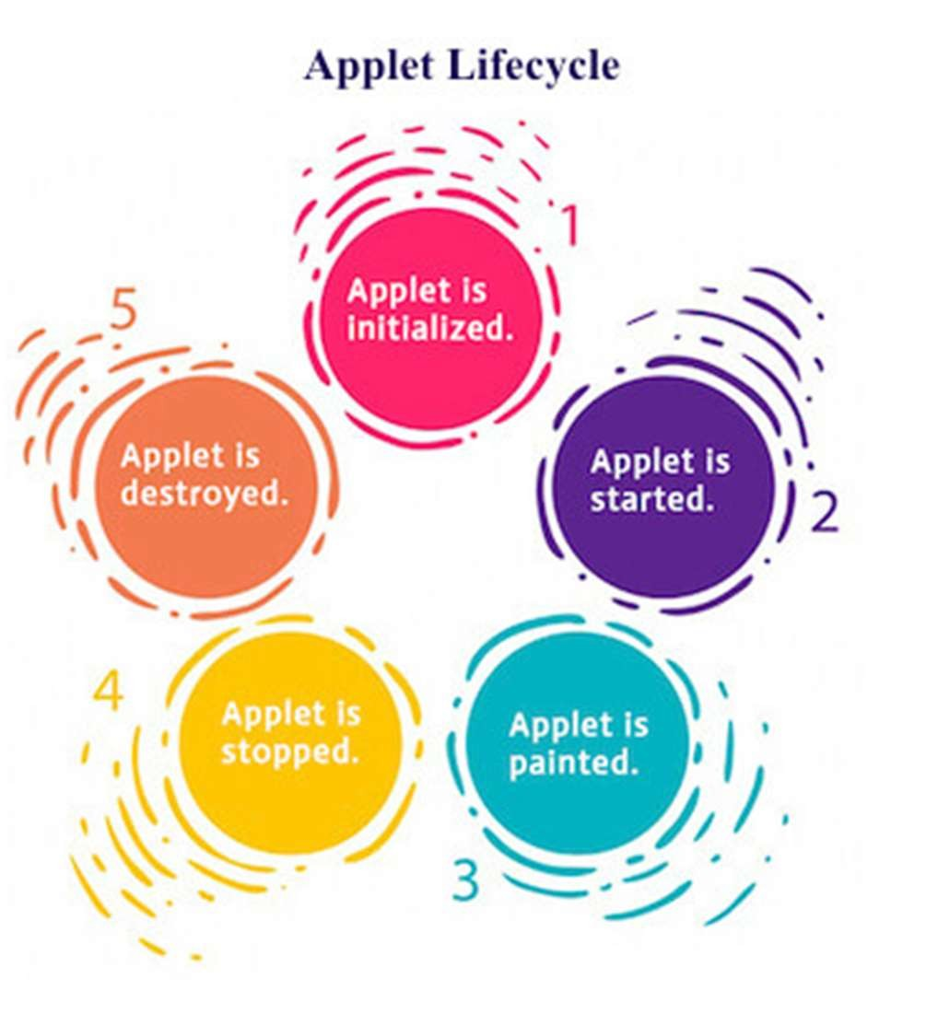Lifecycle of Java Applet

* 1. Applet is initialized.
  2. Applet is started.
  3. Applet is painted.
  4. Applet is stopped.
  5. Applet is destroyed.

## Lifecycle methods for Applet

* The java.applet.Applet class 4 life cycle methods and java.awt.Component class provides 1 life cycle methods for an applet.

**java.applet.Applet class**

1. **public void init():** is used to initialized the Applet. It is invoked only once.
2. **public void start():** is invoked after the init() method or browser is maximized. It is used to start the Applet.
3. **public void stop():** is used to stop the Applet. It is invoked when Applet is stop or browser is minimized.
4. **public void destroy():** is used to destroy the Applet. It is invoked only once.

**java.awt.Component class**

* **public void paint(Graphics g):** is used to paint the Applet. It provides Graphics class object that can be used for drawing oval, rectangle, arc etc.

How to run an Applet?

* There are two ways to run an applet

1. By html file.
2. By appletViewer tool (for testing purpose).

## Simple example of Applet by html file

* To execute the applet by html file, create an applet and compile it. After that create an html file and place the applet code in html file. Now click the html file. **myapplet.html**

//First.java

**import** java.applet.Applet;

**import** java.awt.Graphics;

**public class** First **extends** Applet{ **public void** paint(Graphics g){ g.drawString("welcome",150,150);

}

}

<html>

<body>

<applet code="First.class" width="300" height="300">

</applet>

</body>

</html>

#### Simple example of Applet by appletviewer tool:

* + To execute the applet by appletviewer tool, create an applet that contains applet tag in comment and compile it. After that run it by: appletviewer First.java. Now Html file is not required but it is for testing purpose only.

//First.java

**import** java.applet.Applet;

**import** java.awt.Graphics;

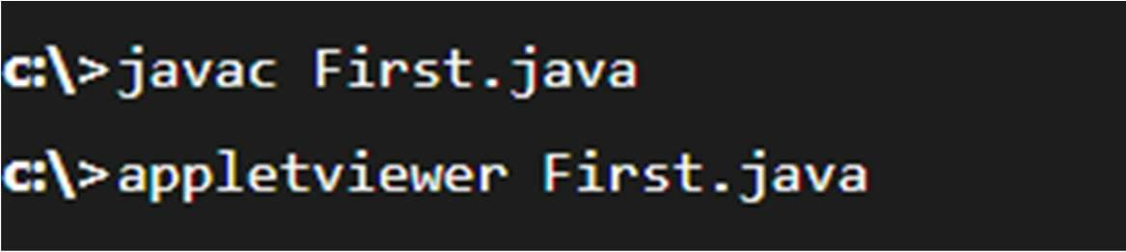**public class** First **extends** Applet{

**public void** paint(Graphics g){ g.drawString("welcome to applet",150,150);

}

}

/*

<applet code="First.class" width="300" height="300">

</applet>

*/

## Displaying Graphics in Applet

* **public abstract void drawString(String str, int x, int y):** is used to draw the specified string.
* **public void drawRect(int x, int y, int width, int height):** draws a rectangle with the specified width and height.
* **public abstract void fillRect(int x, int y, int width, int height):** is used to fill rectangle with the default color and specified width and height.
* **public abstract void drawOval(int x, int y, int width, int height):** is used to draw oval with the specified width and height.
* **public abstract void fillOval(int x, int y, int width, int height):** is used to fill oval with the default color and specified width and height.
* **public abstract void drawLine(int x1, int y1, int x2, int y2):** is used to draw line between the points(x1, y1) and (x2, y2).
* **public abstract boolean drawImage(Image img, int x, int y, ImageObserver observer):** is used draw the specified image.
* **public abstract void drawArc(int x, int y, int width, int height, int startAngle, int arcAngle):** is used draw a circular or elliptical arc.
* **public abstract void fillArc(int x, int y, int width, int height, int startAngle, int arcAngle):** is used to fill a circular or elliptical arc.
* **public abstract void setColor(Color c):** is used to set the graphics current color to the specified color.
* **public abstract void setFont(Font font):** is used to set the graphics current font to the specified font.

## Example of Graphics in applet:

**import** java.applet.Applet;

**import** java.awt.*;

**public class** GraphicsDemo **extends** Applet{ **public void** paint(Graphics g){ g.setColor(Color.red); g.drawString("Welcome",50, 50);

g.drawLine(20,30,20,300); g.drawRect(70,100,30,30); g.fillRect(170,100,30,30); g.drawOval(70,200,30,30); g.setColor(Color.pink); g.fillOval(170,200,30,30); g.drawArc(90,150,30,30,30,270); g.fillArc(270,150,30,30,0,180);

}

**myapplet.html**

<html>

<body>

<applet code="GraphicsDemo.class" width="300" height="300">

</applet>

</body>

</html>

}

#### Displaying Image in Applet

* + Applet is mostly used in games and animation. For this purpose image is required to be displayed. The java.awt.Graphics class provide a method drawImage() to display the image.

Syntax of drawImage() method:

* + public abstract boolean drawImage(Image img, int x, int y, ImageObserver observer): is used draw the specified image.

## How to get the object of Image

* + The java.applet.Applet class provides getImage() method that returns the object of Image. Syntax:

Public Image getImage(URL u, String image){}

Other required methods of Applet class to display image:

* + **public URL getDocumentBase():** is used to return the URL of the document in which applet is embedded.
  + **public URL getCodeBase():** is used to return the base URL.

## Example of displaying image in applet:

**import** java.awt.*;

**import** java.applet.*;

**public class** DisplayImage **extends** Applet { Image picture;

**public void** init() {

picture = getImage(getDocumentBase(),“mypic.jpg");

}

**public void** paint(Graphics g) { g.drawImage(picture, 30,30, **this**);

}

} By Jagadish Sahoo

myapplet.html

<html>

<body>

<applet code="DisplayImage.class" width="300" height="300">

</applet>

</body>

</html>

By Jagadish Sahoo

Animation in Applet

**import** java.awt.*;

**import** java.applet.*;

**public class** AnimationExample **extends** Applet { Image picture;

**public void** init() {

picture =getImage(getDocumentBase(),"bike_1.gif");

**myapplet.html**

<html>

<body>

<applet code="DisplayImage.class" width="300" height="300">

</applet>

</body>

</html>

}

**public void** paint(Graphics g) { **for**(**int** i=0;i<500;i++){ g.drawImage(picture, i,30, **this**);

**try**{Thread.sleep(100);}**catch**(Exception e){}

}

}

}

By Jagadish Sahoo

## EventHandling in Applet

**import** java.applet.*; **import** java.awt.*; **import** java.awt.event.*;

**public class** EventApplet **extends** Applet **implements** ActionListener{ Button b;

TextField tf;

**public void** init(){ tf=**new** TextField();

tf.setBounds(30,40,150,20); b=**new** Button("Click"); b.setBounds(80,150,60,50); add(b);add(tf); b.addActionListener(**this**); setLayout(**null**);

}

**public void** actionPerformed(ActionEvent e){ tf.setText("Welcome");

}

} By Jagadish Sahoo

#### Painting in Applet

**import** java.awt.*;

**import** java.awt.event.*;

**import** java.applet.*;

**public class** MouseDrag **extends** Applet **implements** MouseMotionListener{

**public void** init(){ addMouseMotionListener(**this**); setBackground(Color.red);

}

**public void** mouseDragged(MouseEvent me){ Graphics g=getGraphics(); g.setColor(Color.white); g.fillOval(me.getX(),me.getY(),5,5);

}

**public void** mouseMoved(MouseEvent me){}

}

## Parameter in Applet

* + We can get any information from the HTML file as a parameter. For this purpose, Applet class provides a method named getParameter(). Syntax:

**public** String getParameter(String parameterName)

#### Example of using parameter in Applet:

**import** java.applet.Applet;

**import** java.awt.Graphics;

**public class** UseParam **extends** Applet{

**public void** paint(Graphics g){

String str=getParameter("msg"); <html>

**myapplet.html**

g.drawString(str,50, 50);

}

}

<body>

<applet code="UseParam.class" width="300" height="300">

<param name="msg" value="Welcome to applet">

</applet>

</body>

</html>

#### Java AWT

* Java AWT (Abstract Window Toolkit) is an API to develop Graphical User Interface (GUI) or windows-based applications in Java.
* Java AWT components are platform-dependent i.e. components are displayed according to the view of operating system. AWT is heavy weight i.e. its components are using the resources of underlying operating system (OS).
* The java.awt package provides classes for AWT API such as TextField, Label, TextArea, RadioButton, CheckBox, Choice, List etc.

#### Java AWT Hierarchy

By Jagadish Sahoo

Components

* All the elements like the button, text fields, scroll bars, etc. are called components. In Java AWT, there are classes for each component. In order to place every component in a particular position on a screen, we need to add them to a container.

Container

* The Container is a component in AWT that can contain another components like buttons, textfields, labels etc. The classes that extends Container class are known as container such as Frame, Dialog and Panel.
* It is basically a screen where the where the components are placed at their specific locations. Thus it contains and controls the layout of components.

**Types of containers:**

* There are four types of containers in Java AWT: Window

Panel Frame Dialog

Window

* The window is the container that have no borders and menu bars. You must use frame, dialog or another window for creating a window. We need to create an instance of Window class to create this container.

Panel

* The Panel is the container that doesn't contain title bar, border or menu bar. It is generic container for holding the components. It can have other components like button, text field etc. An instance of Panel class creates a container, in which we can add components.

Frame

* The Frame is the container that contain title bar and border and can have menu bars. It can have other components like button, text field, scrollbar etc. Frame is most widely used container while developing an AWT application.

Useful Methods of Component Class

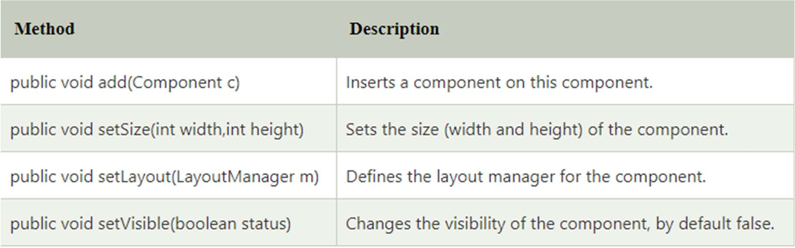

## Java AWT Example

* To create simple AWT example, you need a frame. There are two ways to create a GUI using Frame in AWT.
  1. By extending Frame class (**inheritance**)
  2. By creating the object of Frame class (**association**)

## AWT Example by Inheritance

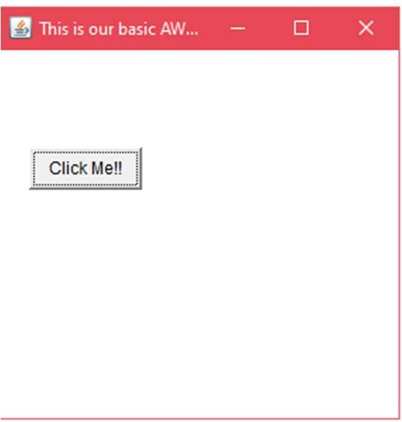**public class** AWTExample1 **extends** Frame { AWTExample1() {

Button b = **new** Button("Click Me!!");

// setting button position on screen b.setBounds(30,100,80,30);

add(b); setSize(300,300);

setTitle("This is our basic AWT example"); setLayout(**null**);

setVisible(**true**);

}

**public static void** main(String args[]) { AWTExample1 f = **new** AWTExample1();

}

}

#### AWT Example by Association

**import** java.awt.*;

**class** AWTExample2 { AWTExample2() {

Frame f = **new** Frame();

Label l = **new** Label("Employee id:"); Button b = **new** Button("Submit"); TextField t = **new** TextField(); l.setBounds(20, 80, 80, 30);

t.setBounds(20, 100, 80, 30);

b.setBounds(100, 100, 80, 30); f.add(b);

f.add(l);

f.add(t); f.setSize(400,300);

f.setTitle("Employee info"); f.setLayout(**null**); f.setVisible(**true**);

}

**public static void** main(String args[]) {

AWTExample2 awt_obj = **new** AWTExample2();

}

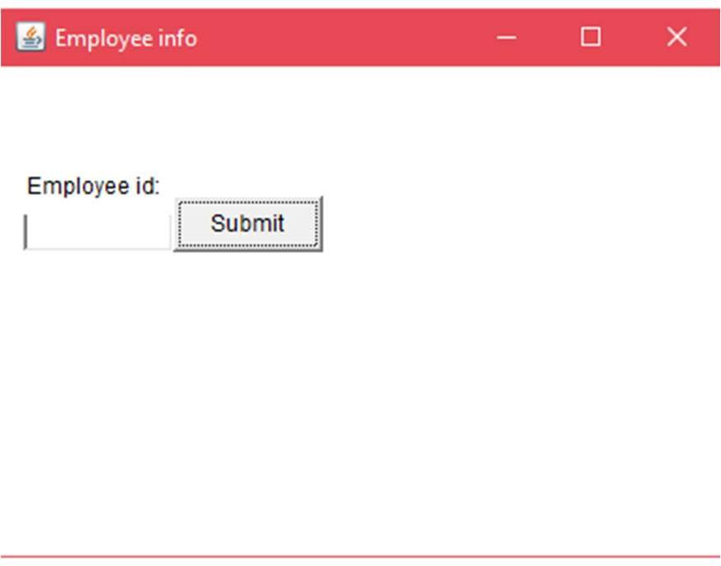}

#### Event and Listener (Java Event Handling)

* Changing the state of an object is known as an event. For example, click on button, dragging mouse etc. The java.awt.event package provides many event classes and Listener interfaces for event handling.

#### Java Event classes and Listener interfaces

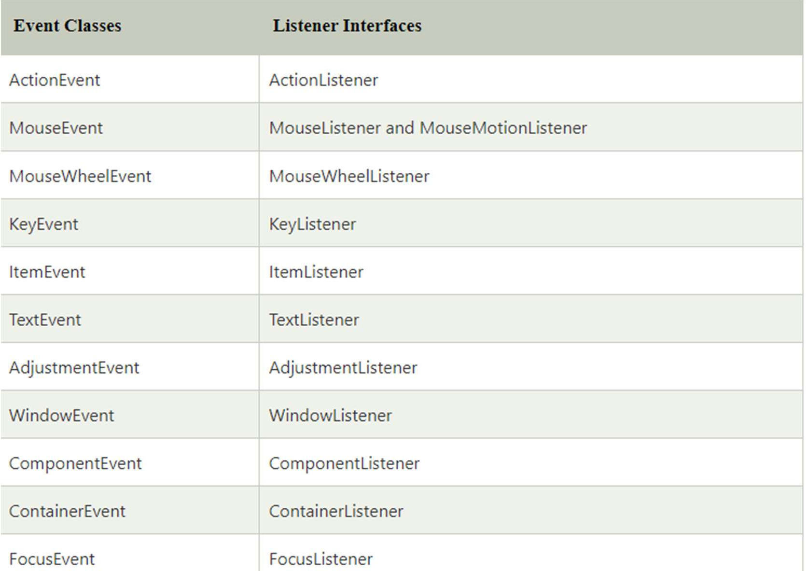

By Jagadish Sahoo

Steps to perform Event Handling

* Following steps are required to perform event handling:

1. Register the component with the Listener

**Registration Methods**

For registering the component with the Listener, many classes provide the registration methods. For example:

**Button**

* + public void addActionListener(ActionListener a){}

**MenuItem**

* + public void addActionListener(ActionListener a){}

**TextField**

* + public void addActionListener(ActionListener a){}
  + public void addTextListener(TextListener a){}

**TextArea**

* + public void addTextListener(TextListener a){}

Checkbox

* + public void addItemListener(ItemListener a){}

Choice

* + public void addItemListener(ItemListener a){}

List

* + public void addActionListener(ActionListener a){}
  + public void addItemListener(ItemListener a){}

#### Java Event Handling Code

* We can put the event handling code into one of the following places:

1. Within class
2. Other class
3. Anonymous class

#### Java event handling by implementing ActionListener

**import** java.awt.*;

**import** java.awt.event.*;

**class** AEvent **extends** Frame **implements** ActionListener{ TextField tf;

AEvent(){

//create components tf=**new** TextField(); tf.setBounds(60,50,170,20);

Button b=**new** Button("click me"); b.setBounds(100,120,80,30);

//register listener b.addActionListener(**this**);//passing current instance

//add components and set size, layout and visibility add(b);add(tf);

setSize(300,300);

setLayout(**null**); setVisible(**true**);

**public void** actionPerformed(ActionEvent e){ tf.setText("Welcome");

}

**public static void** main(String args[]){

**new** AEvent();

}

}

**public void setBounds(int xaxis, int yaxis, int width, int height);** have been used in the above example that sets the position of the component it may be button, textfield etc.

#### Java event handling by outer class

import java.awt.*; import java.awt.event.*;

class AEvent2 extends Frame{

TextField tf; AEvent2(){

tf=new TextField(); tf.setBounds(60,50,170,20); Button b=new Button("click me"); b.setBounds(100,120,80,30); Outer o=new Outer(this);

b.addActionListener(o);//passing outer class instance add(b);add(tf);

setSize(300,300); setLayout(null); setVisible(true);

}

public static void main(String args[]){ new AEvent2();

}

**import** java.awt.event.*;

**class** Outer **implements** ActionListener{ AEvent2 obj;

Outer(AEvent2 obj){

**this**.obj=obj;

}

**public void** actionPerformed(ActionEvent e){ obj.tf.setText("welcome");

}

}

#### Java event handling by anonymous class

**import** java.awt.*;

**import** java.awt.event.*; **class** AEvent3 **extends** Frame{ TextField tf;

AEvent3(){

tf=**new** TextField(); tf.setBounds(60,50,170,20); Button b=**new** Button("click me"); b.setBounds(50,120,80,30);

b.addActionListener(**new** ActionListener(){ **public void** actionPerformed(){ tf.setText("hello");

}

});

add(b);add(tf);

setSize(300,300); setLayout(**null**); setVisible(**true**);

}

**public static void** main(String args[]){

**new** AEvent3();

}

}

#### Java AWT Button

* A button is basically a control component with a label that generates an event when pushed.
* The **Button** class is used to create a labeled button that has platform independent implementation.
* The application result in some action when the button is pushed.
* When we press a button and release it, AWT sends an instance

of **ActionEvent** to that button by calling **processEvent** on the button.

* The **processEvent** method of the button receives all the events, then it passes an action event by calling its own method **processActionEvent**.
* This method passes the action event on to action listeners that are interested in the action events generated by the button.
* To perform an action on a button being pressed and released, the ActionListener interface needs to be implemented.
* The registered new listener can receive events from the button by calling addActionListener method of the button.
* The Java application can use the button's action command as a messaging protocol.

**AWT Button Class Declaration**

**public class** Button **extends** Component **implements** Accessible

#### Button Class Constructors

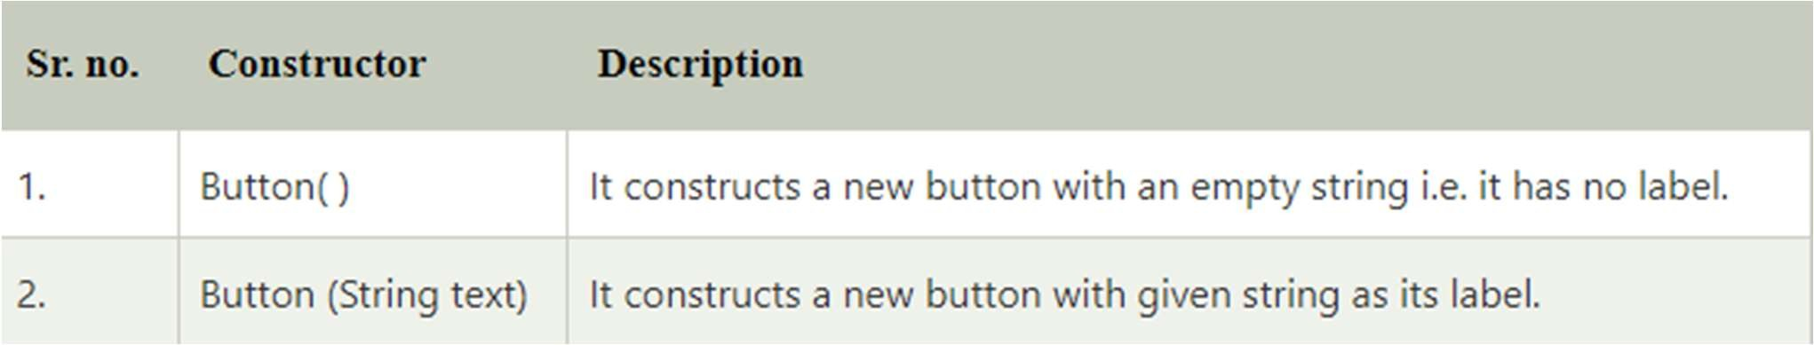

Button Class Methods

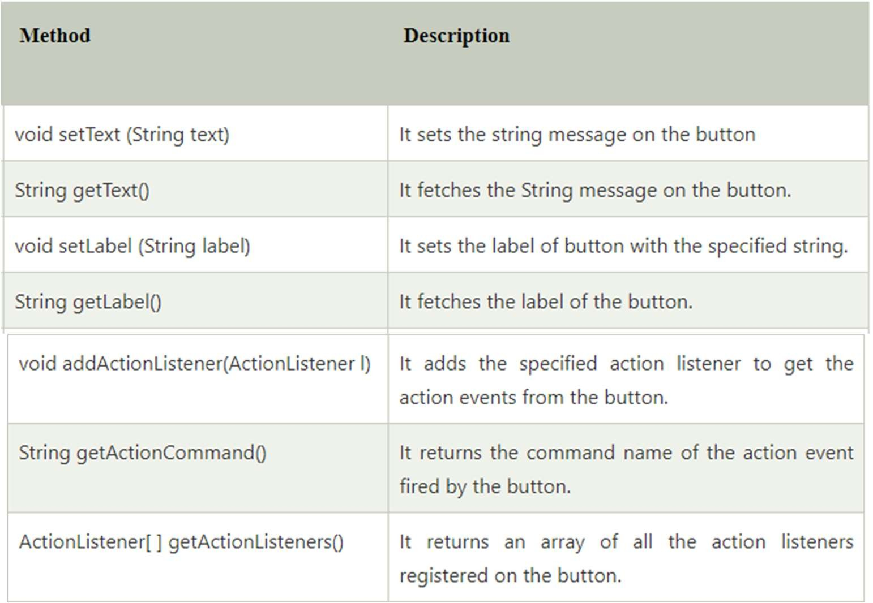

## Java AWT Button Example

**import** java.awt.*;

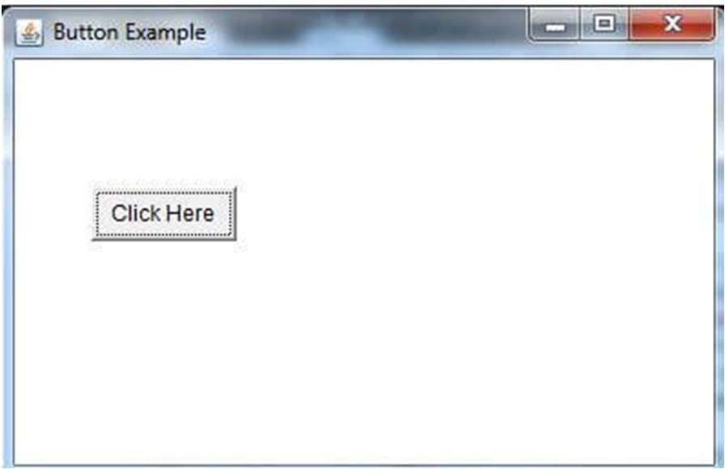**public class** ButtonExample {

**public static void** main (String[] args) {

// create instance of frame with the label Frame f = **new** Frame("Button Example");

// create instance of button with label Button b = **new** Button("Click Here");

// set the position for the button in frame b.setBounds(50,100,80,30);

// add button to the frame f.add(b);

// set size, layout and visibility of frame f.setSize(400,400);

f.setLayout(**null**); f.setVisible(**true**);

}

#### Java AWT Button Example

**import** javax.swing.*;

**import** java.awt.*;

**import** java.awt.event.*;

**public class** ButtonExample2

{

Frame fObj;

Button button1, button2, button3;

// instantiating using the constructor ButtonExample2() {

fObj = **new** Frame ("Frame to display buttons"); button1 = **new** Button();

button2 = **new** Button ("Click here"); button3 = **new** Button(); button3.setLabel("Button 3"); fObj.add(button1); fObj.add(button2); fObj.add(button3); fObj.setLayout(**new** FlowLayout()); fObj.setSize(300,400); fObj.setVisible(**true**);

}

// main method

public static void main (String args[])

{

new ButtonExample2();

}

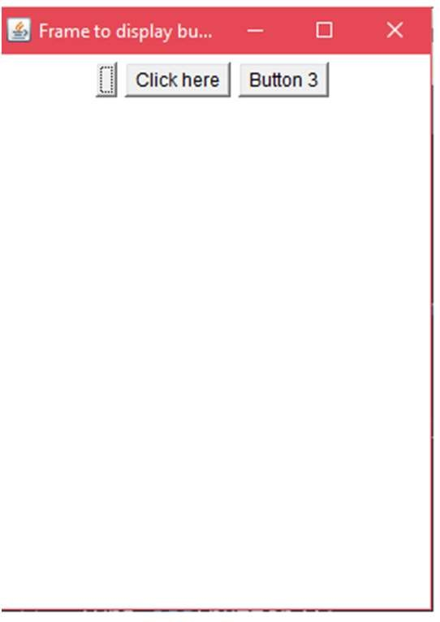}

#### Java AWT Button Example with ActionListener

// importing necessary libraries

**import** java.awt.*;

**import** java.awt.event.*;

**public class** ButtonExample3 {

**public static void** main(String[] args) {

// create instance of frame with the label Frame f = **new** Frame("Button Example"); **final** TextField tf=**new** TextField(); tf.setBounds(50,50, 150,20);

// create instance of button with label Button b=**new** Button("Click Here");

// set the position for the button in frame b.setBounds(50,100,60,30); b.addActionListener(**new** ActionListener() { **public void** actionPerformed (ActionEvent e) {

tf.setText("Welcome to Javatpoint.");

// adding button the frame f.add(b);

// adding textfield the frame f.add(tf);

// setting size, layout and visibility f.setSize(400,400); f.setLayout(**null**); f.setVisible(**true**);

}

}

}

});

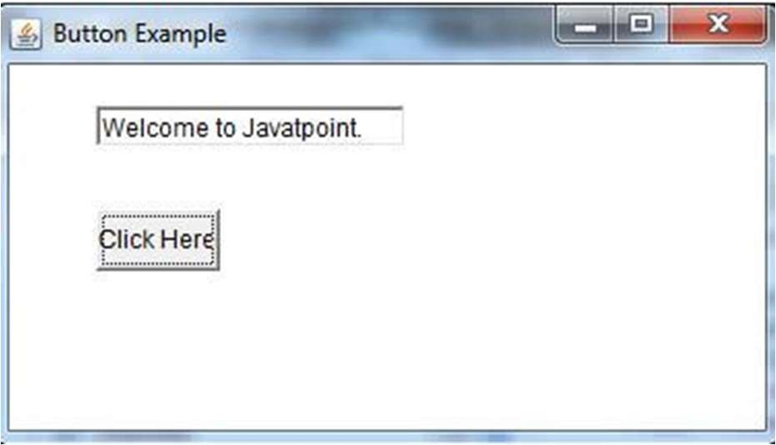By Jagadish Sahoo

#### Java AWT Label

* The object of the Label class is a component for placing text in a container. It is used to display a single line of **read only text**. The text can be changed by a programmer but a user cannot edit it directly.
* It is called a passive control as it does not create any event when it is accessed. To create a label, we need to create the object

of **Label** class.

#### AWT Label Fields

* The java.awt.Component class has following fields:

1. **static int LEFT:** It specifies that the label should be left justified.
2. **static int RIGHT:** It specifies that the label should be right justified.
3. **static int CENTER:** It specifies that the label should be placed in center.

#### Label class Constructors

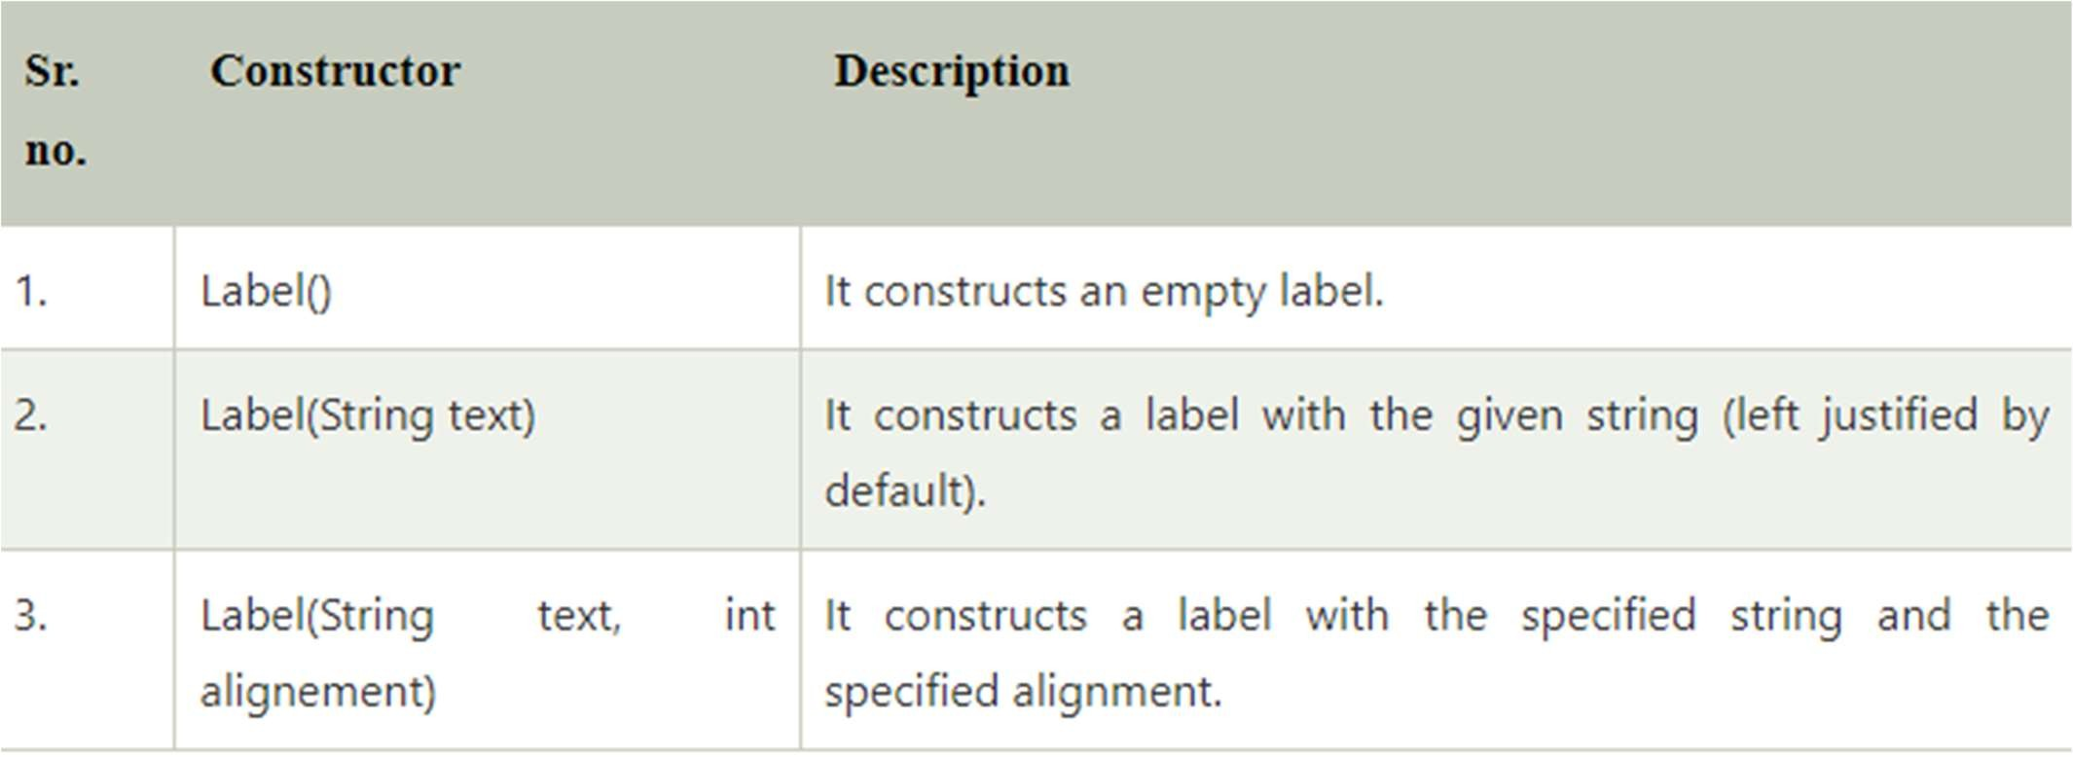

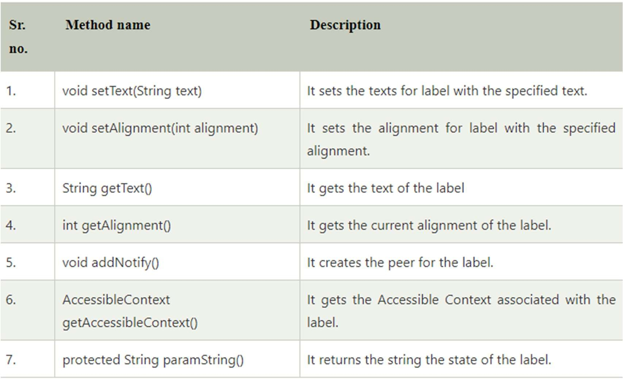Label Class Methods

## Java AWT Label Example

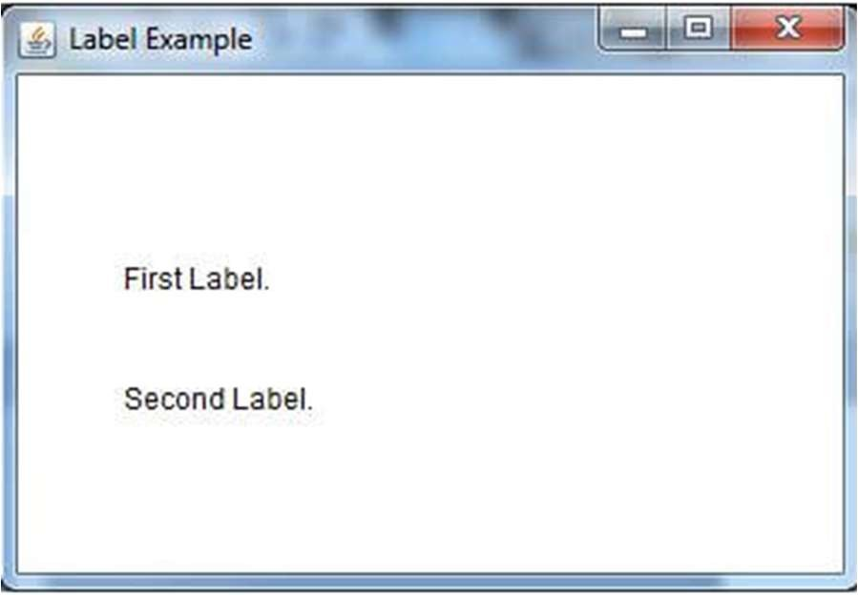**import** java.awt.*;

**public class** LabelExample {

**public static void** main(String args[]){

// creating the object of Frame class and Label class Frame f = **new** Frame ("Label example");

Label l1, l2;

// initializing the labels

l1 = **new** Label ("First Label.");

l2 = **new** Label ("Second Label.");

// set the location of label l1.setBounds(50, 100, 100, 30);

l2.setBounds(50, 150, 100, 30);

// adding labels to the frame f.add(l1);

f.add(l2);

// setting size, layout and visibility of frame f.setSize(400,400);

f.setLayout(**null**); f.setVisible(**true**);

}

}

#### Java AWT TextField

* The object of a **TextField** class is a text component that allows a user to enter a single line text and edit it. It inherits **TextComponent** class, which further inherits **Component** class.
* When we enter a key in the text field (like key pressed, key released or key typed), the event is sent to **TextField**.
* Then the **KeyEvent** is passed to the registered **KeyListener**. It can also be done using **ActionEvent**; if the ActionEvent is enabled on the text field, then the ActionEvent may be fired by pressing return key.
* The event is handled by the **ActionListener** interface.

#### AWT TextField Class Declaration

* **public class** TextField **extends** TextComponent **TextField Class constructors**

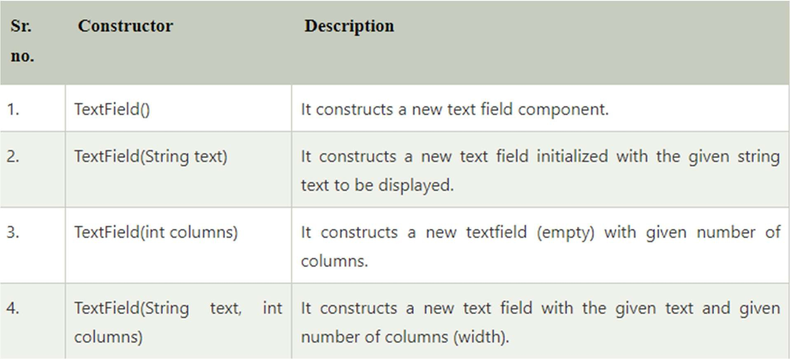

By Jagadish Sahoo

TextField Class Methods

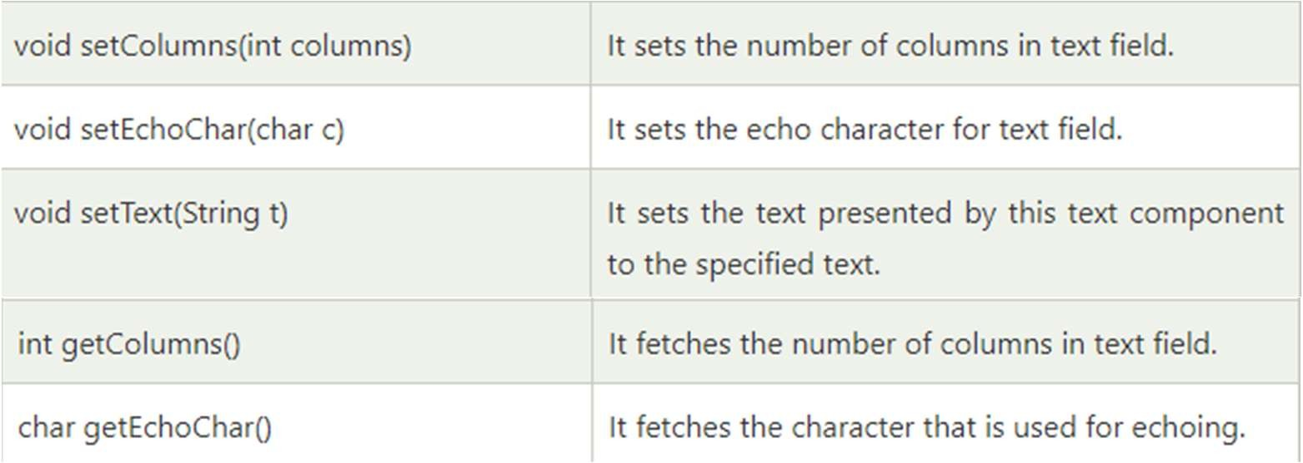

## Java AWT TextField Example

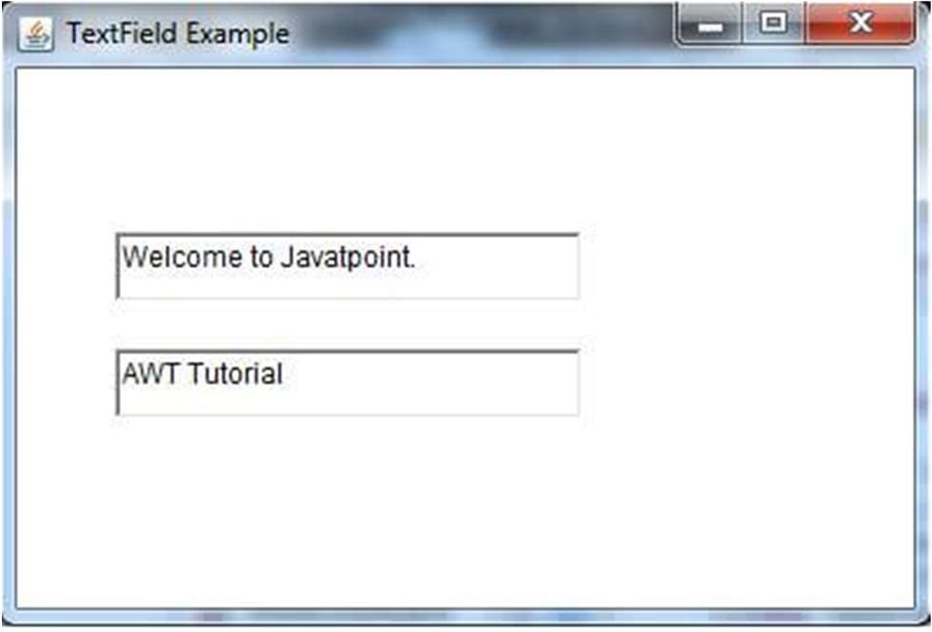**import** java.awt.*;

**public class** TextFieldExample1 {

**public static void** main(String args[]) { Frame f = **new** Frame("TextField Example");

TextField t1, t2;

t1 = **new** TextField("Welcome to Javatpoint."); t1.setBounds(50, 100, 200, 30);

t2 = **new** TextField("AWT Tutorial"); t2.setBounds(50, 150, 200, 30); f.add(t1);

f.add(t2); f.setSize(400,400); f.setLayout(**null**); f.setVisible(**true**);

}

}

#### Java AWT TextField Example with ActionListener

**import** java.awt.*;

**import** java.awt.event.*;

// Our class extends Frame class and implements ActionListener interface

**public class** TextFieldExample2 **extends** Frame **implements** ActionListener {

// creating instances of TextField and Button class TextField tf1, tf2, tf3;

Button b1, b2;

// instantiating using constructor TextFieldExample2() {

// instantiating objects of text field and button

// setting position of components in frame tf1 = **new** TextField();

tf1.setBounds(50, 50, 150, 20); tf2 = **new** TextField(); tf2.setBounds(50, 100, 150, 20); tf3 = **new** TextField();

tf3.setBounds(50, 150, 150, 20);

}

tf3.setEditable(false); b1 = new Button("+");

b1.setBounds(50, 200, 50, 50); b2 = new Button("-"); b2.setBounds(120,200,50,50);

// adding action listener b1.addActionListener(this); b2.addActionListener(this);

// adding components to frame add(tf1);

add(tf2);

add(tf3);

add(b1);

add(b2);

// setting size, layout and visibility of frame setSize(300,300);

setLayout(null); setVisible(true);

**public void** actionPerformed(ActionEvent e) { String s1 = tf1.getText();

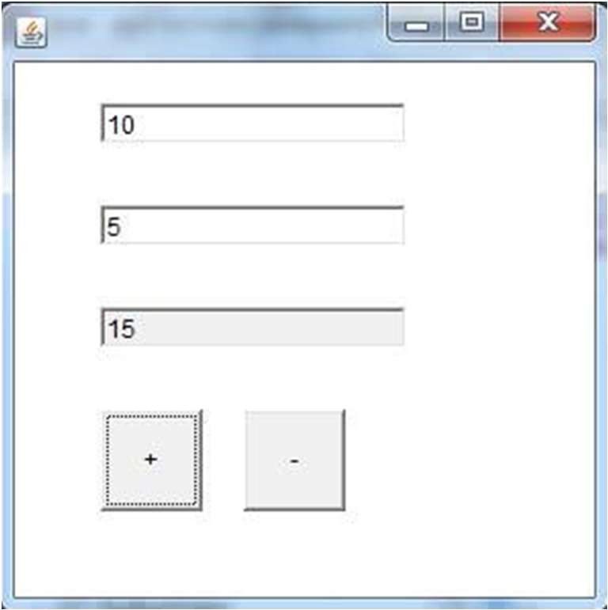String s2 = tf2.getText(); **int** a = Integer.parseInt(s1); **int** b = Integer.parseInt(s2); **int** c = 0;

**if** (e.getSource() == b1){ c = a + b;

}

**else if** (e.getSource() == b2){ c = a - b;

}

String result = String.valueOf(c); tf3.setText(result);

}

// main method

**public static void** main(String[] args) {

**new** TextFieldExample2();

}

} By Jagadish Sahoo

#### Java AWT TextArea

* The object of a TextArea class is a multiline region that displays text. It allows the editing of multiple line text. It inherits TextComponent class.
* The text area allows us to type as much text as we want. When the text in the text area becomes larger than the viewable area, the scroll bar appears automatically which helps us to scroll the text up and down, or right and left.

**AWT TextArea Class Declaration**

public class TextArea extends TextComponent

Fields of TextArea Class

The fields of java.awt.TextArea class are as follows:

* static int SCROLLBARS_BOTH - It creates and displays both horizontal and vertical scrollbars.
* static int SCROLLBARS_HORIZONTAL_ONLY - It creates and displays only the horizontal scrollbar.
* static int SCROLLBARS_VERTICAL_ONLY - It creates and displays only the vertical scrollbar.
* static int SCROLLBARS_NONE - It doesn't create or display any scrollbar in the text area.

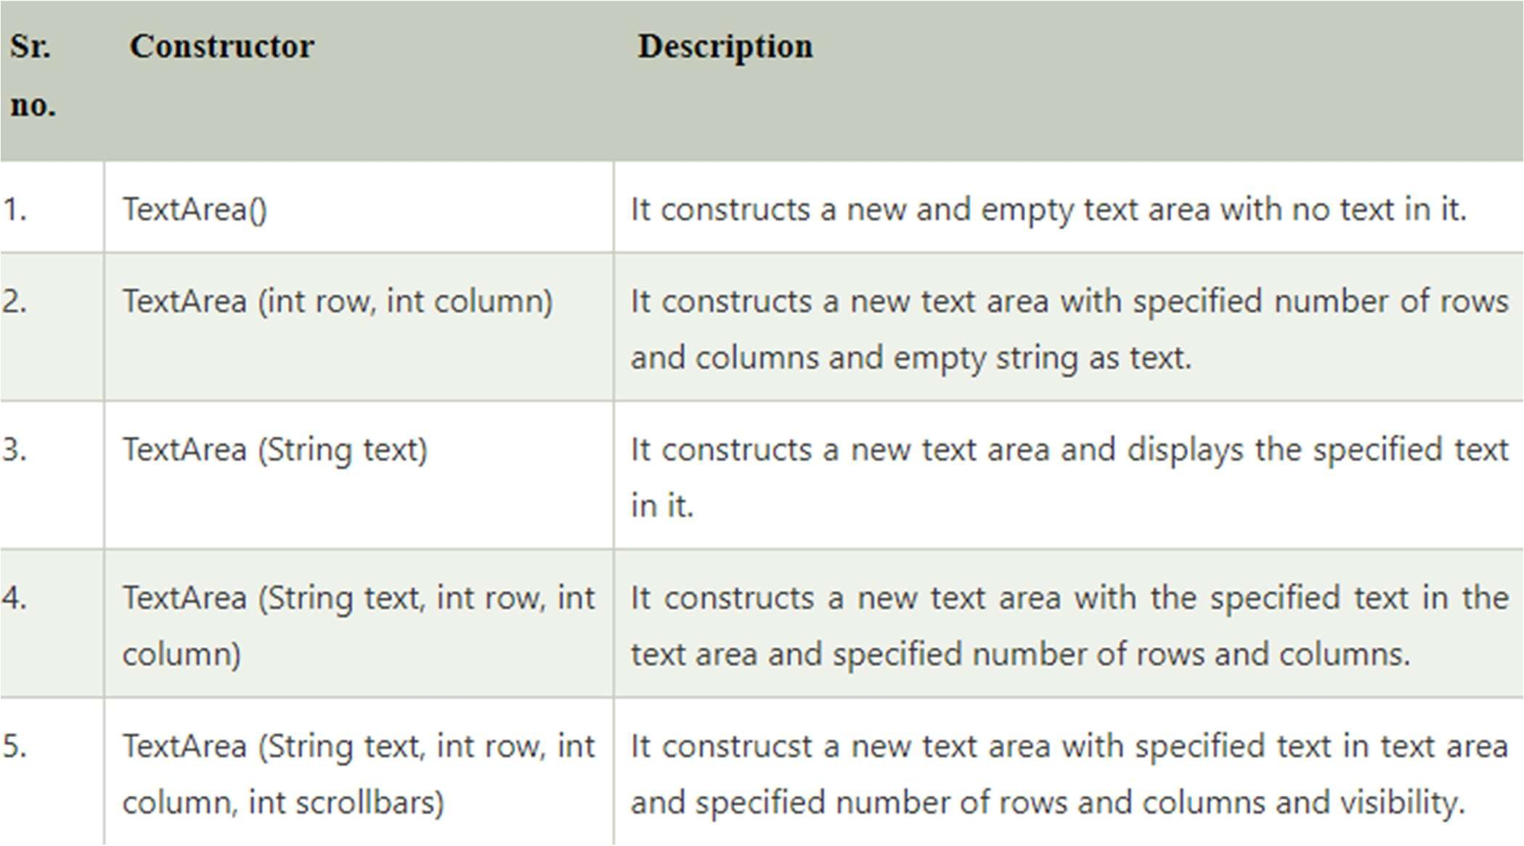

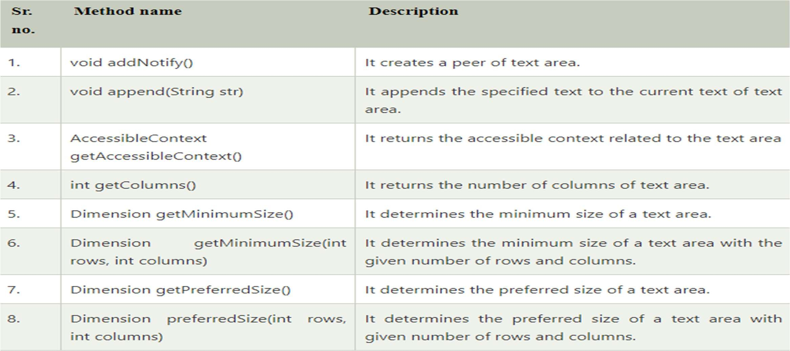

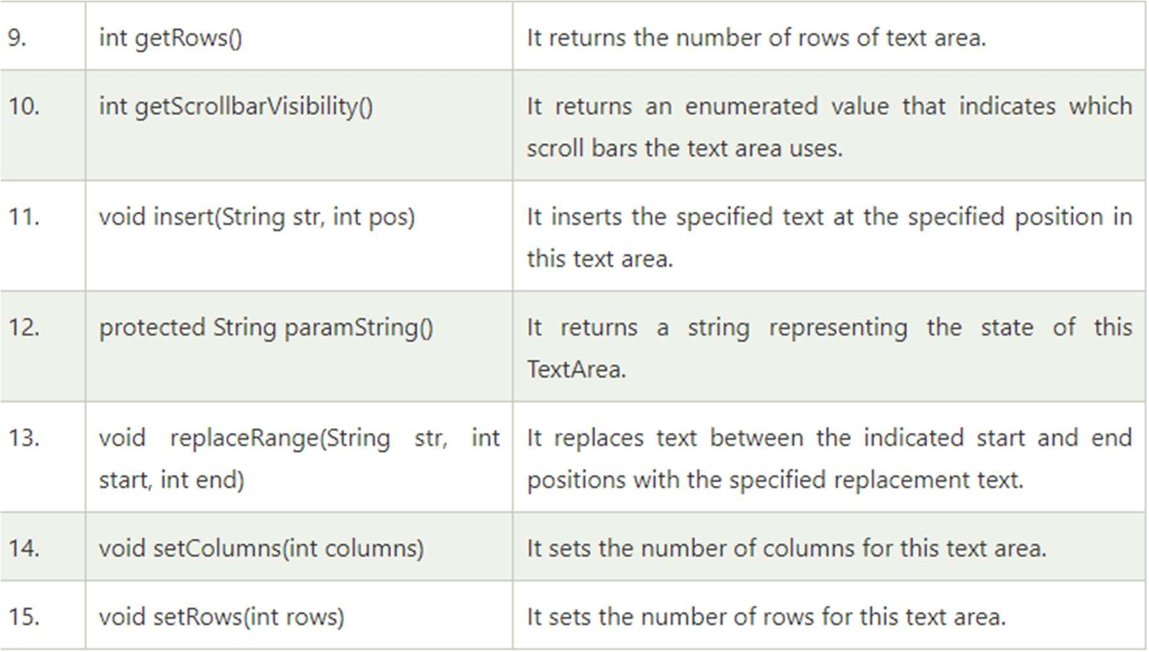

## Java AWT TextArea Example

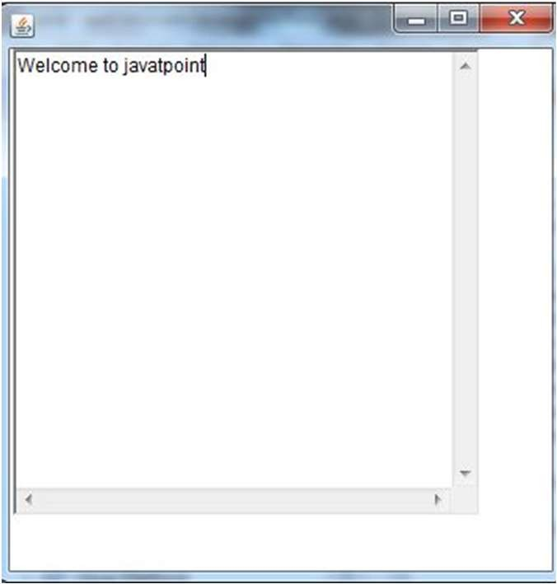**import** java.awt.*;

**public class** TextAreaExample

{

TextAreaExample() { Frame f = **new** Frame();

TextArea area = **new** TextArea("Welcome to javatpoint"); area.setBounds(10, 30, 300, 300);

f.add(area); f.setSize(400, 400); f.setLayout(**null**); f.setVisible(**true**);

}

**public static void** main(String args[])

{

**new** TextAreaExample();

}

}

#### Java AWT TextArea Example with ActionListener

**import** java.awt.*;

**import** java.awt.event.*;

b.addActionListener(**this**);

add(l1);

add(l2);

**public class** TextAreaExample2 **extends** Frame **impleme**a**n**dd**ts**(aArecati)o; nListener {

Label l1, l2; TextArea area; Button b;

TextAreaExample2() {

l1 = **new** Label(); l1.setBounds(50, 50, 100, 30); l2 = **new** Label(); l2.setBounds(160, 50, 100, 30); area = **new** TextArea();

area.setBounds(20, 100, 300, 300); b = **new** Button("Count Words"); b.setBounds(100, 400, 100, 30);

add(b);

setSize(400, 450); setLayout(**null**); setVisible(**true**);

}

**public void** actionPerformed(ActionEvent e) { String text = area.getText();

String words[]=text.split("\\s"); l1.setText("Words: "+words.length); l2.setText("Characters: "+text.length());

}

**public static void** main(String[] args) {

**new** TextAreaExample2();

}

}

#### Java AWT Checkbox

* The Checkbox class is used to create a checkbox. It is used to turn an option on (true) or off (false). Clicking on a Checkbox changes its state from "on" to "off" or from "off" to "on".

AWT Checkbox Class Declaration

**public class** Checkbox **extends** Component **implements** ItemSelectable, Accessible

Checkbox Class Constructors

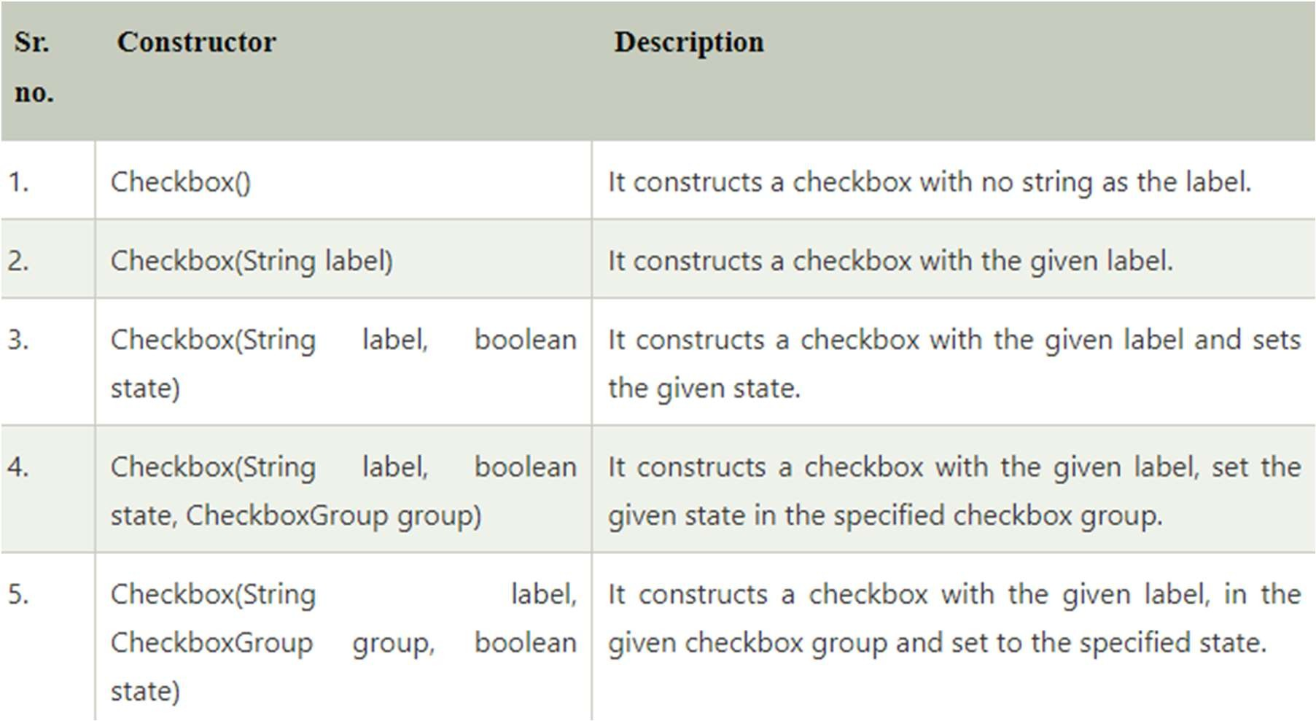

## Checkbox Class Methods

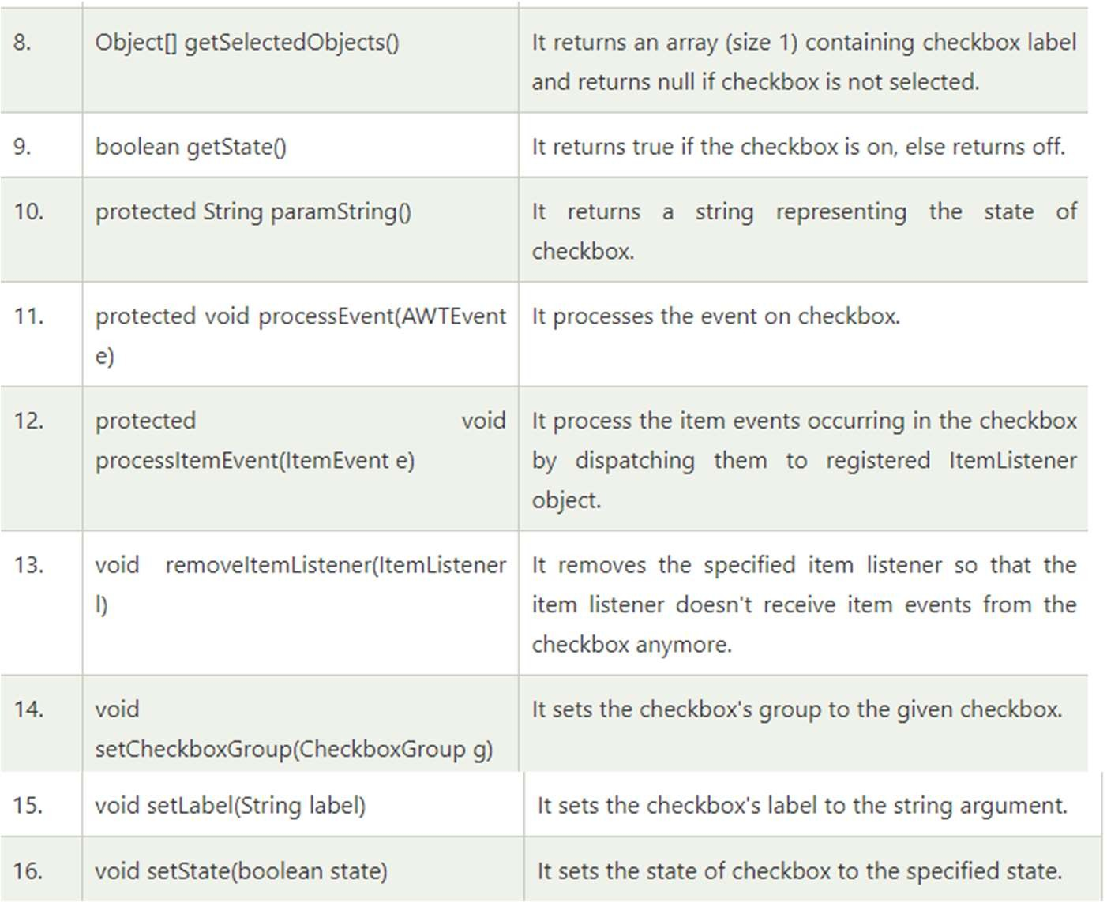

#### Java AWT Checkbox Example

**import** java.awt.*;

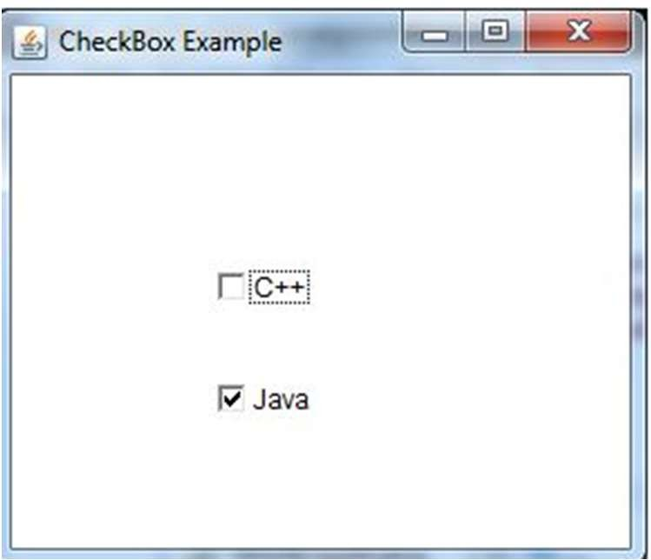**public class** CheckboxExample1

{

CheckboxExample1() {

Frame f = **new** Frame("Checkbox Example"); Checkbox checkbox1 = **new** Checkbox("C++"); checkbox1.setBounds(100, 100, 50, 50);

Checkbox checkbox2 = **new** Checkbox("Java", **true**); checkbox2.setBounds(100, 150, 50, 50); f.add(checkbox1);

f.add(checkbox2); f.setSize(400,400); f.setLayout(**null**); f.setVisible(**true**);

}

**public static void** main (String args[])

{

**new** CheckboxExample1();

}

}

#### Java AWT Checkbox Example with ItemListener

**import** java.awt.*;

**import** java.awt.event.*;

**public class** CheckboxExample2

{

CheckboxExample2() {

Frame f = **new** Frame ("CheckBox Example");

**final** Label label = **new** Label(); label.setAlignment(Label.CENTER);

label.setSize(400,100);

Checkbox checkbox1 = **new** Checkbox("C++"); checkbox1.setBounds(100, 100, 50, 50); Checkbox checkbox2 = **new** Checkbox("Java");

checkbox1.addItemListener(**new** ItemListener() {

**public void** itemStateChanged(ItemEvent e) { label.setText("C++ Checkbox: "

+ (e.getStateChange()==1?"checked":"unchecked"));

}

});

checkbox2.addItemListener(**new** ItemListener() {

**public void** itemStateChanged(ItemEvent e) { label.setText("Java Checkbox: "

+ (e.getStateChange()==1?"checked":"unchecked"));

}

});

f.setSize(400,400); f.setLayout(**null**); f.setVisible(**true**);

}

checkbox2.setBounds(100, 150, 50, 50);

f.add(checkbox1); f.add(checkbox2); f.add(label);

**public static void** main(String args[])

{

**new** CheckboxExample2();

}

}

#### Java AWT CheckboxGroup

* The object of CheckboxGroup class is used to group together a set of Checkbox. At a time only one check box button is allowed to be in "on" state and remaining check box button in "off" state. It inherits the object class.
* Note: CheckboxGroup enables you to create radio buttons in AWT. There is no special control for creating radio buttons in AWT.

AWT CheckboxGroup Class Declaration

**public class** CheckboxGroup **extends** Object **implements** Serializable

#### Java AWT CheckboxGroup Example

**import** java.awt.*;

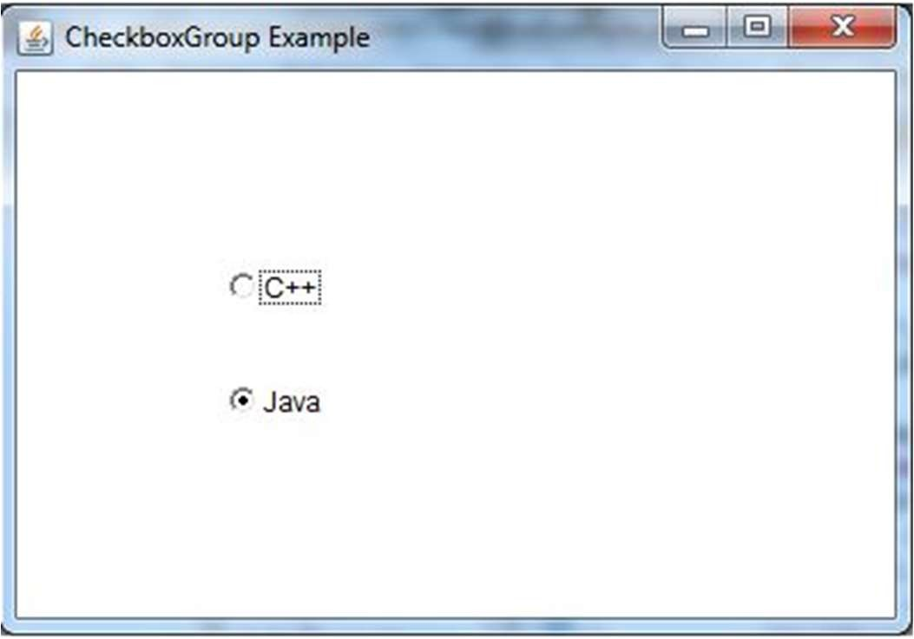**public class** CheckboxGroupExample

{

CheckboxGroupExample(){

Frame f= **new** Frame("CheckboxGroup Example"); CheckboxGroup cbg = **new** CheckboxGroup();

Checkbox checkBox1 = **new** Checkbox("C++", cbg, **false**); checkBox1.setBounds(100,100, 50,50);

Checkbox checkBox2 = **new** Checkbox("Java", cbg, **true**); checkBox2.setBounds(100,150, 50,50); f.add(checkBox1);

f.add(checkBox2); f.setSize(400,400); f.setLayout(**null**); f.setVisible(**true**);

}

**public static void** main(String args[])

{

**new** CheckboxGroupExample();

}

}

#### Java AWT CheckboxGroup Example with

ItemListener

import java.awt.*; import java.awt.event.*;

public class CheckboxGroupExample

{

CheckboxGroupExample(){

Frame f= new Frame("CheckboxGroup Example"); final Label label = new Label(); label.setAlignment(Label.CENTER); label.setSize(400,100);

CheckboxGroup cbg = new CheckboxGroup();

Checkbox checkBox1 = new Checkbox("C++", cbg, false); checkBox1.setBounds(100,100, 50,50);

Checkbox checkBox2 = new Checkbox("Java", cbg, false); checkBox2.setBounds(100,150, 50,50);

f.add(checkBox1); f.add(checkBox2); f.add(label); f.setSize(400,400);

f.setLayout(null); f.setVisible(true);

checkBox1.addItemListener(new ItemListener() { public void itemStateChanged(ItemEvent e) { label.setText("C++ checkbox: Checked");

}

});

checkBox2.addItemListener(new ItemListener() { public void itemStateChanged(ItemEvent e) { label.setText("Java checkbox: Checked");

}

});

}

public static void main(String args[])

{

new CheckboxGroupExample();

}

}

#### Java AWT Choice

* The object of Choice class is used to show popup menu of choices. Choice selected by user is shown on the top of a menu. It inherits Component class.

AWT Choice Class Declaration

public class Choice extends Component implements ItemSelectable, Accessible

**Choice Class constructor**

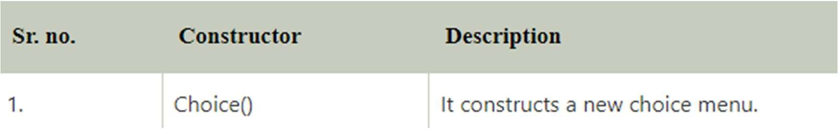

Choice Class Methods

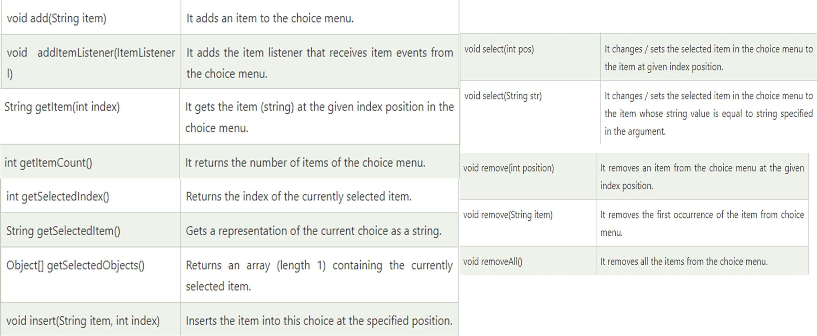

## Java AWT Choice Example

**import** java.awt.*;

**public class** ChoiceExample1 { ChoiceExample1() { Frame f = **new** Frame(); Choice c = **new** Choice();

c.setBounds(100, 100, 75, 75);

// adding items to the choice menu c.add("Item 1");

c.add("Item 2");

c.add("Item 3");

c.add("Item 4");

c.add("Item 5"); f.add(c); f.setSize(400, 400); f.setLayout(**null**); f.setVisible(**true**);

**public static void** main(String args[])

{

**new** ChoiceExample1();

}

}

}

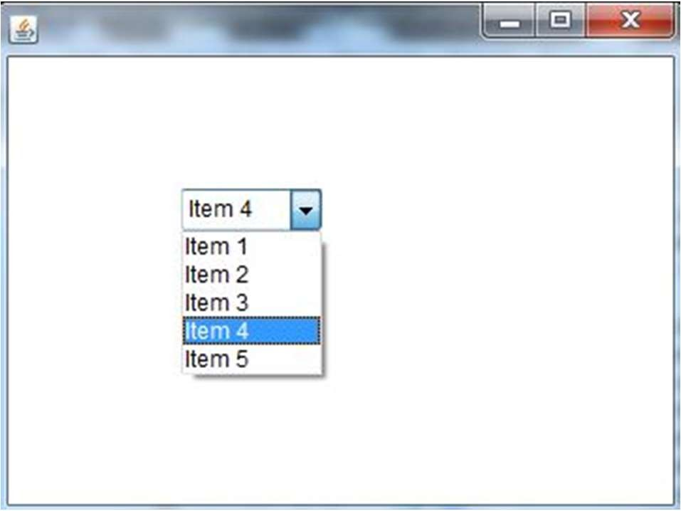

By Jagadish Sahoo

#### Java AWT Choice Example with ActionListener

**import** java.awt.*;

**import** java.awt.event.*;

**public class** ChoiceExample2 { ChoiceExample2() { Frame f = **new** Frame();

**final** Label label = **new** Label(); label.setAlignment(Label.CENTER); label.setSize(400, 100);

Button b = **new** Button("Show"); b.setBounds(200, 100, 50, 20); **final** Choice c = **new** Choice(); c.setBounds(100, 100, 75, 75); c.add("C");

c.add("C++");

c.add("Java");

c.add("PHP");

c.add("Android"); f.add(c);

f.add(label);

f.add(b); f.setSize(400, 400); f.setLayout(**null**); f.setVisible(**true**);

b.addActionListener(**new** ActionListener() {

**public void** actionPerformed(ActionEvent e) {

String data = "Programming language Selected: "+ c.getItem(c.getSelectedIndex());

label.setText(data);

}

});

}

// main method

**public static void** main(String args[])

{

**new** ChoiceExample2();

}

}

#### Java AWT List

* The object of List class represents a list of text items. With the help of the List class, user can choose either one item or multiple items. It inherits the Component class.

AWT List class Declaration

public class List extends Component implements ItemSelectable, Accessible

AWT List Class Constructors

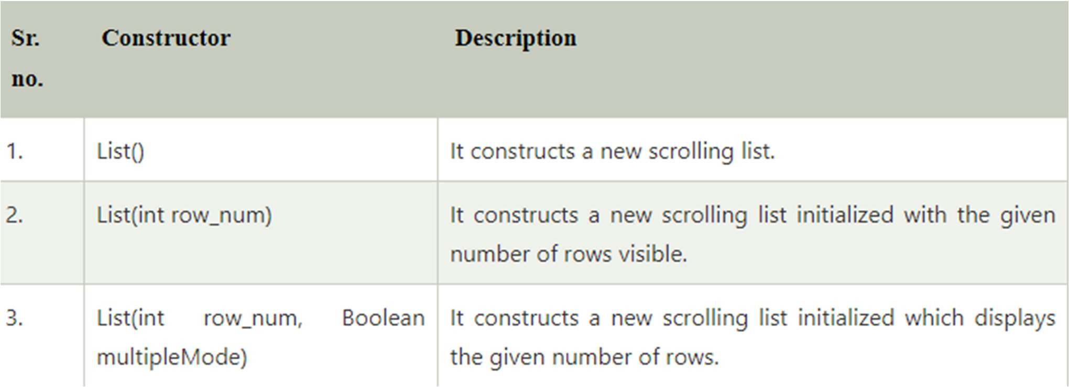

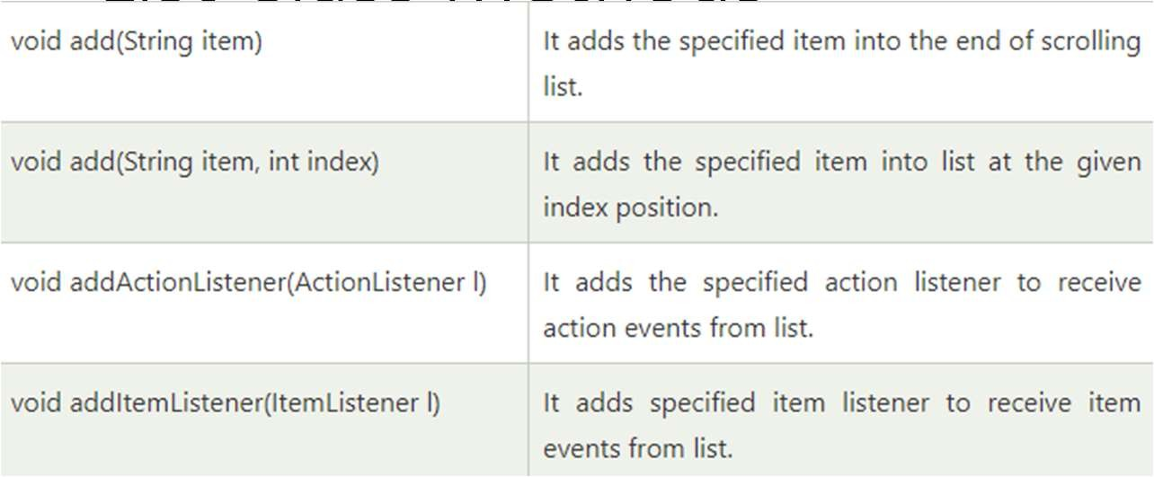

List Class Methods

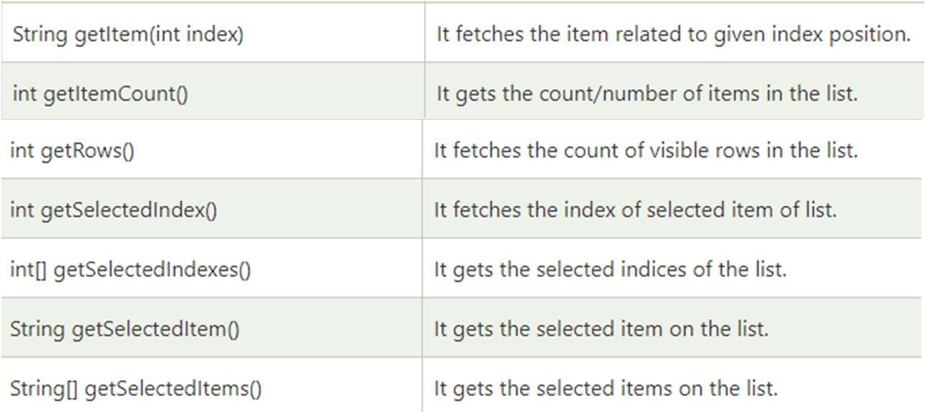

## Java AWT List Example

**import** java.awt.*;

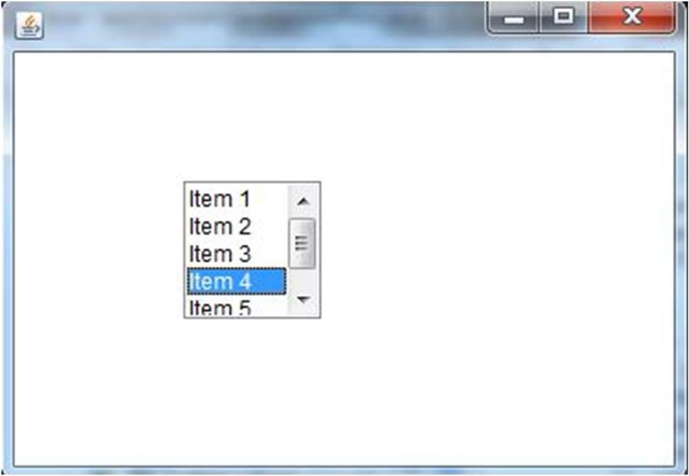**public class** ListExample1

{

ListExample1() {

Frame f = **new** Frame(); List l1 = **new** List(5);

l1.setBounds(100, 100, 75, 75);

l1.add("Item 1");

l1.add("Item 2");

l1.add("Item 3");

l1.add("Item 4");

l1.add("Item 5"); f.add(l1);

f.setSize(400, 400); f.setLayout(**null**); f.setVisible(**true**);

}

**public static void** main(String args[])

{

**new** ListExample1();

}

}

#### Java AWT List Example with ActionListener

**import** java.awt.*; **import** java.awt.event.*; **public class** ListExample2

{

ListExample2() {

Frame f = **new** Frame();

**final** Label label = **new** Label(); label.setAlignment(Label.CENTER);

label.setSize(500, 100);

Button b = **new** Button("Show"); b.setBounds(200, 150, 80, 30);

**final** List l1 = **new** List(4, **false**); l1.setBounds(100, 100, 70, 70); l1.add("C");

l1.add("C++");

l1.add("Java");

l1.add("PHP");

**final** List l2=**new** List(4, **true**); l2.setBounds(100, 200, 70, 70); l2.add("Turbo C++");

l2.add("Spring"); l2.add("Hibernate"); l2.add("CodeIgniter");

f.add(l1);

f.add(l2);

f.add(label);

f.add(b); f.setSize(450,450); f.setLayout(**null**); f.setVisible(**true**);

b.addActionListener(**new** ActionListener() {

**public void** actionPerformed(ActionEvent e) {

String data = "Programming language Selected: "+l1.getItem(l1.getSelectedIndex()); data += ", Framework Selected:";

**for**(String frame:l2.getSelectedItems()) { data += frame + " ";

}

label.setText(data);

}

});

}

**public static void** main(String args[])

{

**new** ListExample2();

}

}

#### Java AWT Canvas

* The Canvas class controls and represents a blank rectangular area where the application can draw or trap input events from the user. It inherits the Component class.

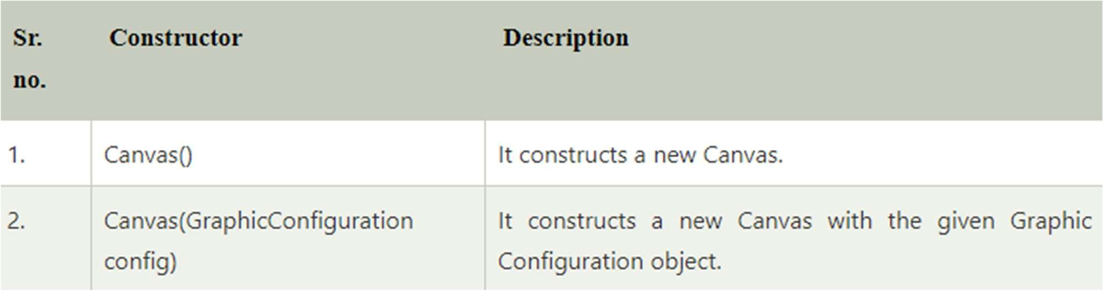

import java.awt.*;

public class CanvasExample

{

public CanvasExample()

{

Frame f = new Frame("Canvas Example"); f.add(new MyCanvas());

f.setLayout(null); f.setSize(400, 400); f.setVisible(true);

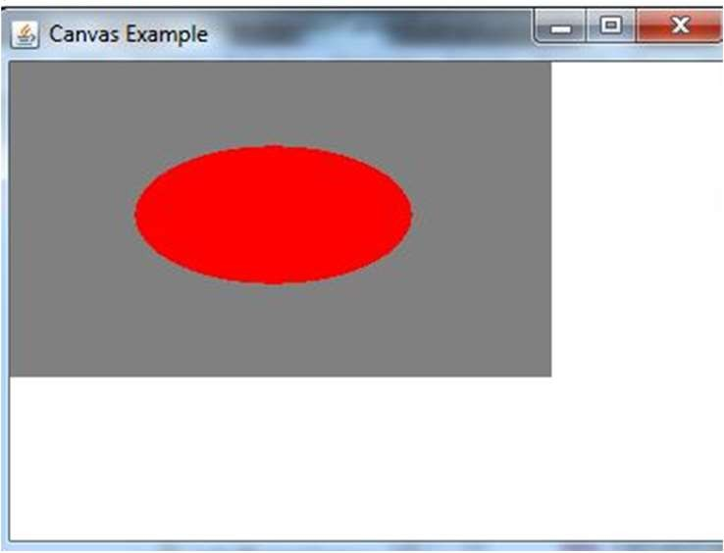}

public static void main(String args[])

{

new CanvasExample();

}

}

class MyCanvas extends Canvas

{

public MyCanvas() { setBackground (Color.GRAY); setSize(300, 200);

}

public void paint(Graphics g)

{

// adding specifications g.setColor(Color.red); g.fillOval(75, 75, 150, 75);

}

}

#### Java AWT MenuItem and Menu

* The object of MenuItem class adds a simple labeled menu item on menu. The items used in a menu must belong to the MenuItem or any of its subclass.
* The object of Menu class is a pull down menu component which is displayed on the menu bar. It inherits the MenuItem class.

AWT MenuItem class declaration

public class MenuItem extends MenuComponent implements Accessible

AWT Menu class declaration

public class Menu extends MenuItem implements MenuContainer, Accessible

#### Java AWT MenuItem and Menu Example

**import** java.awt.*;

**class** MenuExample

{

MenuExample(){

Frame f= **new** Frame("Menu and MenuItem Example"); MenuBar mb=**new** MenuBar();

Menu menu=**new** Menu("Menu");

Menu submenu=**new** Menu("Sub Menu"); MenuItem i1=**new** MenuItem("Item 1"); MenuItem i2=**new** MenuItem("Item 2"); MenuItem i3=**new** MenuItem("Item 3"); MenuItem i4=**new** MenuItem("Item 4"); MenuItem i5=**new** MenuItem("Item 5"); menu.add(i1);

menu.add(i2);

menu.add(i3);

submenu.add(i4); submenu.add(i5); menu.add(submenu); mb.add(menu); f.setMenuBar(mb); f.setSize(400,400); f.setLayout(**null**); f.setVisible(**true**);

}

**public static void** main(String args[])

{

**new** MenuExample();

}

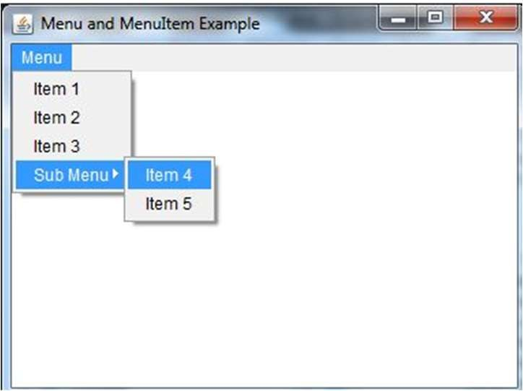}

#### Java AWT Panel

* + The Panel is a simplest container class. It provides space in which an application can attach any other component. It inherits the Container class.
  + It doesn't have title bar.

AWT Panel class declaration

public class Panel extends Container implements Accessible

#### Java AWT Panel Example

**import** java.awt.*;

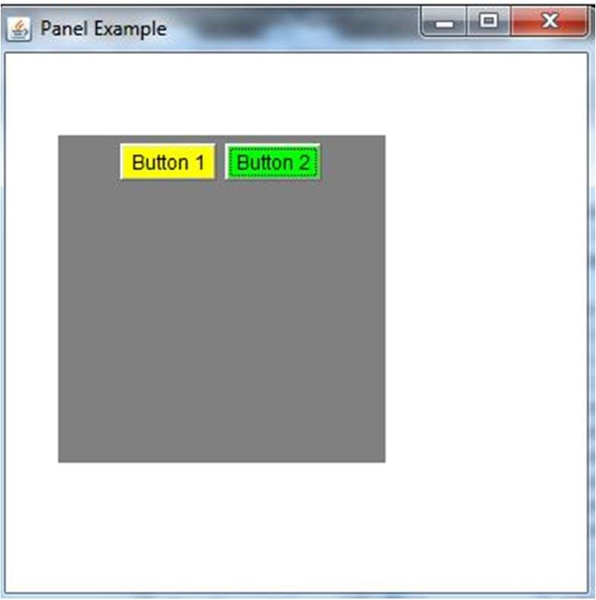**public class** PanelExample { PanelExample()

{

Frame f= **new** Frame("Panel Example"); Panel panel=**new** Panel(); panel.setBounds(40,80,200,200); panel.setBackground(Color.gray); Button b1=**new** Button("Button 1"); b1.setBounds(50,100,80,30); b1.setBackground(Color.yellow); Button b2=**new** Button("Button 2"); b2.setBounds(100,100,80,30); b2.setBackground(Color.green); panel.add(b1); panel.add(b2); f.add(panel);

f.setSize(400,400);

f.setLayout(**null**); f.setVisible(**true**);

}

**public static void** main(String args[])

{

**new** PanelExample();

}

} By Jagadish Sahoo

## Java AWT Dialog

* The Dialog control represents a top level window with a border and a title used to take some form of input from the user. It inherits the Window class.
* Unlike Frame, it doesn't have maximize and minimize buttons.

Frame vs Dialog

* Frame and Dialog both inherits Window class. Frame has maximize and minimize buttons but Dialog doesn't have.

Java AWT Dialog Example

**import** java.awt.*;

**import** java.awt.event.*;

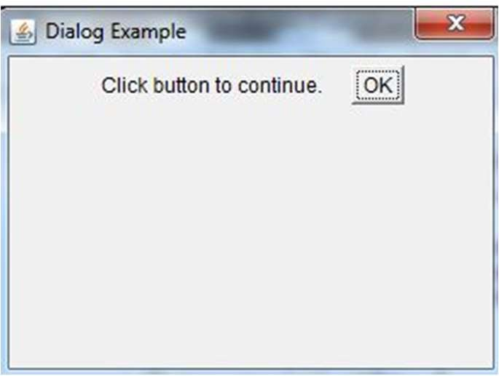**public class** DialogExample { **private static** Dialog d; DialogExample() {

Frame f= **new** Frame();

d = **new** Dialog(f , "Dialog Example", **true**); d.setLayout( **new** FlowLayout() );

Button b = **new** Button ("OK"); b.addActionListener ( **new** ActionListener()

{

**public void** actionPerformed( ActionEvent e )

{

DialogExample.d.setVisible(**false**);

}

});

d.add( **new** Label ("Click button to continue.")); d.add(b);

d.setSize(300,300); d.setVisible(**true**);

}

**public static void** main(String args[])

{

**new** DialogExample();

}

}

#### Java WindowListener Interface

* The Java WindowListener is notified whenever you change the state of window. It is notified against WindowEvent. The WindowListener interface is found in java.awt.event package. It has 7 methods.

1. **public abstract void** windowActivated(WindowEvent e);
2. **public abstract void** windowClosed(WindowEvent e);
3. **public abstract void** windowClosing(WindowEvent e);
4. **public abstract void** windowDeactivated(WindowEvent e);
5. **public abstract void** windowDeiconified(WindowEvent e);
6. **public abstract void** windowIconified(WindowEvent e);
7. **public abstract void** windowOpened(WindowEvent e);

import java.awt.*;

import java.awt.event.WindowEvent; import java.awt.event.WindowListener; public class WindowExample extends Frame implements WindowListener{

WindowExample(){ addWindowListener(this);

setSize(400,400); setLayout(null); setVisible(true);

}

public static void main(String[] args) { new WindowExample();

}

public void windowActivated(WindowEvent arg0) { System.out.println("activated");

}

public void windowClosed(WindowEvent arg0) { System.out.println("closed");

}

public void windowClosing(WindowEvent arg0) { System.out.println("closing");

dispose();

}

public void windowDeactivated(WindowEvent arg0) { System.out.println("deactivated");

}

public void windowDeiconified(WindowEvent arg0) { System.out.println("deiconified");

}

public void windowIconified(WindowEvent arg0) { System.out.println("iconified");

}

public void windowOpened(WindowEvent arg0) { System.out.println("opened");

}

}

#### Java Adapter Classes

* Java adapter classes *provide the default implementation of listener interfaces*. If you inherit the adapter class, you will not be

forced to provide the implementation of all the methods of listener interfaces. So it *saves code*.

* The adapter classes are found

in **java.awt.event**, **java.awt.dnd** and **javax.swing.event** packages.

## java.awt.event Adapter classes

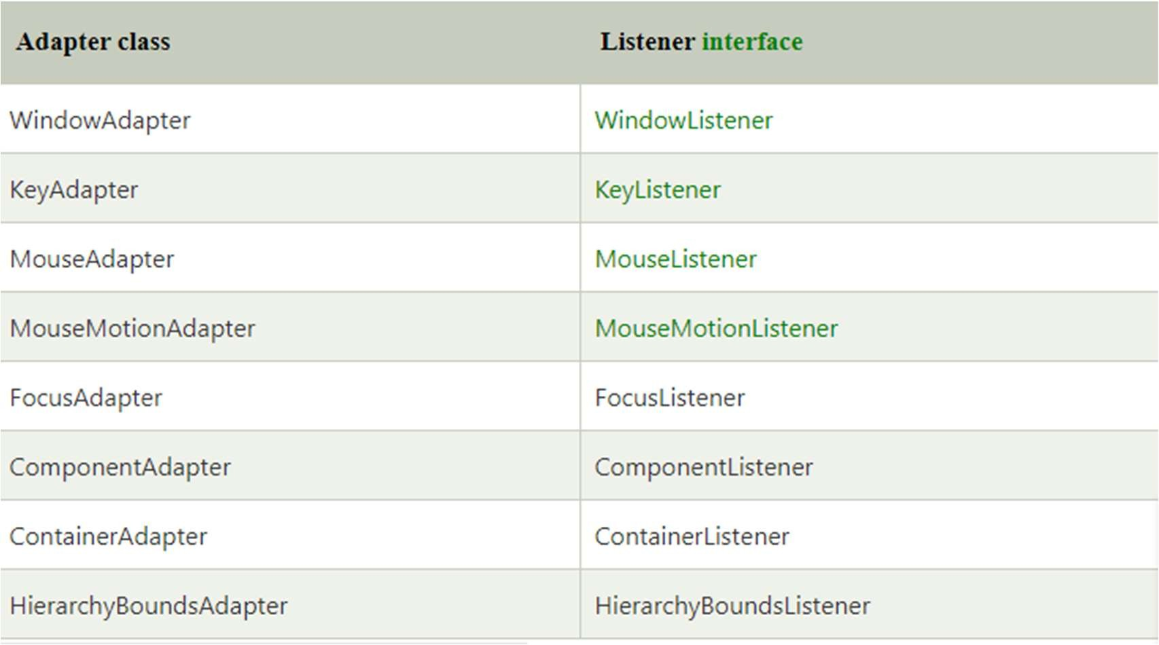

Java WindowAdapter Example

**import** java.awt.*;

**import** java.awt.event.*;

**public class** AdapterExample{ Frame f; AdapterExample(){

f=**new** Frame("Window Adapter"); f.addWindowListener(**new** WindowAdapter(){

**public void** windowClosing(WindowEvent e) { f.dispose();

}

});

f.setSize(400,400); f.setLayout(**null**); f.setVisible(**true**);

}

**public static void** main(String[] args) {

**new** AdapterExample();

}

}

## File Handling in Java

* In Java, a **File** is an abstract data type. A named location used to store related information is known as a **File**. There are several **File Operations** like **creating a new File, getting information about File, writing into a File, reading from a File** and **deleting a File**.
* Before understanding the File operations, it is required that we should have knowledge of **Stream** and **File methods**.

#### Stream

* + A series of data is referred to as **a stream**. **Stream** is classified into two types, i.e., **Byte Stream** and **Character Stream**.

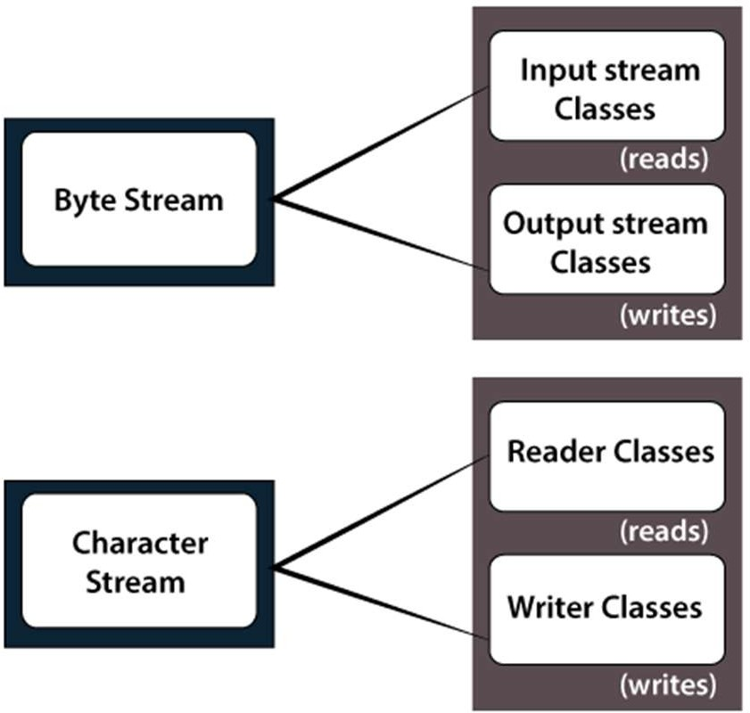

Byte Stream

**Byte Stream** is mainly involved with byte data. A file handling process with a byte stream is a process in which an input is provided and executed with the byte data.

Character Stream

**Character Stream** is mainly involved with character data. A file handling process with a character stream is a process in which an input is provided and executed with the character data.

#### Java File Class Methods

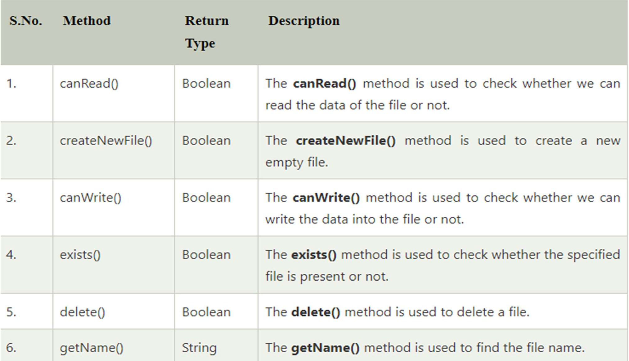By Jagadish Sahoo

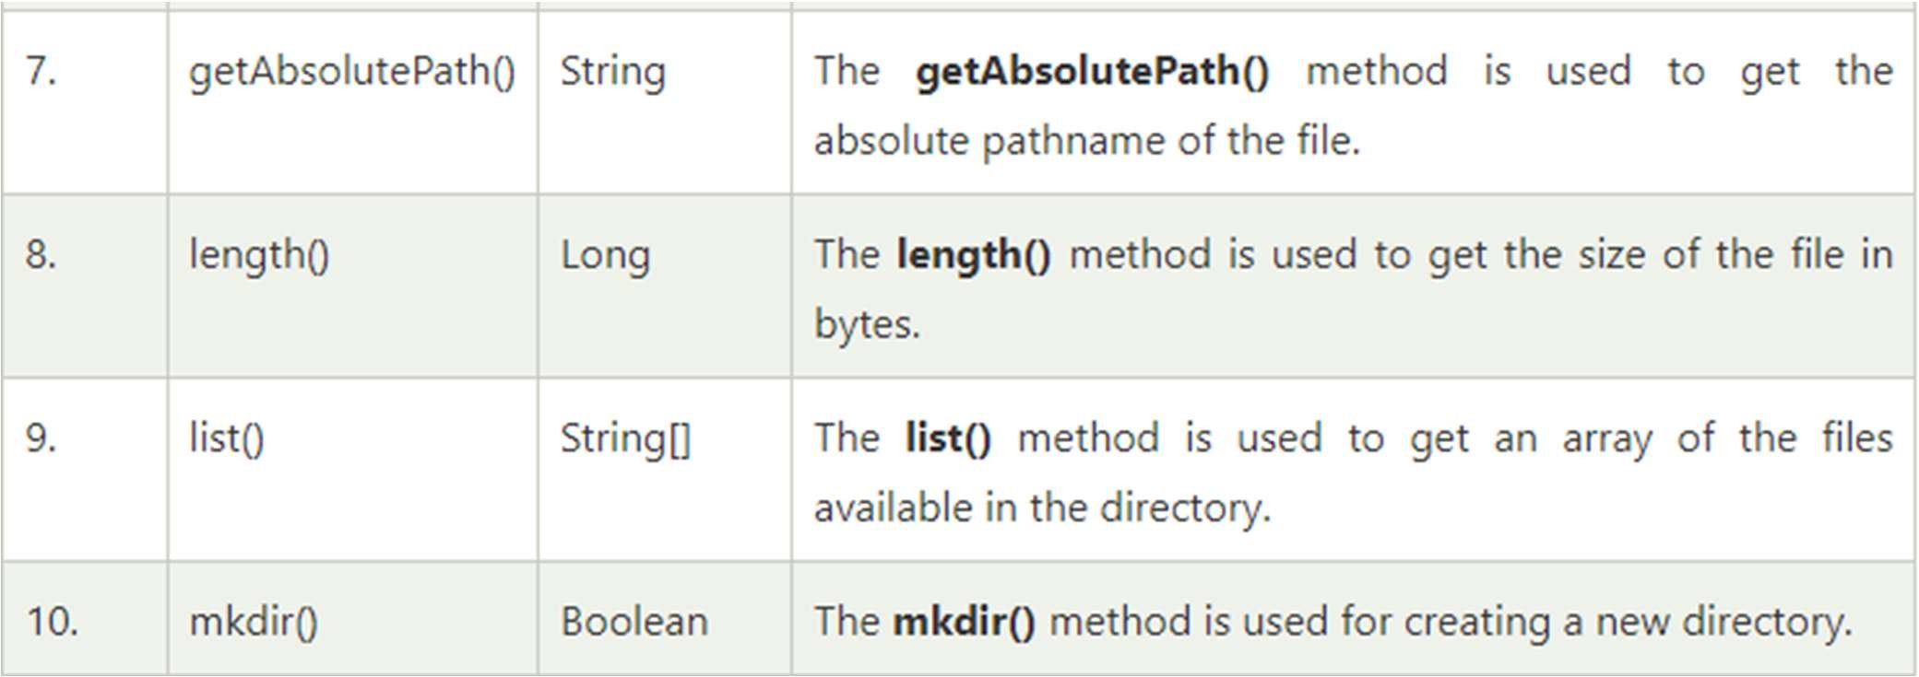

#### File Operations

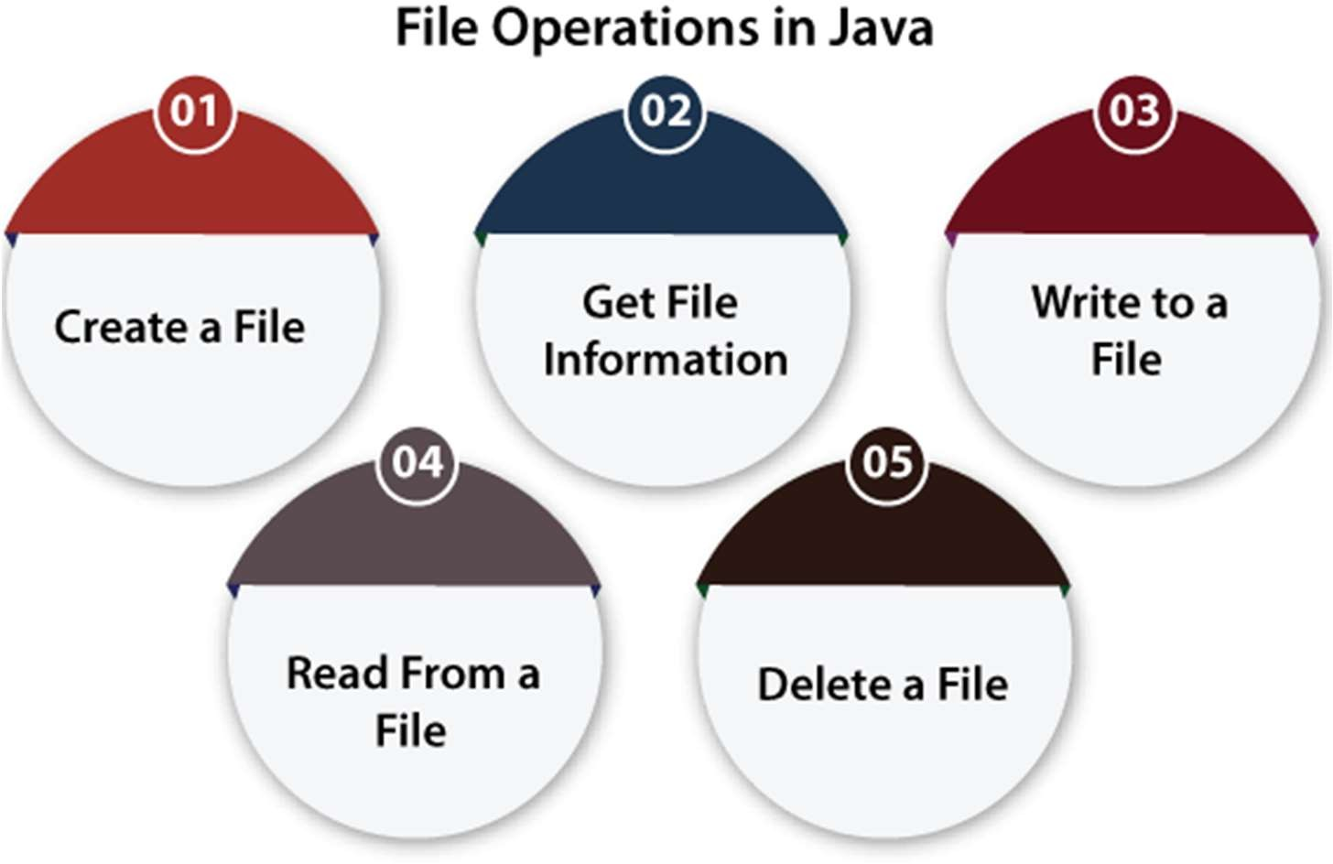

Create a File

* + **Create a File** operation is performed to create a new file. We use the **createNewFile()** method of file. The **createNewFile()** method returns true when it successfully creates a new file and returns false when the file already exists.

import java.io.File;

// Importing the IOException class for handling errors import java.io.IOException;

class CreateFile {

public static void main(String args[]) { try {

// Creating an object of a file

File f0 = new File("D:FileOperationExample.txt"); if (f0.createNewFile()) {

System.out.println("File " + f0.getName() + " is created successfully.");

} else {

System.out.println("File is already exist in the directory.");

}

} catch (IOException exception) {

System.out.println("An unexpected error is occurred."); exception.printStackTrace();

}

}

} By Jagadish Sahoo

#### Get File Information

**import** java.io.File;

**class** FileInfo {

**public static void** main(String[] args) {

File f0 = **new** File("D:FileOperationExample.txt");

**if** (f0.exists()) {

System.out.println("The name of the file is: " + f0.getName()); System.out.println("The absolute path of the file is: " + f0.getAbsolutePath()); System.out.println("Is file writeable?: " + f0.canWrite()); System.out.println("Is file readable " + f0.canRead()); System.out.println("The size of the file in bytes is: " + f0.length());

} **else** {

System.out.println("The file does not exist.");

}

}

}

#### Write to a File

**import** java.io.FileWriter;

**import** java.io.IOException;

**class** WriteToFile {

**public static void** main(String[] args) {

**try** {

FileWriter fwrite = **new** FileWriter("D:FileOperationExample.txt");

fwrite.write("A named location used to store related information is referred to as a File."); fwrite.close();

System.out.println("Content is successfully wrote to the file.");

} **catch** (IOException e) { System.out.println("Unexpected error occurred"); e.printStackTrace();

}

}

}

#### Read from a File

**import** java.io.File;

**import** java.io.FileNotFoundException;

**import** java.util.Scanner;

**class** ReadFromFile {

**public static void** main(String[] args) {

**try** {

File f1 = **new** File("D:FileOperationExample.txt"); Scanner dataReader = **new** Scanner(f1);

**while** (dataReader.hasNextLine()) {

String fileData = dataReader.nextLine(); System.out.println(fileData);

}

dataReader.close();

} **catch** (FileNotFoundException exception) { System.out.println("Unexcpected error occurred!"); exception.printStackTrace();

}

}

}

#### Delete a File

**import** java.io.File;

**class** DeleteFile {

**public static void** main(String[] args) {

File f0 = **new** File("D:FileOperationExample.txt");

**if** (f0.delete()) {

System.out.println(f0.getName()+ " file is deleted successfully.");

} **else** {

System.out.println("Unexpected error found in deletion of the file.");

}

}

}

**Java FileInputStream Class**

* + The FileInputStream class of the java.io package can be used to read data (in bytes) from files.
  + It extends the InputStream abstract class.

Methods of FileInputStream

* + read() Method
  + read() - reads a single byte from the file
  + read(byte[] array) - reads the bytes from the file and stores in the specified array
  + read(byte[] array, int start, int length) - reads the number of bytes equal to length from the file and stores in the specified array starting from the position start

import java.io.FileInputStream; public class Main {

public static void main(String args[]) { try {

FileInputStream input = new FileInputStream("input.txt"); System.out.println("Data in the file: ");

int i = input.read(); while(i != -1) {

System.out.print((char)i); i = input.read();

}

input.close();

}

catch(Exception e) { e.getStackTrace();

}

}

} By Jagadish Sahoo

### available() Method

To get the number of available bytes, we can use the available() method. import java.io.FileInputStream;

public class Main {

public static void main(String args[]) { try {

FileInputStream input = new FileInputStream("input.txt"); System.out.println("Available bytes at the beginning: " + input.available()); input.read();

input.read();

input.read();

System.out.println("Available bytes at the end: " + input.available()); input.close();

}

catch (Exception e) { e.getStackTrace();

}

}

} By Jagadish Sahoo

### skip() Method

import java.io.FileInputStream; public class Main {

public static void main(String args[]) { try {

FileInputStream input = new FileInputStream("input.txt"); input.skip(5);

System.out.println("Input stream after skipping 5 bytes:"); int i = input.read();

while (i != -1) { System.out.print((char) i);

i = input.read();

}

input.close();

}

catch (Exception e) { e.getStackTrace();

}

}

By Jagadish Sahoo

}

### Java FileOutputStream Class

* + The FileOutputStream class of the java.io package can be used to write data (in bytes) to the files.
  + It extends the OutputStream abstract class.

### Create a FileOutputStream

* 1. Using the path to file

// Including the boolean parameter

FileOutputStream output = new FileOutputStream(String path, boolean value);

// Not including the boolean parameter

FileOutputStream output = new FileOutputStream(String path);

* Created an output stream that will be linked to the file specified by the path.
* value is an optional boolean parameter. If it is set to true, the new data will be appended to the end of the existing data in the file. Otherwise, the new data overwrites the existing data in the file.
  1. Using an object of the file

FileOutputStream output = new FileOutputStream(File fileObject);

Created an output stream that will be linked to the file specified by fileObject.

Methods of FileOutputStream write() Method

* write() - writes the single byte to the file output stream
* write(byte[] array) - writes the bytes from the specified array to the output stream
* write(byte[] array, int start, int length) - writes the number of bytes equal to length to the output stream from an array starting from the position start

import java.io.FileOutputStream; public class Main {

public static void main(String[] args) {

String data = "This is a line of text inside the file."; try {

FileOutputStream output = new FileOutputStream("output.txt"); byte[] array = data.getBytes();

output.write(array);

output.close();

}

catch(Exception e) { e.getStackTrace();

}

}

}

### flush() Method

**To clear the output stream, we can use the flush() method. This method forces the output stream to write all data to the destination.**

import java.io.FileOutputStream; import java.io.IOException; public class Main {

public static void main(String[] args) throws IOException { FileOutputStream out = null;

String data = "This is demo of flush method"; try {

out = new FileOutputStream(" flush.txt"); out.write(data.getBytes());

out.flush();

out.close();

}

catch(Exception e) { e.getStackTrace();

### Copy files using i/o streams

import java.io.FileInputStream; import java.io.FileOutputStream; class Main {

public static void main(String[] args) { byte[] array = new byte[50];

try {

FileInputStream sourceFile = new FileInputStream("input.txt"); FileOutputStream destFile = new FileOutputStream("newFile"); sourceFile.read(array);

destFile.write(array);

System.out.println("The input.txt file is copied to newFile."); sourceFile.close();

destFile.close();

}

catch (Exception e) { e.getStackTrace();

#### Java Swing

* **Java Swing tutorial** is a part of Java Foundation Classes (JFC) that

is *used to create window-based applications*. It is built on the top of AWT (Abstract Windowing Toolkit) API and entirely written in java.

* Unlike AWT, Java Swing provides platform-independent and lightweight components.
* The javax.swing package provides classes for java swing API such as JButton, JTextField, JTextArea, JRadioButton, JCheckbox, JMenu, JColorChooser etc.

#### Difference between AWT and Swing

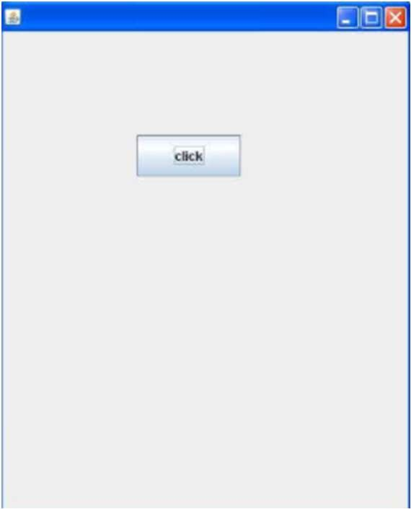Simple Java Swing Example

**import** javax.swing.*;

**public class** FirstSwingExample {

**public static void** main(String[] args) {

JFrame f=**new** JFrame();//creating instance of JFrame

JButton b=**new** JButton("click");//creating instance of JButton b.setBounds(130,100,100, 40);//x axis, y axis, width, height

f.add(b);//adding button in JFrame

f.setSize(400,500);//400 width and 500 height f.setLayout(**null**);//using no layout managers f.setVisible(**true**);//making the frame visible

}

}

#### Java JButton

* The JButton class is used to create a labeled button that has platform independent implementation. The application result in some action when the button is pushed. It inherits AbstractButton class.

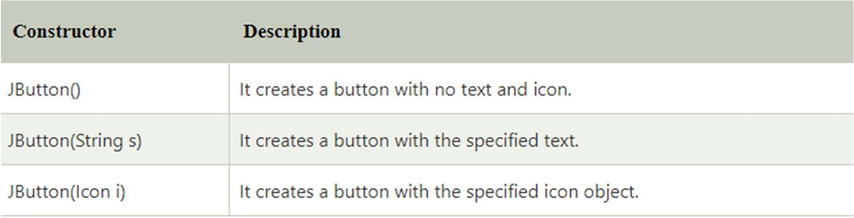

#### Commonly used Methods of AbstractButton class:

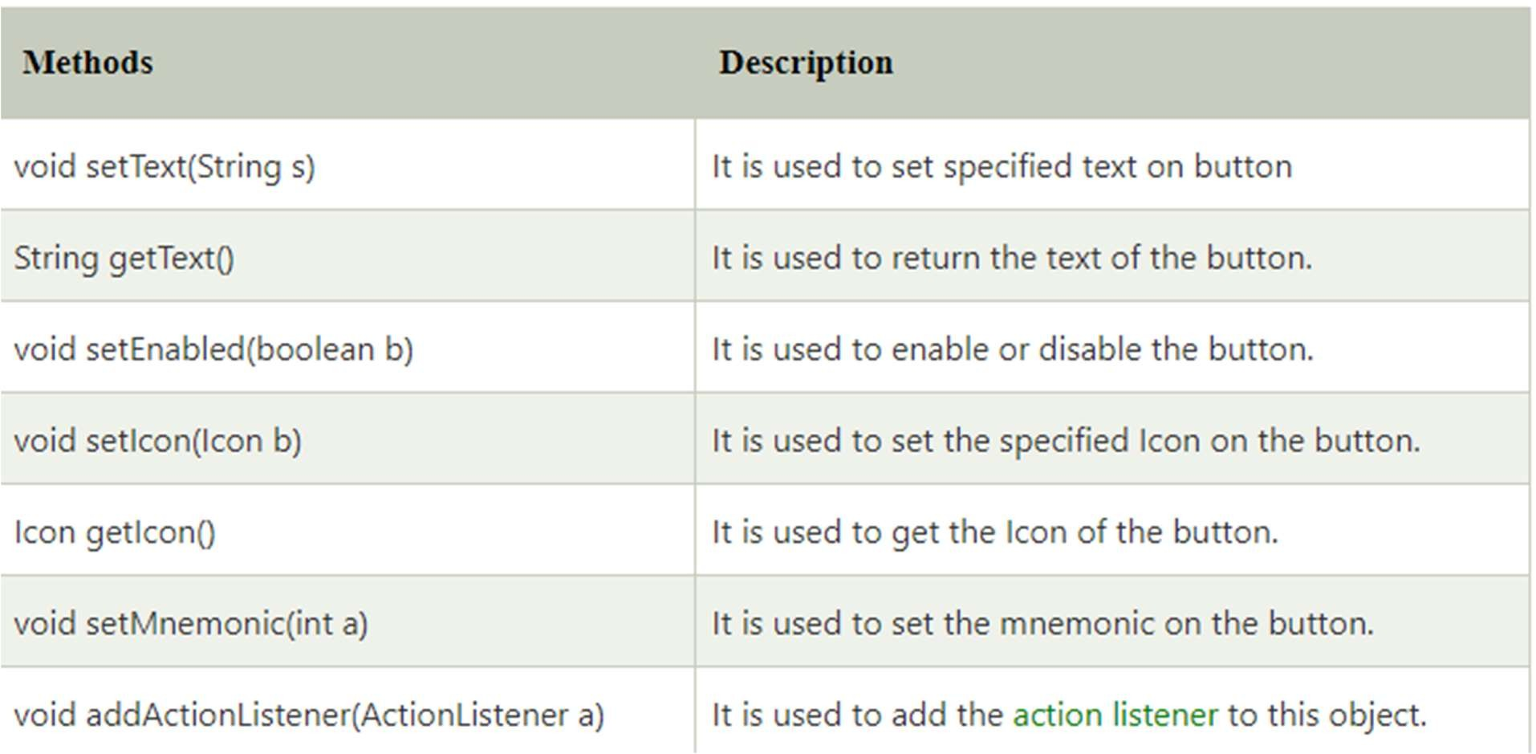

Java JButton Example with ActionListener

**import** java.awt.event.*;

**import** javax.swing.*;

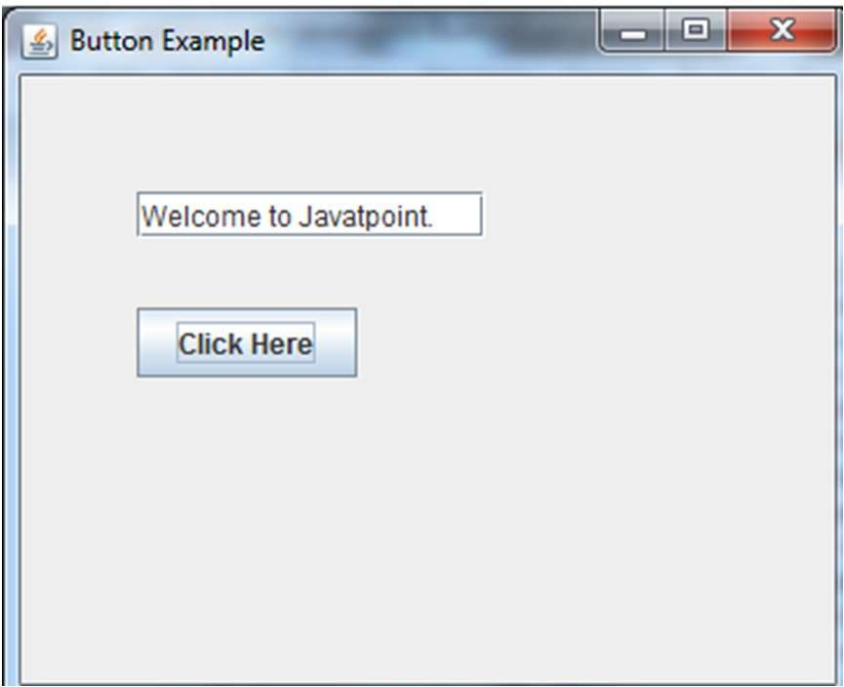**public class** ButtonExample {

**public static void** main(String[] args) { JFrame f=**new** JFrame("Button Example"); **final** JTextField tf=**new** JTextField(); tf.setBounds(50,50, 150,20);

JButton b=**new** JButton("Click Here"); b.setBounds(50,100,95,30); b.addActionListener(**new** ActionListener(){

**public void** actionPerformed(ActionEvent e){ tf.setText("Welcome to Javatpoint.");

}

});

f.add(b);f.add(tf); f.setSize(400,400); f.setLayout(**null**); f.setVisible(**true**);

}

}

#### Example of displaying image on the button:

**import** javax.swing.*;

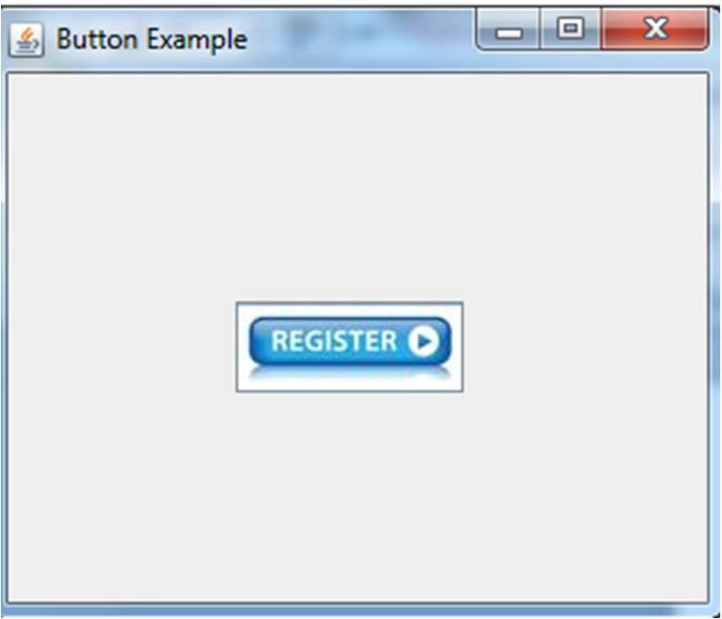**public class** ButtonExample{ ButtonExample(){

JFrame f=**new** JFrame("Button Example");

JButton b=**new** JButton(**new** ImageIcon("D:\\icon.png")); b.setBounds(100,100,100, 40);

f.add(b); f.setSize(300,400); f.setLayout(**null**); f.setVisible(**true**);

f.setDefaultCloseOperation(JFrame.EXIT_ON_CLOSE);

}

**public static void** main(String[] args) {

**new** ButtonExample();

}

}

#### Java JLabel

* The object of JLabel class is a component for placing text in a container. It is used to display a single line of read only text. The text can be changed by an application but a user cannot edit it directly. It inherits JComponent class.

#### Commonly used Constructors:

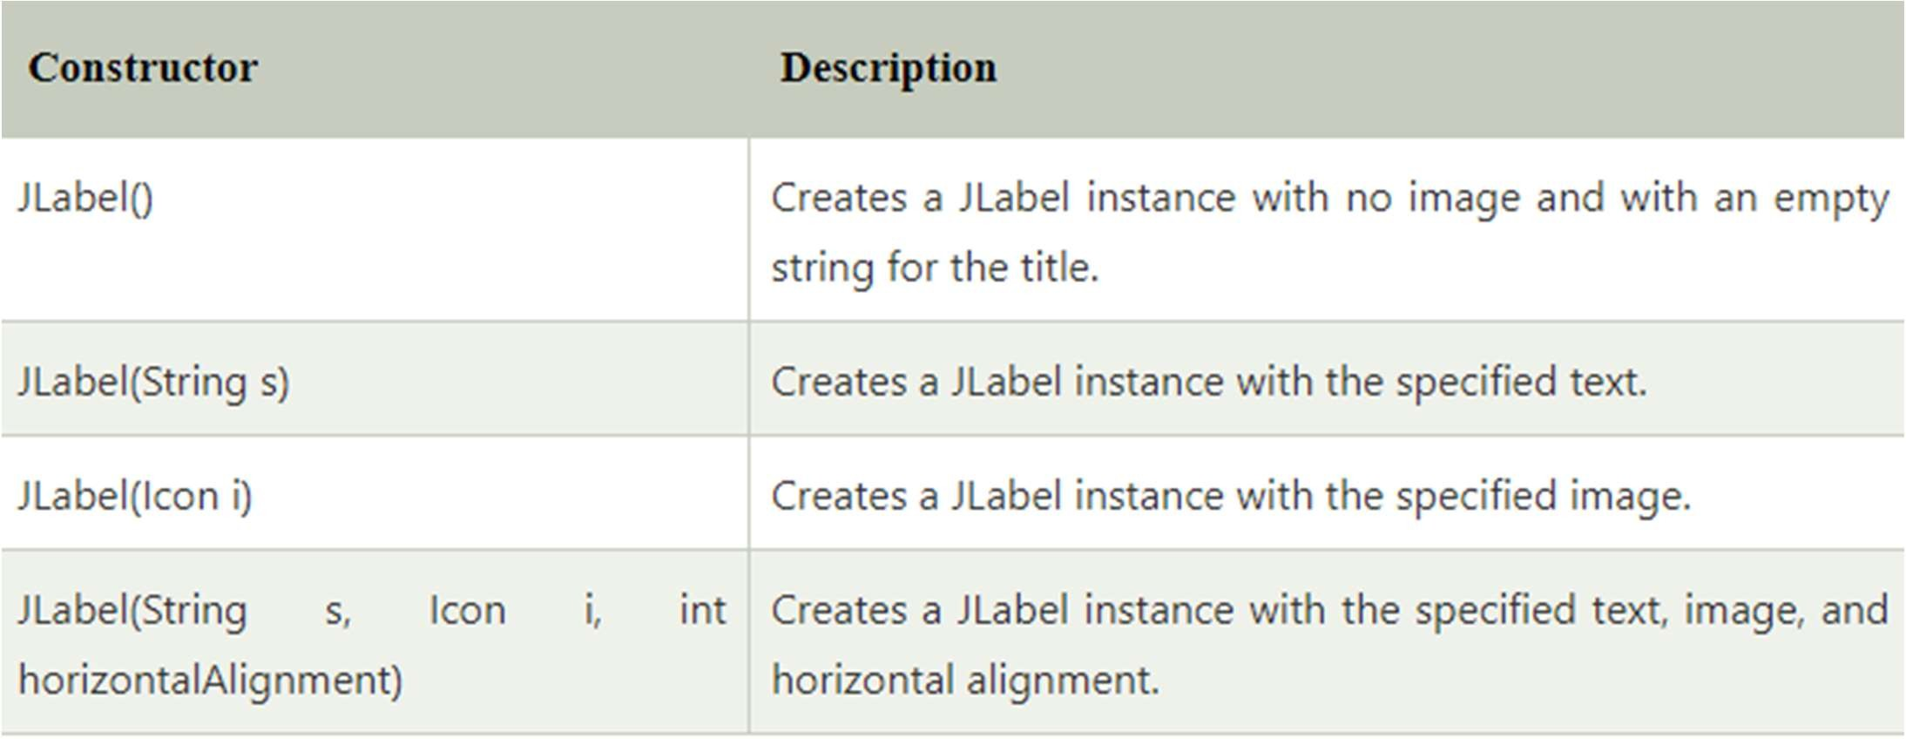

Commonly used Methods:

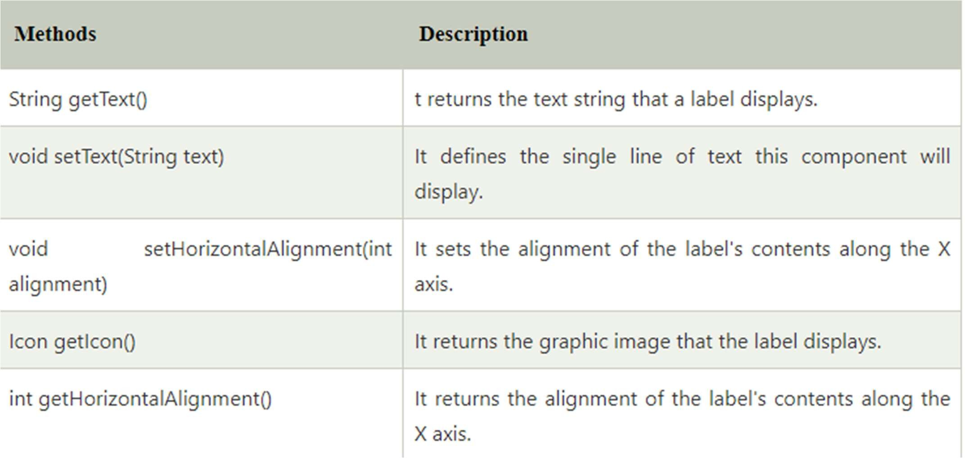

#### Java JLabel Example with ActionListener

**import** javax.swing.*;

**import** java.awt.*;

**import** java.awt.event.*;

**public class** LabelExample **extends** Frame **implements** ActionListener{ JTextField tf; JLabel l; JButton b;

LabelExample(){ tf=**new** JTextField();

tf.setBounds(50,50, 150,20); l=**new** JLabel(); l.setBounds(50,100, 250,20); b=**new** JButton("Find IP"); b.setBounds(50,150,95,30); b.addActionListener(**this**); add(b);add(tf);add(l); setSize(400,400); setLayout(**null**); setVisible(**true**);

**public void** actionPerformed(ActionEvent e) {

**try**{

String host=tf.getText();

String ip=java.net.InetAddress.getByName(host)

.getHostAddress();

l.setText("IP of "+host+" is: "+ip);

}**catch**(Exception ex){System.out.println(ex);}

}

**public static void** main(String[] args) {

**new** LabelExample();

} }

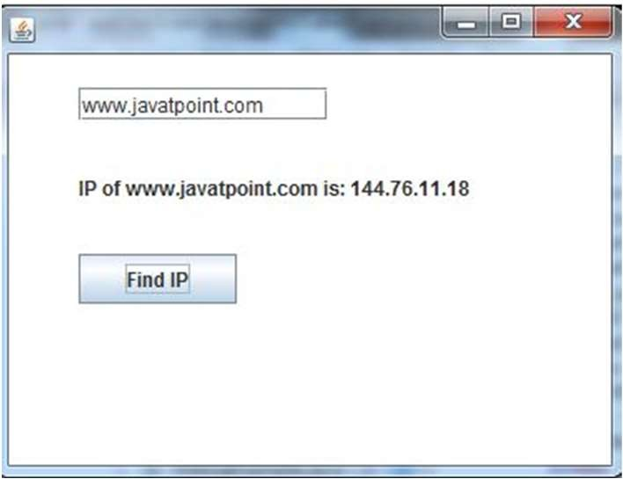}

#### Java JTextField

* The object of a JTextField class is a text component that allows the editing of a single line text. It inherits JTextComponent class.

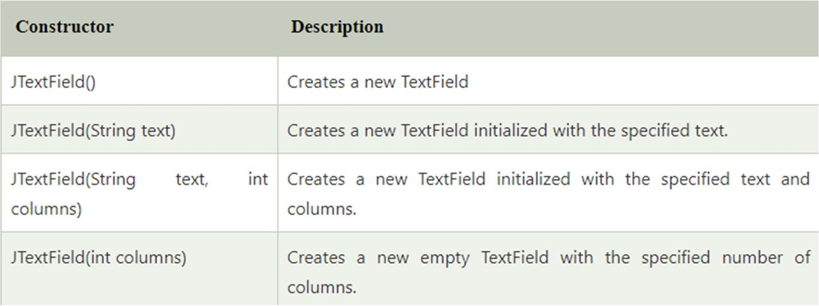

#### Commonly used Methods:

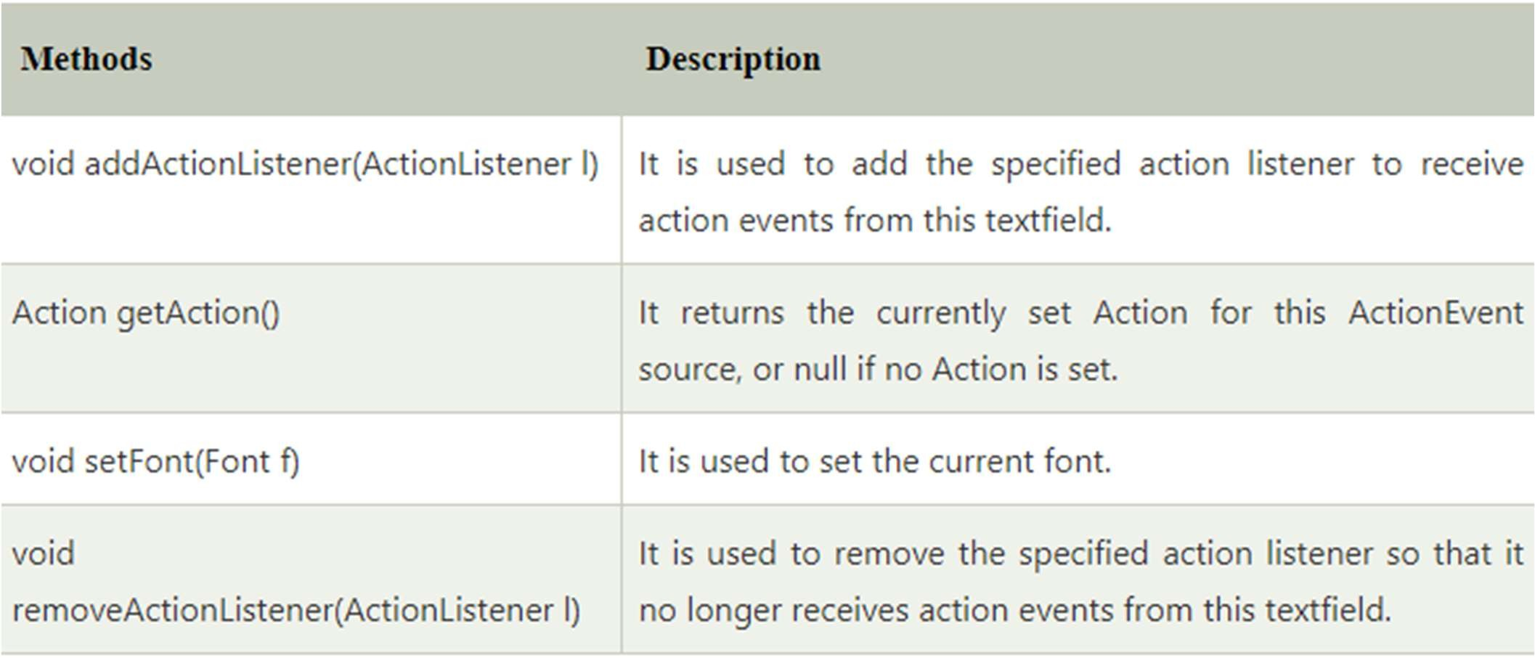

Java JTextField Example with ActionListener

**import** javax.swing.*;

**import** java.awt.event.*;

**public class** TextFieldExample **implements** ActionListener{ JTextField tf1,tf2,tf3;

JButton b1,b2; TextFieldExample(){

JFrame f= **new** JFrame(); tf1=**new** JTextField(); tf1.setBounds(50,50,150,20); tf2=**new** JTextField(); tf2.setBounds(50,100,150,20); tf3=**new** JTextField(); tf3.setBounds(50,150,150,20); tf3.setEditable(**false**);

b1=**new** JButton("+"); b1.setBounds(50,200,50,50); b2=**new** JButton("-"); b2.setBounds(120,200,50,50); b1.addActionListener(**this**); b2.addActionListener(**this**);

f.add(tf1);f.add(tf2);f.add(tf3);f.add(b1);f.add(b2); f.setSize(300,300);

f.setLayout(**null**); f.setVisible(**true**);

**public void** actionPerformed(ActionEvent e) {

String s1=tf1.getText(); String s2=tf2.getText(); **int** a=Integer.parseInt(s1); **int** b=Integer.parseInt(s2); **int** c=0; **if**(e.getSource()==b1){

c=a+b;

}**else if**(e.getSource()==b2){ c=a-b;

}

String result=String.valueOf(c); tf3.setText(result);

}

**public static void** main(String[] args) {

**new** TextFieldExample();

} }

}

#### Java JTextArea

* The object of a JTextArea class is a multi line region that displays text. It allows the editing of multiple line text. It inherits JTextComponent class

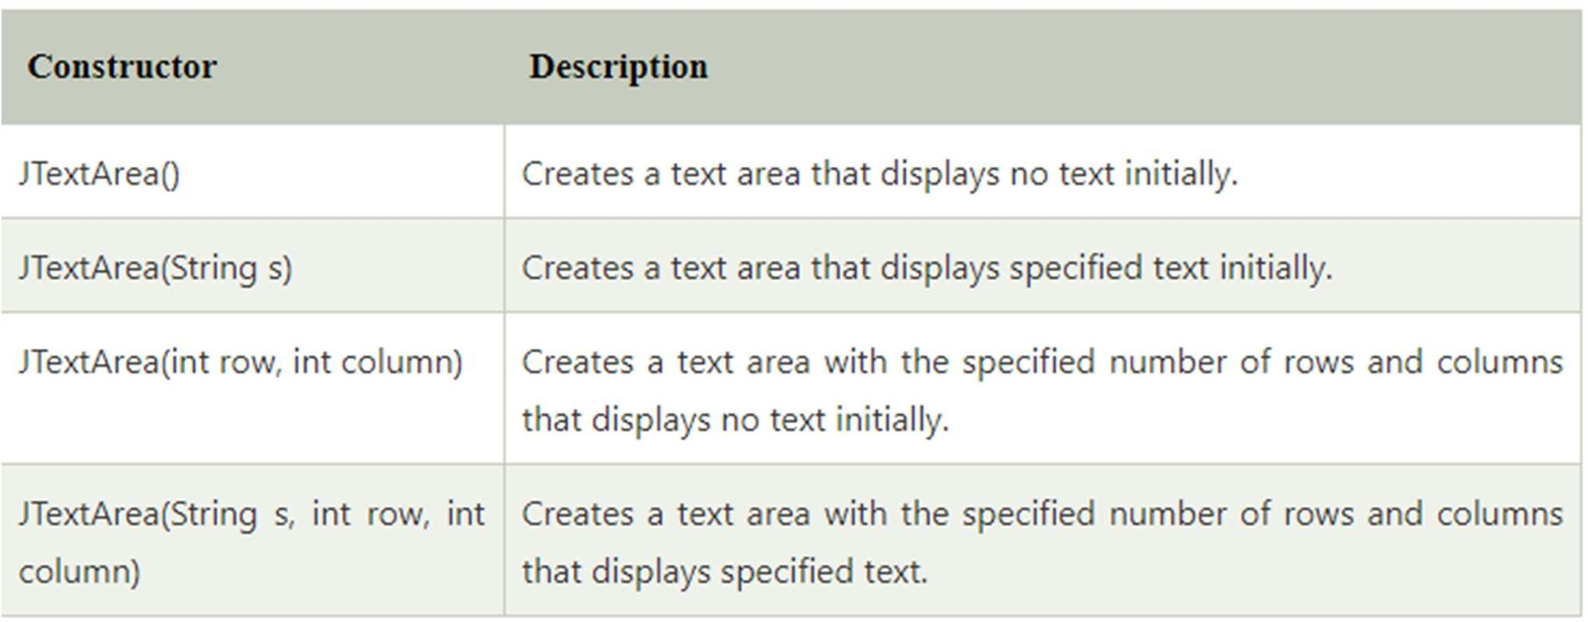

#### Commonly used Methods:

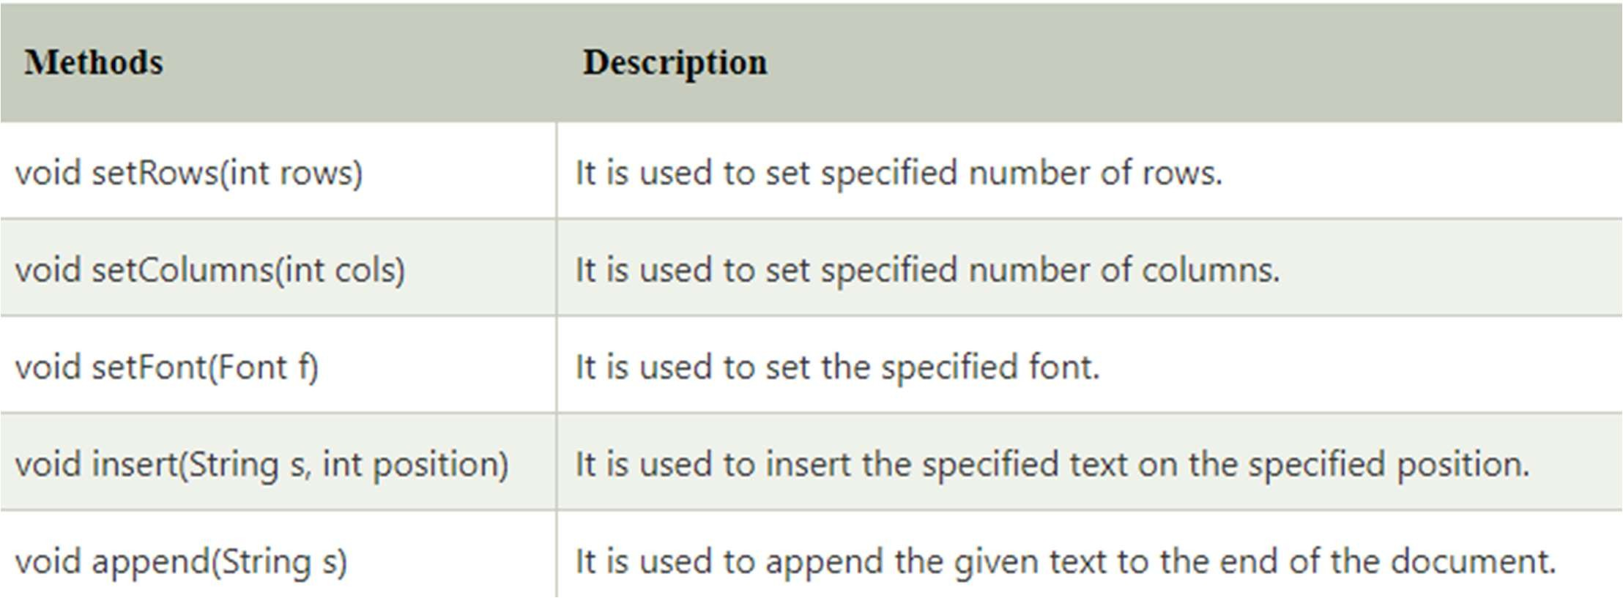

Java JTextArea Example with ActionListener

**import** javax.swing.*;

**import** java.awt.event.*;

**public class** TextAreaExample **implements** ActionListener{ JLabel l1,l2;

JTextArea area; JButton b; TextAreaExample() {

JFrame f= **new** JFrame(); l1=**new** JLabel(); l1.setBounds(50,25,100,30); l2=**new** JLabel(); l2.setBounds(160,25,100,30); area=**new** JTextArea(); area.setBounds(20,75,250,200); b=**new** JButton("Count Words"); b.setBounds(100,300,120,30); b.addActionListener(**this**);

f.add(l1);f.add(l2);f.add(area);f.add(b); f.setSize(450,450);

f.setLayout(**null**); f.setVisible(**true**);

}

public void actionPerformed(ActionEvent e){ String text=area.getText();

String words[]=text.split("\\s"); l1.setText("Words: "+words.length); l2.setText("Characters: "+text.length());

}

public static void main(String[] args) { new TextAreaExample();

}

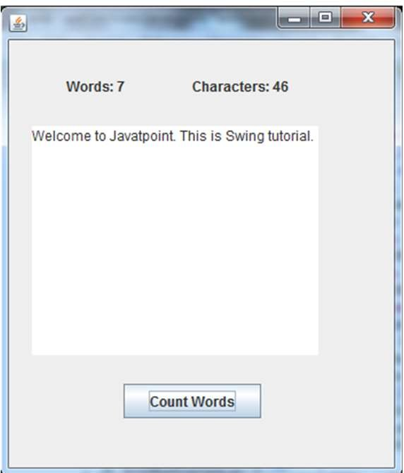}

By Jagadish Sahoo

#### Java JPasswordField

* The object of a JPasswordField class is a text component specialized for password entry. It allows the editing of a single line of text. It inherits JTextField class.

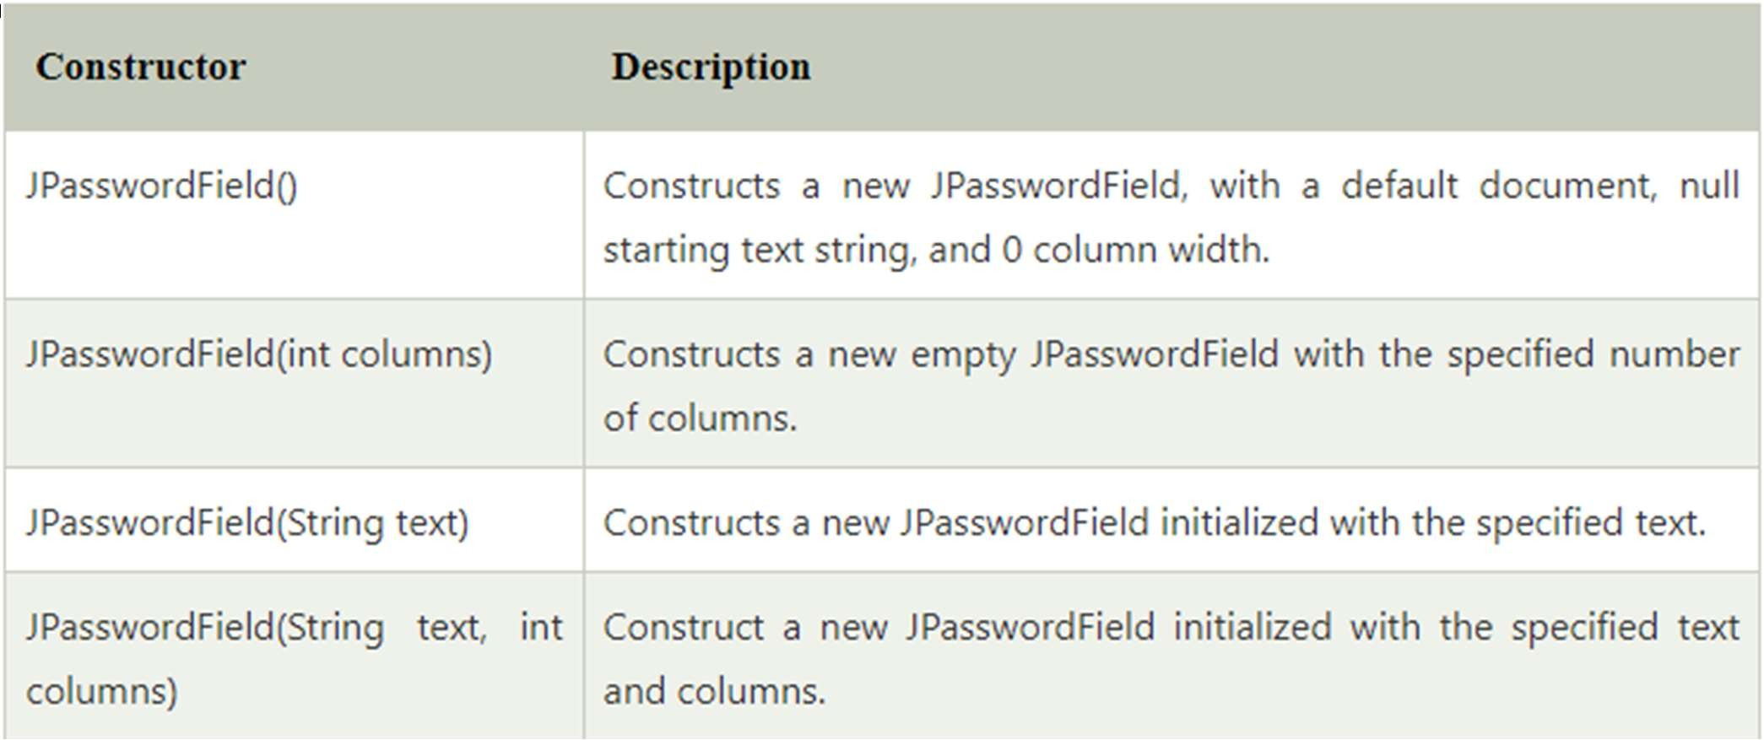•

By Jagadish Sahoo

#### Java JPasswordField Example with ActionListener

**import** javax.swing.*;

**import** java.awt.event.*;

**public class** PasswordFieldExample {

**public static void** main(String[] args) {

**final** JTextField text = **new** JTextField();

text.setBounds(100,20, 100,30);

f.add(value); f.add(l1); f.add(label); f.add(l2); f.ad d(b); f.add(text);

f.setSize(300,300);

JFrame f=**new** JFrame("Password Field Example");

**final** JLabel label = **new** JLabel(); label.setBounds(20,150, 200,50);

**final** JPasswordField value = **new** JPasswordField(); value.setBounds(100,75,100,30);

JLabel l1=**new** JLabel("Username:"); l1.setBounds(20,20, 80,30);

JLabel l2=**new** JLabel("Password:"); }

f.setLayout(**null**); f.setVisible(**true**);

b.addActionListener(**new** ActionListener() {

**public void** actionPerformed(ActionEvent e) { String data = "Username " + text.getText(); data += ", Password: "

+ **new** String(value.getPassword()); label.setText(data);

}

});

l2.setBounds(20,75, 80,30);

JButton b = **new** JButton("Login"); b.setBounds(100,120, 80,30);

}

By Jagadish Sahoo

#### Java JCheckBox

* The JCheckBox class is used to create a checkbox. It is used to turn an option on (true) or off (false). Clicking on a CheckBox changes its state from "on" to "off" or from "off" to "on ".
* It inherits JToggleButton class.

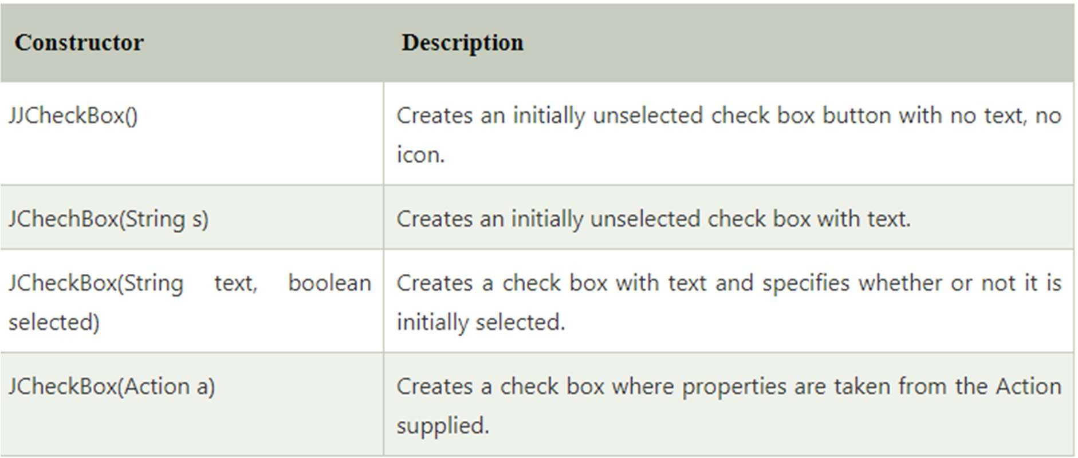

By Jagadish Sahoo

#### Commonly used Methods:

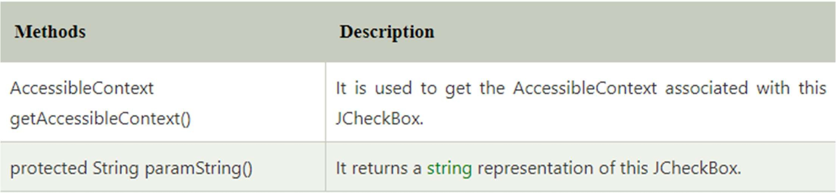

Java JCheckBox Example with ItemListener

**import** javax.swing.*;

**import** java.awt.event.*;

**public class** CheckBoxExample

{

CheckBoxExample(){

JFrame f= **new** JFrame("CheckBox Example"); **final** JLabel label = **new** JLabel(); label.setHorizontalAlignment(JLabel.CENTER); label.setSize(400,100);

JCheckBox checkbox1 = **new** JCheckBox("C++"); checkbox1.setBounds(150,100, 50,50); JCheckBox checkbox2 = **new** JCheckBox("Java"); checkbox2.setBounds(150,150, 50,50); f.add(checkbox1); f.add(checkbox2); f.add(label); checkbox1.addItemListener(**new** ItemListener() {

**public void** itemStateChanged(ItemEvent e) { label.setText("C++ Checkbox: "

+ (e.getStateChange()==1?"checked":"unchecked"));

checkbox2.addItemListener(new ItemListener() {

public void itemStateChanged(ItemEvent e) { label.setText("Java Checkbox: "

+ (e.getStateChange()==1?"checked":"unchecked"));

}

});

f.setSize(400,400); f.setLayout(null); f.setVisible(true);

}

public static void main(String args[])

{

new CheckBoxExample();

}

}

}

});

#### Java JCheckBox Example: Food Order

**import** javax.swing.*;

**import** java.awt.event.*;

**public class** CheckBoxExample **extends** JFrame **implements** ActionListener{ JLabel l;

JCheckBox cb1,cb2,cb3; JButton b; CheckBoxExample(){

l=**new** JLabel("Food Ordering System"); l.setBounds(50,50,300,20);

cb1=**new** JCheckBox("Pizza @ 100"); cb1.setBounds(100,100,150,20); cb2=**new** JCheckBox("Burger @ 30"); cb2.setBounds(100,150,150,20); cb3=**new** JCheckBox("Tea @ 10"); cb3.setBounds(100,200,150,20); b=**new** JButton("Order"); b.setBounds(100,250,80,30); b.addActionListener(**this**);

add(l);add(cb1);add(cb2);add(cb3);add(b); setSize(400,400);

setLayout(**null**); setVisible(**true**);

setDefaultCloseOperation(EXIT_ON_CLOSE);

}

public void actionPerformed(ActionEvent e){ float amount=0;

String msg=""; if(cb1.isSelected()){

amount+=100; msg="Pizza: 100\n";

}

if(cb2.isSelected()){ amount+=30; msg+="Burger: 30\n";

}

if(cb3.isSelected()){ amount+=10; msg+="Tea: 10\n";

}

msg+=" \n";

JOptionPane.showMessageDialog(this,msg+"Total: "+amount);

}

public static void main(String[] args) { new CheckBoxExample();

By Ja}gadish Sahoo

}

#### Java JRadioButton

* The JRadioButton class is used to create a radio button. It is used to choose one option from multiple options. It is widely used in exam systems or quiz.
* It should be added in ButtonGroup to select one radio button only.

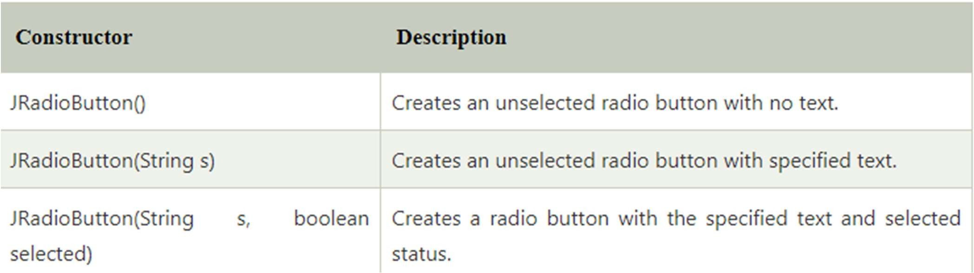

#### Commonly used Methods:

Java JRadioButton Example with ActionListener

**import** javax.swing.*;

**import** java.awt.event.*;

**class** RadioButtonExample **extends** JFrame **implements** ActionListener{ JRadioButton rb1,rb2;

JButton b; RadioButtonExample(){ rb1=**new** JRadioButton("Male"); rb1.setBounds(100,50,100,30);

rb2=**new** JRadioButton("Female"); rb2.setBounds(100,100,100,30); ButtonGroup bg=**new** ButtonGroup(); bg.add(rb1);bg.add(rb2);

b=**new** JButton("click"); b.setBounds(100,150,80,30); b.addActionListener(**this**); add(rb1);add(rb2);add(b); setSize(300,300); setLayout(**null**); setVisible(**true**);

}

**public void** actionPerformed(ActionEvent e){ **if**(rb1.isSelected()){ JOptionPane.showMessageDialog(**this**,"You are Male.");

}

**if**(rb2.isSelected()){ JOptionPane.showMessageDialog(**this**,"You are Female.");

}

}

**public static void** main(String args[]){

**new** RadioButtonExample();

}}

#### Java JComboBox

* The object of Choice class is used to show popup menu of choices. Choice selected by user is shown on the top of a menu. It inherits JComponent class.

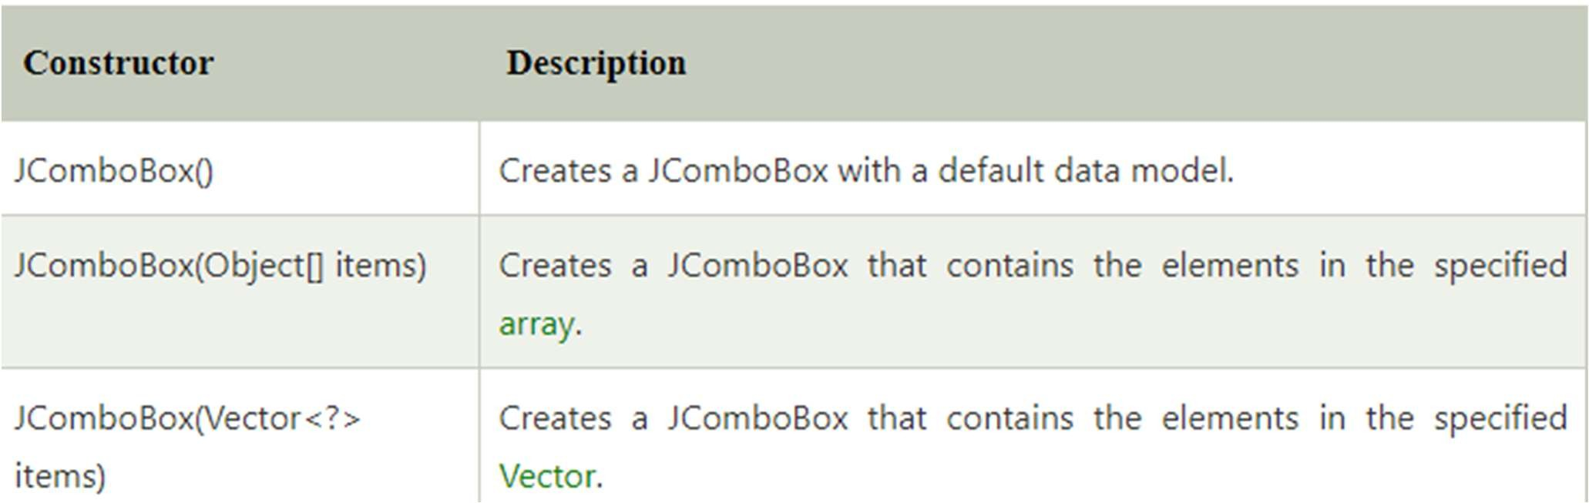

#### Commonly used Methods:

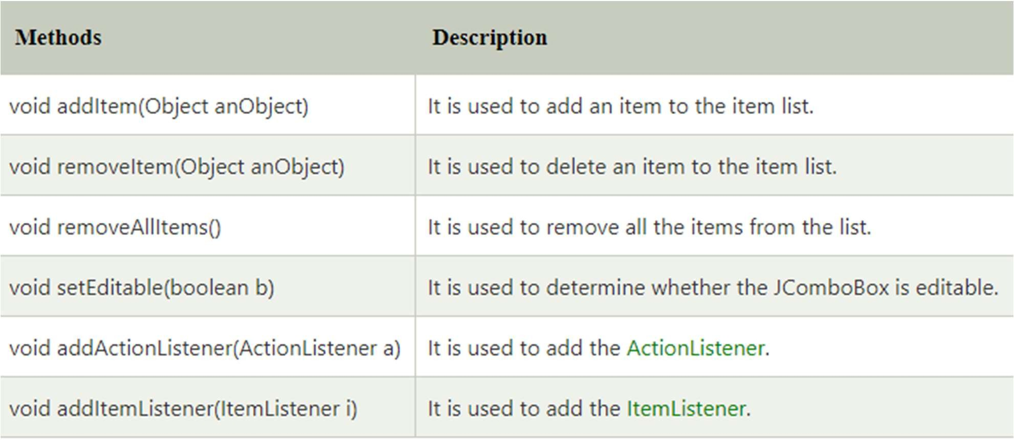

Java JComboBox Example with ActionListener

**import** javax.swing.*;

**import** java.awt.event.*;

**public class** ComboBoxExample { JFrame f;

ComboBoxExample(){

f=**new** JFrame("ComboBox Example");

**final** JLabel label = **new** JLabel(); label.setHorizontalAlignment(JLabel.CENTER); label.setSize(400,100);

JButton b=**new** JButton("Show"); b.setBounds(200,100,75,20);

String languages[]={"C","C++","C#","Java","PHP"}; **final** JComboBox cb=**new** JComboBox(languages); cb.setBounds(50, 100,90,20);

f.add(cb); f.add(label); f.add(b); f.setLayout(**null**); f.setSize(350,350); f.setVisible(**true**);

b.addActionListener(**new** ActionListener() {

**public void** actionPerformed(ActionEvent e) { String data = "Programming language Selected: "

+ cb.getItemAt(cb.getSelectedIndex()); label.setText(data);

}

});

}

**public static void** main(String[] args) {

**new** ComboBoxExample();

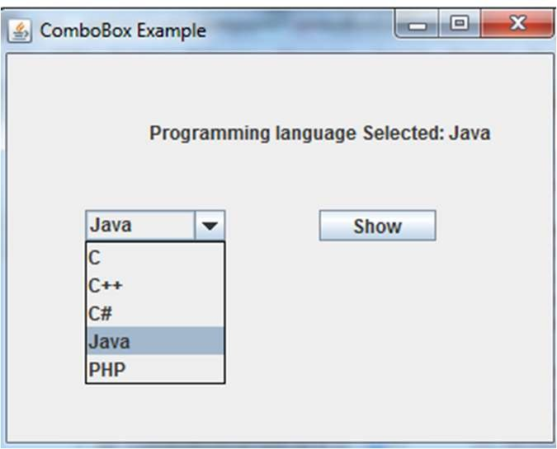}

}

By Jagadish Sahoo

#### Java JTable

* The JTable class is used to display data in tabular form. It is composed of rows and columns.

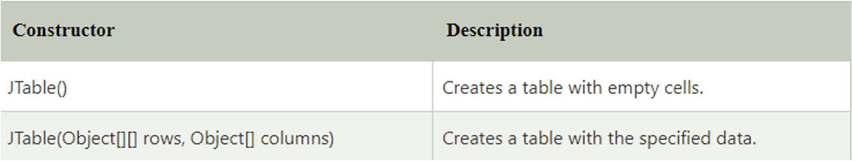

#### Java JTable Example with ListSelectionListener

**import** javax.swing.*;

**import** javax.swing.event.*;

**public class** TableExample {

**public static void** main(String[] a) {

JFrame f = **new** JFrame("Table Example"); String data[][]={ {"101","Amit","670000"},

{"102","Jai","780000"},

{"101","Sachin","700000"}};

String column[]={"ID","NAME","SALARY"};

**final** JTable jt=**new** JTable(data,column); jt.setCellSelectionEnabled(**true**); ListSelectionModel select= jt.getSelectionModel();

select.setSelectionMode(ListSelectionModel.SINGLE_SELECTION);

select.addListSelectionListener(**new** ListSelectionListener() {

**int**[] columns = jt.getSelectedColumns();

**for** (**int** i = 0; i < row.length; i++) {

**for** (**int** j = 0; j < columns.length; j++) {

Data = (String) jt.getValueAt(row[i], columns[j]);

} }

System.out.println("Table element selected is: " + Data);

}

});

JScrollPane sp=**new** JScrollPane(jt); f.add(sp);

f.setSize(300, 200); f.setVisible(**true**);

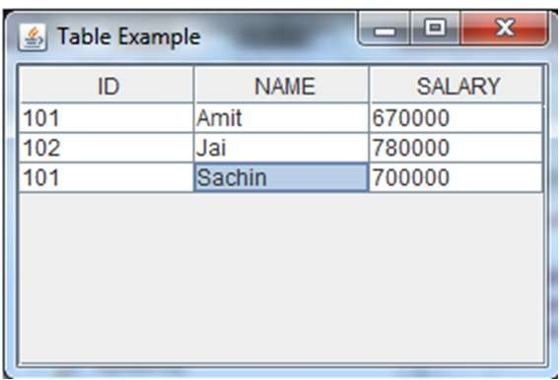}

**public void** valueChanged(ListSelectionEvent e) { }

String Data = **null**;

**int**[] row = jt.getSelectedRows();

#### Java JList

**import** javax.swing.*; **import** java.awt.event.*; **public class** ListExample

{

ListExample(){

JFrame f= **new** JFrame();

**final** JLabel label = **new** JLabel(); label.setSize(500,100);

JButton b=**new** JButton("Show"); b.setBounds(200,150,80,30);

**final** DefaultListModel<String> l1 = **new** DefaultListModel<>();

l2.addElement("YII");

final JList<String> list2 = new JList<>(l2); list2.setBounds(100,200, 75,75);

f.add(list1); f.add(list2); f.add(b); f.add(label); f.setSize(450,450);

f.setLayout(null); f.setVisible(true);

b.addActionListener(new ActionListener() { public void actionPerformed(ActionEvent e) {

String data = "";

if (list1.getSelectedIndex() != -1) {

data = "Programming language Selected: " + list1.getSelectedValue(); label.setText(data);

}

if(list2.getSelectedIndex() != -1){ data += ", FrameWork Selected: ";

for(Object frame :list2.getSelectedValues()){ data += frame + " ";

l1.addElement("C"); }

l1.addElement("C++"); }

l1.addElement("Java"); l1.addElement("PHP");

**final** JList<String> list1 = **new** JList<>(l1);

}

});

}

label.setText(data);

list1.setBounds(100,100, 75,75); DefaultListModel<String> l2 = **new** DefaultListModel<>(); l2.addElement("Turbo C++");

l2.addElement("Struts");

public static void main(String args[])

{

new ListExample();

}}

l2.addElement("Spring"); By Jagadish Sahoo

#### Java JOptionPane

* The JOptionPane class is used to provide standard dialog boxes such as message dialog box, confirm dialog box and input dialog box. These dialog boxes are used to display information or get input from the user. The JOptionPane class inherits JComponent class.

**import** javax.swing.*;

**public class** OptionPaneExample { JFrame f;

OptionPaneExample(){ f=**new** JFrame();

JOptionPane.showMessageDialog(f,"Hello, Welcome to Javatpoint.");

}

**public static void** main(String[] args) {

**new** OptionPaneExample();

}

}

import javax.swing.*;

public class OptionPaneExample { JFrame f;

OptionPaneExample(){ f=new JFrame();

JOptionPane.showMessageDialog(f,"Successfully Updated.","Alert",JOptionPane.WARNING_MESSAGE);

}

public static void main(String[] args) { new OptionPaneExample();

}

}

**import** javax.swing.*;

**public class** OptionPaneExample { JFrame f;

OptionPaneExample(){ f=**new** JFrame();

String name=JOptionPane.showInputDialog(f,"Enter Name");

}

**public static void** main(String[] args) {

**new** OptionPaneExample();

}

}

import javax.swing.*; import java.awt.event.*;

public class OptionPaneExample extends WindowAdapter{ JFrame f;

OptionPaneExample(){ f=new JFrame();

f.addWindowListener(this); f.setSize(300, 300); f.setLayout(null);

f.setDefaultCloseOperation(JFrame.DO_NOTHING_ON_CLOSE); f.setVisible(true);

}

public void windowClosing(WindowEvent e) {

int a=JOptionPane.showConfirmDialog(f,"Are you sure?"); if(a==JOptionPane.YES_OPTION){

f.setDefaultCloseOperation(JFrame.EXIT_ON_CLOSE);

}

}

public static void main(String[] args) { new OptionPaneExample();

}

}

#### Java JMenuBar, JMenu and JMenuItem

* The JMenuBar class is used to display menubar on the window or frame. It may have several menus.
* The object of JMenu class is a pull down menu component which is displayed from the menu bar. It inherits the JMenuItem class.
* The object of JMenuItem class adds a simple labeled menu item. The items used in a menu must belong to the JMenuItem or any of its subclass.

**import** javax.swing.*;

**import** java.awt.event.*;

**public class** MenuExample **implements** ActionListener{ JFrame f;

JMenuBar mb; JMenu file,edit,help;

JMenuItem cut,copy,paste,selectAll; JTextArea ta;

MenuExample(){ f=**new** JFrame();

cut=**new** JMenuItem("cut"); copy=**new** JMenuItem("copy"); paste=**new** JMenuItem("paste"); selectAll=**new** JMenuItem("selectAll"); cut.addActionListener(**this**); copy.addActionListener(**this**); paste.addActionListener(**this**); selectAll.addActionListener(**this**); mb=**new** JMenuBar();

file=**new** JMenu("File"); edit=**new** JMenu("Edit"); help=**new** JMenu("Help");

edit.add(cut);edit.add(copy);edit.add(paste);edit.add(selectAll);

mb.add(file);mb.add(edit);mb.add(help); ta=new JTextArea(); ta.setBounds(5,5,360,320); f.add(mb);f.add(ta);

f.setJMenuBar(mb); f.setLayout(null); f.setSize(400,400); f.setVisible(true);

}

public void actionPerformed(ActionEvent e) { if(e.getSource()==cut)

ta.cut(); if(e.getSource()==paste) ta.paste(); if(e.getSource()==copy) ta.copy(); if(e.getSource()==selectAll) ta.selectAll();

}

public static void main(String[] args) { new MenuExample();

By}Jagadish Sahoo

}

#### Java LayoutManagers

* The LayoutManagers are used to arrange components in a particular manner. The **Java LayoutManagers** facilitates us to control the positioning and size of the components in GUI forms. LayoutManager is an interface that is implemented by all the classes of layout managers.
* There are the following classes that represent the layout managers:

1. java.awt.BorderLayout
2. java.awt.FlowLayout
3. java.awt.GridLayout
4. java.awt.CardLayout
5. java.awt.GridBagLayout
6. javax.swing.BoxLayout
7. javax.swing.GroupLayout
8. javax.swing.ScrollPaneLayout
9. javax.swing.SpringLayout etc.

#### Java BorderLayout

* The BorderLayout is used to arrange the components in five regions: north, south, east, west, and center. Each region (area) may contain one component only. It is the default layout of a frame or window. The BorderLayout provides five constants for each region:

1. public static final int NORTH
2. **public static final int SOUTH**
3. public static final int EAST
4. **public static final int WEST**
5. public static final int CENTER

import java.awt.*; import javax.swing.*;

public class Border

{

JFrame f; Border()

{

f = new JFrame();

JButton b1 = new JButton("NORTH");; // the button will be labeled as NORTH JButton b2 = new JButton("SOUTH");; // the button will be labeled as SOUTH JButton b3 = new JButton("EAST");; // the button will be labeled as EAST JButton b4 = new JButton("WEST");; // the button will be labeled as WEST JButton b5 = new JButton("CENTER");; // the button will be labeled as CENTER

f.add(b1, BorderLayout.NORTH); // b1 will be placed in the North Direction f.add(b2, BorderLayout.SOUTH); // b2 will be placed in the South Direction f.add(b3, BorderLayout.EAST); // b2 will be placed in the East Direction f.add(b4, BorderLayout.WEST); // b2 will be placed in the West Direction f.add(b5, BorderLayout.CENTER); // b2 will be placed in the Center

f.setSize(300, 300); f.setVisible(true);

}

public static void main(String[] args) { new Border();

}

}

#### Java GridLayout

* The Java GridLayout class is used to arrange the components in a rectangular grid. One component is displayed in each rectangle.

import java.awt.*; import javax.swing.*;

public class MyGridLayout{ JFrame f;

MyGridLayout(){ f=new JFrame();

JButton b1=new JButton("1"); JButton b2=new JButton("2"); JButton b3=new JButton("3"); JButton b4=new JButton("4"); JButton b5=new JButton("5"); JButton b6=new JButton("6"); JButton b7=new JButton("7"); JButton b8=new JButton("8"); JButton b9=new JButton("9");

// adding buttons to the frame f.add(b1); f.add(b2); f.add(b3);

f.add(b4); f.add(b5); f.add(b6);

f.add(b7); f.add(b8); f.add(b9); f.setLayout(new GridLayout(3,3));

f.setSize(300,300); f.setVisible(true);

}

public static void main(String[] args) { new MyGridLayout();

}

}

#### Java FlowLayout

* The Java FlowLayout class is used to arrange the components in a line, one after another (in a flow). It is the default layout of the applet or panel.
* Fields of FlowLayout class

1. public static final int LEFT
2. **public static final int RIGHT**
3. public static final int CENTER
4. **public static final int LEADING**
5. public static final int TRAILING

import java.awt.*; import javax.swing.*;

public class FlowLayoutExample

{

JFrame frameObj; FlowLayoutExample()

{

frameObj = new JFrame();

JButton b8 = new JButton("8"); JButton b9 = new JButton("9"); JButton b10 = new JButton("10");

frameObj.add(b1); frameObj.add(b2); frameObj.add(b3); frameObj.add(b4);

frameObj.add(b5); frameObj.add(b6); frameObj.add(b7); frameObj.add(b8);

frameObj.add(b9); frameObj.add(b10); frameObj.setLayout(new FlowLayout());

frameObj.setSize(300, 300); frameObj.setVisible(true);

JButton b1 = new JButton("1"); JButton b2 = new JButton("2"); JButton b3 = new JButton("3"); JButton b4 = new JButton("4"); JButton b5 = new JButton("5"); JButton b6 = new JButton("6"); JButton b7 = new JButton("7");

}

}

// main method

public static void main(String argvs[])

{

new FlowLayoutExample();

}

#### Java CardLayout

* The **Java CardLayout** class manages the components in such a manner that only one component is visible at a time. It treats each component as a card that is why it is known as CardLayout.

**Commonly Used Methods of CardLayout Class**

* **public void next(Container parent):** is used to flip to the next card of the given container.
* **public void previous(Container parent):** is used to flip to the previous card of the given container.
* **public void first(Container parent):** is used to flip to the first card of the given container.
* **public void last(Container parent):** is used to flip to the last card of the given container.
* **public void show(Container parent, String name):** is used to flip to the specified card with the given name.

import java.awt.*;

import java.awt.event.ActionEvent; import java.awt.event.ActionListener; import javax.swing.*;

public class CardLayoutExample3 extends JFrame

{

private int currCard = 1; private CardLayout cObjl;

public CardLayoutExample3()

{

setTitle("Card Layout Methods"); setSize(310, 160);

JPanel cPanel = new JPanel(); cObjl = new CardLayout(); cPanel.setLayout(cObjl);

JPanel jPanel1 = new JPanel(); JPanel jPanel2 = new JPanel(); JPanel jPanel3 = new JPanel();

JPanel jPanel4 = new JPanel(); JLabel jLabel1 = new JLabel("C1"); JLabel jLabel2 = new JLabel("C2"); JLabel jLabel3 = new JLabel("C3");

JLabel jLabel4 = new JLabel("C4"); jPanel1.add(jLabel1);

jPanel2.add(jLabel2); jPanel3.add(jLabel3); jPanel4.add(jLabel4); cPanel.add(jPanel1, "1");

cPanel.add(jPanel2, "2");

cPanel.add(jPanel3, "3");

cPanel.add(jPanel4, "4"); JPanel btnPanel = new JPanel();

JButton firstButton = new JButton("First"); JButton nextButton = new JButton("->"); JButton previousButton = new JButton("<-"); JButton lastButton = new JButton("Last"); btnPanel.add(firstButton); btnPanel.add(nextButton);

By Jagadish Sahoo

btnPanel.add(previousButton);

#### Java GridBagLayout

* + The Java GridBagLayout class is used to align components vertically, horizontally or along their baseline.
  + The components may not be of the same size. Each GridBagLayout object maintains a dynamic, rectangular grid of cells. Each component occupies one or more cells known as its display area. Each component associates an instance of GridBagConstraints. With the help of the constraints object, we arrange the component's display area on the grid. The GridBagLayout manages each component's minimum and preferred sizes in order to determine the component's size. GridBagLayout components are also arranged in the rectangular grid but can have many different sizes and can occupy multiple rows or columns.

By Jagadish Sahoo

import java.awt.Button;

import java.awt.GridBagConstraints; import java.awt.GridBagLayout;

import javax.swing.*;

public class GridBagLayoutExample extends JFrame{ public static void main(String[] args) {

GridBagLayoutExample a = new GridBagLayoutExample();

}

public GridBagLayoutExample() { GridBagLayoutgrid = new GridBagLayout();

GridBagConstraints gbc = new GridBagConstraints(); setLayout(grid);

setTitle("GridBag Layout Example"); GridBagLayout layout = new GridBagLayout();

this.setLayout(layout);

gbc.fill = GridBagConstraints.HORIZONTAL; gbc.gridx = 0;

gbc.gridy = 0;

this.add(new Button("Button One"), gbc);

gbc.gridx = 1;

gbc.gridy = 0;

this.add(new Button("Button two"), gbc); gbc.fill = GridBagConstraints.HORIZONTAL; gbc.ipady = 20;

gbc.gridx = 0;

gbc.gridy = 1;

this.add(new Button("Button Three"), gbc); gbc.gridx = 1;

gbc.gridy = 1;

this.add(new Button("Button Four"), gbc); gbc.gridx = 0;

gbc.gridy = 2;

gbc.fill = GridBagConstraints.HORIZONTAL; gbc.gridwidth = 2;

this.add(new Button("Button Five"), gbc); setSize(300, 300); setPreferredSize(getSize()); setVisible(true);

setDefaultCloseOperation(EXIT_ON_CLOSE);

}

By Jagadish Sa}hoo